Name: …………………………………………..………… Adm No.: ………… Class: ………
233/1
CHEMISTRY PAPER 1
FORM FOUR
MID-TERM EXAM
TERM 2 - 2024
TIME: 2 HOURS

- (a) Excess magnesium ribbon was burnt in air to form a white solid mixture. Write two equations to show the formation of the white solid mixture. (2mks)

(b) When water was added to the white solid mixture effervescence took place and a colourless gas with characteristic chocking pungent smell produced.
- Identify the gas. (1mk)

- State one use of the gas identified in (b) (i) above. (1mk)

- State two laboratory rules that should be followed to avoid contamination and wastage of chemicals. (2mks)

- (a) 200g of radioactive isotope A reduce to 25g in 75 minutes. Determine the half-life of A. (2mks)

(b) Define half-life. (1mk)

- Calculate the enthalpy of formation of ethanol given the enthalpies of;
Combustion of ethanol = -1369 Kjmol⁻¹
Combustion of carbon = -394 Kjmol⁻¹
Combustion of hydrogen = -286 Kjmol⁻¹ (3mks)

- A substance containing only carbon and hydrogen has 80% by mass of carbon. It is also given that 1dm³ of the compound has a mass of 1.35g. Determine the molecular formula of the compound. (C=12, H=1,MGV at s.t.p=22.4dm³) (3mks)

- The formula given below represents part of polymer.

H H H H

C C C C

O H O H n

- Name the polymer (1mk)

- Draw the structure of the monomer used to manufacture the polymer. (1mk)

- Name the process that take place when:
- Natural fats or oils are hydrolysed using alkalis. (1mk)

- Sulphur is added to natural rubber and heated to form cross links. (1mk)

- (a) State Charle’s law. (1mk)

(b) The capacity of a balloon to hold a gas at 5ºC is 1dm³ before it bursts due to expansion. Show very clearly whether it will or will not burst at 25ºC. (Pressure remains constant.) (2mks)

- Dry carbon (II) oxide gas reacts with heated lead (II) oxide as shown in the equation below:
PbO_{(s)} + CO_{(g)} → Pb_{(s)} + CO_{2(g)}
- Name the process undergone by lead (II) oxide. (1mk)

- Give a reason for your answer in (a) above. (1mk)

- Name another gas that can be used in place of carbon (II) oxide in the above reaction. (1mk)

- The structure below represents a type of a cleansing agent.

R ${SO}_{3}^{-}{Na}^{+}$

- Identify the cleansing agent. (1mk)

- Describe how the cleansing agent removes grease from a piece of cloth. (3mks)

- The table below shows the number of valence electrons of elements P, Q and R.
Element | P | Q | R
Number of valence electrons | 3 | 5 | 2

- Explain why P and R would not be expected to form a compound. (1mk)

- Write an equation to show the effect of heat on the carbonate of R. (1mk)

- What is the formula for the most stable ion of Q. (1mk)

- The flow chart below represents an industrial process for the manufacture of bleaching powder.
Z
Bleaching powder
Chlorine gas

- Name substance Z. (1mk)

- Write a formula of bleaching powder. (1mk)

- Explain why a lot of soap is used during washing with water containing bleaching powder. (1mk)

- Give one test by which you could differentiate between solution of lead (II) nitrate and zinc nitrate. (2mks)

- Given the element ${}_{12}^{24}R$
- To which chemical family does R belong? (1mk)

- Write the electron arrangement of the atom. (1mk)

- Draw the structure of its ion. (1mk)

- An element consist of two isotopes with atomic masses 59 and 61 in the ratio of 3:2 respectively. Calculate its relative atomic mass. (2mks)

- You are given the following half-equations:
$${Mg}_{(aq)}^{2+}+{2e}^{-}→{Mg}_{(s)} E^{θ}=-2.37V$$

$${Zn}_{(aq)}^{2+}+{2e}^{-}→{Zn}_{(s)} E^{θ}=-0.76V$$

- Obtain an equation of the cell reaction. (1mk)

- Calculate the e.m.f of the cell. (1mk)

- Give the oxidizing species. (1mk)

- State one function of the salt bridge in electrochemical cells. (1mk)

- (a) When extinguishing fire caused by burning kerosene, carbon (IV) oxide is preferred to water. Explain. (2mks)

(b) Write the formula of the oxide of carbon which is ‘silent killer’ (1mk)

- (a) Complete the table below. (3mks)
Metal | Aluminium | Lead | Sodium
Chief ore | Bauxite | Galena | ……………………
Chemical name | …………………….. | ………………………. | Sodium chloride
Method of extraction | ……………………... | ………………… | ………………….

(b) State two uses of aluminium metal. (2mks)

- Manganese sulphide reacts with acids according to the following equation.
$${MnS}_{(s)}+{2H_{3}O}^{+}⇄{Mn}_{(aq)}^{2+}+ {2H}_{2}O_{(l)}+H_{2}S_{(aq)}$$
- State, giving a reason what would happen to the equilibrium if:
- Water is added to the equilibrium mixture. (1 ½ mk)

- Hydrogen chloride is bubbled into the equilibrium mixture. (1 ½ mk)

- Using dots (.) and crosses (x) to represent outermost electrons, draw diagrams showing bonding in:
- Aluminium oxide. (1 ½ mk)

- Hydroxonium ion. (1 ½ mk)

- The diagram below represents a set up used for the large scale manufacture of hydrochloric acid.
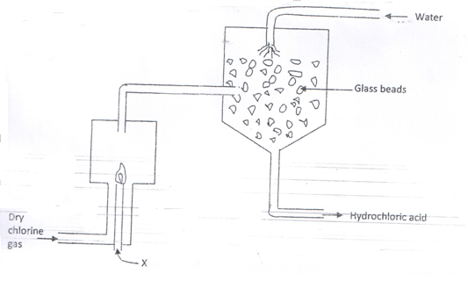
- Name substance x. (1mk)

- What is the purpose of the glass beads? (1mk)

- Give one use of hydrochloric acid. (1mk)

- A volume of 20 litres of hydrogen chloride (HCl) was completely decomposed to its constituent elements (hydrogen and chlorine) what are the volumes of the constituent elements? (2mks)

- Study the diagram below and answer the questions that follow.
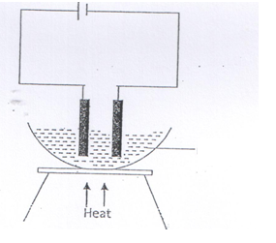
Molten Magnesium Chloride

- On the diagram label the anode and cathode. (1mks)
- Write the equation at the anode. (1mk)

- State a reason why heating is necessary in the set up. (1mk)

- An element E has relative atomic mass 88. When a current of 0.5 amperes was passed through a solution of a chloride of E for 32 minutes and 10 seconds, 0.44g of E were deposited at the cathode. What is the charge on the ion of E? (1 Faraday = 96500C) (3mks)

- State one applications of chromatography. (1mk)

- In an experiment, two 3cm long magnesium ribbons are separately placed in 3cm³ of 2M HCl and 3 cm³ of 2M ethanoic acid respectively. State and explain what is observed. (3mks)

- Explain a test for hydrogen gas. (1mk)

- Name one apparatus that can be used to measure approximately 80cm³ of dilute hydrochloric acid. (1mk)

- Explain why dilute nitric (V) acid is not used in hydrogen gas preparation. (1mk)

- State and explain what you would observe if concentrated Sulphuric (VI) acid is added to cane sugar. (2mks)

