FORM 2
CHEMISTRY
MID-TERM 2 2024 EXAM
NAME………………………………………………………..ADM…………..CLASS………..
Answer all questions.
- The table below gives the atomic numbers of elements represented by letters K,L,M and N.
Element | K | L | M | N
Atomic number | 15 | 16 | 17 | 20
- Name the type of bond that exists in the compound formed between;
N and L (1 mk)

K and M (1 mk)
- Give a reason for your answer in each case in (a) above. (2 mks)

- Use a dot(•) and cross(×) diagram to show bonding between K and M. (1 mk)

- In an experiment,hydrogen gas was passed over heated copper(II) oxide as shown.
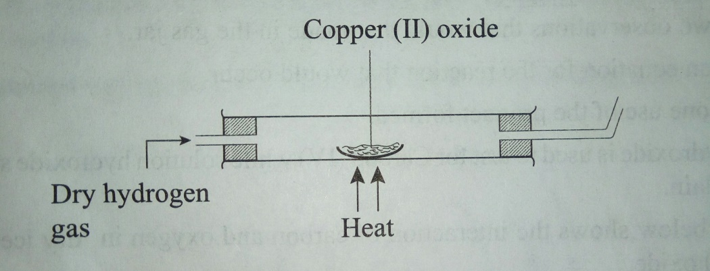
- State the observations made in the combustion tube after the experiment.(2 mks)

- Write an equation for the reaction between copper (II) oxide and hydrogen gas.(1 mk)

- Explain why heat is necessary in this experiment.(1 mk)

- Define the following terms:(3marks)
i)Hygroscopy

ii)Deliquescence

iii)Efflorescence

- Differentiate the following terms:
a) Anode and cathode (2 mks)

b)Electrolysis and an electrolyte(2marks)

c)State two applications of electrolysis(2marks)

5.a) What is an isotope?(2 mks)

b)Lithium has two isotopes with mass number 6 and 7.If the relative atomic mass of lithium is 6.94,determine the percentage abundance of each isotope.(2 mks)

6. The diagrams below represent two nails with some parts covered tightly with zinc and tin respectively.Explain the observations that would be made at the exposed points R and Z if wrapped nails are left in the open for several days.(3 mks)

7. Study the flow chart below and answer the questions that follow.
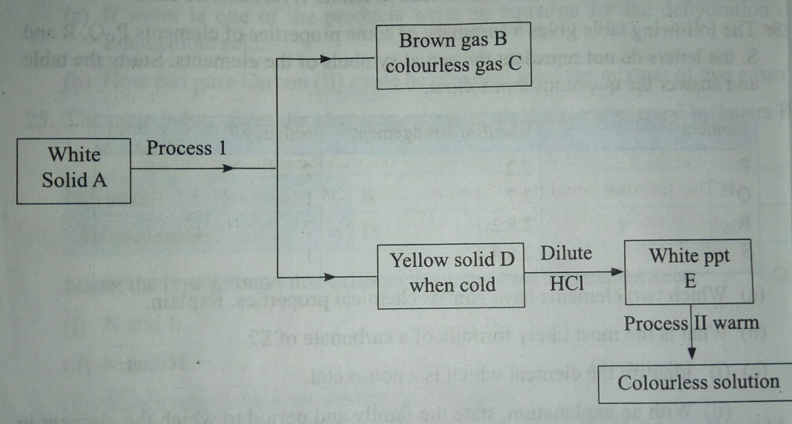
a) Identify substances;(3 mks)
A
D
E
b)Name process 1.(1 mk)

c) Describe the test for colourless gas C.(1 mk)

d)Write a balanced equation for the formation of white precipitate E.(1 mk)

e) What does process (II) indicate about the solubility of E? (1 mk)

8.The diagram below shows a set up which was used by a student to investigate the effect of electricity on molten lead (II) iodide.
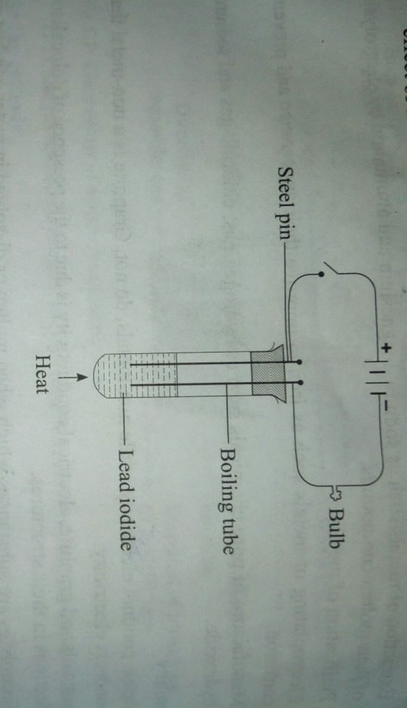
- Explain what happens to the lead iodide during electrolysis.(2 mks)

- Why does solid lead(II) iodide not allow the passage of electricity?(1 mk)

- Why was it important to carry out the experiment in a fume chamber?(1 mk)

- Write equations to show the reaction taking place? (2 mks)
- At the cathode.

- At the anode.

9. Describe how the following reagents can be used to prepare lead sulphate.(3 mks)
Solid potassium sulphate,solid lead carbonate,dilute nitric (V) acid and distilled water.

10. Spots of pure pigments A and B and a mixture of Z were placed on a filter paper and allowed to dry.The paper was then dipped in a solvent. The results obtained were as on the paper chromatogram.
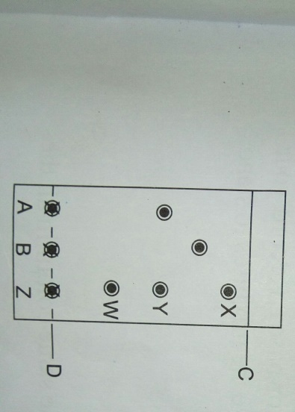
- Which is the:(2 mk)
- Base line?

- Solvent front?
- Which of the pure pigments was a component of Z? Explain.(2 mks)

- Name a solvent that is used in paper chromatography.(1 mk)

- Why is water not a suitable solvent in paper chromatography?(1 mk)

11.When lead nitrate and magnesium sulphate react, a white precipitate is formed.
- Identify the white precipitate.Give a reason.(2 mks)

- Write an ionic equation for the reaction.(1 mk)

