NAME………………………………………………………………ADM………………….CLASS………………
MID TERM 2 EXAM – 2024
CHEMISTRY
Time 1¹/₂ hrs
INSTRUCTIONS: - Answer all questions on the space provided
- All working must be Cleary shown where necessary
- The diagram below shows part of non - luminous flame of the Bunsen burner. Study it to answer questions that follows.
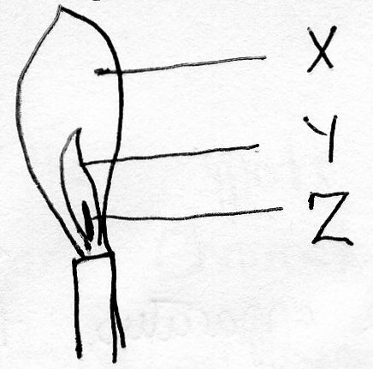
- Name the parts of the flame labeled as; (3mks)
X………………………………………………
Y……………………………………………….
Z……………………………………………….
- Which part of the flame above is the hottest? Explain. (2mks)

- A non – luminous flame is preferred for heating. Explain. (1mks)

- Name the other type of flame and condition under which that flame is produced. (1mk)

- a) State four laboratory rules. (4mks)

b) Name three frequently abused drugs. (3mks)

- a) The set – up below represents the apparatus that may be used to separate two miscible liquids A and B whose boiling point are 80⁰c and 110⁰c respectively.
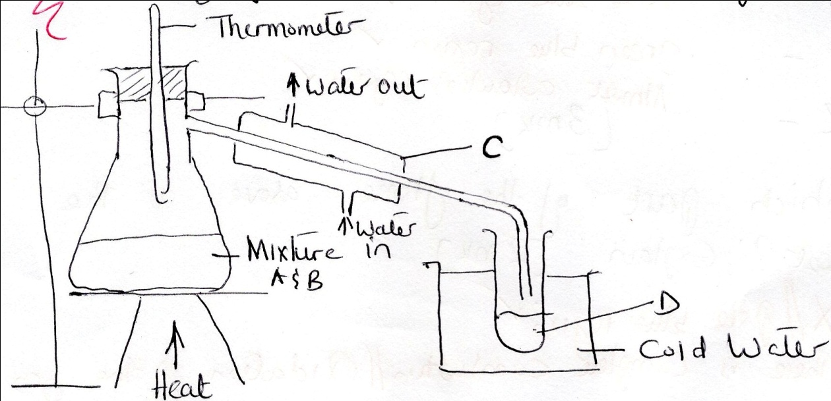
- Name C and D (2mks)

- What is the purpose of thermometer? (1mk)

- Which liquid was collected first? Explain (2mks)

- Name the methods of separation of mixture. (1mk)

- Name two mixture that can be separated using above methods of separation. (2mks)

- Name the above method of mixture. (1mk)

b) The spots in the diagram below represents a paper chromatogram for the three l brands of soda that contains unwanted food additives.

A B C D
A
● ● ●
●
●
● ●
● ● ● ● ●

The results showed presence of unwanted food additives in B and C only. On the
- Label the baseline or origin and the solvent front. (2mks)

- Circle the spots which showed unwanted food additives. (2mks)

- Which food additive was pure? Explain. (2mks)

- a) List the three states of matter. (3mks)

b) State the Kinetic theory of matter. (1mks)

c) The graph below shows the heating curves obtained when solid X and solid Y were heated to boiling point.
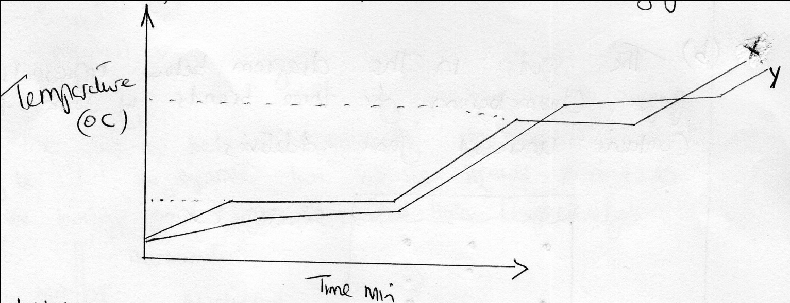
i) Which of the two liquids was pure? Explain. (2mks)

ii) What would be the effect of adding an impurity to the boiling point of a substance? (1mk)
d)Name the elements present in the following compounds
i) Zinc sulphide. (1mk)

ii) Magnesium oxide. (1mk)

iii)Potasium iodide. (1mk)

- a) Draw a set –up of apparatus that can be used to separate iodine and sand. (3mks)

b) Table below shows PH values of various solutions
Solution | PH
A  B  C  D | 1  7  14  9
Classify the solutions in the table above as
- Strong acid………………………………………………..
- Weak base…………………………………………………
- Strong base……………………………………………….
- Neutral…………………………………………………….
c) Name two examples of mineral acid one organic acid. (2mks)

i) Mineral acid (2mks)

ii) Organic acids (1mks)

