Name: …………………………………...........................................…… Adm no ……..…...................... Class.................
231/
BIOLOGY FORM FOUR
TERM TWO: MID-TERM
JUNE/ 2024
TIME: 2HRS 30 MIN

INSTRUCTIONS TO CANDIDATES:
- Answer ALL the questions
- Answers should be written in the spaces provided

1. The figure shows changes that take place during menstrual cycle in human
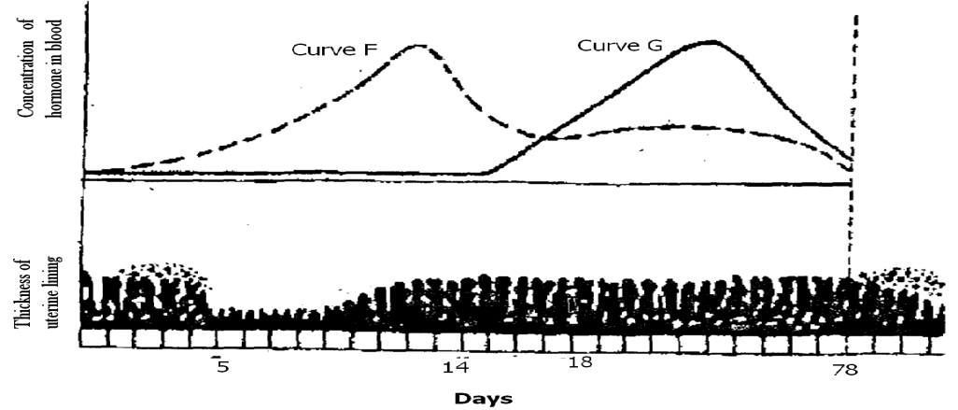
28

a) Name the hormones whose concentrations are represented by curves F and G (2mks)
F......................................................................................................................................................
G.....................................................................................................................................................

b) State the effects of the hormones named in (a) above on the lining of the uterus (2mks)
.................................................................................................................................................................................................................................................................................................................................................................................................................................................................................
c) i) Name the hormone which is released by the pituitary gland in high concentration on the 14th day of the menstrual cycle (lmk)
............................................................................................................................................................................................................................................................................................................................
ii) State two functions of the hormone named in (c) (i) above (2mks)
............................................................................................................................................................................................................................................................................................................................
d) State the fertile period during the menstrual cycle (1mk)
............................................................................................................................................................................................................................................................................................................................
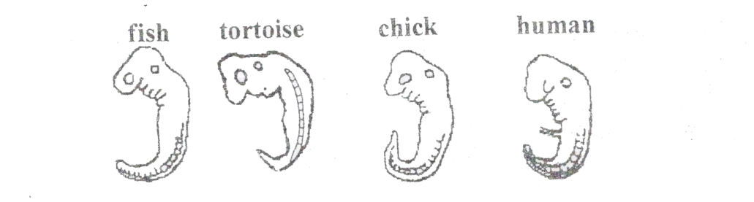
2. The diagrams below show embryos of certain vertebrates animals. Study them and answer the question that follows.

- Mention two observable structural features in these embryos that suggest that they have a common ancestral origin. (2mrks)
………....................................................................................................................................................................................................................................................................................................................................................................................................................................................................................

- What phenomenon in organic evolution is exhibited by these diagrams of embryos? (1mrk)
................................................................................................................................................................................................................................................................................................................................
3. What is meant by the terms? (3mks)
a) Hypogenous flower
…..……………………………………………………………………………………………………..
b) Gamesepalous …………………………………………………………………………………………………………………………………………………………………………………………………………………....
c) Dichagamy ......................................................................................................................................
..........................................................................................................................................................
3. a) Name two salts in bile that aid in emulsification of fats. (2mks)
.........................................................................................................................................................................................................................................................................................................................................................................................................................................................................................................
b) In what ways does sex of an individual determine their energy requirements? (1mrk)
..................................................................................................................................................................................................

- An experiment was set up as shown below.

String
Beaker
Glucose solution
Visking tubing
Distilled water A

Contents of the beaker were tested for the presence of reducing sugars at start of experiment and after 30 minutes using Benedict’s solution. The results were recorded as shown overleaf.
 | Observation | Conclusion
At start | Contents (A) took colour of Benedict’s solution
After 30 minutes | Contents turned blue, green, yellow to orange

- Complete the table above. (2mks)
- i) Name the biological process that was being investigated. (1mrk)
………………………………………………………………………...…………………………………........………………………….………………………………….……….…………………………........
ii) Account for the observations made. (3mks)
………………………………………………………………………...…………………………………........………………………….………………………………….……….…………………………........………………………………………………………………………...…………………………………........………………………….………………………………….……….…………………………........
c) Distinguish between cell physiology and cell specialization. (2mks)
………………………………………………………………………...…………………………………........………………………….………………………………….……….…………………………....…………………………………………………………………...…………………………………........…
5. a) State two ways in which the protection of the heart against mechanical injury is achieved during heartbeat. (2mks)
.........................................................................................................................................................................................................................................................................................................................................................................................................................................................................................................
6. a) State two functions of aerenchyma tissue in hydrophytes. (2mks)
.........................................................................................................................................................................................................................................................................................................................................................................................................................................................................................................
b) State the difference between habitat and ecological niche. (2mks)
............................................................................................................................................................................................................................................................................................................................................................................................................................................................................................................................................................................................................................................................................

7. Name the enzyme in the red blood cell that speeds up the conversion of carbonic acid to carbon (IV) oxide. (1mk)
......................................................................................................................................................................

8. State three ways in which the skin of a frog is adapted for gaseous exchange. (3mks)
............................................................................................................................................................................................................................................................................................................................................................................................................................................................................................................................................................................................................................................................................
9. a) Under which of the following light microscope magnification would one see a larger part of the
specimen. $×40 or ×400$ (1mk)
................................................................................................................................................................
b) Give your reason (1mk)
......................................................................................................................................................................................................................................................................................................................................
10. Give two reasons why blood leaving the lungs may not be fully oxygenated (2mks)
.........................................................................................................................................................................................................................................................................................................................................................................................................................................................................................................
11. State four differences between wind pollinated flower and insect pollinated flower. (4mks)
...............................................................................................................................................................................................................................................................................................................................................................................................................................................................................................................................................................................................................................................................................................................................................................................................................................................
- The diagram below shows how the iris and pupil of human eye appear under different conditions.
X

Y

Radial muscles
B
A

- Name the structures labeled X and Y (2mks)
X ..............................................……………………………………………………………………….
Y................................................………………………………………………………………………
- i) State the condition that lead to the change in appearance shown in the diagram labeled B. (1mk)
……………………………………………………………………………………………………………………………………………………………………………………………..……………………..

ii) Describe the changes that lead to the appearance of the iris and pupil as shown in the diagram labeled B. (4mks)
………………………………………………………………………………………………………………………………………………..……………………..………………………………………………………………………………………………………………………………………………………………………………………………………………………..……………………..…………………
- What is the significance of the changes described in (b) (ii) above. (1mk)
………………………………………………………………………………………………………………………………………………..……………………..……………………………………………
13. a) Name the cartilage found between the bones of the vertebral column. (1mk)
......................................................................................................................................................................................................................................................................................................................................
b) State three functions of the cartilage named in (a) above. (3mk)
............................................................................................................................................................................................................................................................................................................................................................................................................................................................................................................................................................................................................................................................................
14. State the functions of the following organelles
a) Lysosomes (1mk)
......................................................................................................................................................................................................................................................................................................................................
b)Golgi apparatus (2mks)
.........................................................................................................................................................................................................................................................................................................................................................................................................................................................................................................
15. Name two structures found in the cortex of the kidney (2mks)
.........................................................................................................................................................................................................................................................................................................................................................................................................................................................................................................
16. State the role of the following hormones in human body. (2mks)
i) Insulin……………………………………………………………….………………………………
............................................................................................................................................................
ii) Anti diuretic hormone…....………………………………...………………………………………
17. The diagram below shows a life cycle of a cockroach.
- Name the hormone that would be at high concentration during the first and second week and their functions.
- First week (2mks)
Hormone ...............................................................................................................................................
Function ...............................................................................................................................................
...............................................................................................................................................................
- Second week (2mks)
Hormone ...............................................................................................................................................
Function ...............................................................................................................................................
...............................................................................................................................................................
- Name the structure that secreted the hormone named in a(ii) above. (1mk)
............................................................................................................................................................................................................................................................................................................................................
- Name the process represented by the life cycle above. (1mk)
......................................................................................................................................................................................................................................................................................................................................
- State two importance of the process named in (c) above (2mks)
.........................................................................................................................................................................................................................................................................................................................................................................................................................................................................................................
18. Explain how high humidity lowers the rate of transpiration. (2mks)
.........................................................................................................................................................................................................................................................................................................................................................................................................................................................................................................
19. a) Distinguish between breathing and respiration. (2mks)
............................................................................................................................................................................................................................................................................................................................................................................................................................................................................................................................................................................................................................................................................
b) Explain the disadvantages of anaerobic respiration in plant roots. (2mks)
.........................................................................................................................................................................................................................................................................................................................................................................................................................................................................................................
20. a) Suggest the significance of the following adaptations in bony fish.
(i) Flexible vertebral column (1mk)
......................................................................................................................................................................................................................................................................................................................................
(ii) Presence of swim bladder (1mk)
......................................................................................................................................................................................................................................................................................................................................
b) State two features which reduce resistance in fish during swimming. (2mks)
.........................................................................................................................................................................................................................................................................................................................................................................................................................................................................................................
21. State three protective functions of human eye. (3mks
............................................................................................................................................................................................................................................................................................................................................
22. i) Define sex linkage. (1mk)
.........................................................................................................................................................................................................................................................................................................................................................................................................................................................................................................
ii) In a marriage of Jane and Otieno who are both normal for hemophiliac condition, gave birth to four children Susan, Grace, Tom and Peter. Tom the second born child was hemophilic. Later in life Tom married Alice who was normal. Their first born child was hemophiliac. Let H represent gene for normal condition.
a) What was the genotype of Alice. (1mk)
......................................................................................................................................................................................................................................................................................................................................
b) Work out the phenotypic ratio of F2. (5mks)

c) How does the police force use knowledge on genetics. (1mk)
.........................................................................................................................................................................................................................................................................................................................................................................................................................................................................................................
d) What is the name given to points of contact in a pair of homologous chromosomes. (1mk)
……………………………………………………………………………………………………..
22. a) Lietego school biology student used a microscope with x40 objective lens and x5 eyepiece lens which had 2mm radius. Calculate the area of the field of view in micrometers. (2mks)

b) What is the average size of the cell in micrometers (2mks)

