MARKING SCHEME BIOLOGY FORM 4
TERM 2 2024
Question 1
a) Oestrogen
Progesterone
b) - Promotes healing (promotes repair (of the uterus)
- Causes thickening (of the uterine lining) vasculation
c) i) Leutinizing hormone rej LH
ii) - Causes ovulation
- Induces graafian follicle to become corpus luteurn
- Stimulates corpus luteum to release progesterone
d) 12th-16th, 14+ 2

Question 2
a. Have a tail
Notochord rej backbone

b. Comparative embryology

Question 3
a. A flower with superior ovary with other floral parts below the ovary
b. Fused sepals
c. A condition in flowers where either the male or female parts mature before the other.

Question 4
a.- Sodium glycocholate
- Sodium tarocholate
b. Males have more muscles and less fat than females hence require more energy than females

Question 5
a)
At start | Reducing sugars; absent
After 30 minutes | Reducing sugars; present

b) i) diffusion;

ii) There is a high concentration of glucose molecules in the visking tubing than the beaker; glucose molecules are small enough to pass through the pores of the membrane; They move out into the beaker by diffusion;/ acc they diffuse out.

c) Cell physiology is the study of functions of the cell structures while specialisation is the structural modification/differentiation of cells to perform specific functions;

Question 6

a. -Pericardium membrane secretes a fluid that acts as a shock absorber/reduce friction during movement
- outer pericardial membrane is covered with a layer of fat that acts as a shock absorber

Question 7
a. reduces density to give buoyancy to the plant –contains air for gaseous exchange
b. Habitat is a specific locality with a particular set of conditions where an organism lives; Ecological niche is the position that an organism occupies in a habitat in terms of physical state and its role in feeding relationships.

Question 8

Carbonic anyhydrase

Question 9
-Supplied with many blood capillaries/highly vascularised
- Moist skin
-Thin epithelium

Question 10
- X40
- Smaller magnification gives wider field of view/larger part

Question 11
- under ventilation of lungs
- Blockage of alveoli/air sacs
- Disease and infection e.g. pneumonia
High cardiac frequency/high pumping

Question 12
.
Insect pollinated | Wind pollinated
Anthers-short/small firmly attached to filament  Pollen grains-large ,heavy and sticky  Stigma –small ,sticky | - long/large which are loosely attached to filament  - pollen grains are small smooth and light  - large/long feathery

Question 13
(a) X- Pupil;
Y- Circular muscles;

(b) (i) Condition that lead to the change in appearance shown
- Dim light /Low light intensity /darkness/ dull light;

ii) Changes that lead to the appearance of the iris and pupil as shown in the diagram
- Circular muscles in iris relax while radial muscles contract, pupil becomes wider /dilated, allowing more light to enter the eye ;

iii) Significance of changes described - improves visibility

Question 14
a .Interverterbral disc
b.Acts as shock absorber/reduce frinction/allow flexibility of vertebral; column rej prevent shock (a and b tied)

Question 15
a. lysosomes – stores (hydro) lytic enzymes/destruction of worn out tissues/cell organelles/pathogens/digested food material;

b.Transport of cell secretions;production of lysosomes;processing and packaging of synthesized materials;

Question 16
. Proximal convoluted tube of the nephron
- Distal convoluted tubule of nephron
The bowmans capsule
The glomerulus; first 2

Question 17
. Insulin- stimulates conversion of excess glucose in blood to glycogen
Ant diuretic hormone-increases permeability of kidney nephron to water.

Question 18
a) i) Juvenile Hormone (1 mark)
Function: Forms larval cuticle/inhibits moulting (1 mark)
ii) Ecdysone/moulting hormone (1 mark)
Function:Moulting to allow growth and metamorphosis (1 mark)
b) Prothoracic gland (1 mark)
c) Metamorphosis/Incomplete metamorphosis (1 mark)
d) i) Reduces competition for food since they feed on different food substances.
ii) Adapts the organism to escape adverse environment condition. (2 marks)

Question 19
High humidity results in low saturation deficit in the atmosphere hence low rate of water evaporation into the atmosphere and this lowers transpiration rate.

Question 20
a) Breathing is a process which speeds up the rate of gaseous exchange between an animal and its surrounding, respiration oxidation/breakdown of food within cells to release energy
b) Lower rate of mineral ions uptake by active transport, due to low energy output,Acc ethyl alcohol produced poison tissues lead to death

Question 21
a) i.Allow body to move from side to side/allow bending
ii. Air filled to make fish buoyant/keep fish a float
b) Streamlined body, scales overlapping pointing backwards/from anterior to posterior end; mucus on the skin;

Question 22
- Eyeball in socket for protection from mechanical injury
- Eyebrow prevent sweat from entering the eye
- Eyelid prevent, entry of foreign bodies/lubricate eye with tears when blinking
- Tear glands secret antiseptic/tears which lubricate the eye
Choroid layer contain pigment melanin which prevent uv rays from the sun

Question 23
a) X^{H}X^{h}
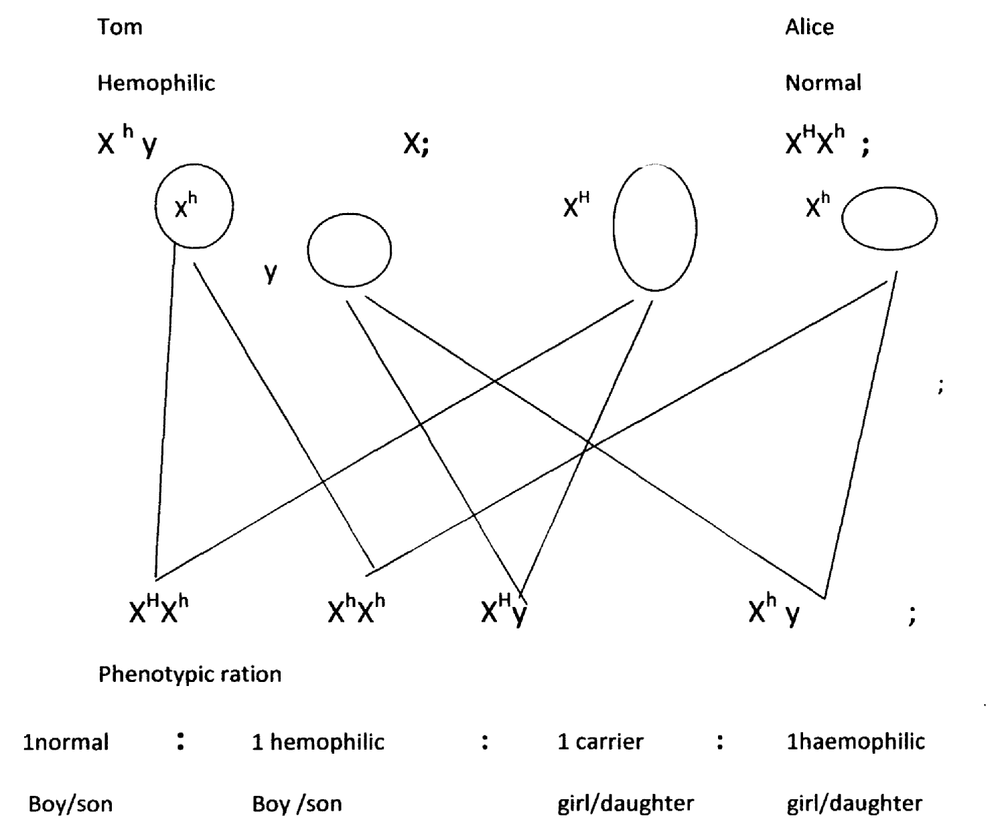
b)

c) Finger print in crime detection;
Settling parentage dispute;
Blood grouping;
Mark any one correct.
d) Chiasma/chiasmata (1 mark)
24. a) 1mm = 1000μm
Areas = πr² = ^{22/}₇ x ( 2000)²
= (²²/₇ x 2000 x 2000);
= 125714.29μm² ; (2mks)
b) 125714.29
5
= 25142.858μm²

