Name: …………………………..................................…… Adm no ……..…...................... Class.................
231/
BIOLOGY FORM THREE
TERM TWO: MID-TERM
JUNE/ 2024
TIME: 2HRS 30 MIN

JOINT EXAMINATION 2024
INSTRUCTIONS TO CANDIDATES:
- Answer ALL the questions
- Answers should be written in the spaces provided

1. The diagram below illustrate the first stage in the energy flow in the ecosystem
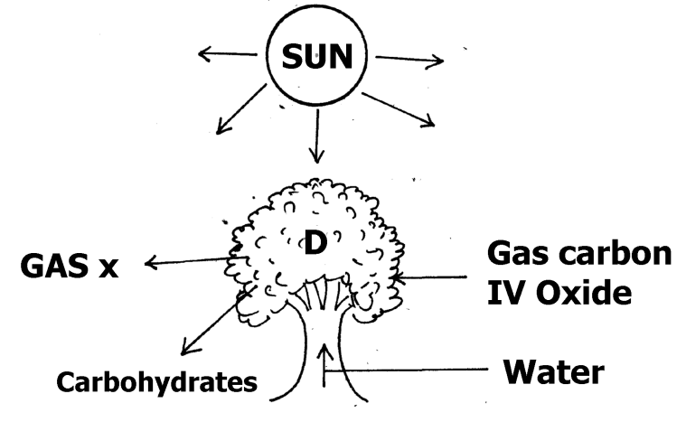

a) Identify (i) organelles responsible for activity in D.

i) in D………………………………………….................................................. (1mk)

(ii) Gas X ...............................................................................................................(1mk)

b) Suggest the roles played by each of the following in the process illustrated above.
i) Light energy (1mk)
..................................................................................................................................................................................................................................................................................................................................................................................................................................................................................................................
ii) Water (1mk)
..................................................................................................................................................................................................................................................................................................................................................................................................................................................................................................................
iii) Carbon (IV) Oxide (1mk)
..................................................................................................................................................................................................................................................................................................................................................................................................................................................................................................................
c) Give three ways in which the carbohydrates produced in the organelles at D is utilized in the plants. (3mks)
........................................................................................................................................................................................................................................................................................................................................................................................................................................................................................................................................................................................................................................................................................

2. State the functions of the following points of a light microscope.
(a) Diaphragm (1mk)
..................................................................................................................................................................................................................................................................................................................................................................................................................................................................................................................
(b) Condenser (1mk)
..................................................................................................................................................................................................................................................................................................................................................................................................................................................................................................................

3. State the functions of the following organelles.
(a) Nucleolus......................................................................................................................(1mk)
(b) Ribosomes....................................................................................................................(1mk)

4. The reaction represented by the equation below occurs in the body.
Hydrogen peroxide Enzyme Y Oxygen + Water
(a) Name enzyme Y..........................................................................................................(1mk)
(b) Name an organ in the body where the reaction occurs. (1mk)
........................................................................................................................................................
(c) What is the significance of the reaction (1mk)
........................................................................................................................................................
........................................................................................................................................................
5. Study the diagram of the embryo sac below and answer questions that follow.
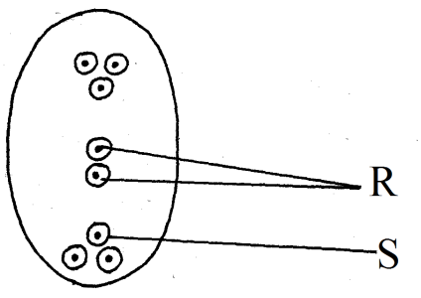
a) Name the type of fertilization that occurs in the embryo sac. (1mk)
............................................................................................................................................................................................................................................................................................................................................

b) What do the structure labelled R and S develop into after fertilization. (2mks)
R........................................................................................................................................................
S........................................................................................................................................................

6. a) Explain how the following factors control population.
i) Predation (1mk)
..................................................................................................................................................................................................................................................................................................................................................................................................................................................................................................................
ii) Competition (1mk)
..................................................................................................................................................................................................................................................................................................................................................................................................................................................................................................................
iii) Parasitism (1mk)
..................................................................................................................................................................................................................................................................................................................................................................................................................................................................................................................
b) A cat was used to control the population of rats.
i) What term is used to refer to this method. (1mk)
............................................................................................................................................................................................................................................................................................................................................
ii) State one advantage of using the method you named in (i) above. (1mk)
............................................................................................................................................................................................................................................................................................................................................
7. State the role played by the following substance in digestion.
(i) Hydrochloric acid (2mks)
........................................................................................................................................................
........................................................................................................................................................
(ii) Bile salts (2mks)
........................................................................................................................................................
........................................................................................................................................................
8. The chemical equation below represent a reaction that occurs in cels.
2C₅₁H₉₈O₆ + 145O₂ 102CO₂ + 98H₂O
(i) Calculate the respiratory quotient (RQ) (2mks)
........................................................................................................................................................
........................................................................................................................................................
........................................................................................................................................................
........................................................................................................................................................
........................................................................................................................................................
(ii) Identify the substrate used in the reaction. (1mk)
........................................................................................................................................................
- Give two reasons why the substrate you have identified in 9. (ii) above is not the
not the main respiratory substrate. (2mks)
........................................................................................................................................................
........................................................................................................................................................
........................................................................................................................................................
9. List down five differences between mitosis and meiosis (5mks)
........................................................................................................................................................
........................................................................................................................................................
........................................................................................................................................................
........................................................................................................................................................
........................................................................................................................................................
........................................................................................................................................................
........................................................................................................................................................
........................................................................................................................................................

10. Explain what happens in humans when the concentration of glucose in the blood
decreases below normal level. (4mks)
........................................................................................................................................................
........................................................................................................................................................
........................................................................................................................................................
........................................................................................................................................................

11. State two adaptations of the alveolus to its functions. (2mks)
........................................................................................................................................................
........................................................................................................................................................
........................................................................................................................................................
........................................................................................................................................................

12. (a) Explain the role of oxygen in Active transport (1mk)
........................................................................................................................................................
........................................................................................................................................................ ........................................................................................................................................................

(b) Name two processes that depend on Active transport in animals (2mks)
........................................................................................................................................................
........................................................................................................................................................
........................................................................................................................................................

13. Name support tissues in plants thickened with:
(a) Cellulose.....................................................................................................................(1mk)
(b) Lignin ..........................................................................................................................(1mk)

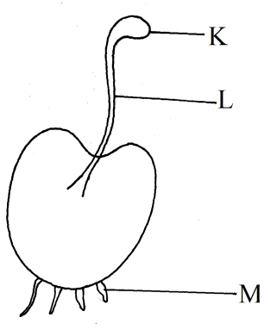
17. Study the diagram below and answer questions that follow
a) State the division the organism belongs (1mk)
.........................................................................................................
b) Name the parts labelled K and L (1mk)
K......................................................................................................
L.......................................................................................................

c) What is the function of the part labelled M. (1mk)
M.......................................................................................................................................................
18. a) Draw a well labeled transverse section of a berry fruit (6mks)

b) State four factors that hinder self-pollination and fertilization. (4mks)
........................................................................................................................................................
........................................................................................................................................................
.....................................................................................................................................................................................................................................................................................................................
19. A mango tree is known as mangifera Indica
(a) Identify two mistakes made in the writing of the name (2mks)
........................................................................................................................................................
........................................................................................................................................................
........................................................................................................................................................
(b) What is the scientific naming called? (1mk)
........................................................................................................................................................

20. Differentiate between gamosepolous and polysepolous (4mks)
........................................................................................................................................................
........................................................................................................................................................
......................................................................................................................................................................................................................................................................................................................
21. State two ways in which chloroplasts are adapted for photosynthesis (2mks)
........................................................................................................................................................
........................................................................................................................................................
........................................................................................................................................................

22. State the role of the following chemicals in a test for non-reducing sugar.
(i) Hydrochloric acid (1mk)
........................................................................................................................................................
(ii) Sodium hydrogen carbonate (1mk)
........................................................................................................................................................

23. Name two chemical compounds that are protein in nature that regulate metabolic activities in the body (2mks)
........................................................................................................................................................
........................................................................................................................................................
........................................................................................................................................................

24. State three environmental factors that increase the rate of transpiration. (3mks)
........................................................................................................................................................
........................................................................................................................................................
........................................................................................................................................................
........................................................................................................................................................

25. Carbon (II) oxide is a respiratory poison. Explain (3mks)
........................................................................................................................................................
........................................................................................................................................................
........................................................................................................................................................
........................................................................................................................................................
........................................................................................................................................................
........................................................................................................................................................
........................................................................................................................................................

26. In a physiological experiment, starch, protein, diastase and sodium chloride were added to water and put inside a visking tubing. The visking tubing was then placed in a water bath maintained at a temperature between 35 - 40°C. The set up was as shown in the diagram below.
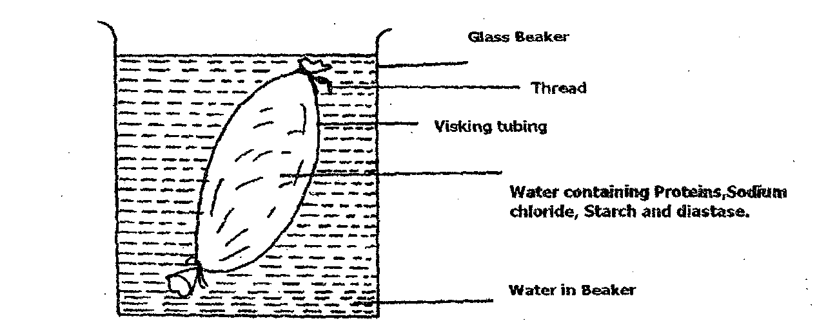
The following observations were made after the procedures indicated.
Contents in | At the start of experiment | After 1 hour
Visking tubing | i) Solution tastes salty | Solution tastes salty
 | ii) Visking tubing is not firm | Visking tubing is firm
 | iii) After boiling with Benedicts  solution, solution remains blue | After boiling with Benedicts solution the solution turns brown
 | iv) On addition of solution  hydroxide followed by copper  sulphate solution to the solution,  the colour changes to purple | On addition of sodium hydroxide followed by coppers sulphate to the solution, the colour changes to purple
Beaker | i) Water is tasteless | Solution tastes sweet/salty
 | ii) After boiling solution with  Benedicts solution, Blue colour  remains | After boiling solution with Benedicts solution, colour turns to brown
 | iii) On addition to sodium hydroxide  followed by copper sulphate solution,  colour remains blue | On addition of sodium hydroxide followed by copper sulphate solution, colour remains blue

a) Name the process by which salt moved into the water in the beaker from the visking tubing.
(l mk)
……………………………………………………………………………………………………

b) i) Name the food substance responsible for the brown colour observed after 1 hour both in
the beaker and visking tubing when solutions are boiled with benedicts solution. (1 mk)
…………………………………………………………………………………………………………………………………………………………………………………………………………

ii) Account for the observation in (b i) above. (3mks)
……………………………………………………………………………………………………………………………………………………………………………………………………………………………………………………………………………………………………………………….……………………………………………………………………………………………
c) i) Name the food substance tested with sodium hydroxide followed by copper sulphate solution(s) (1mk)
………………………………………………………………………………………………………………………………………………………………………………………………………....

ii) Account for the absence of the food substance named in (c i) above in the beaker after
1 hour. (l mk)
……………………………………………………………………………………………………………………………………………………………………………………………………………….................................................................................................................................................

d) After one hour the visking tubing was firm. State the term used to describe this state. (1 mk)
…………………………………………………………………………………………………………………………………………………………………………………………………………

27. You are provided with photographs of specimens labelled P, Q, R, S and T. Examine them carefully.
Q
P
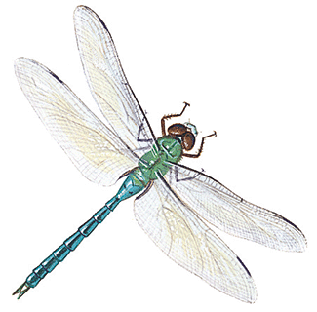
R
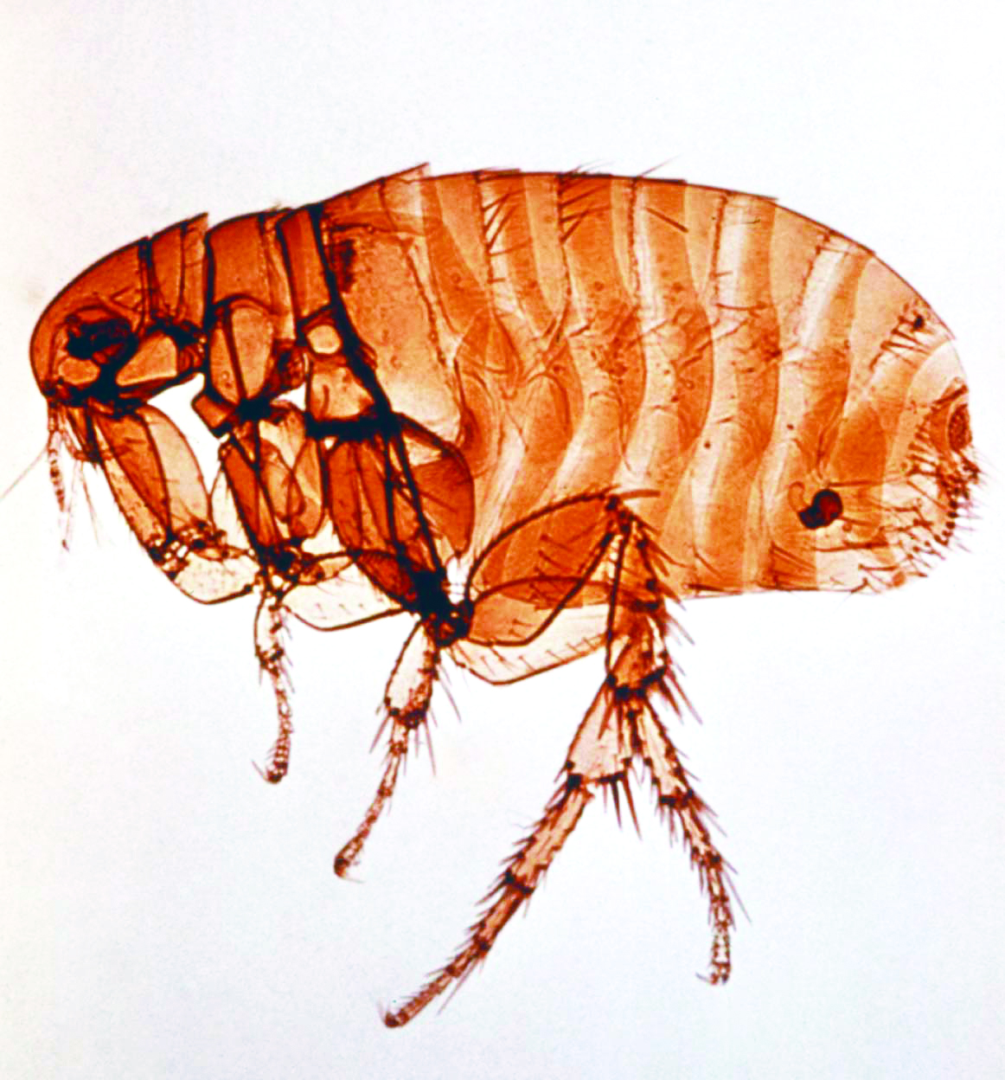
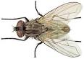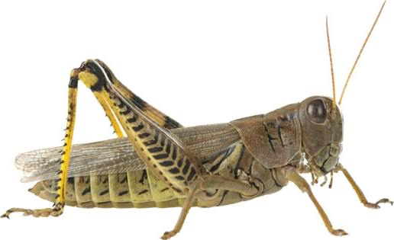
S
T

(a) Use the dichotomous key provided below to answer the questions that follow
1 a Wings present……………………………………………….Go to 2
b Wings absent………………………………………………..Go to 7
2 a One pair of wings…………………………………………...Housefly
b Two pairs of wings …………………………………….......Go to 3
3 a Wings membranous ………………………………………..Go to 4
b Hind wings only membranous……………………………....Go to 6
4 a Long and thin abdomen…………………………………......Dragon fly
b Medium sized abdomen…………………………………......Go to 5
5 a Wings peckled….....................................................................Butterfly
b Wings not peckled …………………………………………..Bee
6 a Forewings shell-like……………………………………........Beetle
b Fore wings hand……………………….………………........Grasshopper
7 a Body laterally flattened…..……………………………........Louse
b Body horizontally flattened…………………..………..........Flea

- Use the dichotomous key provided to identify each of the specimens. (5mks)
Specimen Steps followed Identity
P …………………….. ……………………
Q …………………….. ……………………
R …………………….. ……………………
S …………………….. …………………….
T …………………….. …………………….

- (i) State the class to which the specimens belong. (1mk)

…………………………………………………………………………………………………………

(ii) Give a reason for your answer in (b)(i) above. (1mk)
…………………………………………...……………………………………………………………………………………………………………...………………………………………………………

- Give two observable similarities and three observable differences between specimens S and T.
- Observable similarities. (2mks)
…………………………………………...……………………………………………………………………………………………………………...………………………………………………………
- Observable differences. (3mks)
................................................................................................................................................................................................................................................................................................................................................................................................................................................................................................................................................................................................................................................................
(d)(i) Identify the type of habitat specimen S is likely to be found living. (1mk)
…………………………………………..………………………………………………………………
(ii) Give a reason for your answer in (d) (i) above. (1mk)
………………………………………………………………….…………………………………………………………………………………..………………………………………………………………………………………………………………………………….………………………………

