MID TERM CAT EXAMS 2024

BIOLOGY

FORM 2
1Hr 20min

NAME: ...............................................................................CLASS............ADM........

- Distinguish between diffusion and osmosis. (2 marks)

..............................................................................................................................................................................................................................................................................................................................................................................................................................
- . 5C₅₁ H₉₈ 0₆ + 145 O_{2.} 102 CO₂ + 98 H₂O. The above equation shows an oxidation reaction of food substances.
    - What do you understand by the term respiratory quotient? (1mark)

    - Determine respiratory quotient of the oxidation of food substances. (1mark)

    - Identify the food substances. (1 mark)

- (i) Name the gaseous exchange surface in insects. (1mark)..................................................................................................................................................

(ii) State two ways the surface named in (a) above is suited to its function. (2 marks)

- The diameter field of view of a light microscopic is 6.5mm. Plant cells lying across the diameter are 12. Determine the size of one cell in micrometers.
(2 marks)

- The diagram below shows a section through plant organ.
.

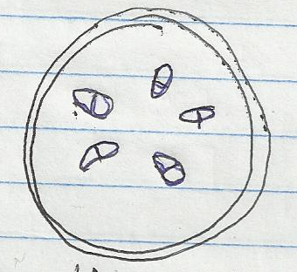

- (i) Name the class of the section was obtained.(1 mark)
......................................................................................................................
(ii) Give a reason for your answer in (a) above (1 mk)
........................................................................................................................................................................................................................................................................................................................................................................................................................................................................
- What is the role of vascular bundles in plant nutrition? (2 marks)
......................................................................................................................
........................................................................................................................................................................................................................................................................................................................................................................................................................................................................
- The following is a dental formula of a dog and rabbit, state two differences between them. (2 marks)

Dog: I 3 C 1 PM 4 M 2
3 1 4 3
Rabbit: I 2 C 0 PM 3 M 3
1 0 2 3

........................................................................................................................................................................................................................................................................................................................................................................................................................................................................

- The diagram below represents gaseous exchange in the alveolus

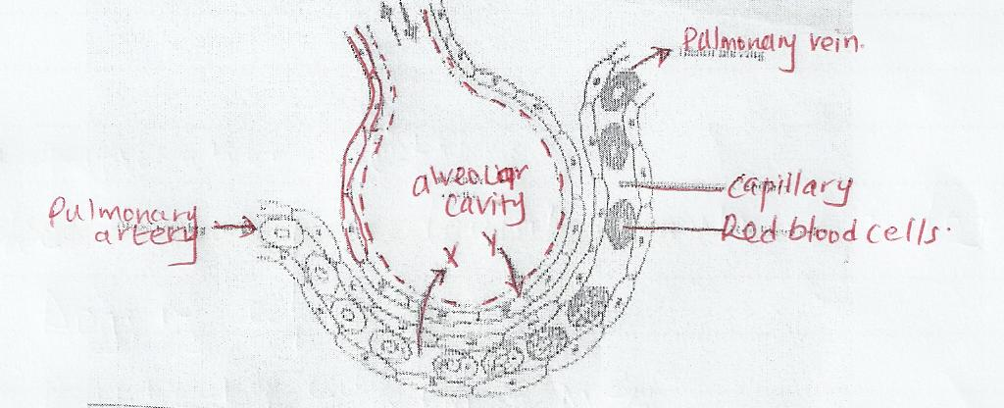

  - Mention the path followed by gas y from alveolar space until it reaches the red blood cells.(2mks)
........................................................................................................................................................................................................................................................................................................................................................................................................................................................................
- Explain how water from the soil is gained by root hair in plants. (2 marks)
........................................................................................................................................................................................................................................................................................................................................................................................................................................................................
- In what form is carbon IV oxide transported in blood. (1 mark)
........................................................................................................................................................................................................................................................................................................................................................................................................................................................................
- State the importance of each of the following features in animals; (2 marks)

  - Solid food being broken down into small pieces.
........................................................................................................................................................................................................................................................................................................................................................................................................................................................................
  - Presence of caecum in herbivorous mammals.
.......................................................................................................................................................................................................................................................................................................................................................................................................................................................................................

- Name the substance that accumulates in muscles when respiration occurs with insufficient oxygen. (1 mark)

- State the name given to the study of (2 marks)
(a) Micro-organisms ………………………………………………………………………………

(b) Inheritance and variation …………………………………………………………………………...........

- State the function of the following parts of a light microscope (2 marks)

(a) body-tube ………………………………………………………………………………

(b) Objective lens ………………………………………………………………………………
- How do;
(a) White blood cells provide protection against pathogenic bacteria in blood (2 marks)

……………………………………………………………………………………………………………………………………………………………………………………………………………………………………………… (b) The leucocytes pass from a blood vessel into a skin wound to provide protection (2 marks)

………………………………………………………………………………………………………………………………………………………………………………………………………………………………………………

- The diagram below represents the process that occurs in the synthesis of proteins.

(a) What is the name given to the units represented by the above symbols

……………………………………………………………………(1 mark)

(b) Name the process that occurs in the synthesis of the proteins

……………………………………………………………………(1 mark)

(c) Name the bond formed between any of the these units ………………………………................................................. (1 mark)

(d) State the site where the above process occurs in organisms ……………………….. ..............................................................(1mark)
- What is the effect of contraction of diaphragm muscles during breathing in mammals (3 marks)

………………………………………………………………………………

……………………………………………………………………………….............................................................................................................................

- (a) What is active transport (2 marks)

………………………………………………………………………………
………………………………………………………………………………

(b) How does oxygen concentration affect the rate of active transport (2 marks)
………………………………………………………………………………

………………………………………………………………………………

- Study the following equation and answer the questions that follow;

6CO_{2(g)} + 6H₂O _{(l)} chlorophyll C₆H₁₂O₆ + x
light
(a) Identify x………………………………………………… (1 mark)

(b)Name the organelle where the above process occurs………………...........................………………… (1 mark)

- A student added equal amounts of blood to equal volumes of salt of different concentrations. She observed and counted the red blood cells at the beginning of the experiment and at end of the experiment. The results were as shown:-
Set up | Concentration of salt | Beginning | After 30 mins
A | 0.1mol | 500 | 500
B | 0.01mol | 500 | 250
Account for the results in:
- Set up A (2mks)
……………………………………………………………………………………………………………………………………………………………………………………………….......................................................................

- Set up B (2mks)
………………………………………………………………………………………………………………………………………………………………………………………………......................................................................

- State one way in which aerenchyma tissues in aquatic plants are adapted to their function. (1mk)
…………………………………………………………………………………… 21. (a) State two functions of the blood other than transport. (2mks)
…………………………………………………………………………………………………………………………………………………………………………
(b) Name one defect of the circulatory system in humans. (1mks)

22. (a) Name the carbohydrate that is stored in Mammalian muscles. (1mk)
……………………………………………………………………………………

(b) List down two differences between polysaccharides and Monosaccharides. (2mks)

Polysaccharides Monosaccharides
……………………………………………….................................................. ……………………………………….............................................................
……………………………………………….................................................. ………………………………………............................................................
………………………………………………................................................ ………………………………………............................................................
23. State two beneficial effects of transpiration to a plant. (2mks)
…………………………………………………………………………………………………………………………………………………………………………

24.Name the carbohydrate that is stored in Mammalian muscles. (1mk)
………………………………………………………………………………………

25. Name two dental diseases (2mk)
………………………………………………………………………………………………………………………………………………………………………………………………………………………………………………………………………..

