MIDTERM CAT EXAMS 2024
BIOLOGY
FORM 1
NAME……………………………….…...................................……….CLASS………….ADM……..
- Give three differences between plants and animals(3mks)

- What is the term used for the intake of oxygen and release of carbon (iv)oxide by living organisms?(1mk)

- Define the following terms:
- cell

- tissue

- an organ

- an organ system (8mks)

- List four differences between light and electron microscope(8mks)

- Study instrument below and answer the following questions.
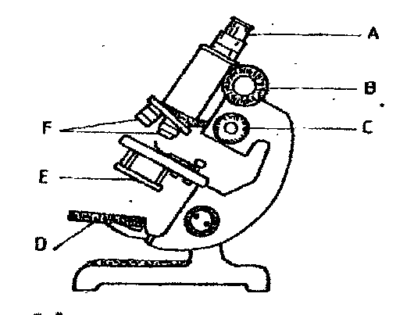
- Name the parts labelled A, B, C, D, E and F. (6 marks)

- State the functions of the following cell organelles: (4 marks)
- Ribosome

- Golgi apparatus

- Lysosome

- Nucleus

- Explain how the following factors affect diffusion:
- Diffusion gradient

- Thickness of tissues

- Temperature (6mks )

- List five skills that are gained on studying biology(5mks)

- State five rules that should be observed when handling a light microscope(5mks)

- Define the term nutrition(2mks )

- Distinguish between autotrophism and heterotrophism (2mks)

- Explain four roles of osmosis in living organisms (8mks )

- A student observing a leg of an insect under a hand lens made a drawing of the leg whose length was 4cm with a magnification of ×2 what was the actual length of the leg? (3mks )

