Name: …………………………………………..………… Adm No.: ………… Class: ………
AGRICULTURE
FORM FOUR
MID-TERM EXAM
TERM 2 - 2024
TIME:

INSTRUCTIONS
Answer ALL questions.

SECTION A: (30 MARKS)
- Outline three factors that limit the use of shifting cultivation in Kenya today. (1 ½ mks)

- Give three practices that would improve crop yields in areas with inadequate rainfall. (1 ½ mks)

- Name four components of the soil. (2mks)

- Give two farming practices that may cause pollution of water sources. (2mks)

- List down two advantages of early seedbed preparation. (2mks)

- A farmer is supposed to apply a compound fertilizer 20:30:10 on a plot measuring 5m long and 4m wide at the rate of 200kg/ha.
- What do figures 20:30 stand for? (1mk)
………………………………. Nitrogen
……………………………… Phosphorous.

- Calculate the amount of fertilizer the farmer will require for the plot. Show your working. (3mks)

- Name two types of labour records. (2mks)

- Give two activities carried out during hardening off of tomatoes seedlings in the nursery. (2mks)

- Differentiate between carrying capacity and stocking rate. (2mks)

- State four disadvantages of communal land ownership. (2mks)

- State four ways of improving labour productivity in Agricultural production. (2mks)

- State four sources of capital for a maize farmer. 2mks)

- Give four examples of joint products. (2mks)

- State two disadvantages of hiring a tractor to provide labour on the farm. (1mk)

SECTION B: (20MARKS)
Answer All questions in this section.
- The diagrams labeled R and S illustrate some arable weeds. Study the diagrams and answer the questions that follow.
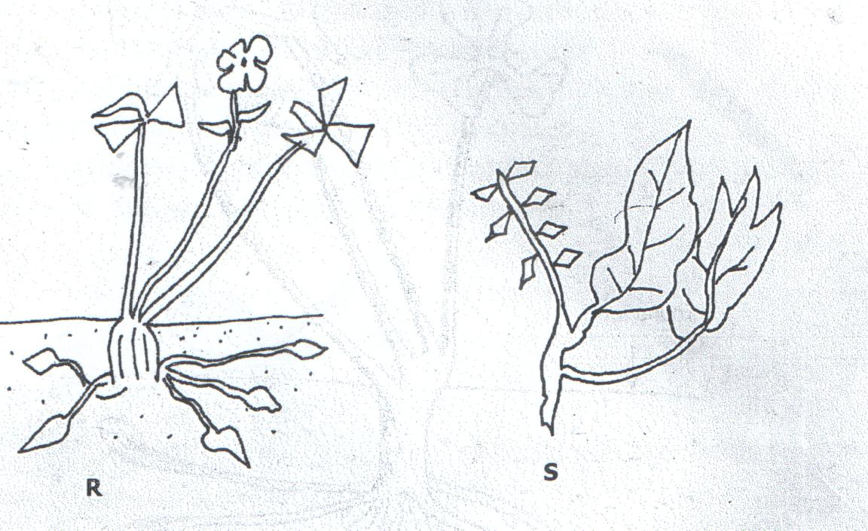
- Identify weeds:
R –

S –

- Why is weed R difficult to control in the field. (1mk)

- State two harmful effects of weed S in crop production. (2mks)

- Study the diagram below and answer the questions that follow
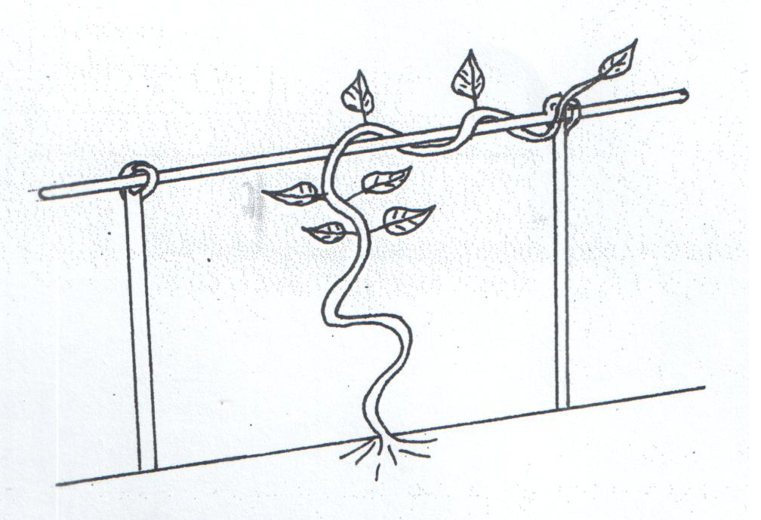

- Identify the practice carried out in the above diagram. (1mk)

- Identify a crop that requires the above practice. (1mk)

- Identify any 3 practices carried out on crops after harvesting. (3mks)

- The diagrams below illustrate some common bird pests. Study them and answer questions that follow.

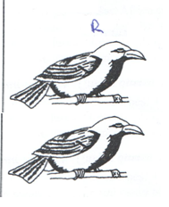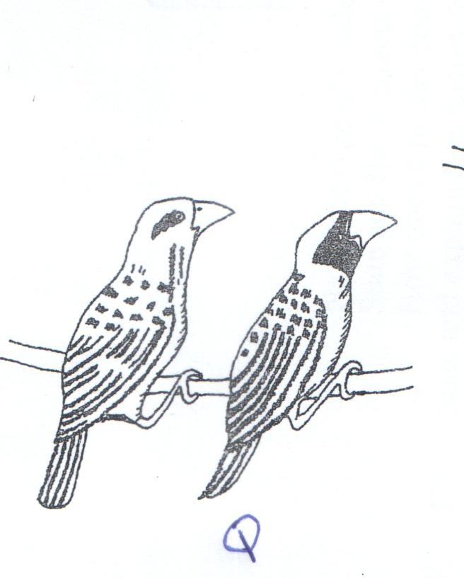
- Identify birds pests. (2mks)

- State one effect of bird pest R on crops.

- Give two possible control measures of Bird pest Q. (2mks)

- Study the diagram below and answer the questions that follow.

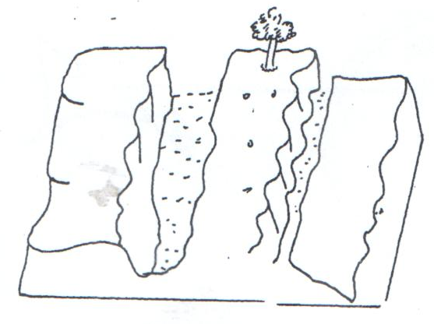

- Name the type of soil erosion illustrated above. (1mk)

- State three effects of the above type of soil erosion in Agriculture. (3mks)

- State one control of the above type of soil erosion. (1mk)

SECTION C: (40 MARKS)
Answer any TWO Questions in this section.
- (a) The table below shows the production of maize at various levels of N.P.K fertilizer application. Study it carefully and answer the questions that follow.
Fixed factor land ha | Variable input N.P.K in Kgs | Total product of maize in 90kg bags | Marginal product of maize in 90kg bags | Average product
1 | 50 | 10 | 0 | 10
1 | 100 | 27 | a. | f.
1 | 150 | 42 | 15 | 14
1 | 200 | 56 | b. | 14
1 | 250 | 63 | 7 | 12.6
1 | 300 | 65 | c. | g.
1 | 350 | 65 | d. | 9.3
1 | 400 | 60 | -5 | 7.5
1 | 450 | 52 | e. | h.
1 | 500 | 42 | -10 | 4.2

- Complete the table above. (4mks)
- Using the graph provided, draw a graph of total product, marginal product and average product against variable input of N.P.K fertilizer and mark three zones of production. (6mks)
(b) State and explain five problems experienced by tea farmers when marketing Agricultural produce. (10mks)

- (a) Explain eight cultural methods of soil and water conservation.(8mks)
(b) Describe the establishment of Napier grass under the following subheadings.
- Seed bed preparation. (5mks)
- Planting. (5mks)
- Utilization. (2mks)

- (a) Describe five ways in which biotic factors influence crop production. (10mks)
(b) Explain ten functions of marketing. (10mks)

