**FORM THREE AGRICULTURE**

**MID TERM 2 2024 EXAMS**

**NAME………………………………………………………………………….ADM………..…….CLASS……………**

1.State **four** importance of organic matter to the soil(2mmks)

…………………………………………………………………………………………………………………………………………………………………………………………………………………………………………………………………………………………………………………………………………………………………………………………………………………………………………………………………………………………………………………………………………………………………………………………………………………………………………………………………………

2.State **four** factors to consider when selecting nursery site(2mks)

…………………………………………………………………………………………………………………………………………………………………………………………………………………………………………………………………………………………………………………………………………………………………………………………………………………………………………………………………………………………………………………………………………………………………………………………………………………………………………………………………………

3.State **four** disadvantages of tissue culture(2mks)

…………………………………………………………………………………………………………………………………………………………………………………………………………………………………………………………………………………………………………………………………………………………………………………………………………………………………………………………………………………………………………………………………………………………………………………………………………………………………………………………………………

4.Outline **four** importance of earthing up(2mks)

…………………………………………………………………………………………………………………………………………………………………………………………………………………………………………………………………………………………………………………………………………………………………………………………………………………………………………………………………………………………………………………………………………………………………………………………………………………………………………………………………………

5.State **four** factors that influence the stages of harvesting(2mks)

…………………………………………………………………………………………………………………………………………………………………………………………………………………………………………………………………………………………………………………………………………………………………………………………………………………………………………………………………………………………………………………………………………………………………………………………………………………………………………………………………………

6.Define the term soil erosion as used in soil and water conservation(2mks)

…………………………………………………………………………………………………………………………………………………………………………………………………………………………………………………………………………………………………………………………………………………………………………………………………………………………………………………………………………………………………………………………………………………………………………………………………………………………………………………………………………

7.Outline **four** factors that influence soil erosion (2mks)

…………………………………………………………………………………………………………………………………………………………………………………………………………………………………………………………………………………………………………………………………………………………………………………………………………………………………………………………………………………………………………………………………………………………………………………………………………………………………………………………………………

8.Describe **four** stages undergone in the development of gully erosion (2mks)

…………………………………………………………………………………………………………………………………………………………………………………………………………………………………………………………………………………………………………………………………………………………………………………………………………………………………………………………………………………………………………………………………………………………………………………………………………………………………………………………………………

9.List **six** biological and cultural measures of controlling soil erosion(3mks)

…………………………………………………………………………………………………………………………………………………………………………………………………………………………………………………………………………………………………………………………………………………………………………………………………………………………………………………………………………………………………………………………………………………………………………………………………………………………………………………………………………

10.Differentiate between afforestation and reafforestation (2mks)

…………………………………………………………………………………………………………………………………………………………………………………………………………………………………………………………………………………………………………………………………………………………………………………………………………………………………………………………………………………………………………………………………………………………………………………………………………………………………………………………………………

11.**State** the difference between a weir and a dam (2mks)

…………………………………………………………………………………………………………………………………………………………………………………………………………………………………………………………………………………………………………………………………………………………………………………………………………………………………………………………………………………………………………………………………………………………………………………………………………………………………………………………………………

12.State **two** farming practices that can encourage soil erosion(2mks)

…………………………………………………………………………………………………………………………………………………………………………………………………………………………………………………………………………………………………………………………………………………………………………………………………………………………………………………………………………………………………………………………………………………………………………………………………………………………………………………………………………

13.Describe **four** harmful effects of weeds (2mks)

.....................................................................................................................................................................................................................................................................................................................................................................................................................................................................................................................

14.Differentiate between pre-emergence and post emergence herbicides (2mks)

…………………………………………………………………………………………………………………………………………………………………………………………………………………………………………………………………………………………………………………………………………………………………………………………………………………………………………………………………………………………………………………………………………………………………………………………………………………………………………………………………………

15.State **two** limitation of chemical weed control (2mks)

…………………………………………………………………………………………………………………………………………………………………………………………………………………………………………………………………………………………………………………………………………………………………………………………………………………………………………………………………………………………………………………………………………………………………………………………………………………………………………………………………………

16.List **four** cultural weed control methods(2mks)

…………………………………………………………………………………………………………………………………………………………………………………………………………………………………………………………………………………………………………………………………………………………………………………………………………………………………………………………………………………………………………………………………………………………………………………………………………………………………………………………………………

17. Identify the type of erosion below. (1 mark)

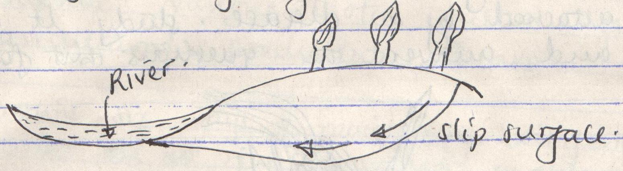

**Slip surface**

**River**

…………………………………

b) Name **four** agents of soil erosion. (2 marks)

…………………………………………………………………………………………………………………………………………………………………………………………………………………………………………………………………………………………………………………………………………………………………………………………………………………………………………………………………………………………………………………………………………………………………………………………………………………………………………………

18.The illustration below shows a structure used for controlling soil erosion.

Study it carefully and answer the questions that follow.

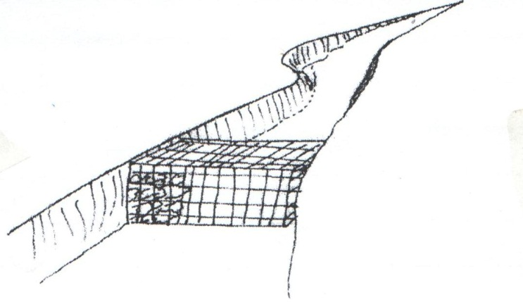

1. Identify the structure. (1 mark)

………………………………………………………………………………………………

1. List **two** ways in which the structure helps to control soil erosion. (1 marks)

19.The diagram below shows common weeds, study them and answer the questions that follow. 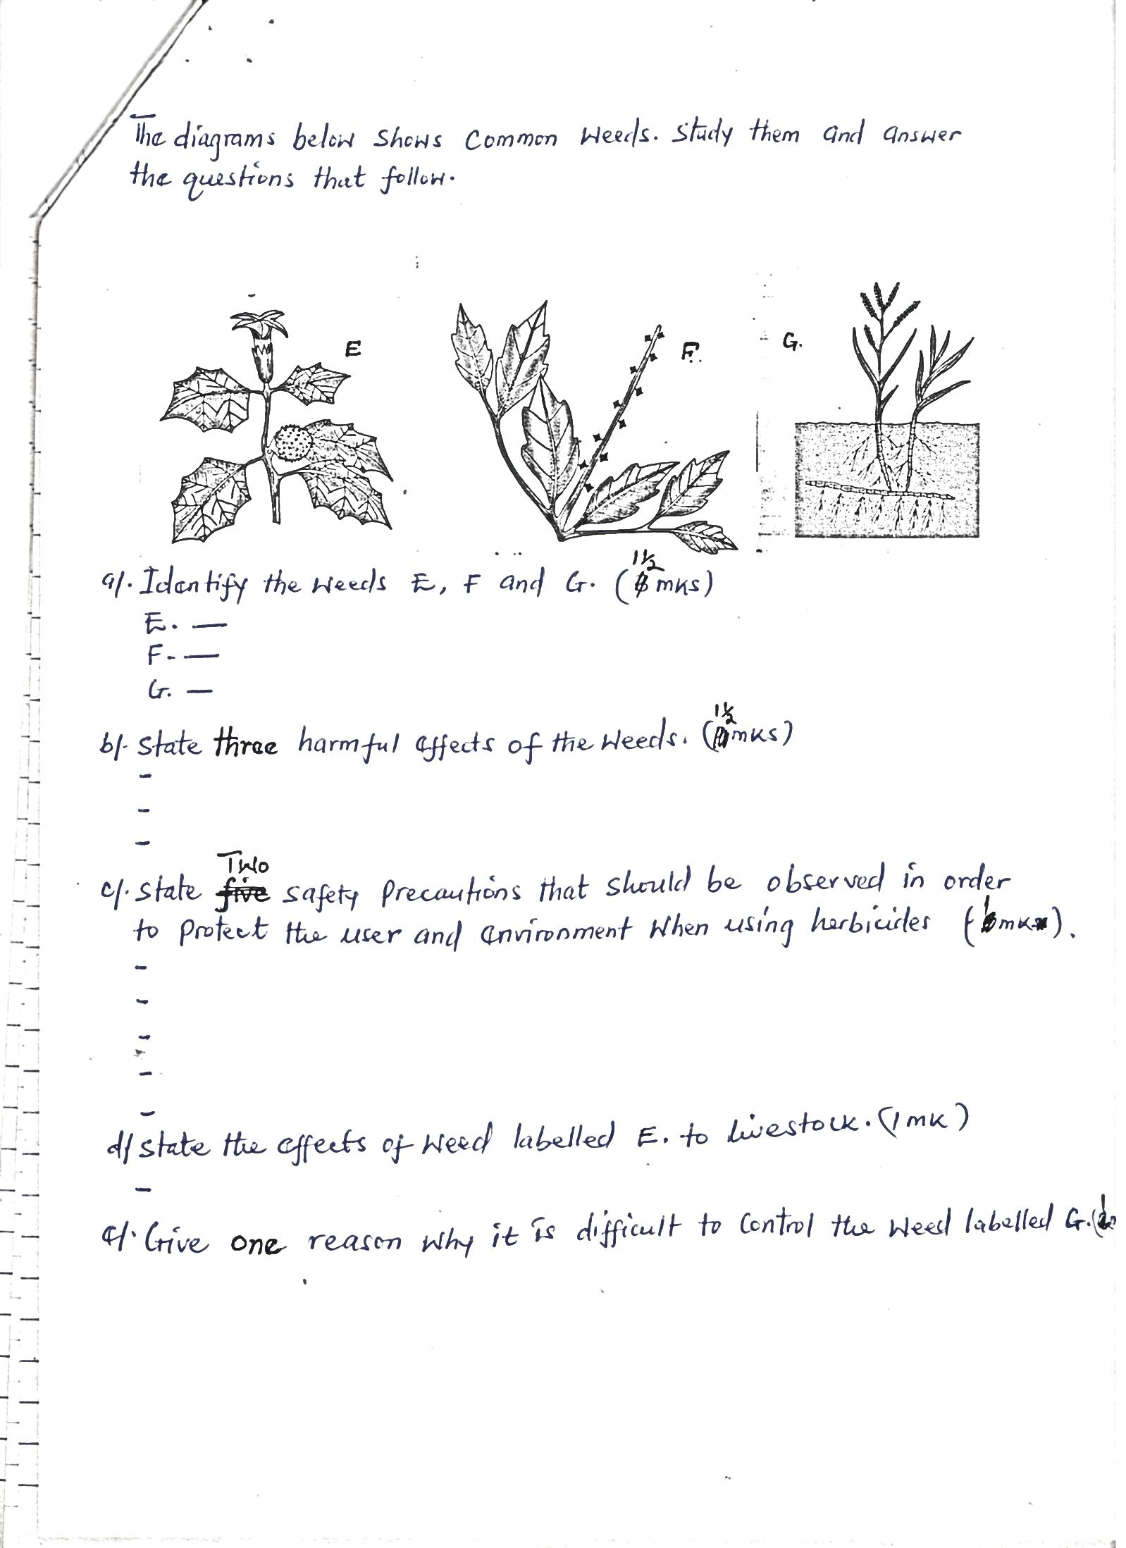

**G**

**F**

**E**

1. Identify the weeds E, F and G. (1½ marks)

…………………………………………………………………………………………………………………………………………………………………………………………………………………………………………………………………………………………………………………………………………………………………………………………………………………………………………………………………………………………………………………………………………………………………………………………………………………………………………

1. State **two** harmful effects of the weeds. (1 marks)

…………………………………………………………………………………………………………………………………………………………………………………………………………………………………………………………………………………………………………………………………………………………………………………………………………………………………………………………………………………………………………………………………………………………………………………………………………………………………………

1. State **two** safety precautions that should be observed in order to protect the user and environment when using herbicides. (1 mark)

……………………………………………………………………………………………………………………………………………………………………………………………………………………………………………………………………………………………………………………

1. State the effects of weed labeled E to livestock. (1 mark)

……………………………………………………………………………………………………………………………………………………………………………………………………………………………………………………………………………………………………………………

1. Give **one** reasons why it is difficult to control the weed labeled G. ( 1 mark)

……………………………………………………………………………………………………………………………………………………………………………………………………………………………………………………………………………………………………………………………………