NAME: ………………………………. ADM NO: ………… CLASS: ………..
MID TERM TWO EXAM 2024
FORM TWO AGRICULTURE
TIME: 1 HOUR 15 MINUTES

Answer all the questions in the spaces provided.

1. State one reason why it is not advisable to use manure in carrot production. (1 mks)

2. State four field management practices carried out in onions. (2 mks)

3. (a) Define the term crop rotation. (1 mk)

(b) State six importance of crop rotation. (3 mks)

4. State three ways on how training in plants is achieved. (3 mks)

5. Differentiate between monocropping and mixed cropping. (2 mks)

6. State four factors that determine the time of harvesting a crop. (2 mks)

7. Mention four examples of leafy vegetables. (2 mks)

8. List four reasons for staking in tomatoes. (2 mks)

9. State four factors that determine quality of farm yard manure. (2 mks)

10. State four cultural uses of livestock. (2 mks)

11. Name four examples of nitrogenous fertilizers. (2 mks)

12. Name two systems of pruning practiced in coffee. (1 mk)

13. State four advantages of mulching in crop production. (2 mks)

14. Name three dual purpose breeds of cattle. (1¹/₂ mks)

15. Differentiate between fine plucking and coarse plucking as used in tea. (2 mks)

16. State three basic economic concepts in agricultural economics. (1 ½ mks)

17. The diagram below shows a seedling attacked by a pest.

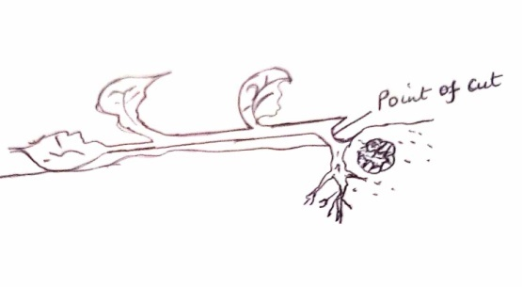

(a) Identify the pest. ( 1 mk)

(b) State two control measures of the pest. (2 mks)

(c) Name two diseases that affect cabbages. (2 mks)

18. Given that maize is planted at a spacing of 75cm x 25cm, calculate the plant population in
half a hectare. (2 mks)

19. State six characteristics of a good grain store. (3 mks)

20. Differentiate between over-sowing and under-sowing. (2 mks)

21. The diagram below shows a process used in cop propagation.

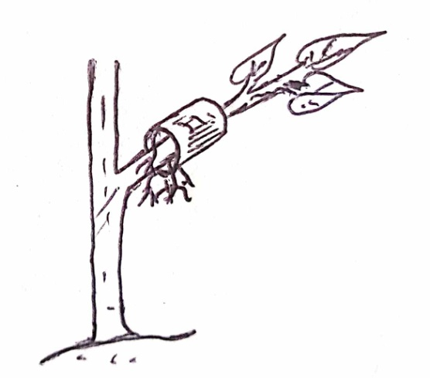

(a) Name the process. (1 mk)

(b) Apart from the process above, name two other methods used. (2 mks)

22. Name one disease in coffee that can be controlled through open pruning. (1 mk)

23. Differentiate between viticulture and apiculture. (2 mks)

