NAME……………………………………………….CLASS……………ADM……………..
AGRICULTURE, FORM 1, TERM 2 – 2024
MID – TERM EXAMS
TIME 1 Hr
- What is Agriculture? (1mk)

- Give three field of horticultural farming and describe what they entail. (3mks)

- Why is agriculture very important to the economy of Kenya. (5mks)

- What do you understand by the term Agro forestry? (1mk)

- What is soil profile? (1mk)

b) Below is a diagram of a vertical section through the soil. Label the different layers 1 to 5. (5mks)

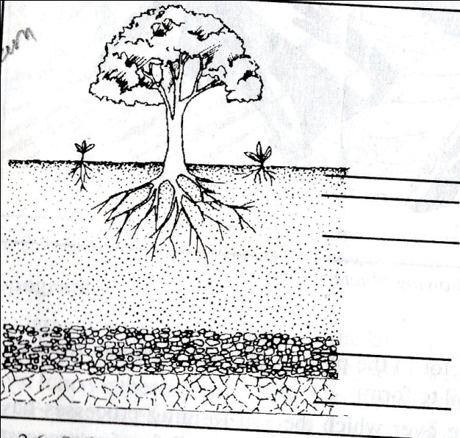

1…………………………………………
2…………………………………………
3…………………………………………

4……………………………………….

5……………………………………….
- List three biotic factors that have negative effect in Agricultural production.(3mks)

b) Name two micro – organisms beneficial to plant growth and production. (1mk)

- Pair up the tools in list B to list A according to their use. (8mks)
List A List B
Spanner Lead stick
Bull nose ring Nut and bolt
Mallet Hypodermic needle
Ball pen hammer Auger bit
Syringe Cold chisel
Elastrator Canular
Trocar Rubber ring
Brace Wood chisel
b) Identify the tool below and name the parts labeled. (3mks)
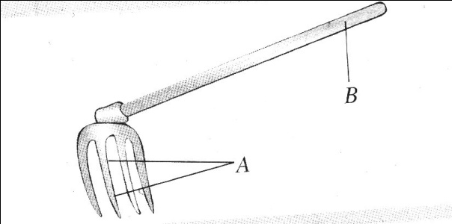
A…………………………………………………………………………………..

B…………………………………………………………………………………..

- State the reasons for preparing land before planting. (5mks)

- Name the implements that can be used for the following practices. (3mks)

- a) What is a seedbed? (1mk)

b) State the main reasons of carrying out secondary tillage.

c) What are tertiary operations. (1mk)

d)Below is a diagram of a tertiary operation study it and answer the questions that follow.
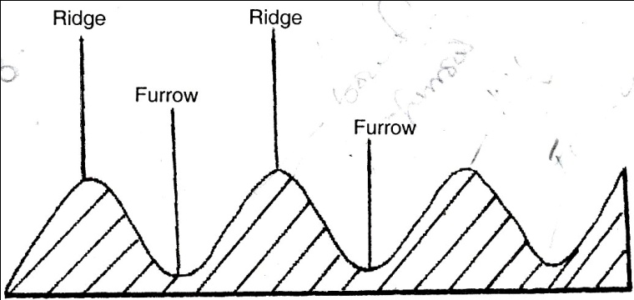
- Name the operation. (1mk)

- State the importance of carrying out the operation. (1mk)

- a)What is minimum tillage. (1mk)

b) State the reasons for carrying out minimum tillage. (4mks)

