PHYSICS FORM ONE ASSIGMENT
INSTRUCTIONS.
Answer all the questions in the spaces provided.

- Name two instruments that can be use to measure the volume of an irregular object.(2mks)
2.What is atmospheric pressure (1mks)
3.States three factors affecting thermal conductivity (3mks
4 a. Give two precautions necessary while handling a density bottle. (2mks
b. The mass of an empty density bottle is 20g. its mass when filled with water is 40g and 50g when filled with liquid X. calculate the density of liquid X if the density of water is 1000 kg/m³
5.Give limitation of a lift pump. (1mk)

6.State two effects of force (2mks)
7.Explain why water rises up in narrow tubes but mercury, which is also a liquid, falls in narrow tubes to a level below the outside surface. (2mks)
8.Give two factors affecting surface tension. (2mks
9.List three conditions to be observed for effective operation of a siphon .

10.The figure below shows a U-tube filled with water, mercury and another liquid, determine the density of the liquid. (3mks)

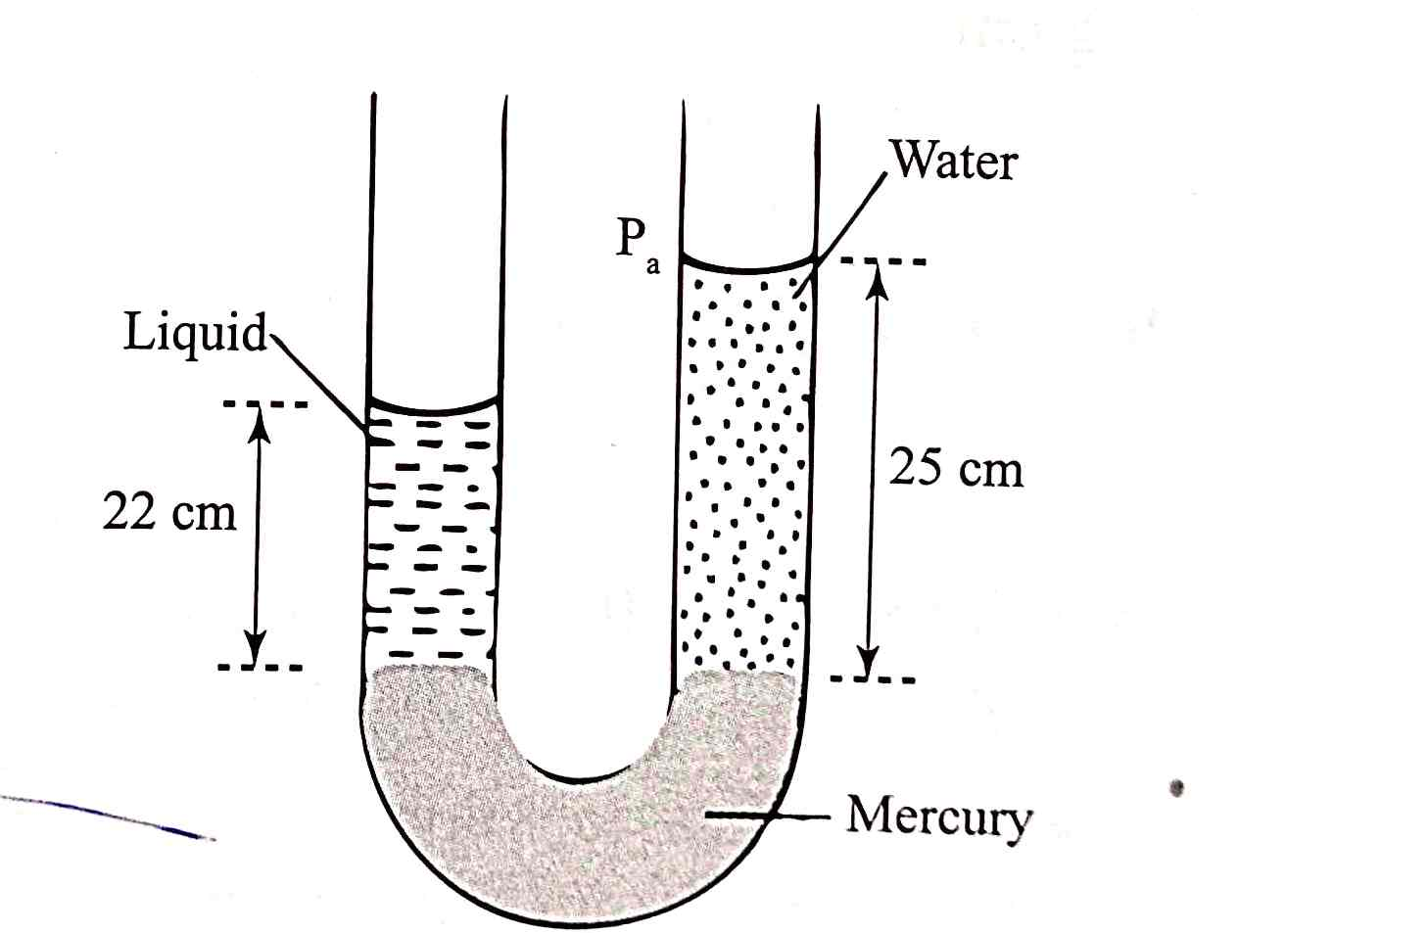
11The figure below, ammonia gas and an acid gas diffuse and react to form a white deposit on the walls of the glass tube, the deposit forms nearer end B.

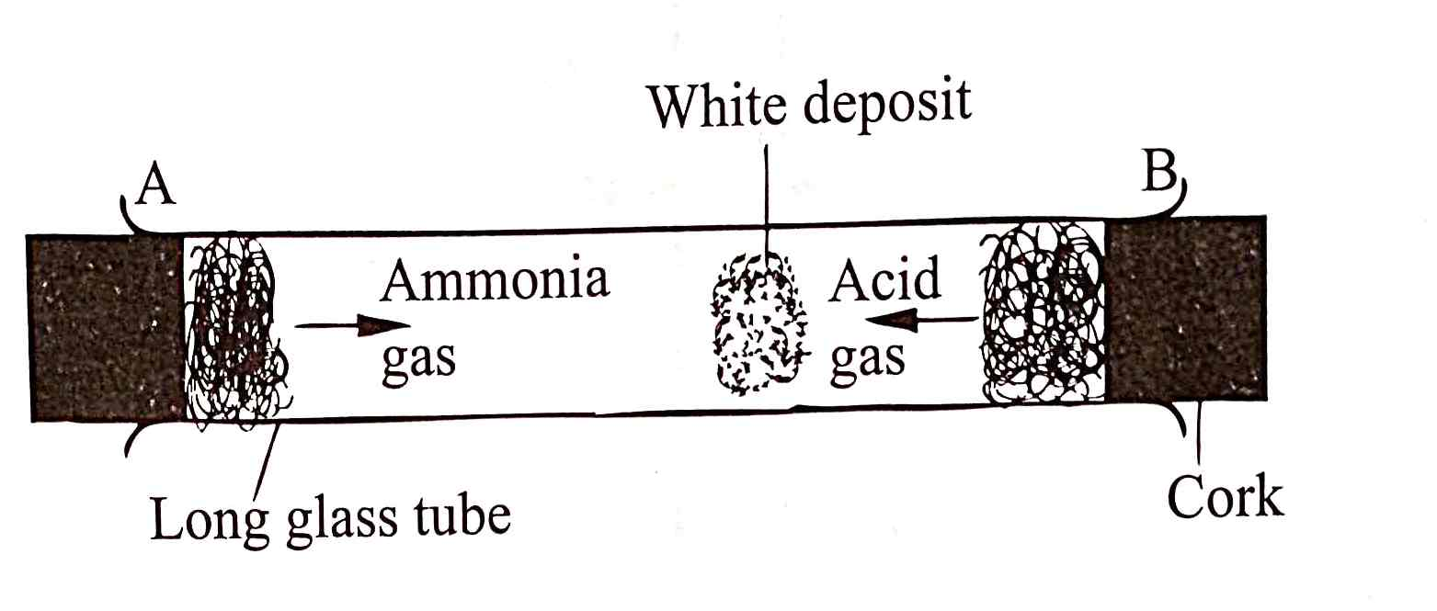
a.State which gas diffused faster. (1mk)

b.Explain how the rate of diffusion depends on the density of a gas. (2mks)

c.Explain the effect of performing the experiment above at a higher temperature. (2mks)

12. In an experiment to determine the density of sand using a density bottle ,the following measurements were recorded:
Mass of empty density bottle = 43.2g
Mass of density bottle full of water=66.4g
Mass of density bottle with some sand =67.5g
Mass of density bottle with the sand=82.3g
Use the above data to determine the:
a)Mass of water that completely filled the bottle (2marks)

b)Volume of water that completely filled the bottle (1mark)

c)Volume of the density bottle. (1mark)

d) Mass of sand (1mark)

e)Mass of water that filled the space above the sand (1mark)

f)Volume of the sand (3marks)

g)Density of the sand (2marks

13.Name three sources of electrical energy. (3marks)
b Calculate the amount of current flowing through a bulb if 420 C of charge is flowing through the circuit in 3.5 minutes. (3marks)
14.The diagram in the figure below shows an arrangement for observing Brownian motion .
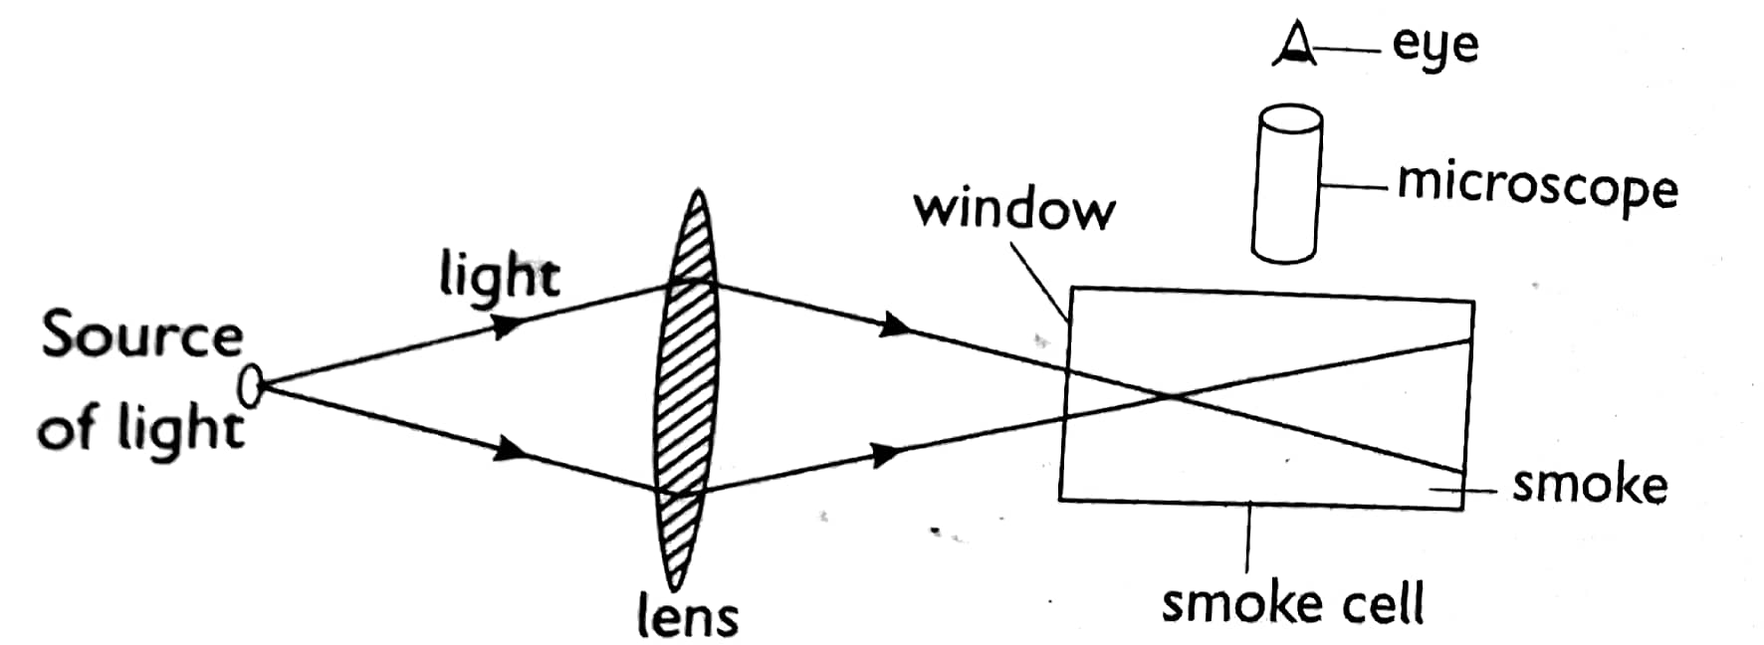

a)Explain the observation made. (2marks)
b)What will be observed when the glass cell temperature is lowered? (2marks)
c)State the kinetic theory of matter (1mark)
SECTION (B 55 MARKS)
15.The figure below shows a thermos flask.
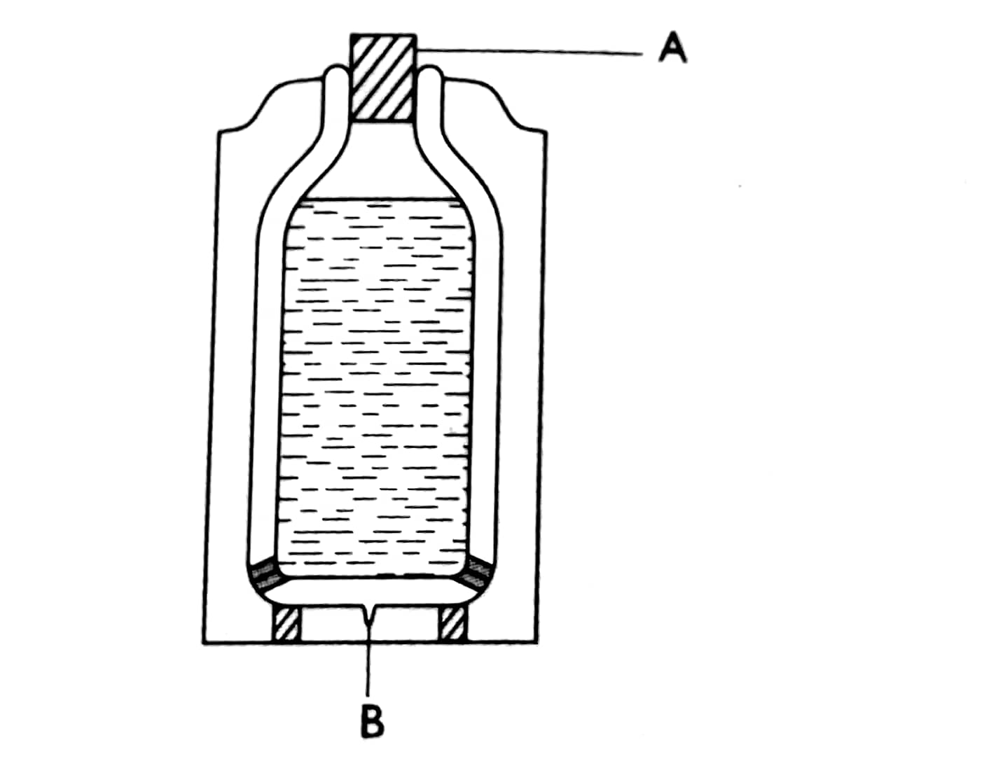
a)Name the part labelled:
A (1mark)
B (1mark)
b)State the use of part labeled B. (1mark)
c)Explain how the heat loss is minimised in the thermos flask (4marks)
16. a)State the pascals principle. (1mark)
b)The figure below shows a simple hydraulic lift used to lift a load
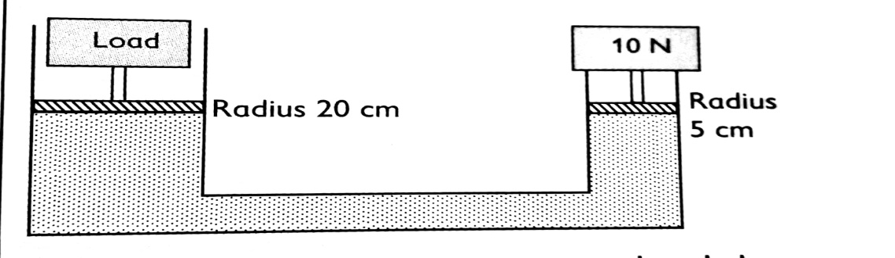
Calculate the maximum load that can be lifted using a downward effort of 10 newtons. (4marks
c) State two limitation of a lift pump that make it impossible to rise water to a height greater than 10m. (2marks)
(d)Name three conditions necessary for a siphon to work effectively (3marks)

