**Marking Scheme**

**Physics 232/2**

**Paper 2**

**Section A (25 marks**)

1. The figure **below** shows an object O placed in front of a plane mirror.

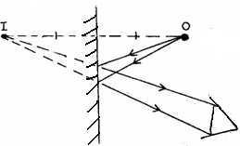

Object

E

2 diverging rays 🗸¹

Position of the image

1. i) The ammeter reading decreases✓

ii) The resistance of the metal increases with increase in temperature.✓

60

30

1. always upright

always smaller than oject / accept diminished

*reject: formed behind the mirror*

5. (a) State the basic law of magnetism. (1 mark)

(a) *Unlike poles attract, like poles repel* 🗸*¹*

*(b) The keepers become magnetized thus neutralizing 🗸 the pole; this reduces*

repulsion at the poles 🗸 thus helping in retention of magnetism.

One cycle = a  a = 4 spaces

each space = 0.7 = 0.1 second

7

T = 0.1 × 4 = 0.4 second ***✓1***



***✓1***

1. A current carrying conductor AB is in a magnetic field as shown in figure 1 below.

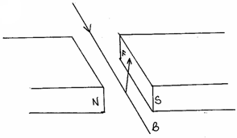(a)

(1mk)

1. - Direction of magnetic field. 🗸

Direction of the current (2mk)

1. (a) Distinguish between a transverse and a longitudinal wave. (1 mark)

|  |  |  |  |
| --- | --- | --- | --- |
|  | (a) | Transverse | Longitudinal wave |
|  | 1. | Displacement of particles  in the wave is perpendicular  to the direction of wave motion. | - Displacement of particles in the  wave is parallel to the direction  of wave motion. |
|  | 2. | Requires no medium for propagation. | - Requires a material medium for  propagation. |
|  | 3. | Can be mechanical or electromagnetic  in nature. | - Purely mechanical wave. |

Any 1 combination

(b) 

Hence 

1. a) Topping is adding distilled water in the lead acid accumulator so that the plates are submerged ✓

b) It has a higher e.m.f compared to nickel iron type. It is less expensive than nickel iron type ***any one ✓***

10. Charges concentrate***1*** on the sharp end of the pin resulting into net reduction of charges on the leaf making it collapse.

11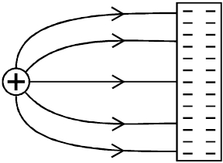

**Section B (55 Marks)**

12a) This is the ratio of sine of the angle of incidence to the sine of the angle of refraction.

OR



b) for the graph check

scale I mk

line I mk

ploting 2 mks

axes 1 mk

5 mks

 ii)

3 marks

c)

**13** a)current through conductor is directly proportional to the applied voltage provided temperature and other physical conditions are kept constant.



b) i) Parallel resistance



Parallel resistance

Series resistance = 3.00

Effective resistance

= 2.73 + 1.33 + 3.00

= 7.06 ***✓1*** ***3 marks***





c) i)



ii)



 14. a) Leaf in A decreases in divergence

B increases in divergence electrons flow from B to A ***✓1***

 b) P is negatively charged ***✓1*** The body repels more negative charge from the cap to the leaf. ***✓1***

  c)

d) Decreasing distance between plates.

- Increase area of overlap of the plates

- using a dielectric with a higher dielectric constant. ***(any two✓1*** ***✓1*** ***)***

15.a) Diffraction ***✓1***

b) l = 24 = 8cm

3

v = f

= 50 × 8/100 ***✓1***

= 4 m/s ***✓1***

c) The speed will be lower because of low temperature ***✓1***

d) i) V = n × 2d

= 20 × 2 × 80

9.5

= 336.8 m/s

ii) The time for the 20 claps might not be accurate. ***✓1***

iii) Requires a material medium to travel through. ***✓***