**231/ 2 - Physics -Paper 2 (Theory)**

**END OF TERM 3 2022**

**Time: 2 Hours**

**Name …………………………………………….……… Index Number…………………………..**

**Candidate’s Signature ………………….…...……….. Date ……………………………………**

**INSTRUCTIONS TO CANDIDATES**

1. *Write your* ***name, admission number*** *and* ***class*** *in the spaces provided above.*
2. ***Sign and write the date*** *of examination in the spaces provided above.*
3. *This paper consists of* ***TWO*** *sections:* ***A*** *and* ***B****.*
4. *Answer* ***ALL*** *the questions in sections* ***A*** *and* ***B*** *in the spaces provided.*
5. ***ALL*** *working* ***MUST*** *be clearly shown.*
6. *Non-programmable silent electronic calculators and KNEC mathematical tables may be used.*
7. ***Candidates should check the question paper to ascertain that all the pages are printed as indicated and that no questions are missing****.*

**FOR EXAMINER’S USE ONLY:**

|  |  |  |  |
| --- | --- | --- | --- |
| **Section** | **Question** | **Maximum**  **Score** | **Candidate’s**  **Score** |
| **A** | **1 – 13** | **25** |  |
|  | **14** | **07** |  |
|  | **15** | **12** |  |
| **B** | **16** | **12** |  |
|  | **17** | **13** |  |
|  | **18** | **11** |  |
| **Total Score** | | **80** |  |

Turn over

**SECTION A (25 MARKS)**

***Attempt ALL the questions in this section.***

1. The figure **below** shows an object O placed in front of a plane mirror.

Object O

•

On the same diagram, draw rays to locate the position of the image I as seen from the eye E. (2marks)

1. A circuit consists of a battery, metal wire, ammeter and a switch connected in series. The switch is closed and the ammeter reading noted. The metal wire is now heated.
2. State the observations made on the ammeter reading. (1mark)

……………………………………………………………………………………………………………………………………………………………………………………………………………………………………………………………………………………

1. Give one reason for the above observation made (1mark)

………………………………………………………………………………………………………………………………………………………………………………………………

1. Figure 2 shows an incident ray normal to the surface BC of a right-angled glass prism ABC. The critical angle of the glass is 420

300

**C**

600(E)

eye

**B**

**A**

Complete the diagram to show the path of the ray. (2marks)

1. The image formed by a convex mirror is virtual. State two other characteristics of image formed by the convex mirror. (2 Marks)

………………………………………………………………………………………………………………………………………………………………………………………………………………………………………………………………………………………

1. (a )State the basic law of magnetism. (1 mark)

…………………………………………………………………………………………………………………………………………………………………………………………………………………………………………………………………………

1. The figure **below** shows how magnets are stored in pairs with keepers at the ends.

S

N

N

**O**S

Bar magnets

Keeper

Keeper

Explain how this method of storing helps in retaining magnetism longer. (2 marks)

……………………………………………………………………………………………………………………………………………………………………………………………………………………………………………………………………………………

……………………………………………………………………………………………………………………………………………………………………………………………………………………………………………………………………………………

1. The figure below shows a hack-saw blade clamped horizontally on a bench and the free end is made to vibrate about the rest position.



The movement o  a  o  b  o a  o b takes 0.7seconds

Determine the frequency of vibration of the blade. (3 marks)

……………………………………………………………………………………………………………………………………………………………………………………………………………………………………………………………………………………………….

…………………………………………………………………………………………………………………………………………

1. A current carrying conductor AB is in a magnetic field as shown in figure 1 below.

Conductor

Direction of current

S

N

Fig 1

1. Indicate the direction of the force F acting on the conductor. (1mark)
2. State t factors that determine the direction of the force F. (2marks)

…………………………………………………………………………………………………………………………………………………………………………………………………………………………………………………………………………………………

1. (a) Distinguish between a transverse and a longitudinal wave. (1 mark)

……………………………………………………………………………………………………………………………………………………………………………………………………………………………………………………………………………………

(b) Determine the frequency of the wave shown below. (2 marks)

0.5

1.0

1.5

2.0

Time(s)

Displacement (m)

……………………………………………………………………………………………………………………………………………………………………………………………………………………………………………………………………………………………….

……………………………………………………………………………………………………………………………………………………………………………………………………………………………………………………………………………………………….

1. (a) What is meant by the term “topping” as applied to a lead acid accumulator ? (1 mark)

……………………………………………………………………………………………………………………………………………………………………………………………………………………………………………………………………………………………….

b) State two advantage of a lead acid accumulator over nickel-iron accumulator. (2 mark)

……………………………………………………………………………………………………………………………………………………………………………………………………………………………………………………………………………………………….

1. The figure below shows a sharp pin fixed on a cap of the electroscope. The electroscope is highly charged and then left for some time.



Explain why the leaf collapses. (2 marks)

……………………………………………………………………………………………………………………………………………………………………………………………………………………………………………………………………………………………….

1. The figure below shows a positive charge near a plate carrying negative charge.



Draw an electric field pattern between them (1 mark)

**SECTION B (55 MARKS)**

***Attempt ALL the questions in this section.***

1. (a)Define the refractive index of a substance . (1 mark)

b) In an experiment to determine the refractive index in a liquid, the liquid was poured into a measuring cylinder. A pin was placed at the bottom of the cylinder and another pin was used to locate the apparent position of the first pin. The real and apparent depth were measured. The experiment was repeated with other values of real depth. The table below shows the results obtained.

|  |  |  |  |  |  |
| --- | --- | --- | --- | --- | --- |
| Real depth (cm) | 5 | 10 | 15 | 20 | 25 |
| Apparent depth (cm) | 3.3 | 6.7 | 10 | 13.3 | 16.7 |

i) Plot the graph of real depth against apparent depth. (5 marks)

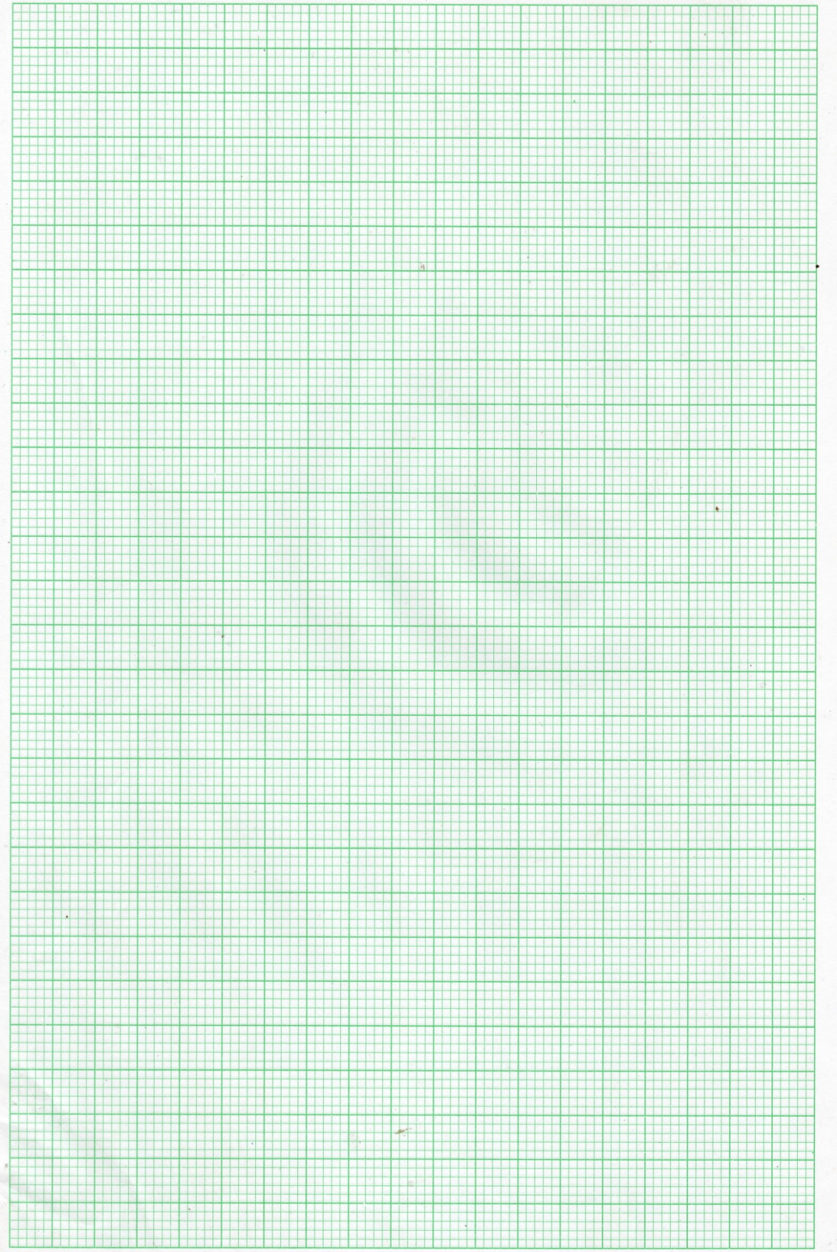

ii) From the graph determine the refractive index of the liquid. (3 marks)

……………………………………………………………………………………………………………………………………………………………………………………………………………………………………………………………………………………………….……………………………………………………………………………………………………………………………………………………………………………………………………………………………………………………………………………………………….

c) The figure 5 shows a ray of light incident on a glass-air interface.



    Given that the refractive index of the glass is 1.6, determine angle  (3 marks)

……………………………………………………………………………………………………………………………………………………………………………………………………………………………………………………………………………………………….

……………………………………………………………………………………………………………………………………………………………………………………………………………………………………………………………………………………………….

1. (a) State Ohm's law. (2 mark)

**b)** Study the circuit diagram (Fig 6) below and answer the questions that follow.



i) Calculate the effective resistance of the circuit. (4marks)

ii) Find the total current in the circuit. (3 marks)

**c)** The figure 7 below shows a low voltage lighting circuit.



Fig 7

i) On the figure indicate with letter S a point in the circuit where a switch could be placed that would turn off lamp Y and Z at the same time but would leave lamps X still lit. (1 mark)

ii) The current in lamp Z is 3.0A, calculate the resistance of this lamp. (3 marks)

……………………………………………………………………………………………………………………………………………………………………………………………………………………………………………………………………………………………….

……………………………………………………………………………………………………………………………………………

1. In figure 15 shown below. Two identical electroscopes A and B carry the same type of charges as shown. The two are then connected with a copper wire.



Fig 15

State and explain the observations made. (2 marks)

……………………………………………………………………………………………………………………………………………………………………………………………………………………………………………………………………………………………….

…………………………………………………………………………………………………………………………………………….

b) When a charged body P is brought close to the cap of a negatively charged electroscope the leaf of the electroscopes rises. State with reason the charge on the body P. (2 marks)

……………………………………………………………………………………………………………………………………………………………………………………………………………………………………………………………………………………………….

…………………………………………………………………………………………………………………………………………….

c) Four capacitors were connected in a circuit as shown in figure 16 below. Determine the charge stored in the combination of the capacitors when the switch is closed. (4 marks)



Fig 16

d) State tw ways in the capacitance of a parallel plate capacitor can be increased. (2 marks)

……………………………………………………………………………………………………………………………………………………………………………………………………………………………………………………………………………………

…………………………………………………………………………………………………………………………………………

1. (a) A person standing behind a wall hears a bell ringing although he cannot see the bell. What property of sound enables him to hear the sound? (1 mark)

 b) The figure below is a sketch of ripples caused by a vibrator in a ripple tank whose frequency is 50Hz.

Using the above information, determine the speed of the wave motion. (3 marks)

……………………………………………………………………………………………………………………………………………………………………………………………………………………………………………………………………………………

…………………………………………………………………………………………………………………………………………

c) The speed of sound in air determined on a warm day is 330m/s. Explain any difference you would expect in the results if the measurement is done on a cold day. (2 marks)

……………………………………………………………………………………………………………………………………………………………………………………………………………………………………………………………………………………

…………………………………………………………………………………………………………………………………………

d) In an experiment to determine the speed of sound, an observer stood in front of a high wall at a distance of 80m. He clapped two boards together at such a rate that each clap coincided with the echo from the wall. A second observer noted a time of 9.5 seconds starting with first clap and ending with the 21st clap.

i) Calculate the speed of sound under these conditions. (4 marks)

……………………………………………………………………………………………………………………………………………………………………………………………………………………………………………………………………………………………….

…………………………………………………………………………………………………………………………………………….

ii) Describe two probable source of error in this experiment. (2mark)

……………………………………………………………………………………………………………………………………………………………………………………………………………………………………………………………………………………

iii) State two way in which sound wave differ from light waves. (2 mark)

…………………………………………………………………………………………………………………………………………………………………………………………………………………………………………………………………………………………

**THIS IS THE LAST PRINTED PAGE**