**Name:** …………………………………………………………… **Adm No**: ………………………………

**School:** …………………………………………………………. **Candidate’s Sign**: …………………….

**Date:** ………………………………………………………….

**231/2**

**BIOLOGY**

**PAPER 2**

**TIME: 2 HOURS**

**END OF TERM 3 2022 EXAM**

*Kenya Certificate of Secondary Education (K.C.S.E.)*

**FORM THREE**

**INSTRUCTIONS TO CANDIDATES:**

* *Write* ***your name*** *and* ***admission number*** *in the spaces provided.*
* *Sign and write the date of examination.*
* *This paper consists of* ***two*** *sections A and B.*
* *Answer* ***all*** *the questions in Section* ***A*** *in the spaces provided.*
* *In section* ***B*** *answer questions* ***6*** *(compulsory) and either question* ***7*** *or* ***8*** *in the spaces provided.*
* *Check and ascertain that no questions are missing.*

***For Examiner’s Use Only:***

|  |  |  |  |
| --- | --- | --- | --- |
| **SECTIONS** | **QUESTION** | **MAXIMUM SCORE** | **CANDIDATES SCORE** |
| **A** | **1**  **2**  **3**  **4**  **5** | **8**  **8**  **8**  **8**  **8** |  |
| **B** | **6**  **7**  **8** | **20**  **20**  **20** |  |
| **TOTAL SCORE** |  | **80** |  |

***SECTION A (40 MARKS)***

***Answer all questions in this section***

1. The following organisms were found to exist in a certain ecosystem, lizards, grass, Grasshopper, centipedes, ants, toads, millipedes and snakes.
2. In a chart below, fill in the boxes A to D with the organisms listed above to complete a food web in the ecosystem. (4mks)

Snakes

Sunlight

D

A

Grasshoppers

Millipedes

B

Ants

C

1. From the list of organisms given above, name the organism which has the largest biomass. (1mks)

…………………………………………………………………………………………………………………

1. Give a reason for your answer. (1mks)

…………………………………………………………………………………………………………………

d) Explain the ecological importance of fungi to plants. (2mks)

............................................................................................................................................................................................................................................................................................................................................................

1. The set up shown was used to investigate a certain process. The set up was left in bright sunlight for 4 hours.

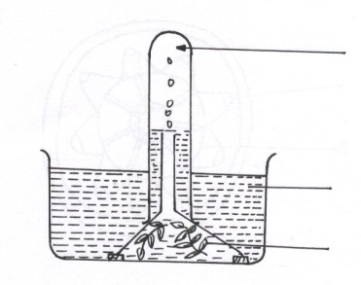

Y

Water containing sodium hydrogen carbonate

Gas X

1. State the aim of experiment (1mk)

…………………………………………………………………………………………………………………

…………………………………………………………………………………………………………………

1. Name X and Y (2mks)

…………………………………………………………………………………………………………………

…………………………………………………………………………………………………………………

…………………………………………………………………………………………………………………

1. Other than sunlight name three factors that would affect the experiment (3mks)

…………………………………………………………………………………………………………………

……………………………………………………………………………………………………………………………………………………………………………………………………………………………………

…………………………………………………………………………………………………………………

1. State how the identity of gas X could be confirmed (1mk)

…………………………………………………………………………………………………………………

…………………………………………………………………………………………………………………

1. Explain why submerged water plants was used in the experiment (1mk)

…………………………………………………………………………………………………………………

…………………………………………………………………………………………………………………

…………………………………………………………………………………………………………………

1. (a) What is meant by:
2. Autecology (1mk)

…………………………………………………………………………………………………………………

…………………………………………………………………………………………………………………

1. Synecology (1mk)

…………………………………………………………………………………………………………………

…………………………………………………………………………………………………………………

(b) Using the table below, answer the questions that follow

|  |  |  |
| --- | --- | --- |
|  | **Number of stomata** | |
| **Leaf** | **Upper epidermis** | **Lower epidermis** |
| **A** | 300 | 0 |
| **B** | 150 | 200 |
| **C** | 02 | 13 |

Suggest the possible habitat of the plants from the leaves were obtained (3mks)

A

…………………………………………………………………………………………………………………

B

…………………………………………………………………………………………………………………

C

…………………………………………………………………………………………………………………

(c) State the modifications in the stomata of leaf C (3mks)

…………………………………………………………………………………………………………………

…………………………………………………………………………………………………………………

…………………………………………………………………………………………………………………

…………………………………………………………………………………………………………………

1. In an investigation, a raw banana was peeled, mashed into a paste and treated as shown in the set up below.

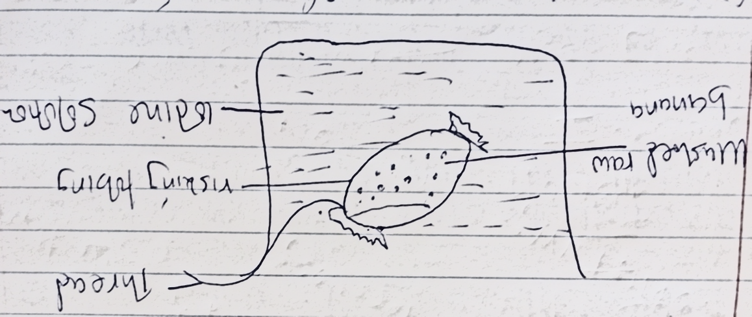

1. Name the physiological process being investigated (1mk)

…………………………………………………………………………………………………………………

…………………………………………………………………………………………………………………

1. State the expected observations in the above set up after 30 minutes (2mks)

…………………………………………………………………………………………………………………

…………………………………………………………………………………………………………………................................................................................................................................................................................

1. Account for the observations made in (b) above. (2mks)

…………………………………………………………………………………………………………………

…………………………………………………………………………………………………………………

……………………………………………………………………………………………………………………………………………………………………………………………………………………………………

1. State three role of active transport in human (3mks)

…………………………………………………………………………………………………………………

…………………………………………………………………………………………………………………

…………………………………………………………………………………………………………………

…………………………………………………………………………………………………………………

…………………………………………………………………………………………………………………

1. **Study the table below and answer the questions that follows:**

|  |  |  |  |
| --- | --- | --- | --- |
| **substance** | **% in blood Plasma** | **% in glomerular**  **Filtrate** | **% in urine** |
| Water  Protein  Urea  glucose | 100  6.5  0.03  0.1 | 90  0  0.03  0.1 | 60  0  1.8  0 |

1. Why is the concentration of protein in glomerular filtrate and urine zero? (1mk)

…………………………………………………………………………………………………………………

…………………………………………………………………………………………………………………

1. (i) By how many times is urea more concentrated in urine than in glomerular Filtrate? (1mk)

…………………………………………………………………………………………………………………

…………………………………………………………………………………………………………………

(ii) Explain why there is greater concentration of urea in urine than glomerular filtrate (1mk)

…………………………………………………………………………………………………………………

…………………………………………………………………………………………………………………

…………………………………………………………………………………………………………………

1. Explain why there is no glucose in urine (1mk)

…………………………………………………………………………………………………………………

…………………………………………………………………………………………………………………

…………………………………………………………………………………………………………………

1. State the economic importance of the following plant excretory products
2. Rubber (1mk)

…………………………………………………………………………………………………………………

…………………………………………………………………………………………………………………

1. Papain (1mk)

…………………………………………………………………………………………………………………

…………………………………………………………………………………………………………………

1. State two reasons why plants lack complex excretory organs. (2mks)

…………………………………………………………………………………………………………………

…………………………………………………………………………………………………………………................................................................................................................................................................................

***SECTION B: (40MARKS)***

***Answer question 6 (compulsory) and either question 7 or 8 in the spaces provided.***

1. During germination and growth of cereal, the dry weight of the endosperm, the weight of the embryo and the total dry weight were determined at two days intervals. The results are shown in the table below.

|  |  |  |  |
| --- | --- | --- | --- |
| **Time after planting (days)** | **Dry weight of endosperm (mg)** | **Weight of embryo (mg)** | **Total dry weight (mg)** |
| 0  2  4  6  8  10 | 43  40  33  20  10  6 | 2  2  7  16  25  33 | 45  42  40  37  35  39 |

1. On the same axes, plot a graph of dry weight of endosperm, weight of the embryo and the total dry weight against time. (8mks)
2. What was the total dry weight on day 5? (1mk)

…………………………………………………………………………………………………………………

…………………………………………………………………………………………………………………

1. Account for the;
2. Decrease in dry weight of the endosperm from day 0 to 10 (2 mks)

…………………………………………………………………………………………………………………

……………………………………………………………………………………………………………………………………………………………………………………………………………………………………

1. Increase in weight of the embryo from day 0 to 10 (2mks)

…………………………………………………………………………………………………………………

…………………………………………………………………………………………………………………

…………………………………………………………………………………………………………………

1. Decrease in the total dry weight from day 0 to 8 (1mk)

…………………………………………………………………………………………………………………

…………………………………………………………………………………………………………………

1. Increase in the total dry weight after day 8 (1mk)

…………………………………………………………………………………………………………………

…………………………………………………………………………………………………………………

1. State two factors within the seed and two outside the seed that cause dormancy. Inside seed

Inside seed (2mks)

…………………………………………………………………………………………………………………

…………………………………………………………………………………………………………………

…………………………………………………………………………………………………………………

…………………………………………………………………………………………………………………

1. (a) Explain how xerophytes are adapted to their habitat. (12mks)

(b) State four differences between mitosis and meiosis.. (8mks)

1. (a) Explain inspiration in the gills of bony fish (10mks)
2. Explain the factors affecting the rate of breathing in humans (10mks)

…………………………………………………………………………………………………………………………………………………………………………………………………………………………………………………………………………………………………………………………………………………………………………………………………………………………………………………………………………………………………………………………………………………………………………………………………………………………………………………………………………………………………………………………………………………………………………………………………………………………………………………………………………………………………………………………………………………………………………………………………………………………………………………………………………………………………………………………………………………………………………………………

…………………………………………………………………………………………………………………………………………………………………………………………………………………………………………………………………………………………………………………………………………………………………………………………………………………………………………………………………………………………………………………………………………………………………………………………………………………………………………………………………………………………………………………………………………………………………………………………………………………………………………………………………………………………………………………………………………………………………………………………………………………………………………………………………………………………………………………………………………………………………………………………

…………………………………………………………………………………………………………………………………………………………………………………………………………………………………………………………………………………………………………………………………………………………………………………………………………………………………………………………………………………………………………………………………………………………………………………………………………………………………………………………………………………………………………………………………………………………………………………………………………………………………………………………………………………………………………………………………………………………………………………………………………………………………………………………………………………………………………………………………………………………………………………………

…………………………………………………………………………………………………………………………………………………………………………………………………………………………………………………………………………………………………………………………………………………………………………………………………………………………………………………………………………………………………………………………………………………………………………………………………………………………………………………………………………………………………………………………………………………………………………………………………………………………………………………………………………………………………………………………………………………………………………………………………………………………………………………………………………………………………………………………………………………………………………………………

…………………………………………………………………………………………………………………………………………………………………………………………………………………………………………………………………………………………………………………………………………………………………………………………………………………………………………………………………………………………………………………………………………………………………………………………………………………………………………………………………………………………………………………………………………………………………………………………………………………………………………………………………………………………………………………………………………………………………………………………………………………………………………………………………………………………………………………………………………………………………………………………

…………………………………………………………………………………………………………………………………………………………………………………………………………………………………………………………………………………………………………………………………………………………………………………………………………………………………………………………………………………………………………………………………………………………………………………………………………………………………………………………………………………………………………………………………………………………………………………………………………………………………………………………………………………………………………………………………………………………………………………………………………………………………………………………………………………………………………………………………………………………………………………………

………………………………………………………………………………………………………………………………………………………………………………………………………………………………………………………………………………………………………………………………………………………………………………………………………………………………………………………………………………………………………………………………………………………………………………………………………………………………………………………………………………………………………………