Computer Studies for Form One-2022
ANSWER ALL THE QUESTIONS

- Define the following terms
- Program
- Is a set of instructions that guides the computer on how to handle tasks.
- Data
- Raw facts that are meaningless to the user
- Process
- Refers to the way data is manipulated and turned into information
- Information
- Refers to processed data that is meaningful to the user
(Award 1 mark each max 4)
- Mention four areas where supercomputers are mainly used
- Aerodynamics design
- Defense and weapons analysis
- Petroleum research
- Simulation
(Award 1 mark each max 4)
- List four examples of special purpose computers
- Play stations
- Computer controlling traffics
- Computer for controlling satellites and robots
- Computer embedded to fuel and vehicle
(Award 1 mark each max 4)

- Computers have evolved through a number of generations. List four limitation of the first generation of computer
- They consumed a lot of power
- They generated a lot of heat
- They were difficult to program and use
- They were large in size hence not portable
- Limited memory capacity
- Very slow in terms of data processing
- Unreliable due to frequent circuit breaks
(Award 1 mark each max 4)

- What is artificial Intelligent
- Is the development of computers that operate at the same level of human experts that is computers that are capable of doing what human beings can do
(Award 2 marks max 2)
- Mention three characteristics of fifth generation computer apart from supporting artificial intelligence
- Mass storage
- Capable of making very complex decisions
- Fast data processing
- Very small in size hence portable
- Support artificial intelligence
(Award 1 mark each max 3)

- Describe the functions of the following Keyboards keys
- Return Key
- Used to instruct the computer to execute a command
- Move the cursor to the next line
- Delete key
- Used to delete characters from left to right
- Home key
- Used to move the cursor to the beginning of the current line
(Award 1 mark each max 3)

- Mention ways that can be employed by the school to deter illegal access to a computer room by unauthorized persons
- Employing security personnel
- Fitting grill doors and windows
- Install CCTV cameras that monitor the computer room
- Locking the computer room when not in use
- Use biometric systems for user authentication
- Use smartcards to allow entry to restricted places
(Award 1 mark each max 4)

- Describe the following mouse skills
- Drag and Drop
- Refers to pressing the left mouse button on a given item and then dragging the item while still holding the mouse button. The button is released when the item reaches the desired location on the screen
- Clicking
- Pressing the left mouse button once
- Right Clicking
- Pressing the right mouse button once
- Double clicking
- Process of pressing the left mouse button twice in quick succession
(Award 1 mark each max 4)

- Identify the peripheral devices in the table below
Peripheral Device1 | Name | Peripheral Device2 | Name
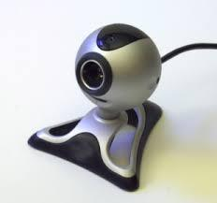 | Camera | 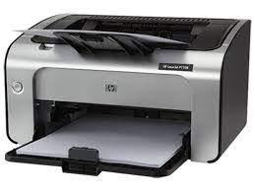 | Printer
Peripheral Device3 | Name | Peripheral Device4 | Name
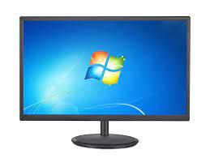 | Monitor | 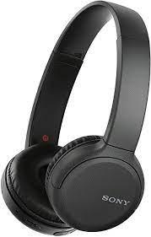 | Wireless Headphone
Peripheral Device5 | Name | Peripheral Device6 | Name
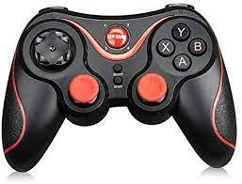 | joystick | 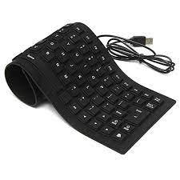 | keyboard

(Award 1 mark each max 6)

- Identify four measurement units that can be measured by analog computers
- Temperature
- Pressure
- Speed
- Weight
- Voltage
(Award 1 mark each max 4)

- Most large scale business enterprises in Kenya have computerized their business operations to enhance customer service delivery but this initiative still pose some challenges. Give five challenges faced by such business enterprises
- Computers are power dependent
- Use of computers lead to some health problems such as headache
- Overreliance of computers may lead to shortage of services when the computers break down
- initial cost of computers is high
- Require skilled personnel
- Security threats leading to data loss
(Award 1 mark each max 5)

