Name_________________________________Adm No__________________
Class__________ Sign _________________Date_______________________
MARKS HERE

MID TERM 2 EXAMINATION
Computer Studies Form One-2022

ANSWER ALL THE QUESTIONS

- Define the following terms (8mark)
- Program
______________________________________________________________________________________________________________________________________________________________________________________________________________________________________________________________________________
- Data
______________________________________________________________________________________________________________________________________________________________________________________________________________________________________________________________________________
- Process
______________________________________________________________________________________________________________________________________________________________________________________________________________________________________________________________________________
- Information
______________________________________________________________________________________________________________________________________________________________________________________________________________________________________________________________________________
- Mention four areas where supercomputers are mainly used (4marks)
__________________________________________________________________________________________________________________________________________________________________________________________________________________________________________________________________________________________________________________________________________________________________________________________________________________________________________________________________
- List four examples of special purpose computers (4marks)
____________________________________________________________________________________________________________________________________________________________________________________________________________________________________________________________________________________________________________________________________________________________________________________________________________________________________________________________________________________________________________________________________________________________
- Computers have evolved through a number of generations. List four limitation of the first generation of computer (4marks)
____________________________________________________________________________________________________________________________________________________________________________________________________________________________________________________________________________________________________________________________________________________________________________________________________________________________________________________________________________________________________________________________________________________________

- What is artificial Intelligent (2marks)
____________________________________________________________________________________________________________________________________________________________________________________
- Mention three characteristics of fifth generation computer apart from supporting artificial intelligence (3marks)
________________________________________________________________________________________________________________________________________________________________________________________________________________________________________________________________________________________________________________________________________________________________________________________________________________________________________________________________
- Describe the functions of the following Keyboards keys (3marks)
- Return Key
____________________________________________________________________________________________________________________________________________________________________________________
- Delete key
____________________________________________________________________________________________________________________________________________________________________________________
- Home key
____________________________________________________________________________________________________________________________________________________________________________________
- Mention ways that can be employed by the school to deter illegal access to a computer room by unauthorized persons (4marks)
______________________________________________________________________________________________________________________________________________________________________________________________________________________________________________________________________________
______________________________________________________________________________________________________________________________________________________________________________________________________________________________________________________________________________
- Describe the following mouse skills (4marks)
- Drag and Drop
____________________________________________________________________________________________________________________________________________________________________________________
- Clicking
____________________________________________________________________________________________________________________________________________________________________________________
- Right Clicking
____________________________________________________________________________________________________________________________________________________________________________________
- Double clicking
____________________________________________________________________________________________________________________________________________________________________________________
- Identify the peripheral devices in the table below (6marks)
Peripheral Device1 | Name | Peripheral Device2 | Name
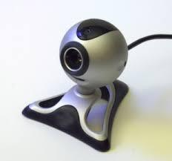 |  | 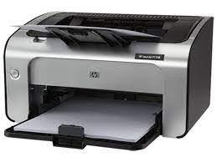
Peripheral Device3 | Name | Peripheral Device4 | Name
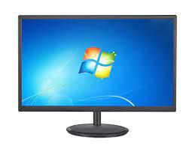 |  | 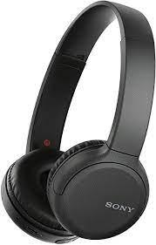
Peripheral Device5 | Name | Peripheral Device6 | Name
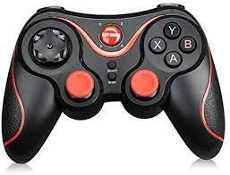 |  | 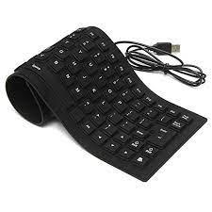

- Identify four measurement units that can be measured by analog computers (4marks)
__________________________________________________________________________________________________________________________________________________________________________________________________________________________________________________________________________________________________________________________________________________________________________________________________________________________________________________________________
- Most large scale business enterprises in Kenya have computerized their business operations to enhance customer service delivery but this initiative still pose some challenges. Give five challenges faced by such business enterprises (4marks)
______________________________________________________________________________________________________________________________________________________________________________________________________________________________________________________________________________
_____________________________________________________________________________________________________________________________________________________________________________________________________________________________________________________________________________
__________________________________________________________________________________________

