INTRODUCTION TO COMPUTERS
1. (a) Clearly define a computer
- A computer is an electronic device that operates (works) under the control of programs stored in its own memory unit
- An electronic device that accepts data, as input and transforms it under the influence of a set of special instructions called programs, to produce the desired output (referred to as information)

(b) Give one reason why a computer is refered to as an electronic device
- It uses electrical signals to process data
- It is made up of electronic components and uses electric energy to operate

2. Explain the following terms as used in computer science
(i) Data
A collection of raw facts, figures or instructions that do not have much meaning to the user

(ii) Program
A computer program is a set of related instructions which specify how data is to be processed
A set of instructions used to guide a computer through a process

(iii) Data processing
It is the process of collecting all terms of data together & converting them into information

(iv) Information
Data which has been refined summarized & manipulated in the way you want it, or into a more meaningful form for decision- making

3. State any three functions of a computer
- Accepting data
- Processing the data
- Producing information

4. Explain the following input/ output terms as used in computer systems. Give an example for each
(a) Read - To transfer data from an input device to the computer, e.g. the computer
reads data from a disk, a keyboard, etc
- To move or copy data from backing storage to the main
Storage
(b) Write - To transfer information from the computer to an output
Device e.g. the computer writes output on a printer or onto a disk.
- To move or copy data from the main storage to a backing storage

5. State four different parts that make up a computer (2 mks)
- System unit
- Monitor
- Keyboard
- Mouse
- Printer
- Modem
- Scanner
- Speakers
- Graph plotters

6. (a) Explain the term system Unit
This is the casing that houses the internal components of the computer such as the CPU and storage devices

(b) List four devices located under the cover of the system unit
- Central processing Unit (CPU)
- Motherboard
- Power supply unit
- Main memory
- Hard disk
- Disk drives
- Battery
- Buses
- Input/ output ports
- Video card
- Expansion slots

(c) Give two differences between tower – style and desktop system units
- Tower style system unit is designed to stand alone or to be placed on the floor, desktop units lie on the desk with the monitor placed on top
- Tower style units have more space for expansion than the typical desktop units (2 mks)

7. Computers have evolved through a number of generations. List any 4 characteristics of the first generation of computers.
- Large in physical size
- Relied on thermionic valves (vacuum tubes) to process and store data
- Consumed a lot of power
- Produced a lot of heat
- The computers constantly broke down due to the excessive heat generated; hence were short- lived, and were not very reliable
- Their internal memory capacity/ size was low
- Processing speed was very slow
- Very costly
- Used magnetic drum memory

8. Briefly explain the classification of computer according to historical development (generations)
First generation computers
- Used vacuum tubes in their memory
- Large in physical size
- consumed a lot of power
- Produced a lot of heat
- The computers constantly broke down due to the excessive heat generated; hence were short- lived and were not very reliable
- Their internal memory capacity/ size was low
- Slow in processing data
- Very costly
- Used magnetic drum memories
- Cards were sued to enter data into the computers

Second generation computers
- Used transistors in their memory
- They consumed less power & produced less heat than the first generation computers
- They were relatively faster than the 1st generation computers
- Used magnetic core memories
- Were less costly than first generation computers
- RAM memory capacity was 32 KB

Third Generation computers
- Used integrated circuits in their memory
- They were faster than second generation computers
- RAM memory capacity was 2 GB
- Slightly smaller in size than 1st & 2nd generation computers
- They used a wide range of peripheral devices
- Could support remote communication facilities/ more than one user at the same time
- Magnetic disks were introduced for storage purposes

Fourth generation computers
- Used large scale integrated (LSI) circuits & very large scale integrated (VLSl) circuits in their memory
- They were small & very fast
- Had storage (memory) capacity
- Magnetic disks, bubble memories & optical disks were used for storage
- The first operating system was introduced

Fifth generation computers
- Are the modern computers
- Are designed/ constructed using parallel architectures, 3 –D circuit design & superconducting materials
- Are very powerful, with very high processing speeds
- The computers can perform multiprocessing
- Have virtually unlimited ( very high) memory sizes
- Can support complex programs
- Use advanced hard disks and optical disks for storage, e.g. DVDs
- Use of zip disks
- Use of multi user operating systems & advanced application programs

- State four factors used to classify computers
- Physical size & processing power
- Power
- Functionality (mode/ method of operation)
- Type of processor (CPU)

- State the differences between desktop computers and laptop computers
- Desktop is designed to be used when placed on a desk in an office environment. A laptop can be used comfortably when placed on the User’s lap
- A laptop is small & portable; desktop computers are not portable

- (a) Explain the emerging trends in microcomputer technology in relation to
size
- PCs are becoming small and portable, e.g. personal Digital Assistant (PDA).

(b) Give two reasons why smaller computers like Laptops tend to be more expensive than Desktop computers
- The technology of producing smaller devices is expensive
- They are convenient because they are portable
- They have advanced power management capabilities (they consume less power since a laptop can operate on rechargeable batteries

- Which category of computers would you place an N- series Nokia phone
- Microcomputer/ palmtop

- Give three reasons why a mobile phone is regarded to be a computer
- It is electronic * uses electric energy to operate
- It has a display unit (screen)
- It has a keypad
- It has a memory for storage
- It is programmable

- (a) Mention three Analogue devices
- Computer used to control a flight Simulator for training pilots
- Bathroom scale
- Thermometer
- Speedometer
- Post- office scale
- A radio with a knob that slides in a slot to increase volume

(b) Give three example of special – purpose computers
- Robots
- Mobile phones used for communication only
- Calculators that carry out calculations only
- Computers used in digital watches & in petrol pumps
- Computers used in petrol pumps
- Computers used in washing machines
- An automatic pilot
- A word processor

15. State a specific example where each of the following types of computers can be used
(a) Supercomputer
- Weather forecasting
- Petroleum research
- Defense and weapon analysis
- Aerodynamic design and simulation

(b) Mainframe computer ( 1 mk)
- Banks for preparing bills, payrolls, etc
- Hospitals
- Airports (i.e., in Airline reservation systems for booking & storing flight information)
- Communication networks as servers

(c) Minicomputer (1 mk)
- Scientific laboratories & research institutions
- Engineering plants for controlling chemical or mechanical processes
- Space industry
- Insurance companies & banks for accounting purposes
- Communication centers as servers

(d) Microcomputer / personal computer ( 1 mk)
- Training & Learning institutions, e.g. schools
- Communication centers as terminals
- Small business enterprises e.g. shops, small offices and homes

16. (a) Define a microcomputer ( 1 mk)
- A computer who’s CPU (processor) has been implemented with a microprocessor

(b) Differentiate between a microcomputer and a personal computer ( 2 mks)
- A microcomputer is larger in physical size than a PC
- A microcomputer is more powerful than a PC
- A PC was designed to be used by one person only

(c) List three factors to be considered when purchasing a microcomputer (3 mks)
- Type of processor
- Processing speed
- Amount of main memory (RAM)
- Storage capacity of the hard disk
- Cost of the computer
- Speed of output devices
- Number of users who can access the computers at the same time

17. Explain four reasons which make microcomputers suitable for personal computing work
- Reduced cost, i.e. are cheaper than the minicomputers & mainframe computers
- Have high processing speed
- Are small in size (occupy less office space)
- Are more energy efficient (i.e. consume less power)
- Are more reliable in doing various functions than the early mainframe computers
- Are versatile (i.e. can be used for many different tasks)

18. (a) Identify and explain five areas where computers are used to process data ( 10 mks)
Supermarkets
- For stock control i.e. records of what is in store, what has been sold, and what is out of stock
- For calculating customer’s change
- For production of receipts
- It can be used as a barcode reader
Banks
- Manage financial transactions through the use of special cash dispensing machines called ATMs used for cash deposit & withdrawal services
- Processing of cheques
- For preparation of payrolls
- Better record keeping & processing of documents
- Provide electronic money transfer facilities
Homes
- Entertainment e.g. watching movies, playing music, playing computer games
- For storing personal information/ documents
- For calculating & keeping home budgets
Industries
- To monitor and control industries processes through the use of robots
- For management control, i.e. to keep track of elders, bills and transactions
- For advertisement purposes, which enable an industry to attack more customers
Police stations
- Matching, analyzing & keeping databases of fingerprints
- For taking photographs & other identification details
- For record keeping
- For face recognition, scene monitoring & analysis which help the police carry out criminal investigations speedily
Transport industry
- Airports; to control the movement of aircrafts, their take off & landing using radar equipment
- For making reservations (booking purposes)
- Storing flight information
- Automobile traffic control; to monitor vehicle traffic in busy towns
- In Railways corporations; to coordinate the movement of goods & wagons
- In shipping control, for efficient management of fleets, cargo handling & communication
Offices
- For receiving & sending of information through e- mails, fax, etc
- Production of documents
- Keeping of records

19. Identify three advantages of using computers in banking (3 mks)
- Speed and accuracy
- Easy to access information
- Easy to update records
- Requires less space for storage
- Improves data security and privacy

20. (a) Define the term ‘ computer laboratory’ ( 2 mks)
- A computer laboratory is a room that has been specially prepared to facilitate installation of computers, and provide a safe conducive environment for teaching & learning of Computer studies.
(b) Give two factors to be considered when preparing a computer laboratory (2 mks)
- Security of computers
- Reliability of the source of power
- Number of computers to be installed and the amount of space available
- The maximum number of users that the laboratory can accommodate

21. List down three safety precautions one should observe when entering a computer laboratory (3 mks)
- Avoid smoking or exposing computers to dust
- Avoid carrying foods & drinks/ beverages to the computer room
- Avoid unnecessary movements as you may accidentally knock the peripheral devices
- Only authorized people should enter the computer room
- Computers users should be trained on how to use computers frequently
- Computer illiterates should not be allowed to operate the computers
- collect any waste papers which might be lying in the computer room & put them into the dustbin
- Shut the door of the computer room properly

22. Describe the ideal environment for a computer to work properly (3 mks)
- Should be free from dust, water and magnets
- Should be kept in well ventilated rooms with optimum (medium) humidity

23. Explain why smoke and Dust particles are harmful to a computer
- Dust and smoke particles settle on storage devices and may scratch them during read/ write operation
- It affects the cooling of the computer

24. Identify three facilities that will ensure proper ventilation in a room
- Large & enough windows and doors
- Installing fans
- Installing air conditioning system
- Avoid overcrowding of either machines or people in the room

25. Why must foods and beverages be kept out of the computer room?
- Food particles may fall into the moving parts of the computer and damage them. Liquids may spill into the computer parts causing rusting or electrical faults
26. Why would it not be good to install Powder or Water – based fire extinguishers in the computer room?
- Powder particles settle on storage devices and may scratch them during read/ write operation
- Water causes rustling of metallic parts and short – circuits if used

27. (a) State one reason why a computer needs to be connected to a stable power supply
(1 mk)
- To prevent damage to the computer’s secondary storage media
- To avoid damage and loss of important data or information such as application software stored on the media
- Prevent loss of data/ information that had not been saved before the failure

(b) List down four functions of the uninterruptible Power Supply (UPS) (4 mks)
- It prevents sudden power surges that might destroy the computer
- It supplies power to the Computer during blackouts and brownouts
- It provides stable (clean) power supply
- Alerts the user of power loss (by beeping)
- Allows the user to save his/ her work, and switch off the system using the correct procedure
28. Mention two things that are likely to cause strain- in the computer room
- Poor lighting of the room
- Bright monitors
- Flickering monitors
- Very bright wall paints reflect too much light
29. Identify three proper sitting postures while using the computer
- Adopt relaxed and straight back position to avoid bending forward or learning far backwards
- The feet should be firmly placed flat on the floor
- The seat must be high enough allowing the eyes to be the same level with the top of the
Screen
- The seat must have a straight backrest that allows someone to sit upright. This prevents muscle pains & backaches caused by poor sitting posture
- The height of the chair or working surface must be high enough such that your forearms are parallel with the floor and your wrists are straight.
- The seat must be high enough relative to the table to enable the user use the hands on the peripheral devices comfortably.
30. State two methods of minimizing dust in a computer laboratory
- Fit the computer room with special curtains to reduce entry of dust particles
- Cover the floor with carpets in order to absorb dust
- Regular cleaning of the laboratory
- Cover the computer devices with dust covers when cleaning the room

31. Name two main causes of fire in the computer laboratory and give the precautions that should be taken to guard against them
- Inflammable chemical such as those used to clean the computer equipment
Keep the chemicals away in store after use
- Open wires/ cables
- Ensure that all electrical wires are properly insulated
- Ensure that the computer room has a gaseous fire extinguisher containing carbon dioxide in case of any accidents
- Smocking

32. What is the purpose of labeling a diskette?
- To prevent confusing the data in the different diskettes
- To prevent mixing diskettes that are used everyday with those used for long- term storage of important data.

33. List three things that can spoil a printer if they are not of the correct specification, and explain what damage may be caused
(i) Printer Paper: Different printers have different sensitivity to printing papers. Using the wrong quality paper in a particular printer can make the paper get stuck
(ii) Cartridges & Ribbons: Printers are very specific to manufacture’s cartridges & ribbons
Use of clones or imitations ( i.e., the wrong make & model) can damage the printer mechanism
(iii) Refilling of cartridges or re- inking of ribbons: It can spoil the printer due to leakage or use of poor quality materials

34. Explain three ways that computer technology could make office more efficient (3 mks)
- There is easier & faster retrieval of data, i.e. they reduce the time and effort needed to access and retrieve information
- Increased accuracy of data
- Better presentation of data
- Ensure faster processing of data
- Ensures economic use of storage space

35. (a) Explain the steps you would follow to set up a new computer
- Gently and carefully connect the interface cable of each device to the correct port and to the device.
- Connect the computer to the source of power and switch it on.
- Observe boot up information on the screen to see whether Power-On Self Test (POST) displays any error message. A successful boot means that the computer was properly setup.
(b) Outline three reasons why it is important to first shut down the computer before turning it off
- To avoid damaging storage devices that may still be in use
- To avoid damaging system and application files
- To avoid loss of data and information ( 3 mks)

36. A computer must go through the process of booting/ initialization before use
(a) Briefly explain the term “computer booting”.
Booting refers to the starting up of a computer. It is the entire process that makes the computer ready for use.
(b) Explain what happens in the computer during the booting process
When the power is switched on, internally, it first checks whether all the components are in good working condition, i.e. the RAM, CMOS (BIOS), hard disk & floppy disk drive controllers, and the keyboard. If no problem is found, it then loads the operating systems

(c) Give and explain two types of booting
(i) Cold booting:
It happens when a computer which was originally off is switched on by pressing the power button on the systems unit
The Computer starts by checking all its components to determine whether they are functioning properly

(ii) Warm Booting
This happens when a computer that was originally on is forced to restart by pressing the restart button on the system unit by pressing a combination of keys on the keyboard ( CTRL + ALT + DEL)
(d) What type of memory is used to store the boot up program (the first program to be executed on switching on a computer?
Read – only Memory (ROM) ( 1 mk)

37. (a) What is a computer keyboard
An input device that lets the user enter commands into the computer for execution by
typing

(b) List four types of keys found on a computer keyboard, giving an example of each
( 4 mks)
- Function/ command keys (F1- F12)
- Alphanumeric Keys (A-Z, 0-9)
- Numeric keypad (0-9)
- Cursor control keys (PgUp, PgDn, Home, end, Arrow keys)
- Special PC keys (Ctrl, Shift, Alt, Ins, Enter, Spacebar, Caps lock, Num
lock, etc)
- Editing keys (Del, Backspace, and spacebar)

(c) Name the keyboard keys that will help you: (2 mks)
(i) Type the upper character in a key - SHIFT Key
(ii) Execute a selected command - ENTER Key

COMPUTER SYSTEMS
1. Define the following terms as used in computing
(i) System
A collection of independent entities that collectively work together to achieve a desired goal
(ii) Computer system
- A collection of entities that work together to process and manage information using computers
- A collection of hardware software and live- ware all working together in data inputting, processing and production of required output from a computer
2. Differentiate between a computer and a computer system
A computer is made up of both hardware and software, while a computer system integrates hardware, software and user

3. (a) List and explain three functional elements of a computer system ( 6 mks)
- Hardware
They are the physical & tangible devices that make up a computer systems, e.g system unit, input devices, output devices and storage devices

- Software
These are programs & data used in a computer system that enable it perform a number of specific functions, e.g. operating systems, application programs, utility programs, programming languages & device drives

- Live – ware ( people – ware)
These are the people who coordinate the various activities which are necessary to make a computer system perform useful tasks e.g. data entry clerks, computer operators, programmers, system analysis, etc
(b) Draw a well – labeled diagram showing the functional units of computer hardware

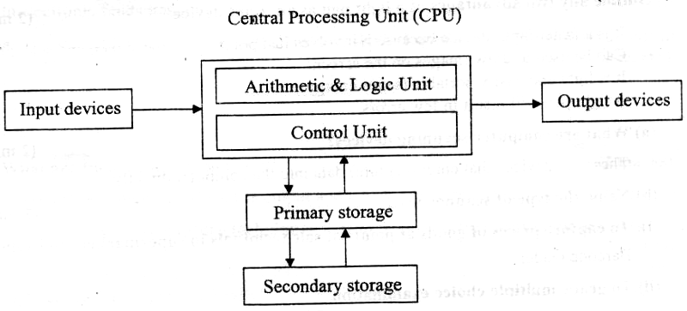
4. (a) Give two main functions of a computer input device. (2 marks)
- Accepts data & instructions from the user and sends them into the CPU. V
- Converts data into a form that the computer can understand (i.e., machine-
Sensible/readable form)
(b) Give an example of a: (3 marks)
(i). Device that reads data (scanning device).
- Scanner,
- Digital cameras,
- Barcode readers.
~ Credit/smart card readers,
- Kimball tag readers.
- OMR, OCR, MICR, etc
(ii). Keying device.
- Keyboard,
- Keypad.
oh). Pointing device.
- Mouse.
- Trackball.
- Light pen
- Joystick.
(h). Voice input device.
- Microphone.
(v). Printing device.
- Printer.
- Plotter.
5. State two advantages of using a mouse instead of a keyboard. (2 marks)
- The mouse is easy & convenient to use.
- Modern software includes an option to use it.
- It selects a position on screen much more quickly than a keyboard.
6. Outline any two advantages of a light pen as an input device, (2 marks)
- It is a faster input device because it involves just pointing on the screen and selecting options.
- Can be used to draw images on the screen.
~ It is light and easily portable (saves energy).
- A light pen will result in few errors.
7. (a) What are computer scanning devices? (2 marks)
These are devices that enter (capture) data into the computer directly.
(b) Name the type of scanner used: (2 marks)
(i). To capture prices of goods at points of sale terminals in supermarkets and superstores.
Barcode reader
(ii).To grade multiple choice examination
Optical mark reader (OMR)
-12- Computer studies

8. Mr. Otieno a French teacher used speech method to store students oral answers to an exam into a computer
(a) What is a speech input?
It is a type of input where a microphone connected to a computer system is used to enter data in form of spoken words into the computer
(b) State two advantages and two disadvantages of using this method of data input
(4 mks)
Advantages
- Voice input is fast
- Its suitable for people with special needs especially those with impaired hands
- Can be used in emergency situations

Disadvantages
- Voice input is complex to develop
- Voice input does not take care speech related problems such as accents, tone etc
- The response rates of speech input devices are relatively slow
- Most speech input devices can recognize a limited, standard vocabulary of spoken words, and the voice of only one speaker
- Cannot differentiate words that have same sounds (homophones)

(c) State four areas where speech input would be used
- For people with special needs or disabilities (e.g. the handicapped especially those with impaired hands.
- Emergency situations
- Where faster data input is required
- In language translator or programs
- Voice tags for voice dialing
- In automated materials handling e.g. in airports, a good handlers give spoken commands that direct the luggage to the appropriate conveyor belt.
- For house/ office or car security where voice activated locks are used for access control
- In voice- activated toys and games
- In electronic funds transfer

9. Name two examples of scanning (data capture) devices used at point of scale terminals in supermarkets
- Barcode reader
- Light pen
- Cash registers

10. (a) What are turnaround documents
These are documents produced as output and which can be re-used as input by the computer
(b) Name any two data capture techniques that make use of turnaround documents
( 2 mks)
- Optical character recognition (OCR)
- Optical Mark Recognition (OMR)
- Magnetic Ink Character Recognition (MICR)
- Optical Bar Recognition (OBR)
- Magnetic Stripe Recognition

11. List five factors one would consider when selecting a data input device (4 mks)
- The needs of the user
- Type of data to be input
- Volume of data to be entered
- Input speed
- Cost, i.e. the initial cost of the input device & cost of using the device on a day – to – day basis.
- Availability & reliability of the data entry device
- Accuracy required
- Availability of space
- Appropriateness of the device in reference to where it is to be used

12. Describe three functions performed by the CPU ( 3 mks)
(i) It carries out processing of data
(ii) System control- it controls the sequence of operations within the computer
- It gives commands to all parts of the computer
- It controls the use of the Main Memory in storing of data & instructions
- Storage of data- It provides temporary storage (RAM) & permanent storage (ROM)

13. Explain the functions performed by each of the following central processing unit elements
(i) Control Unit ( 2 mks)
- Interpreting instructions
- Issuing control instructions to the operating system

(ii) Arithmetic and logic Unit
- Performs arithmetic calculations such as addition, or multiplication of figures
- Performs logical operations & comparison on data
- Performs output of logical functions (variables)

(iii) Registers
- Holds data and instructions temporarily just before and after processing

(iv) The main memory
- Stores data just before and after processing
- Stores instructions waiting to be obeyed/ executed
- Holds program instructions & the data currently being processed
- Stores intermediate results of processing awaiting transfer to the output devices

(v) The system clock
It determines the processing speed of the CPU

14. In reference to ALU, explain the meaning of logic operations and give an example of this processing operation
Logic operation is the ability to compare two quantities or numbers to determine which is greater than, less than, equal to, or not equal to the other.
It also involves the testing for existing of a condition encountered during the processing of an application & altering the sequence of instructions accordingly.

15. Give four types of registers found in the CPU
- Accumulator
- Instruction
- Address register
- Storage register

16. (a) Name the basic unit used to measure the processing speed of a computer ( 1 mk)
Hertz (Hz)
(b) A computer processor speed is measured in Hertz. What fraction of a second is the
following?

(i) 1. Nanosecond
1 1__________
1 x 10⁹ = 1,000,000,000 seconds

(ii) 1. Microsecond
1 = 1________
1 x 10⁶ 1,000,000 seconds

17. (a) What is a computer bus? ( 1 mk)
- A communication path/ medium within the computer that connects the basic computer components. It allows different elements or sections of the computer to communicate with each other.
- A parallel collection of conditions that carry data & control signals from one element to another

- State the functions of each of the following computer bus ( 3 mks)
- Data bus- carries data from the processor to memory during the write operations and from memory to the processor during the read operations
- Address bus- it conveys addresses, i.e it carries the address of the memory location or device to be acted on by the processor
- Control bus- it carries the timing & control signals necessary to coordinate the activities of the entire system

18. (a) What is the computer Motherboard?
This is the electronic board where all electronic components such as processor, memory chips, BIOS, bus connections etc are assembled
(b) State any four components found on the computer motherboard
- Processor (CPU)
- SIMM/DDR sockets
- Memory chips
- BIOS
- Interface chips
- Buses

19. (a) What is a Drive?
A drive is a computer device for reading data from or writing data into a storage media, e.g. a tape or disk

(b) State any two types of computer drives, giving an example of a storage device used by each ( 3 mks)
- Hard disk drive (HDD) - Floppy Disk drive (FDD)
- CD- ROM drive - DVD – ROM drive
- Tape drive - Zip drive
- USB port – for flash disk

20. (a) Give two reasons why there are many forms of computer storage devices ( 2 mks)
- Permanency of storage
- Cost of implication
- Capacity of storage systems

(b) State three different examples of auxiliary storage devices
- Magnetic tape
- Floppy disk
- Cassette tapes
- Hard disk
- Zip disks
- Jazz disks
- Flash disks
- Video Compact Disk (VCD)
- Digital video Disks (DVD’s)
- Punched cards
- Optical discs (e.g., Compact Disks LS- 120 super disks, optical card, optical tape)

21. Using examples, distinguished between:
(i) Primary and secondary (2 mks)
Primary storage devices are accessed directly by the CPU, while secondary storage is
not
(ii) Fixed and removable disks
Fixed disks are mounted inside the computer system unit, e.g. Hard disk.
Removable disks are not hosed inside the system unit & are portable, e.g. floppy disk, Jazz disk, Zip disk, flash disk, CD- R, CD – RW, DVD
22. Explain the following storage devices
(i) Hard disk
A fixed storage device housed inside the Computer System Unit
(ii) Flash disk
A high capacity plug-in portable storage device. Usually attached at the USB port of the computer
(iii) Zip disk
High capacity disk that resembles a floppy disk, but is slightly larger and thicker in size
23. (a) Compare a floppy disk and zip disk in relation to size ( 2 mks)
A floppy disk is physically small in size and capacity, while a zip disk is slightly large in size and has large storage capacity.

(b) Give three disadvantages of floppy disks as storage devices

- Floppy disks are slower than hard disks
- Highly affected by viruses
- Low storage capacity
- Not reliable
- Affected by environmental factors, exposure to sunlight, magnetism and dirt

24. (a) State three advantages of using hard disks as medium of storage
- They provide permanent storage of data
- They have a large storage capacity
- Are cheap per unit of storage
- Are rewritable (provide read & write facilities)
- Are very fast compared to other secondary storage devices in terms of data transfer

(b) Describe three precautions you would take to avoid damaging the hard disk ( 3mks)
- Do not drop the disk drive
- Do not expose it to strong heat
- Do not expose it to dust/ smoke particles
- Do not unprocedurally switch off the computer

(c) Describe the structure of a hard disk in reference to cylinders, tracks and sectors
The surface of hard disk is divided into circles called Tracks. Parallel tracks on several platters are called cylinders
The tracks are further subdivided into sectors. Several sectors can be grouped to form clusters.
25. State two reasons why Magnetic tapes are not commonly used as computer data storage medium today
- Are slow when retrieving data. This is because of the linear storage of data o the tape.
- Do not fully use their recording surface due to inter- record Gaps

26. Differentiate between:
(i) Microcomputer and microprocessor
A microcomputer is a computer whose Central Processing Unit (CPU) has been implemented with a microprocessor
A microprocessor is a small computer processor, mainly a combination of the ALU & CU manufactured on a single chip.

(ii) Volatile memory and non- volatile memory
Volatile memory is temporary, while non- volatile memory is permanent

(iii) RAM and ROM
RAM is a temporary and rewritable memory, while ROM is a permanent and read only memory.
(iv) Hard disk and floppy disk
Hard disk is a hard metallic platter used to store data and is encased in a metallic housing (casing)
Hard disk is metallic. Shinny and non- flexible

(v) Magnetic and optical storage media
In magnetic storage media, data is recorded using magnesium, while in optical storage media data is recorded using a beam of light (laser)

(vi) Hardcopy and softcopy output
Hardcopy is printed copy, e.g. printout on paper such as letters while softcopy is intangible information e.g. screen display or music.

(vii) MICR and OCR scanners
MICR uses magnetic technology to read magnetic characters, while OCR uses laser/ light technology to read characters

27. Explain four rules for handling magnetic disks
- Keep magnetic away from excessive heat. This is because heat energy weakens the ability of the magnetic media to store data.
- Store the media in their cases when not in use in order to protect/ safeguard their recording surfaces against environmental influences such as dust, touch, direct sunlight, radiations, etc
- Do not drop the disk on the ground
- Never bring them near moving or strong magnetic bodies. Such bodies might demagnetize the recording surfaces making recording in terms of magnetism impossible
- When mounting the media into its reading/ writing unit, avoid brushing the recording surfaces against the mechanical components of the drive
- Put on the power before mounting the media and off after removing the media from the drive.
This is because; the fluctuation in power might cause demagnetization

28. (a) Calculate the capacity in MB of a two sided floppy disk with 6 sectors per surface, and 512 bytes per sectors
No. of sectors = (2 sides x 6 sectors)
= 12 sectors
If 1 sector = 512 bytes
(12 x 512) = 6,144 bytes
1,000,000 bytes 1 MB
6,144
1,000,000 = 0.006144 MB

(b) A double – sided disk contains 40 tracks on each side. The tracks are divided into 9 sectors of 512 bytes each. What is the total capacity of the disk in megabytes? ( 2mks)
Total tracks = (40 x 2) = 80
Total sectors = (80 x 9) = 720
Total bytes (720 x 512) = 368, 640 bytes

If 1 MB = 1,048, 576 bytes
? = 368, 640 bytes
368, 640
1,048, 576
= 0.352 MB

29. By giving examples, differentiate between primary and Secondary Computer storage
( 3 mks)

Primary Memory | Secondary Memory
- Used for holding data & instructions required immediately by the CPU  - It is accessed directly by the CPU  - Provides fast access to information is accurate & reliable  - It is expensive per bit of memory dues to the technology involved  - It has low/ limited storage capacity  - It is volatile & therefore it is used to store temporary programs & data  - The speed of the processor depends on the size & type of primary storage  E.g. Read Only Memory (ROM) & Random Access Memory (RAM) | - Used for storing backup information that is not needed immediately by the CPU.  - It is not accessed directly by the CPU  - Provides slow access of information  - Secondary storage devices are cheap  - it has high storage capacity  - It is non- volatile i.e. stores data permanently.  E.g. punched cards, magnetic tapes, floppy disks, hard disks, etc

30. (a) State four functions of Read – Only Memory (ROM)
- It stores Firmware (bootstrap instructions) - the essential files the computer uses while booting/ starting up.
- It stores the system data & instructions that are necessary for the normal functioning of the computer hardware e.g. the Kernel / supervisor of the OS
- It stores translation programs (code converters) used for converting a user’s program into machine language
- It stores special functions (facilities) peculiar to a given machine
- It stores character generators for printers & Video displays
- It stores instructions used in special – purpose computers & computerized fuel pumps
(b) Give three characteristics of ROM
- It can only be read, but cannot be written to (i.e., the user can only read the information in the ROM, but cannot write on it unless it is a special type of ROM).
- Provides permanent or semi permanent storage of instructions & data from the manufacturer.
- It is non volatile memory
- Forms a small proportion of the main storage ( i.e. it contributes 30% of the internal Memory).
- Stores essential files for starting the computer (Bootstrap programs)

(c) Name two different types of ROM
- Masked ROM
- Programmable Read- Only Memory (PROM)
- Erasable Programmable Read- Only Memory (EPROM)
- Electrically Alterable Read- Only Memory (EAROM)

31. (a) Outline three characteristics of Random Access Memory (RAM)
- Stores data & programs temporarily during the times when they are needed in the Main Memory (or during execution).
- Provides “read & write facilities” i.e. it allows instructions to be written, read out & to be changed at will.
- The contents in RAM are user – defined, i.e. the user dictates what is to be contained in the RAM
- Its contents are temporary
- It is a volatile memory
- Forms the major proportion of main storage

(b) Name the two types of RAM clearly starting their differences (3 mks)

(i) Static RAM
A static RAM can retain its data/ content as long as power is provided to the memory chips, i.e. it does not need to be re- written periodically
(ii) Dynamic RAM
- Dynamic RAM can only hold its content for a short while even when power is on.
Therefore, in order to maintain its content/ data, a DRAM must undergo the refreshing process (i.e. it must be re- written continually)
- Static RAM is much faster than Dynamic RAM
- SRAM chips are physically large & much more expensive than DRAM chips
- Dynamic RAM has a much higher packing density than SRAM, i.e., a DRAM chip is able to store more information than a SRAM chip of the same size.

32. The diagram below shows as example of a secondary

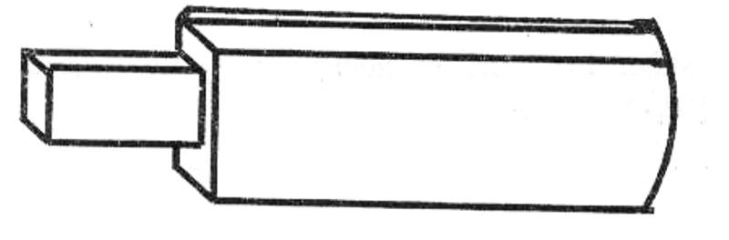

(i) Identify the name of the devices
Flash Disk

(ii) List down two advantages of this device over a floppy disk in storage ( 2 mks)
- Smaller in size than a floppy disk, hence, easily portable
- Has a high data storage capacity compared to a floppy disk
- Flash disks are more reliable than floppy disks

33. (a) List any four examples of optical storage devices
- Compact Disk Read – Only Memory (CD – ROM)
- Compact Disk Recordable (CD-R)
- Compact Disk Rewritable (CD-RW)
- LS- 120 super disk
- Digital Versatile Disk (DVD)
- Optical card
- Optical tape

(b) Give two advantages of a digital Versatile Disk over a normal Compact disk
- DVD has a larger storage capacity than a CD ( 2 mks)
- A DVD offers better data storage quality

34. (a) State the two types/ forms of computer output
- Softcopy
- Hardcopy

(b) List any four examples of output devices in a computer
- Monitors
- Printers
- Sound output, e.g. speakers
- Audio response units
- Plotters
- Sound cards
- Digital projectors
- Computer output on microforms (COM)
- Storage devices

- Identify three Functions of computer devices
- Transmit the intermediate & final results to the users
- Convey messages e.g. error messages to the operators
- Provide immediate response to queries
- Convert the coded results produced by the computer to human- readable form
35. (a) State one function of the screen (monitor)
- Used to display the results of all the data that has been processed from the computer
- It converts machine- coded outputs results from the processor into a form that can be understood by people

(b) Show two differences between a CRT monitor and a flat- panel display
- CRT monitor uses a cathode ray tube to display information, while a flat panel does
not.
- CRT has a protruding back, while a flat panel does not.
- Flat panel displays are light & easily portable, while CRT’s are heavy
- CRT can display a wide range of colours, while a flat panel displays a limited number
of colours
- CRT consumes more electrical power than flat panel displays
- The screen of a flat panel is much thinner & smaller than that of a CRT
- The screen resolution of a CRT is adjustable, while that of a flat panel is often set

(c) Give there examples of flat- panel monitors available in the market today
- Liquid crystal displays (LCD)
- Electro luminescent (EL)
- Gas plasma
- Thin Film Transistor (TFT)

36. (a) What are pixels?
Pixels (picture elements) are dots on the screen that form characters and images

(b) What role do pixels play in screen display?
They determine the clarity of images on the screen

(c) Give two advantages of the higher number of pixels per square centimeter (2 mks)
- Higher screen resolution
- Displays of sharp & clear images
- The screen is able to display a higher number of different images

37. (a) What are character printers? (1 mk)
Are usually low- speed printers that print one character at a time?

(b) Give two examples of character printers
- Dot matrix
- Thermal
- Daisy wheel
- Inkjet
- Golf ball

38. Distinguish between impact and non impact printers and give two examples of each
Impact printers print by striking mechanism & are noisy, e.g Dot matrix, Daisy wheel, and Golf Ball, drum and chain printer.
Non- impact printers print either by laser, ink or thermal transfer mechanism & are silent, e.g. Laser, Inkjet, thermal printer, electrostatic and xerographic

39. (a) Distinguish between a line printer and a page printer
A page printer prints documents page by page, while a line printer prints documents line by line

(b) State three advantages and one disadvantages of:
(i) Laser Printers
Advantages - Cheap running cost
- Produces high quality of printouts
- Has a very high speed of printing ( it is fast)
- Economical in maintenance
- It is very silent

Disadvantages - Expensive to purchase & maintain
- Involves expensive multiply colour printing

(ii) Inkjet Printers
Advantages - Cheap to purchase
- Cheaper multiple colour printing
- Produces high quality prints

Disadvantage - Expensive to run (i.e. to buy cartridges)
- Produces a water based print which fades easily

40. Highlight four factors one should consider when purchasing a printer (4 mks)
- Cost involved i.e. the printer’s buying price, cost of maintenance & cost of consumable items like printing papers, ribbons/ cartridges
- Volume of printing expected ( speed of the printer)
- Quality of printing e.g. ability to print graphics & colour
- Capability of the selected printer, i.e. multiple copy production, paper size, etc
- Compatibility with other computers
- Environment in which the printer will operate
- Ease of maintenance
- Reliability of the printer
- Application it is required for (i.e. purpose/ use of the printer)
- Type of paper used by the printer
- Documentation
- Availability

41. List three advantages of a plotter over normal printer machines
- Plotters produce information in an easily understandable form
- Their presentation is quick & reliable
- Produces large graphical designs of high quality, which are east to read & use
- Can print on large sized papers, e.g. papers e.g. Al, Which a normal printer cannot

42. Give two advantages of using sound output devices
- Very fast making it useful in emergency situations
- One can receive the output even when a few meters away from the computer
- No reading ability is required of the user
- Suitable for the blind and people with poor sight
- Can be used for distant communication if done over telephone lines
- Errors are easily corrected, e.g. if used in a camera, one know when the film or exposure is set wrongly.
- Makes computing interesting and entertaining

43. George connected new multimedia speakers to his computer and tried to play his favorite music CD, but no sound came out. Suggest two problems that might have occurred ( 2 mks)
- Volume control was too low
- Loose or improper connection to the sound card
- Speakers not powered
- Multimedia not supported
- Lack of analogue cable connecting the optical drive to the motherboard or sound card
- Sound card drivers not installed

44. List down 4 factors to consider when buying an output device
- The volume of the data
- The speed at which the output is required
- Cost of the method chosen as compared with the benefits to be derived
- Suitability of the application
- Whether a printed version is required

45. Define the following terms
(a) Port
A special kind of socket found at the back of a computer used to connect an external peripheral device such as a printer, monitor, mouse, scanner, modem, flash disk, etc to the interface cards inside the computer

(b) Data interface cable
These are special cables that connect all the peripheral devices to the motherboard and the CPU. They transmit data signals and information to and from the devices

(c) Power cable
Cable for power supply to devices

46. State the function of the power supply unit found in the system unit (1 mk)

- It supplies stable power to the motherboard and other internal devices of a computer
- Converts the potentially dangerous alternating current (AC) into a steady low- voltage direct current (DC) usable by the computer.

47. (a) Name any two peripheral devices which get their power supply through ports
- Keyboard
- Mouse

(b) State the type of port that would commonly be used to connect the following devices
(i) Mouse - PS/2, Serial, or USB
(ii) Modem - Serial
(iii) External CD drive - Parallel

48. (a) Explain two differences between serial and parallel communication ports of a computer
- Serial ports have 9 pins, while parallel ports have holes for 9 or 25 pins
- Parallel cables transmit several bits of data simultaneously, while serial cables transmit
One bit at a time
- Serial cables are slower than parallel cable
- Serial cables allow for 2 ways communication (i.e. communication to and from the computer and the device connected to it) while parallel cables usually offer 1- way communication.
(b) Give two major advantages of a USB interface cable over other cables in the computer
- It is light & convenient to carry
- It provides faster transmission of high – quality data
- Its serial nature enables it to connect devices a longer distance away
- The USB port can be used to connect a wide range of peripheral devices due to its common universal interface

49. Outline three precautions one should take when assembling a computer
- Disconnect all diverts from the power source before starting to work on them
- Never work alone because you may need help in ease of energy
- Discharge ant static electricity that might have built up on the hands by touching an earthed metallic object and wearing an anti- static wrist member.

50. State six factors which you would consider when selecting computer hardware for an organization
- Cost of the system
- Processor type and speed
- Storage capacity of hard disk & RAM memory size
- Warranty (service contract)
- Upgradeability of the computer
- Compatibility of the system
- Portability (light to carry)
- User needs
- Popularity of the hardware manufacturer
- Availability of spare parts
- Multimedia capability

51. List down any four hardware components you can add or upgrade in a computer system
(4 mks)
- Processor (CPU)
- Ports e.g. USB ports/ SCSI ports
- Hard disk
- DVD drives/ tape drives
- RAM memory
- Expansion slots

52. (a) What is warranty with reference to the purchase of computers
A warranty is an agreement between the buyer and the seller that spells out terms and conditions of after selling a product in case of failure or malfunction.
A warranty is usually the duration in which your computer is supposed to work without any problem.

(b) Why is it important to carefully study a warranty before committing yourself by signing it?
In order to negotiate on sensitive items like duration, after sales services etc.

(c) List down three issues to understand about warrants
- Duration (scope of cover)
- How comprehensive is the warranty- good warranty should cover all the parts of the
Computer.
- Liability agreement e.g. how long should the supplier take to repair a fault or replace the product, and if he/ she delays, who bears the cost.
- Does the warranty offer online support?
- Regularity of service or maintenance

53. What are clones with reference to computers and what is their disadvantage?
- Clones are locally assembled computers

Disadvantages
- Their components are not optimized to work with each other
- They are not as reliable as their brand names like IBM, Compaq, Hewlett Packard (HP), Dell, Gateway etc.

54. (a) What is standard software?
These are programs developed, packaged and then made available for purchase either directly from the developer, though a vendor or a distributor
They may be used for a wide variety of purposes

(b) Small and large scale organizers are turning to the use of in- house developed software for the processing activities rather than use of standard software

(i) What is in- house developed software?
These are programs that are uniquely designed & written by the user or a software house under contract, to meet the specific needs of a particular user or organization.

They are usually customized (tailored) to perform a specific job or solve only specific processing tasks in one organization

(ii) Give two reasons that may be influencing these organizations for such a decision
( 2 mks)
- The user gets well tested program, which he/ she is able to use with confidence
- The program provides all the facilities required to solve a particular problem
- The purchaser has direct control over the package, as he/ she is involved in its
Production
- The user is able to quickly implement the results obtained from the use of the package
- They can easily be modified to meet specific user’s needs without involving expert programmers.
55. Differentiate between single- purpose programs and integrated software
- Single – purpose software is developed for only one purpose, while integrated software is a suite of more than one program and can be used to carry out a variety of tasks

56. Explain the following considerations when purchasing software ( 2 mks)
(i) Authenticity
It is the genuineness, validity or legitimacy of software. The copy of the software you buy should be accompanied by the license and certificate of authenticity of the developer.
(ii) Portability
It refers to whether a program can be copied or installed in more than one computer

57. Differentiate between portability with reference to hardware and software
In hardware, the computer device should be sufficiently small & light to carry
In software, portability refers to whether a program can be copied from one computer to another or installed in more than one computer.

58. (a) Explain why documentation is necessary for any software package
It contains details on how to install use and maintain the software. It also shows the purchaser how the program can be used to solve particular problem as well as provide the user with assistance on using the program.

(b) A firm intends to purchase new software. List three items of documentation that should accompany the software
- A license
- Installation guide
- User manual (guide)
- Reference manual
- Warranty
- Upgrades
- Service pack

OPERATING SYSTEMS
- The central processor and peripheral devices of a computer system are coordinated by the operating system
(a) Define the term ‘operating system’
- A set of computer programs that normally reside in the main memory and used to control the basic computer hardware resources & the operation of the entire system
- The main program that controls the execution of user applications, and enables the user to access the hardware & software resources of the computer

(b) List two resources/ components that an operating system manages
- Processor
- Memory (RAM)
- Secondary storage devices
- Input/ output devices
- Communication devices
- I/O & communication ports
- Files
(c) There are several types of operating systems in use today. State two examples of
Operating systems which you are familiar ( 2 mks)
- Disk Operating System (DOS)
- Windows
- MacOS
- Unix
- Linux

- Name the two latest operating systems from Microsoft corporation ( 2 mks)
- Windows XP
- Windows Vista

- Explain any four functions of an operating system software ( 8 mks)
(i) Memory allocation & loading of programs
- Loads application programs from an external storage into the available locations in the Main memory (RAM)
- It keeps track (monitors) of the parts of the memory that are in use, and those which are free
(ii) Processor management:
The processor can only execute one program at any one time. Therefore, in a multi- tasking system access to the CPU must be carefully control & monitored. The OS must decide, which program will be allowed into the system, and for how long
(iii) Job scheduling- it schedules & loads programs in order to provide a continuous sequence of processing. This is necessary when more than one application program is occupying the main storage
(iv) Error reporting and interrupt handling- The OS reports any errors that occur during program execution.
(v) Management of CPU time:
In a multi- taking system where several user programs share the computer resources, the processing is done according to the job priorities allocated and in a continuous process until all the jobs in the queue within the memory are executed. This ensures that the CPU does not remain idle at any given time.
- Manages the input and output devices
The OS controls the allocation of I/O devices and tries to resolve any conflicts that arise. It also monitors the state of each I/O device and signals any faults detected
- File management
OS is concerned with the logical organization of the files in the computer & provides ways for sorting, retrieving & sharing of the files
It also provides a means of protecting the data files & programs against unauthorized access and corruption.
- It controls the selection & operation of the hardware devices used for input, output & storage
- It interfaces the user to the system’s hardware, i.e. it provides a quick means of communication between the computer user and his programs
- Logging & accounting
The OS keeps records (internal logs) on how the computer resources (e.g. CPU time, memory, peripherals) are being used
It also keeps a complete record of all what happens during processing (usually in the form of a printed log)

- What is an interrupt?
An interrupt is break from the normal sequential flow of instructions processing in a program

- Give three ways in which operating system are classified ( 3 mks)
  - The number of users they handle
  - The number of tasks they execute concurrently
  - Human computer interface

- Giving an example in each case, explain the following types of operating systems
(a) Single – user / single tasking
A system that allows only one user to run one user program at a time in an interactive, conversational mode. E.g. Ms- DOS, PC- DOS.

(b) Multi- User/ Multi- tasking
A multi- user computer system can allow interactive facilities to several at a time. A Multi- tasking Computer system can allow more than one program which are in the memory to be processed at the same time. E.g. Microsoft Windows, Linux.

- A computer user may interact with a computer either through Graphical User Interface (GUI) or though typed commands
(a) Give one advantage of using GUI based operating system over a command line interface
( 1 mk)
  - User friendliness
  - Easy to learn & use even by those who do not have much knowledge about them
  - One does not need to master any commands
  - It is faster to work with than a command line interface as it only relies on clicking the icons by use of a pointing device
(b) Some computer systems still use command line interfaces. State two advantages of command line interface
- They are more flexible than menu- driven interfaces
- There is security of data as only those who know how to use the commands will access
it.
- They use cheap hardware & software facilities
- One has a better control over the system resources

- What is a deadlock in reference to operating systems?
- It is a situation in an OS when a particular task holds a needed resource and refuses to release it for use by other tasks

- Explain briefly the following concepts as used in the windows environment:
(a) Desktop
Desktop is mostly an empty screen that appears when windows starts and has some standard icons that show that the computer is ready for use.

(b) Window
A rectangular area on a computer screen in which text, graphical images or the contents of a folder or disk may be displaced
(c) Icon
A little picture on the computer screen representing a program, disk file folder or any other item
(d) Sidekick menu
A submenu that appears either on the right or left of a main menu

(e) Taskbar
A long bar/ strip that runs across the desktop and displays the start button and any other active tasks.

(f) Task
Any activity taking place in windows and is displayed on the taskbar, e.g. running program (3 mks)

- Identify three functions of taskbar
  - Indicates what programs are running
  - Holds minimized programs
  - Provides a shortcut menu for arranging programs

- State two differences between Disk Operating System (DOS) and Windows operating system ( 2 mks)
DOS | Windows
(i) Single - tasking  (ii) Single- user  (iii) Command driven interface  (iv) Not easy to use | (i) Multi- tasking  (ii) Multi- user  (iii) Graphical User Interface  (iv) User friendly

- Identify three factors you would consider when choosing an operating system for use in a computer ( 3 mks)

(i) Hardware configuration of the computer, e.g. RAM memory size, Hard disk capacity, type of processor, etc
(ii) Basic design of the computer – It is an IBM compatible, or apple computer?
(iii) Hardware compatibility
(iv) User (type of work to be done), i.e. the applications intended for the computer
(v) User friendliness or human computer interface, i.e. it is command line based, Menu driven or graphical user interface?
(vi) Availability in the Markey, e.g. Microsoft Windows based operating systems are very common
(vii) Portability
(viii) Cost- how expensive the OS is
(ix) Reliability, i.e. can it run without crashing (stop responding to commands)?
(x) The method of communicating with the computer, e.g. the number of peripherals
(xi) The method of operating the computer

- Explain how windows organizes information in reference to files and folders
It stores related data & information records into files, and related files into folders & subfolders

- (a) Distinguish between systems files and application files ( 2 mks)
System files hold critical system information while application files hold programs data
(b) State the extensions used signifying the following file types (2 mks)
(i) Driver or system file - DLL, SYS, INI
(ii) Batch file – BAT

- (a) List and explain down the three parts of the windows Taskbar ( 3 mks)
  - Start button - Provides access to the start menu
  - Task Manager - Displays buttons of currently running tasks
  - System tray - displays icons of applications that automatically start and run in the background

(b) Outline the procedure of renaming a file or folder using windows operating system
(3 mks)
Method 1:
- In an explorer window, click the file/ folder you want to rename
- Click on file, choose rename
- Type the new name, then press enter
Method 2:
- In an explorer window, right- click the file/ folder you want to rename
- Choose Rename from the shortcut menu that appears
- Type the new name, then press Enter

- (a) What is a dialog box?
Window that appears temporarily to request or supply information. It contains options (settings) one must select to complete a task

(b) List five settings that may be found in a dialog box
- Textbox- a box you can type data in
- List box – a box that contains a list of options, one of which is selected
- Checkbox- a small, square box that can be selected or cleared. It appears with an option that you can turn on or off. When the checkbox is selected, a selected, a checkbox (☑ or )appears in the box
- Radio button – a round button that can either be blank or can contain a dot. If the button contains a dot, it is selected.
- Pull down menu – A box with a downward – pointing triangular button at its right end (). When the triangular button is clicked, it displays a menu.
- Command button- A button that can click to carry out or cancel the selected action. E.g. the OK or cancel button.
- (a) Define ‘ folder/ directive tree’
Directory tree is the hierarchical arrangement of folders and storage locations from the root downwards.
(b) Give two examples of root directories you know (1 mk)
- A:\
- C:\
- D:\
- E:\
(c) Give three uses of sub- directories or subfolders (3 mks)
- Used to store files that are not required currently until they are needed again
- Used to store the files of one program separately from the files of another program
- It allows each user to keep his/ her files separately, even if all the users are using the same systems.

- The Hierarchical system represented below shows how a school organizes its files. Study it and answer the questions below.
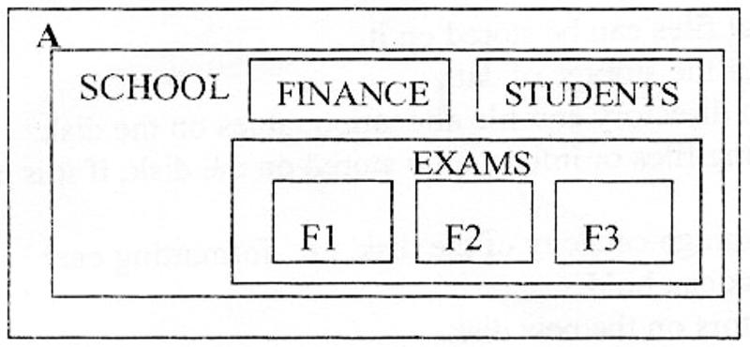

The F2 directory has the files: classlist.doc, Districts.xls, and the tribe.mdb. Write down the path of accessing the Districts. xls file.
A:\SCHOOL\EXAMS\F2\Districts.xls (2 mks)

- (a) (i) Explain the meaning of backup ( 2 mks)
It means making of duplicate copies of data or programs from the hard disk into storage media so that in case the system fails, or originals are corrupted or lost, the data can be reconstructed from the backups.
This is used to protect data from accidental erasure or hardware problems

(ii) Explain two methods you can use in windows to back up data into a storage device
(2 mks)
- Using copy and paste commands on the Edit Menu
- Using the send to command on the file menu
- Using the backup facility to compress the data into another disk

(b) Identify two reasons why a user needs to know the space available for data storage in the hard disk
- To know the amount of data that can be stored in the hard disk
- To know how much space is left in the hard disk in case a new programs needs to be installed
- To detect the likelihood of a virus infection

- Name the command one would use to repair cross- linked files in graphical user interface software ( 1mk)
Scandisk
- (a) Explain the team Disk Defragmenter, and give two advantages of this feature ( 3 mks)
Disk defragmenter is a tool that is used to re- arrange scattered files & folders on a storage media
Advantages
- Rearranges scattered folders & files on storage media
- Reduces the time by the read / write head to locate files or folders on the storage media
This speed up access to files & folders, hence, makes files to open more quickly
- Consolidates related data close to each other, hence, frees space on the storage media

(b) Distinguish between disk compressing and disk defragmenting
Compressing is creating more space on a disk by squeezing disk contents (files) into a smaller storage location on the disk.
Defragmenting is rearranging scattered related files/ folders closer to each other on the surface of a storage unit.
22. Give two reasons why a new disk must be formatted before using it (2 mks)
- To prepare a new disk so that files can be stored on it
- To create sectors & tracks for the storage of data
- To create/ prepare a new root directory and file allocation tables on the disk
- To remove/ delete any existing files or information stored on the disk, if it is no longer needed
- To determine the effective storage capacity of the disk, i.e. formatting enables the user to know how much data the disk can hold.
- It can also check for bad sectors on the new disk.

23. (a) What is meant by the term ‘disk partitioning’?
It is the process of dividing a large physical disk into 2 or more partitions/ volume

(b) Give two reasons why the hard disk may be partitioned
- To install more than one operating systems on the same disk
- For the purposes of backup on the same disk, so that if one partition fails the other will still be working.

24. A Form four computer student is attempting to print a programming documentation.
The printer is not responding to the print command. Explain three possible causes for the anomaly. (3 marks)
- The printer may not be installed.
- The printer may not have been set as the default printer.
- The data interface cable to the printer could be loose. Make sure it is firm at the ports.
- The printer could still be off. Switch it on, and it will start printing.
- The wrong printer could have been selected. Select the right printer in the print dialog box and send the print job again.

25. State two purposes of the recycle bin. (2 marks)
- Contains the files and folders that have been deleted.
- Can be used to restore files & folders accidentally deleted from the computer.

WORD PROCESSING

1. a) What is a word Processor? (1 mk)
A computer program that enables a person to create, retrieve, edit, format, and print text based documents
b) List two common examples of word processing software widely used in the market today. (2 mks)
-Microsoft word
-WordPerfect
-Lotus WordPerfect
-WordStar
-WordPad
2. Give three comparisons of the traditional method of typing a document on a
Typewriter against using a word processor (6mks)
- Correcting typing mistakes using a word processor is easy; it is hard to correct mistakes on a typewriter.
- Producing multiple copies of the same page is possible using a word processor, but it is not possible to produce multiple copies on a typewriter.
- Text formatting features are available on a word processor, e.g. front size, font type, font colour, boldfacing, italicization, etc.
- The documents created can be stored in the computer for future reference
- Typing using a word processor is easier & more efficient because most of the actions are automatic. For example; the word wrap feature automatically takes the text cursor to the beginning of the next line once it reaches the end of the current line.
- A new page is automatically inserted after reaching the end of the current page
- Graphics can be added within documents using a word processor
- Grammar& spelling mistakes can be checked & a text-editing tool that provides alternative words with similar meanings.
- A word processor allows mail merging, which makes it possible to produce similar letters and sent them to several people.

3. a) What is a template? (1mk)
It is a document that acts as a blue print or outline for other documents of the same type. It contains the standard text, graphics and formatting for use in all documents of this type.
b) State two advantages of using a template to create a document.
(2mks)
- It helps save time and makes creating of new documents easy
- It ensures that there is consistency between the documents being created.

4. Explain the difference between overtypes and insert mode in word processing
(2mks)
Type over deletes the current text at cursor position and inserts new text.
Inserting pushes the old text away as new text is inserted at cursor position.

5. Veronica tried to retrieve a document file following all the steps correctly. The filename did not appear in file list box. State three causes for this.
(3mks)
- The file may not have been saved
- The file may have been deleted
- The file may be located in a different folder from the one she was trying to
retrieve from (or may have been moved).
- The file may have been destroyed by a computer virus.
6. Mwikali selected a paragraph in word processing. Explain what happened after pressing the following keys on the keyboard: (3mks)
i) CTRL + B -Changes the paragraph to bold/removes bold from paragraph
ii) CTRL +A -the whole document is selected
iii) CTRL+ U -the selected text is underlined/removes underline from the
selected text.

7. Precisely explain the role of the following editing features of a word processor; (3mks)
i) Find and replace -To find words that you want replaced by others
ii) Undo and redo- Undo reverses the previous/latest action, while redo
does the undone action
iii) Thesaurus -It gives suggestion of words or phrases with similar meaning
(synonyms), and sometimes antonyms to the selected word.
iv) Autocorrect -It checks for wrongly spelled words, and automatically replaces
them with the correct ones as set by the user.
8. Give the steps you would use to find and replace the occurrence of a particular word in Microsoft Word. (4mks)
- Click on edit, select find (or replace)
- Type the word you want to replace with in the replace with box
- Click replaces or Replace all if you want to replace all the occurrences of that word in your document at once.

9. Name and explain the use of any three buttons found in a spell-check dialog box
(6mks)
Change: Accepts the current selection in the suggestions box
Ignore Once: Leaves the highlighted error unchanged (if the highlighted
word is a valid word) & finds the next spelling or grammar error
Ignore all: retains all the occurrences of the same word or phrase in the document from another language, e.g. a Kiswahili.
Add: Adds the highlighted word in the Suggestions box to the Custom dictionary.

10. Clearly explain the meaning of the following terms as used in word processing:
(7mks)

i) Editing a document - Making changes to an already typed/existing document.
ii) Blocking text- Selecting a group of text in order to work with it as a
whole, e.g. a word sentence or paragraph.
iii) Printing – having your work copied on a piece of paper as output
iv) Saving- Storing a file/document permanently in the computer’s secondary
memory (e.g., hard disk) so as to be used in the future.

v) Italicizing text- making the text saint forward
vi) Header- It is a standard text or information such as page numbers, chapter
titles, etc that appears above the top margin of every page in a document or in a section
vii) Footer-It is a standard text or information that appears below the bottom
margin of every page in a document.

11. a) What is document formatting? (1mk)
Applying various styles to enhance the appearance of a document
b) Give any five document formatting features of a word processor.
(5mks)
- Bolding
- Font colouring
- Text alignment
- Font type
- Setting tabs
- Underlining
- Italicizing
- Font size.

c) Differentiate between ‘superscript’ and ‘Superscript is text formatted
to be at the bottom of a line.
Superscript is text formatted to be at the top of a line, Subscript is text formatted to be at the bottom of a line.

12. What are page margins?
Non-printing but visible text-limiting borders that mark the distance that text starts on a page away from the edge of the page

13. Differentiate between:
a) A Hard page break and a Soft page break. (2mks)
A hard page break is inserted on a page even before the end of the page, e.g. by pressing CTRL+ ENTER or setting a manual page break.
For a Soft page break, the text cursor moves or creates a new page automatically when at the end of the current page during typing.

b) Auto complete and AutoCorrect (2mks)
AutoComplete helps a person to type quickly by completing automatically a word that he/she has already started to type
AutoCorrect automatically replaces mistyped words with the correct ones as set by the user.
c) Drawing and inserting a table in a document (2mks)
Drawing – use the pen tool to draw the table

Inserting table- use the Table-Insert-table Command
14. Explain how a paragraph can be moved from one page to another using a word processor. (4mks)

- Select the paragraph
- Click Cut on the Edit menu/ standard toolbar, (or Press CTL + ‘X’)
- Click to place the insertion point here you want to put the text
- Click on Edit, then choose Paste (or Press CTRL + ‘V’)
15. a) What is line spacing? (1mk)
The vertical distance between two text lines in a document
b) Explain any three line spacing specification used in Microsoft Word.
(3mks)
i) Single space – accommodates the largest font in a line
ii) 1.5 line space- 1 ½ time that of single line spacing
iii) Double – twice that of single line spacing
iv) Exactly – a fixed line spacing that word does not adjust
v) At least – the minimum line spacing that is needed to fit the largest
font or graphic on the line.
vi) Multiple- a line spacing that is increased or decreased by a
percentage that you specify . (4mks)
16. Give any four text alignment features (4 mks)
- Left alignment
- centre alignment
- Right alignment
- Justified
17. List any thee sources of graphics that can be used in Microsoft word. (3mks)
- From Microsoft clip gallery
- From Scanner
- By drawing using the Drawing tools available in Ms-World
- Import from another file
18. a) Explain the concept of graphics that can be used in Microsoft word.
(3mks)
Getting ready-made objects and text from other applications into the word
processor.
b) What is the difference between object linking and embedding? (2mks)
In linking, the object imported can only be edited in the original
application from which it was created.
In embedding, the object imported becomes part of the current application
and can be edited there.

19. Give a reason why it may be necessary to merge cells in a table. (1mk)
To create larger cells in a table without increasing the height or width of the existing cells.

20. a) Define mail merging. (2mks)
- The process of generating personalized letters or documents by combining a standard document, but addressed to different recipients.
b) Give two advantages of mail merge over copy and pasting several times to
mass mail a document. (2mks)
- combining of letters saves time when printing
- It allows producing of many documents at once
- The mailing list can be re-used on another document
21. a) Give two advantages of previewing a document before printing.
(2mks)
- To check whether the page layout is OK
- To confirm that no details are outside the printable area
- to go through the document before printing
- To save on printing papers & printer toner because; errors on the
printouts that may require reprinting will be minimal.

22. a) Distinguish between Portrait and Landscape orientations.
(2mks)
- In Portrait, text & graphics are printed with the longest side of the page
vertically upright, while in Landscape, text & graphics are printed with the longest side of the page placed horizontally.
b) State two reasons why it is necessary to specify the correct paper size
before printing a document? (2mks)
- Select a paper size depending on the document page size needed
- To comply with printer capabilities

23. Outline any three main features that make word processors popular
programs.
(3mks)
- Saving of documents for future reference
- Printing of multiple documents after editing
- formatting of documents into required form
- Mailing features such as mail merging of standard document with another saved file.

SPREADSHEETS
1. What is electronic spreadsheet software? (2mks)
- A computer program that looks like the manual ledger sheet with rows & columns for entering data that can be manipulated mathematically using formulae.
2. Give any two application programs classified as spreadsheets. (2mks)
- Microsoft Excel
- Lotus 123
- -Corel Quattro Pro
- -super calculators
- -Multiplan
- -VP-Planner
- -VisiCalc
3. Differentiate between the traditional analysis ledger sheet and an electronic
spreadsheet. (5mks)

An electronic spreadsheet;
- Has a large worksheet for data entry & manipulation as compared to manual worksheet
- Has inbuilt formulae (called functions) that are non-existent in manual worksheets
- Uses the power of the computer to quickly carry out operations
- Has better document formatting & editing qualities than a manual worksheet
- Utilizes the large storage space available on computer storage devices to save & retrieve documents.
- Can easily be modified, while manual spreadsheets involve a lot of manual calculations & are very difficult to amend
- The user can very quickly & efficiently perform complicated computations using the information stored in an electronic spreadsheet.
- Enables the user to produce neat work
- Offers graphical representation of data leading to comprehensive decisions.
- It is accurate in its calculations & allows automatic recalculation on formulae. For a manual worksheet, changing one value means rubbing the result & writing the correct one again.
4. Explain five application areas where spreadsheet software can be used.
(5mks)
i) Accounting: - spreadsheet software can be used by accountants to record
their daily transactions & also keep financial records, e.g. they can record
sales & purchases, produce invoices, compile financial statements, calculate profits, prepare budgets, etc.
ii) Data management: - a spreadsheet enables data & information to be
arranged neatly in tables, produced easily and also kept up-to-date, e.g. one can edit, save , sort, filter, use forms to enter and view records, and worksheet data.
iii) Scientific applications: - spreadsheets can be used by scientists &
researchers to compile and analyze their results.
iv) Statistical analysis: - spreadsheets provide a set of statistical
Functions/tools that can be used to develop complex statistical or
engineering analyses, e.g., teachers can compile their students’ marks and
produce results.
v) Forecasting: - using the ‘what if’ analysis technique, spreadsheets can be
used to find out the effect of changing certain values in a worksheet on the other cells. This helps in financial forecasting, budgeting, etc.
5. State five features of spreadsheets that are useful in financial modeling. (5mks)
- Have inbuilt functions & formulae which can be used to perform most mathematical statistical, trigonometric or financial calculations
- Allows automatic recalculation on formulae
- #have ability to perform ‘what if’ analysis, which can be used to find out the effect of changing certain values in a worksheet on the other cells
- Have the ability to sort & filter data
- Have a data validation facility, which ensures that the correct data is entered into the spreadsheet.
- Have a chart facility that can be used to draw Line graphs, Bar charts, Pie charts, Histograms, etc.
- Some spreadsheets have a SOLVER facility that is used to uncover the best uses of scarce resources so that desired goals such as profit can be maximized, or undesired goals such as cost can be minimized.
- They enabled printing of entire worksheets, portions of a worksheet or several worksheets within the shortest time possible
- Have the ability to summarize data using Consolidation and Pivot tables.

6. Define the following terms as used in a worksheet: (3mks)
i) Columns
These are the fields that make up the worksheet of a spreadsheet, and are
identified by letters.
They run vertically from top downwards
ii) Rows
These are the records that form a worksheet, and are identifies by numbers.
They run horizontally from left to right.

iii) Cell
A box formed when a row & a column intersect in a worksheet where the data is entered
7. Explain the following concepts as used in spreadsheets: (4mks)
i) Automatic recalculation
This is whereby an electronic spreadsheet will adjust the result of a formula automatically when the values are changed, so that they correspond with the different input.

ii) ‘What if’ analysis
‘What if’ analysis is a feature in spreadsheets that is used to find out the
effect of changing certain values in a worksheet on the other cells.
It involves changing the values of one of the arguments in a formula in
order to see the difference the change would make on the result of the calculation.
iii) Sheet tabs
These are names of the worksheets that appear at the bottom of the worksheet window. They enable the user to move from one worksheet to another.
iv) Worksheet
A page (single sheet) stored in a workbook
8. Name four data types used in spreadsheets (2mks)
- Labels
- Values
- Functions
- Formulae
9. An Agrovet Company wants to analyze its employee’s personal details using Microsoft Excel. The company has five employees: Mary Anne, Francis Kihara, Lena Achieng, Hellen Wanjiku, and mwangi Peter. Their ages are 20, 45, 90, 45 and 34 years respectively. Mary department; Mwangi Peter in finance department and Hellen Wanjiku in Computer department
Mary Anne and Hellen Wanjiku are single whereas Francis Kihara, Lena Achieng and Mwangi Peter are married.
Construct a worksheet showing the above information. Use appropriate column headlings

(6mks)
 | A | B | C | D
1 | AGROVET COMPANY
2 | NAMES | AGE | DEPARTMENT | STATUS
3 | Mary Anne | 23 | Research | Single
4 | Francis Kihara | 45 | Personnel | Married
5 | Lena Achieng | 90 | Research | Married
6 | Hellen Wanjiku | 45 | Computer | Single
7 | Mwangi Peter | 34 | Computer | Married
8

10. a) What is a cell reference? (1mk)
A cell reference is the identity of a cell in a worksheet. A cell is identified by use of the column letter and the row number headings.

b) For each of the following, state the type of cell reference. (4 mks)
i) A5 Relative reference
ii) $F$5 Absolute row reference (only the row reference is absolute)
iii) H$21 Absolute column reference (only the column reference is
absolute)
iv) $D7 Absolute column reference (only the column reference is
absolute)
11. a) A formula to add the contents of B5 and C4 was entered in Cell F5.
what will it become when it is copied to Cell H8? (1 mk)
= D8 +E7

b) Explain the reason for your answer. (2mks)
When we move to cell H8 from F5, the column changes by 2 while the
row changes by 3. The formula = B5 +C4 is also updated likewise. This is because of relative referencing.

c) What is the equivalent R1C1 reference for G20? (1mk)
=R20C7
12. Differentiate between relative and absolute cell reference as used in Ms-excel.
(2mks)
Relative cell referencing means the referencing means that the references of cell used in a formula are relative to the location of the cell where the formula is placed, e.g. E3= C3* D3. this tells Excel to multiply the contents of C3 by D3 which have been defined in relation to E3.
Absolute cell addressing means reference is made to one or more cells in a way which doesn’t vary(change) according to circumstances.
13. The fist column in the table below contains formulas as entered into cell D46. In the second column, enter the formulas as they would appear when copied to cell B56. (4mks)

Formula in D46 | Formula when copied to B56
=D1 | =B11
=F5*C10 | =D15 * A20
=H$46 + J40 | =F$46 + H50
=$E12 – D$14*$F$2 | =$E22-B$14*$F$2

- A worksheet contains the data shown below:

Cell | Al | A2 | A3 | C1 | C2 | C3
Entry | 5 | 7 | 10 | 10 | 15 | 15 | =SUMIF  (C1:C3 “<> 10”,Al:A3)

State the value displayed in G1 (2mks)
Solution:
= SUMIF (Cells to be tested/evaluated, expression that defines which cells will be added,
actual cells to be added).
= 7+10 = 17

15. Study the worksheet below and answer the questions that follow:

 | A | B | C | D | E | F
1
2 | SKYWAYS AGENCIES
3 | PRODUCT | REGION 1 | REGION 2 | REGION 3 | REGION 4 | TOTAL Sale
4 | Rexona | 3400 | 3,700 | 4000 | 4100
5 | Lifebuoy | 2500 | 2600 | 2100 | 2500
6 | Omo | 6000 | 6100 | 6300 | 1600
7 | Ushindi | 1200 | 1500 | 1400 | 6400
8 | Carmel | 7000 | 6900 | 7200 | 8000
9 | Total
10 | Maximum
11 | Average

i) Write functions that can be entered to get total, maximum, and average of
each region. (3 mks)
Total = Sum (B4:B8)
Maximum: = Max (B4:B8)
Average: = Average (B4: B8)

ii) Write down the function that returns the number of sales in the four regions
whose value is greater than or equal to 2000. (1 mk)
= SUMIF (B4:E4, “>=2000”) (1mk)
iii) The function = sum (B4:E4) is entered at F5 and then copied to F8. Write down the function as it appears in the destination cell. (2mks)
= sum (B7:E7)
16. a) What is a chart wizard in spreadsheets? (1mk)
A chart wizard is a step by step procedure of designing spreadsheet charts.

b) State the use of: (2mks)
i) A pie chart- A pie chart is used to show distribution. It shows the
Proportional size of items that make up a data series to the sum of
the items.
ii) A line graph- A line graph is used to show trend
DATABASES
1. a) Define a database. (2mks)
- A collection of related files organized to provide consistent and controlled access
to the data items.
- A collection of related data elements stored together under one logical structure so as to provide a consistent & controlled access to the items.
- A collection of information related to a particular subject or purpose
- A common data pool, maintained to support the various activities taking place within the organization.
b) List four examples of database programs in the market today. (2mks)
  - Microsoft Access
  - Oracle
  - FoxPro
  - Dbase
2. State the components of a Database hierarchy in ascending order. (2mks)
- Character (alphabets, numbers and special characters)

- Fields (Facts, attributes, set of related characters)

- Records (Collection of fields)

- File (Collection of records)

- Database (Logical collection of files)

3 a) Explain three types of database models. (6 marks)

- Flat file database: It holds only one set of data
- Relational database: Related data items are stored or organized together in structures called relations or tables. Each table consists of rows and columns.
- Hierarchical database: The data items are organized in hierarchical (tree-like) structure. The records are stored in multiple levels, where units further down the system are subordinate to the ones above
- Network database: It allows a data element (or record) to be related to more than one other data element/record. Links are used to express the relationship between different data items forming a network of items.

b) Define the term sorting (2mks)
Sorting involves arranging of records in a logical order in the database. It can either be in Ascending or descending order.

4. a) What are database management system software? (2mks)
A collection of programs used to store & retrieve data, and manage files or records containing related information from a database.

b) Give the two classes of database software. (2mks)
PC-based database software:-Are usually designed for individual users or small businesses, e.g. Ms-Access, Dbase, Paradox, FoxPro
Corporate database software:-Are designed for big corporations that handle large amounts of data, e.g. Oracle, SQL Server, Sybase, etc
5. State the use of the following objects in databases. (3mks)
i) Tables To store related records
ii) Forms They act as screens for entering, changing & viewing data
in tables
iii) Query Searching for specific records/Data manipulation/Selecting
6. a) Define the term normalization as used in database design. (2mks)
Normalization is the process of trying to eliminate storage of duplicate
values in a database.
b) State three objectives of normalization. (3mks)
- To relate different tables in a database
- To ease the retrieval of data from a relational database
- Breaking up multi theme tables into smaller workable tables
7. Give three advantages of separating data from the applications that use the data in database design. (3mks)
- You can retrieve recorded data easily
- You can do calculations in an easy way
- Creating of queries, forms, reports will be easy by using data separation.

8. Differentiate between:
i) Primary key and relationship (2mks)
Primary key is a field or a set of fields that can be used to uniquely identify each individual record in a table. It is used to relate a table to the foreign keys in other tables.

ii) Tabular and columnar form layout. (2mks)
Tabular – the records are displayed from left to right across the page, and
the labels appear at the top of each column, with each row representing a new record.
Columnar – the fields for each record are displayed down a column, i.e. each value is displayed on a separate line with field labels to the left.
9. State three types of relationships that can be used to link tables in databases.
(3 mks)
- One-to-One
- One-to-many
- Many –to-Many
10. Explain how ‘parents’ and ‘child’ tables are related in relational database. (4mks)
A parent table is the one that has the primary key of the relationship, while a child table is the one that has the foreign key of the relationship.
Parent and child tables are related through a common field that links the two tables. Records in a child table relate to one record in a parent table.

11. a) Describe four major shortcomings of the conventional (paper )file
structures that are being addressed by the database approach. (4mks)
- Unnecessary duplication of data
- Boredom & time wastage especially when searching for a particular item
- In order to carry out any file processing task(s), all the related files have to be processed
- Misleading reports due to poor data entry and organization
- Difficulty in sorting, retrieving & updating records
- Security: no protection of files against unauthorized access and corruption
- Sharing of files is difficult
- Some information resulting from several files may not be available.

b) List any two methods used to secure data in a database (2mks)
- Password protection
- User and group permissions
- User-level security
- Data encryption

12. The following car details are to be entered in a database: Make, Date-of-manufacture, colour, and cost.
a) Prepare a suitable database structure showing field names and their field data types (5 mks)
Field name Data type
ID (Primary key) Auto Number
Make text
Date of manufacture Date/time
Colour Text
Cost Currency
b) Explain how you index the data such that cars of the same make and colour are together. (2mks)
Create a query to show same make and colour
c) Write a statement that can be used to select cars of colour green. (2mks)
Create a query. In the colour field, and in the Criteria row, write “green”
d) Give an instruction that would:
i) Select cars whose cost is between 500,000/= and 1,000,000/= (3mks)
Create a query. In the cost field, and in the criteria row, write “.>500000
and <1000000”
ii) Determine the average cost of all cars. (3mks)
Create a query. Choose average of costs “Avg” option in the total section.

DESKTOP PUBLISHING (DTP)

1 a) Define the term desktop publishing. (2mks)
The process of producing publications such as newspapers, books, newsletters, cards, etc by marking areas for text and graphical objects using specialized programs installed on a desktop computer.
b) Give any three examples of desktop publishing software available in the market today. (3mks)
- Adobe PageMaker
- Adobe Photoshop
- Adobe illustrator
- Ventura
- Microsoft Publisher
- CorelDraw
- Harvard graphics
2. Identify four different types of publications that can be produced using desktop publishing software. (4mks)
- Cards, e.g. for special occasions such as weddings, graduations, congratulations, etc
- Newsletters
- Newspapers
- Calendars
- Advertisements/Posters
- Magazines
- Certificates
- Notices
- Catalogues
- Pamphlets
- Books
- Brochures
3. Differentiate between the following:
a) Pasteboard and printable page. (2mks)
Pasteboard is where text & objects are placed for editing before transferring them to the printable area; Printable page refers to the area enclosed in margin guides. (2mks)

b) Margins and column guides. (2mks)
Margins mark text areas on the page along the edges, while column guides
divide the page into several fields. They are used to define the printable area.
c) Change case and drop cap. (2mks)
Change case is changing text from upper to lower case, sentence, title, or toggle case, while drop cap refer to making the first character in a line bigger and drops down to occupy the space in the lines that follow.

d) Kerning and tracking. (2mks)
Tracking refers to changing the visual denseness or openness of characters in aline, while Kerning is fixing particular pairs of letters that are too close or too far apart from each other.
e) Fill and stroke
A stroke refers to a line style, while a fill refers to applying background pattern such as shading to a graphical object.
4 a) What is layering as used in DTP (1 mk)
Layering is the placing of text or objects on top of each other.
b) Why is layering very useful in a desktop publisher? (1mk)
It may be used to create watermarks.
5. What commands are used in place of portrait and landscape page orientation in PageMaker? (1mk)
- Portrait-tall;
- Landscape-wide

6. Give three methods that are used to transform an object. (3mks)
- Rotating
- Skewing
- Reflecting
7. a) what is text wrap? (1mk)
Text wrap is controlling the flow of text over or around a graphical object.
b) Give three ways you can wrap text on an object. (3mks)
- Make the text jump the object to the next page or column
- Allow to text to jump over the object and continue on the same page
- Create a rectangular text wrap around all the sides of the object.
8. Define the term object grouping (2mks)
- This refers to joining objects in order to manipulate them as one object.

INTERNET & E-MAIL

1. The first computer Network was set up by ARPA in the United States of America. What is the full meaning of the acronym ARPA (1mk)
Advanced Research Projects Agency

2. Your manager wishes to be connected to the Internet. He already has a powerful personal Computer (PC), a printer, and access to a Telephone line. However, he understands that he will need a Modem.
State why a modem is required to connect him to the internet. (2mks)
A modem enables one to connect to the Internet and access information by transmitting data from one computer to another across telephone lines.

3. The Internet connects millions of computers and telecommunication devices that have different hardware and software configurations. For these incompatible devices to be able to communicate, a protocols? (1mk)
A protocol is a set of rules that govern how tow computers can send and receive data on a network
Special communication rule that government sending and receiving of messages by computers on a network

b) Name the two most common protocols for the Internet, and state their functions. (3mks)
Transmission control Protocol (TCP); - It governs how data is transferred from one place to another
Internet Protocol (IP); - It is used to provide routing from one network to another (i.e. it enable data to be sent& received by the different computers on a network)
4. a) Explain the following terms as used in internet:
i) Website ( ½ mk)
A collection /group of related Web pages belonging to an organization or
individual
ii) Browse/Surf the web. ( ½ mk)
Moving around and between the Web pages
5. a) What is meant by the term e-learning? (1mk)
This is learning through interaction with special programs on the
computer.
b) A school intends to set-up an e-learning system. List three problems that are likely to be encountered. (3mks)
- Lack of capital
- Lack of skilled manpower (required technology to run & support the e-learning system)
- Spread of computer viruses
- Availability of pornographic material & literature to the students from the internet.

6. a) Identify the parts of the following e-mail address labelled A, B, C and
D
(4mks)
lat @africaonline . co.ke

A B C D

A Name of the individual or organization
B Name of the host computer in the network on which the e-mail account is hosted
C Identifies the type of the organization or institution offering a particular service, i.e. commercial organization
D Name of the country where the site is located, i.e. Kenya.

b) Mention two examples of e-mail software. (2mks)
- Microsoft Outlook
- Outlook express
- Microsoft exchange
- Eudora

7. Discuss four advantages and two disadvantages that electronic mails have over regular mails. (6mks)
Advantages
i) Cheap & economical: -It costs almost nothing to transmit and e-mail
message over the network. There is no need for stamps, envelopes, etc
ii) Secure;-Access to a user’s mailbox can be restricted by use of a password
iii) Faster: - The delivery of an e-mail message normally takes seconds or
minutes depending on the distance to the receiver.
iv) Efficient:- A message prepared only once can be sent to several people
v) Convenient: - with e-mail, one can send his/her messages when it is
convenient for him/her & the recipients can respond at their convenient times.
vi) Cheaper in preparing the message: - Most e-mail users accept less well-formatted messages and slight typing errors are overlooked, unlike in business letters which are expected to be error-free and formatted according to certain standards.

Disadvantages
- the initial installation cost is higher
- Messages may be lost before they can be read due to virus infection
- Messages may not be kept for future reference due to the high cost of storage
(2mks)

8. a) What is a search engine? (2mks)
- Google .com
- Yahoo. Com
- Hotmail.com
- Excite.com
9. Briefly describe four factors contributing to Internet access and growth in Kenya. (6mks)
i) Cost: - for effective use of internet, a powerful & costly computer is
needed. The cost of installing internet services, telephone bills is also high hence discouraging internet growth.
ii) Illiteracy: - Many people are computer illiterate and therefore have no idea
of computer internet services.
iii) Inadequate infrastructure: - Lack of infrastructures such as telephone
services in rural areas also hinders growth of internet access. Lack of electricity discourages people from installing internets in their offices.
iv) lack of awareness of the existence of such services by the public.

DATA SECURITY & CONTROL
1. Differentiate between data security and data integrity. (2mks)
Data security – the protection of data & information from accidental or intentional
disclosure to unauthorized person or from unauthorized modification.
Data integrity-the accuracy & completeness of data entered in a computer.
Define integrity – the accuracy & completeness of data entered in a
computer.

2. a) Define the term Computer crime (2mks)
- The use of computer hardware or software for illegal activities, e.g., stealing, forgery defrauding, etc.
- A deliberate theft or criminal destruction of computerized data
- Committing of illegal acts using a computer or against a computer system.
b) Explain the meaning of each of the following with reference to computer crimes. (7mks)
i) Cracking – use of guesswork over and over again trying to look for
weak access points in software in order to get access to data & information
ii) Hacking – Breaking of security codes and passwords to gain
unauthorized access to a computer system.
iii) Tapping - Listening to a transmission line to gain a copy of the
message being transmitted.
iv) Piracy –Making illegal copies of copyrighted software, data, or
information (i.e. copying of software illegally).
v) Data alteration – Illegal changing of stored data & information
without permission with the aim of gaining or misinforming the authorized users. Alteration changes the information inferences from the data.
vi) Fraud- use of computers to conceal information or cheat other
people with the intention of gaining money or information
vii) Trespass-illegal physical entry to restricted places where computer
hardware, software & backed up data is kept.
3. Outline four ways of preventing piracy with regard to data and information.
(4mks)
- Enact & enforce copyright laws and other regulatory frameworks that protect the owners of data & information against piracy
- make software cheap enough to increase affordability
- -use licenses and certificates of authenticity to identify originals
- Set installation passwords that prevent illegal installation of software.
4. a) What is a Computer virus? (2mks)
This is a program intentionally written to destroy data, information or the working of other programs inn a computer system
b) i) State two ways through which computer viruses may be controlled.
(2 mks)
Running antivirus software programs regularly
Controlling the movement of storage media (e.g. floppy disks, flash disk, etc) in and out of the computer room
Disabling the floppy disk drives
ii) Explain how each of the two ways listen in b (i) above assist in controlling computer viruses. (2mks)
Antivirus software helps to detect and remove the viruses from the computer controlling the movement of floppy disks ensures that infected disks are not inserted into computers.

5. Computer systems need maximum security to prevent an unauthorized access. State six precautions that you would expect an organization to take to prevent illegal access to its computer-based systems. (6mks)
- Lock the doors, (i.e. keep the computers in a strong room, which should remain firmly locked when nobody is using it).
- Avoid welcoming strangers into the computer room
- Use of personal identification cards
- Use of fingerprint identification
- Install security alarms at strategic access points so as to alert the security personnel in case of a break in.
- Use of special voice recorders that would be able to analyse the voice of a trespasser & check against the database containing the voice patterns of valid users
- Enforce data & information access control policies on all employees to control access to data
- Use file passwords to prevent any person from getting access to the electronic files
- Enforce network security measures, e.g. use of firewalls
- Encrypt the data & information during transmission
- Perform frequent audit trails to identify threats to data & information.

6. Give four rules that must be observed in order to keep within the law when
working with data and information. (4mks)
- It should be kept secure against loss or exposure
- Should not be kept longer than necessary
- Should be accurate and up-to-date
- Should be collected, used & kept for specified lawful purposes (e.g., data should not be used for unlawful gain)
- The owner of the data has a right to know what data is held by the person or organization having it.
- Data should not be transferred to other countries without the owner’s permission
- Do not collects irrelevant and overly too much information for a purpose.
7. An individual has a right to demand guarantee to privacy of personal information stored on a computer. Give three such types of information. (3 mks)
- Name
- Date of birth
- ID. Number
- Residence
- Address
- Phone number

DATA REPRESENTATION IN A COMPUTER

1. With the aid of a diagram, explain the difference between a digital signal and an analogue signal. (2mks)
An analogue signal is continuous in nature, while a digital signal is in discrete
form.

Analogue signal- sine wave

Digital signal – rectangular shaped

2. Explain the role of a modem is communication. (2mks)
A modem converts (modules) data from digital to analogue form to be transmitted
over the telephone ling. At the receiving end, the modem attached to the
receiving computer converts (demodulates)the analogue signal back to the original digital form.

3. Explain each of the following computer terminogies as used in data representation. (4mks)
i) bit - The smallest binary unit, ‘0’ or ‘1’
ii) Byte - A group/collection of 8 bits used to represent a character.
iii) Nibble - a group of four binary digits usually representing a numeric
value.
iv) word - The total number of bits that a single register of a particular
machine can hold

4. State two reasons for using binary in digital technology. (2mks)
- It is easier to develop devices that understand binary language
- Devices designed using binary logic are simple, more reliable & consume less
energy.

5. Distinguish between Binary and Octal number systems, and give an example of each. (2mks)
Binary (base 2) system has just two states usually called “ON” and “OFF” or “0”
and “1”, Octal (base 8) system has eight different characters, I.e, 01234567.

6. Perform the following computer arithmetic. In each case, show how you arrive at your answer.

a) Convert the following Decimal numbers to their Binary equivalent.
i) 45₁₀ (2mks)

2 | 45 | Rem
2 | 22 | 1
2 | 11 | 0
2 | 5 | 1
2 | 2 | 1
2 | 1 | 0
 | 1 | 1

45₁₀ = 101101₂

ii) 4.75 (1mk)

2 | 4 | Rem
2 | 2 | 0
2 | 1 | 0
 | 1 | 1
=0.11₂
0.75 x 2 = 1.50 → 1
0.50 x 2 = 1.00 → 1
= 100₂ = 100.11₂

b) Convert 77₈ to Binary. (2mks)
Step 1: Convert the octal number given to decimal
(7x8¹) + (7x8⁰)
56 + 7 = 63₁₀

Step 2: Convert the resulting decimal number to binary
2 | 63 | Rem
2 | 31 | 1
2 | 31 | 1
2 | 15 | 1
2 | 7 | 1
2 | 3 | 1
 | 1 | 1

` =111111₂
c) Use binary addition to solve the following: 4₁₀ +3₁₀ (2mks)

Step 1: Convert the decimal numbers to binary.

2 | 4 | Rem
2 | 2 | 0
2 | 1 | 0
 | 1 | 1
4₁₀ = 100₂
Step 2: Add binary notations
100₂
11₂ +
111₂ 111₂

 | 3 | Rem
2 | 1 | 1
 | 1 | 1
3₁₀ = 11₂

d) Convert 10100000001111111₂ to its Hexadecimal equivalent. (2mks)

2⁰ | 2³2²2¹2⁰ | 2³2²2¹2⁰ | 2³2+2¹2⁰⁺ | 2³2²2¹2⁰
1 | 0100 | 0000 | 0111 | 1111

= [1] + [4] + [0] + [4+2+1] +[8+4+2+1]
=[1] +[4] +[0] +[7] +[15]
= 1407F₁₆

7. a) State one use of hexadecimal notation in a computer. (1mk)
- Helps to manage long binary digit properly
- Helps to improve the processing speed and optimize memory usage.
b) Convert 767₈ to hexadecimal equivalent. (2 mks)
Step 1: Convert 767₈ to decimal
8² | 8¹ | 8⁰
7 | 6 | 7

7x8² + 6 x 8¹ + 7 x 8⁰
448 + 48 + 7 = 503₁₀

Step 2: Convert 503₁₀ to hexadecimal

 | 503 | Rem
16 | 31 | 7
16 | 1 | 15
 | 1 | 1
767₈ = 1 F7₁₆
8. Use One’s compliment to solve the following the following sum: - 5₁₀ (2mks)

2 | 5 | Rem
2 | 2 | 1
2 | 1 | 0
 | 1 | 1

9. Perform the following conversions: (3mks)
(a). 34₁₀ to Binary.

2 | 34 | Rem
2 | 17 | 0
2 | 8 | 1
2 | 4 | 0
2 | 2 | 0
2 | 1 | 0
 | 1 | 1
34 ₁₀ =100010₂ (2mks)

b) 7.125₁₀ to binary (2mks)

2 | 7 | Rem
2 | 3 | 1
2 | 1 | 1
 | 1 | 1
=111₂

0.12 x2 0.250 → 0
0.20 x2= 0.500 → 0
0.500x2=1.000 → 1
= 0.001₂
= 111.001₂ (1mk)

c) 101101₂ to a base 10 number.

2⁵ | 2⁴ | 2³ | 2² | 2¹ | 2⁰
1 | 0 | 1 | 1 | 0 | 1

= (1x2⁵) + (1x2³) + (1x2²) + (1x2⁰)
=32 + 8 + 4+ 1
=45₁₀

d) 10.11₂ to decimal (2mks)

= (1x2¹) + (0x2⁰) (1x2⁻¹) + (1x2⁻²) √ 1
= 2 + 0 ½ + ¼
= 2. {0.5 + 0.25} = 2.75₁₀ √1 (3mks)

e) 20.2₁₆ to decimal (2mks)

16¹ | 16¹ |  | 16⁰
7 | 0 |  | 2

= [2x16¹] + [ 0x16⁰] [2x (1/16)]
=32. [0.125]
= 32.123₁₀

f) 7AB₁₆ to decimal (2mks)
16² | 16¹ | 16⁰
7 | A | B

= [7x16²] + [10x 16¹ ] + [11x16⁰]
=1792 + 160 +11 = 1963₁₀

g) 0.111011.010₂ to Octal (2mks)

 | 2² 2¹ 2⁰ | 2¹ 2⁰ |  | 2¹
000 | 1 1 1 | 0 1 1 | . | 0 1 0

= {4 + 2+ 1} {2+1} {2 +1} {2}
=73.2₈

10. Convert 57.4₁₀ to its Octal equivalent (2mks)

8 | 57 | Rem
8 | 7 | 1
8 | 7 | 1
2 | 7 | 7

0.4 x 8 = 3.2 →3
0.2 x 8 = 1.6 →1 = 0.31₈

=71₈ 71.31₈

11. a) Perform the following Binary arithmetic:
i) 11100111 + 00101110 (1mk)

11100111
00101110 +
(1) 00010101 =100010101₂ (1 mk)

ii) 10101₂ – 110+2 (1mk)
10101₂
110₂
1111₂

b) Use Two’s compliment to subtract 101 from 1000: (2mks)
Step 1: change the values to 8 binary digits.
00001000₂ - 00000101₂
Step 2: Add the binary equivalent of the first value to the Two’s complement of
the second value
00001000

11111011 +

(1)00000011 =100000011₂ (2mks)

12. Convert 7AE₁₆ to a decimal number. (2mks)
Step 1
16²⁺ | 16¹ | 16⁰
7 | A | E
=[7x16²] + [12x16¹] + [1x16⁰]
= 3840 + 192 +1 = 4033₁₀

Step 2
2 | 4033 | Rem
2 | 2016 | 1
2 | 1008 | 0
2 | 504 | 0
2 | 252 | 0
2 | 126 | 0
2 | 63 | 0
2 | 31 | 1
2 | 15 | 1
2 | 7 | 1
2 | 3 | 1
2 | 1 | 1
 | 1 | 1

4033₁₀ = 111111000001₂
14. Write the following abbreviations in full: (4mks)

i) BIT -Binary digit
ii) BCD -Binary Coded Decimal
iii) ASCII -American Standard Code for information Interchange
iv) EBCDIC -Extended Binary Coded decimal Interchange Code

DATA PROCESSING

1. With an aid of a diagram, explain the stages of the data processing cycle. (6mks)
Data Collection

Data Input

Data processing

Output of ‘information’

- Data collection involves getting the data/facts needed for processing from the point of its origin to the computer
- Data Input- the collected data is converted into machine-readable form by an input device, and send into the machine.
- Processing is the transformation of the input data to a more meaningful form (information) in the CPU
- Output is the production of the required information, which may be input in future.

2. Clearly differentiate between data collection and data capture. (2mks)
- Data capture is the process of obtaining data in a computer-sensible form for at the point of origin (the source document itself is prepared in a machine-sensible form for input)
- Data collection involves getting the original data to the ‘processing centre’, transcribing it, converting it from one medium to another, and finally getting it into the computer.

3. Outline the 5 stages of data collection. (3mks)
- Data creation
- Data transmission
- Data preparation
- Media conversion (i.e, conversion of data from one medium to another
- Input validation
- Sorting

4. a) Explain the relevance of the term garbage in garbage out (GIGO) in
reference to errors in data processing. (1mk)
The accuracy of the data entered in the computer directly determines the accuracy of the information given out.
b) Give and explain two transcription and two computational errors committed
during data processing. (8mks)

- Misreading errors: -they occur when the user reads source document incorrectly, thus entering wrong values, e.g. a user may confuse 5 in the number 586 with S, and type S86 instead.
- Transposition errors: - they result from incorrect arrangement of characters (i.e., putting characters in the wrong order especially when keying data onto a diskette), e.g. the user may enter 396 instead of 369 computational errors
- Overflow errors: -An overflow occurs if the result from a calculation is too large to fit in the allocated memory space, e.g., if the allocated memory space is able to store an 8-bit character, then an overflow will occur if the result of the calculation gives a 9-bit number.

5. a) Define the term data integrity. (2mks)
Data integrity refers to the dependability, timeliness, availability, relevance, accuracy & completeness of data/information
b) State three ways of minimizing threats to data integrity. (3mks)
- Backing up the data on external storage media
- Enforcing security measures to control access to data
- Using error detection & correction software when transmitting data
- Designing user interfaces that minimize chances of invalid data being entered.

6. a) briefly explain real-time processing. (2mks)
- Airline reservation systems
- Theatre (cinema) booking
- Hotel reservations
- Banking systems
- Police enquiry systems
- Chemical processing plants
- Hospitals to monitor the progress of a patient
- Missile control systems

c) Give three advantages and two disadvantages of a real-time system. (5mks)
Advantages
- Provides up-to-date information
- The information is readily available for instant decision-making
- Provides better services to users/customers.
- Fast &reliable
- Reduces circulation of hardcopies.
Disadvantages
- Require complex Os & are very expensive
- Not easy to develop
- Real time systems usually use 2 or more processors to share the workloads, which is expensive.
- Require large communication equipment.

7. Differentiate between CPU bound jobs and I/O bound jobs. (2mks)
CPU bound jobs require more of the CPU time to process these jobs. Most of the work the I/O devices perform is on the Input; and Output; hence, they require very little CPU time.

8. Most companies are now shifting from the use of geographically distributed personal computers. This method of data processing is known as Distributed Data Processing (DDP)

Required:
i) Name any threes computing resources that can be distributed. (3mks)
-CPU (Processors) time
-Files
-Application software
-Data/information/messages
-Computer processing power
-Memory (computer storage)
-Input/Output devices, e.g. printers
-communication devices/communication ports

ii) Name four examples of industries and business organizations that extensively use distributed processing systems. (4mks)

- Banks
- Computerized retails stores, e.g. supermarkets
- Learning institutions with many departmental offices
- Bureaus or communication cyber cafes
- Airline reservation systems

iii) List down two benefits and three risks that might be associated with the distributed data processing system. (5mks)
Benefits
- The load on the host computer is greatly reduced
- The use of low cost minicomputers minimizes the cost in data processing
- Delays in data processing are reduced
- Provides better services to the customers
- There is less risk in case of system breakdown
- The design & implementation of the system is less complex due to decentralization
- The level of expertise required is less.
Risks
  - Data duplication is very common
  - Programming problems occur with microcomputers & minicomputers
  - Security threats, i.e. the data & information sent one the network from one place to
  - another can be tapped, or listened to by unauthorized parties
  - More training is needed for the users involved
  - It is expensive due to the extra cost of communication equipment.

9. a) Explain the concept of multi-programming (2mks)
A Multi-programming system allows the user to run 2 or more programs, all of which are in the computer’s main memory, at the same time.

b) Give two benefits that are derived from multi-programming (2mks)
- It increases productivity of a computer
- Reduces the CPU’s idle time
- Reduces the incidence of peripheral bound operation

10. State at least four advantages of storing data in computer files over the manual filing system (4mks)
- Stored information takes up less space
- Easier to update and modify
- Provides faster access and retrieval of data
- Reduces duplication of data or stored records
- Cheaper
- Enhances data integrity (i.e. accuracy and completeness)

11. Distinguish between logical and physical computer files. (2mks)
  - A logical file is viewed in terms of what data items it contains and what processing operations may be performed on the data
  - A physical file is viewed in terms of how the data items found in a file are arranged on the storage media and how they can be processed.

12. Arrange the following components of the information system data hierarchy in ascending order of complexity:
Field, Database, Byte, Record, Bit, and file (4mks)

Bit Byte Field Record File Database

13. In a computer based information system, state the purpose of the following files, and give one example where such a file may be required in a school. (8mks)

i) Report file- It contains a set of relatively permanent records extracted from the data in a master file.
They are used to prepare reports, which can ve printed at a later date, e.g. report on student’s class performance in the term, extract of students who have not cleared their school fees, report on absentees.
ii) Backup file- Used to backup data or to hold duplicate copies of data/information from the computer’s fixed storage or main file for security purposes e.g. a copy of all the students admitted in a school fees, report on absentees
iii) Reference file - Used for reference purposes. It contains records that are fairly permanent or semi-permanent, e.g. Deductions in caution money, wage rates, tax deductions, employees address, price lists etc.
iv) Sort file – used to sort/rank data according to a given order, e.g. ranking position in a class of students.
14. a) What is file organization?
It is the way records are arranged (laid out) within a particular file or any secondary storage device in a computer
b) Differentiate between the following file organization methods: (4mks)
i) Sequential and serial
In sequential file organization, records are stored in a sorted order using a
key field, while in serial; the records are stored in the order they come into the file, and are not sorted in any way.

ii) Random and indexed-sequential
In random file organization, records are stored in the file randomly and accessed directly, while in indexed –sequential, the records are stored sequentially but accessed directly using an index.

ELEMENTARY PROGRAMMING PRINCIPLES
Section A
1. Define the following terms: (3mks)
i) Computer Program
A computer program is a set of instructions that directs a computer on how
to process a particular task.
ii) Programming
Programming is the process of designing a set of instructions which can be used to perform a particular task or solve a specific problem.
iii) Programming language
A programming language is a language (set of instructions) used in
writing of computer programs. The language must be understood by the computer for it to execute.
2. Explain the meaning of the following as used in computer programming. (2mks)
i) Syntax -these are rules that govern the arrangement of commands in a
particular language
ii) Semantic - the meaning attached to every command in a particular
language.
3. a) What are low-level languages? Give their features. (4mks)
These are the basic programming languages, which can easily be understood by the computer directly, or which require little effort to be translated into computer understandable form.

Features:
- They are machine hardware-oriented
- They are not portable, i.e. , a program written for one computer cannot be installed and used on another computer of a different family
- They use Mnemonic codes
- They frequently used symbolic addresses.

b) Give three advantages of high-level languages as opposed to low-level
languages (3mks)
- Easier to learn, understand and use
- Easily portable, i.e. they can be transferred between computers of different families and run with little or no modification
- The programs are short & take shorter time to be translated
- More flexible, hence they enhance the creativity of the programmer and increase his/her productivity in the workplace
- Easier to debug (correct errors)& maintain
- Easy to modify
- They are user-friendly & problem –oriented, hence can be used to solve problems arising from the real world.

4 a) Examine two features of fourth generation languages (4GLS) (2mks)
- Have programming tools such as command buttons, forms, textboxes, etc
- Use of mouse pointer to drag an object on a form
- Use application generators to generate program codes
- Can enquire & access data stored in database systems

b) List three examples of fourth generation programming languages. (3mks)
- Visual Basic
- Delphi Pascal
- Cobol
- Access Basic

5. Describe 5 factors to be considered while choosing a programming language. (5mks)
i) The availability of the relevant translator
ii) Whether the programmer is familiar with the language
iii) Ease of learning and use
iv) Purpose of the program, i.e. application areas such as education, business,
scientific, etc.
v) Execution time: High –level languages are easy to read, understand & develop; hence, they require less development time. Machine code & Assembly languages are relatively difficult to read, understand and develop; hence, they are time-consuming.

vii) Popularity: - the language selected should be suitable and /or successful in the market with respect to the problems to be solved.
viii) Documentation: - It should have accompanying documentation (descriptions on how to use the language or maintain the programs written in the language
ix) Availability of skilled programmers: - The language selected should have a pool of readily available programmers to ease the programming activity, and reduce development time.

6. Differentiate between the following as used in programming:
a) A source program is a program that is not yet translated;
Object code is a program that is in machine readable form obtained from a source program by use of a translator

b) Flowchart and pseudo code. (2mks)
A flowchart is a graphical representation of step-by-step processing logic of a program, while pseudo code is a set of structured English like statements that describe the processing steps to be followed to solve a given problem.

7 What do the following abbreviations stand for: (2mks)

i) FORTRAN - formula Translator
ii) COBOL - Common business oriented language
iii) OOP - Object Oriented Programming

8 a) Define a Language translator (1mk)
This is a language processor such as an assembler, interpreter, or compiler that converts the source program into object code.

b) Give two advantages of compiling a program rather than interpreting
it. (2mks)
- Interpreters translate the source program one statement/line at a time, Compilers translate the entire source code at once before execution.
- Interpreters translate the program each time it runs, hence slower than compiling. Complied programs can be saved on a storage media. It does not require any further translation any time the program is run, hence executes faster than interpreted programs.
- Interpreter translation takes less memory, while compiled programs require more memory as the object code files are larger.

9. Name the stages of a program development in their logical sequence. (31/2)
- Problem recognition
- Problem definition
- Program design
- Program coding
- Program testing and debugging
- Program implementation and maintenance
- Program documentation
10. (a) Give two reasons why it is necessary to have a program design. (2mks)
- It identifies the exact order in which the processing tasks will be carried out so as to solve the problem
- It provides for easy maintenance & modification

b) State two requirements during computer program testing. (2mks)
Compilation to check the whole program if there are any errors
Debugging the program

11. a) State any four rules/guidelines that should be followed when drawing
program flowcharts. (4mks)
- A flowchart should have only one entry (starting point) and one exit point
- The flowchart should be clear, neat and easy to follow
- Use the correct symbol at each stage in the flowchart
- The flowchart should not be open to more than one interpretation
- Avoid overlapping the lines used’ to show the flow of logic as this can
- create confusion in the flowchart
- Make comparison instructions simple, i.e , capable of Yes/No answers
- The logical flow should be clearly shown using arrows
- Ensure that the flowchart is logically correct & complete
b) Give one advantage of pseudo codes over flowcharts (1mk)
- Pseudo codes are easier to write and understand
- They are convenient especially for long algorithms which span over several pages.

12. Explain the following types of computer program errors:
a) Syntax error (2mks)
These are programming errors/mistakes that occur due to incorrect/improper use of the grammatical rules of a particular language
E.g., Punctuation mistakes, (i.e. omitting a comma or a semicolon), improper naming of variables, wrong spellings of user defined and reserved words.
b) Logical Errors
These are errors that occur as a result of bad program design
Logical errors relate to the logic of processing followed in the program to
get the desired results e.g. they may occur as a result of misuse of logical operators.

c) Run-time (execution) error. (2mks)
Run-time (execution) errors. They occur when the programmer develops statements, which are not projecting towards the desired goal. Such statements will create deviations from the desired objectives

13. Explain four error detecting methods in program development (4mks)
i) Dry running (desk checking); - checking a program for errors by
making the corrections on a paper before entering it in the program editor.
ii) Translator system checking: - It involves the running of a translator
program (e.g., compiler or Interpreter) after entering the set of coded instructions in order to detect any syntax errors.
iii) Use of debugging utilities: - It involves supplying data values to the program for which the answer is known. If the program does not give the correct answers, it shows that it contains some errors.

14. Describe three types of program documentation in reference to programming (6mks)
i) User-oriented documentation: - It is a manual that enables the user
to learn how to install and use the program
ii) Operator –oriented documentation: - It is a manual that enables the user to learn how to install and use the program.
iii) Programmer-oriented documentation: - This is a detailed documentation written for skilled programmers. It provides the necessary technical information to help the programmer in future modification of the program.
15. a) State three types of control structures use in programming. (3mks)
-Sequence
-Selection/decision
-Iteration/looping

b) Draw a simple flowchart diagram to illustrate the FOR-DO structure. (3mks)
Counter Increment
Boolean Expression
Stop

16. a) Define the term structured programming (2mks)
This is the technique of program design that allows large programs can be broken down into smaller components/sub-programs called modules or sub-routines), each performing a particular task.
b) List any two characteristics of Structured programming. (2mks)
Modules or sub-routines
Use of control structures in problems solving

c) Give two benefits of structured programming. (2mks)
- Breaks (splits) a large program into smaller sub-programs (modules) each able to solve a particular/specific problem
- Structured programs are easier to read
- They are easy to code and run
- Programs are easy to modify because; a programmer can change the details of a section without affecting the rest of the program
- Modules are easy to test & debug (i.e correct mistakes/errors). This is because; each module can be designed, coded & tested independently
- It is easier to document specific tasks.
- Use of modules can be named in such a way that, they are consistent & easy to find in documentation
- It is flexible.

17. a) Define the term selection to program control structures. (1mk)
Selection refers to a situation where further program execution depends on making a decision from two or more alternatives.
b) List four selection control structures used in writing a program (4mks)
- IF…THEN
- IF…THEN…ELSE
- Nested IF
- CASE …OFF
18. a) Name the control structure depicted by the following diagram (2mks)
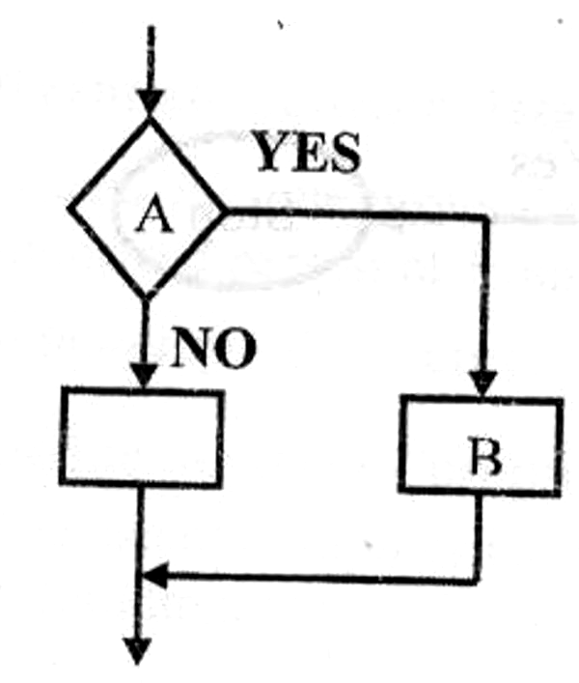

Selection control structure, e.g. If –then –else

b) Name the symbols labeled A and b in the diagram above. (2mks)
A-Decision box
B- Process symbol
19. Define the term ARRAY as used in computer programming. (1mk)
An array is a data structure that stores several data items of the same type.

20. Draw a simple flowchart diagram showing: (2mks)
a) IF….THEN…. selection
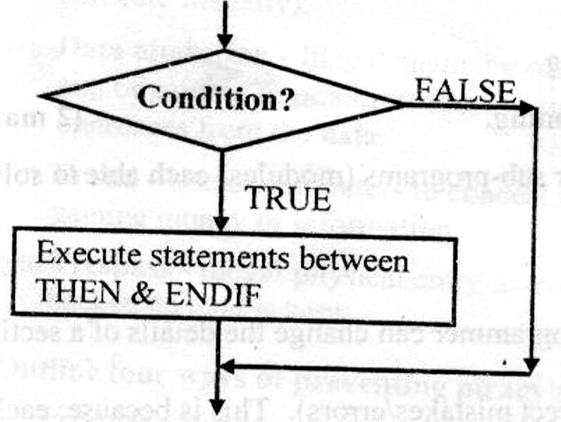

Continuation of program

b) IF...THEN…ELSE selection (2mks)
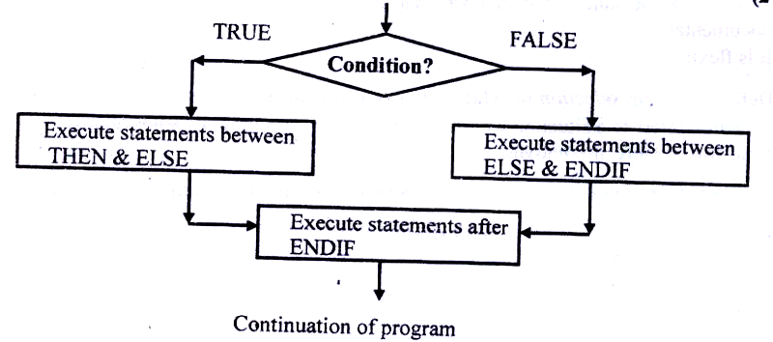

c) REPEAT…UNTIL loop (4mks)

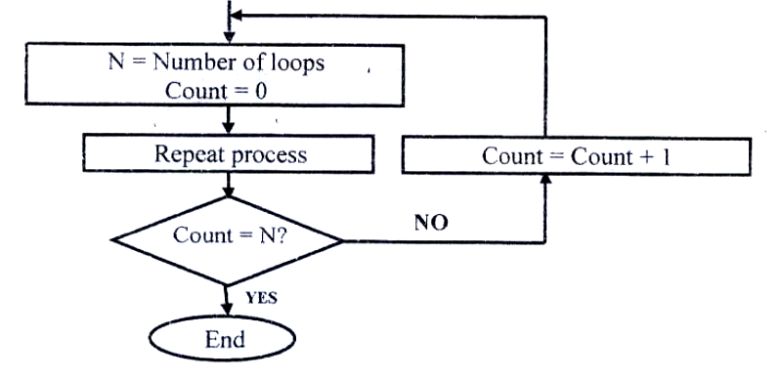

21. a) With aid of a pseudo code and a flowchart, design an algorithm that
would:
- Prompt the user to enter two number X and Y
- Divide X by Y. However, if the value of Y is 0, the program should display an error message “Error: Division by zero”.

START
PRINT (“Enter two numbers, X and Y”) Input X, Y
IF Y=0 THEN
PRINT ‘Error: division by zero’
ELSE
Quotient = X/Y
PRINT X, Y, Quotient
ENDIF
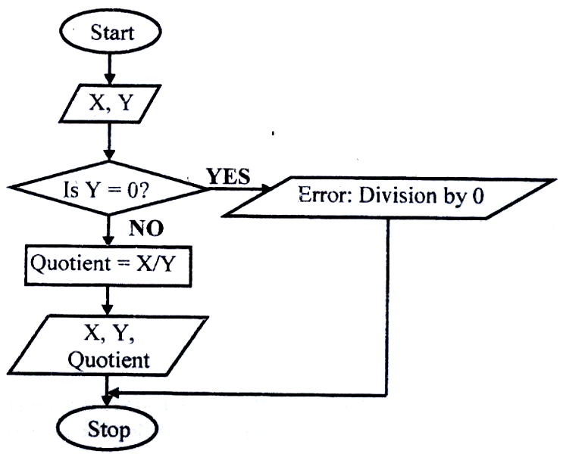
STOP
Flowchart

b) Write down the assignment statement used in the algorithm above. (2mks)
Quotient=x/Y

c) Which program control structure is depicted in the algorithm? (1mk)
If …then...Else

22. Draw a flowchart for a program that is to prompt for N numbers, accumulate the sum and them find the average. The output is the accumulated totals and the average.
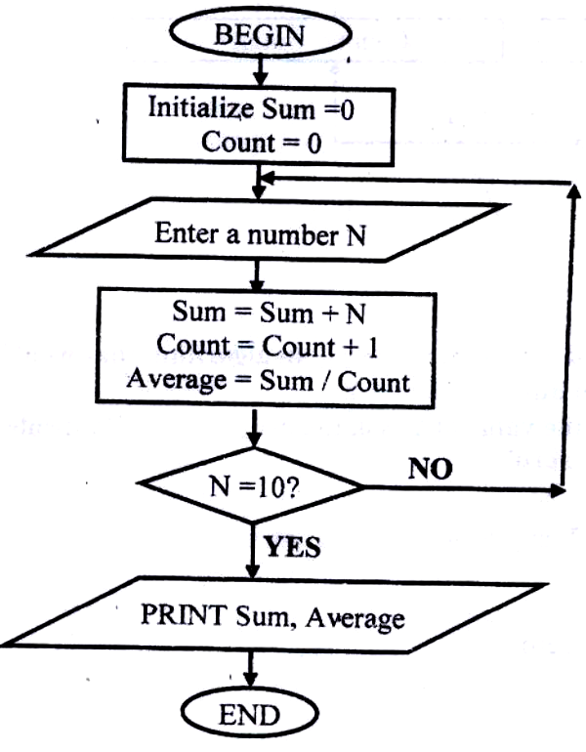

23. Write a pseudo code that reads temperature for each day in a week, in degree Celsius, converts the celcius into Fahrenheit and then calculate the average weekly temperatures. The program should output the calculated average in degrees Fahrenheit.

START
INPUT temperature in ⁰C
SET Initial day to 0
WHILE Initial day <=6 DO
F = 32 + (9c/5)
INPUT temperature in ⁰C
Initial day = Initial day + 1
Cumulative = Cumulative + ⁰F
END WHILE
Average = Cummulative/7
PRINT average
Stop

24. Michael deposits 1,000 in a bank at an interest rat of 10% per year. At the end of each year, the interest earned is added to the amount on deposit and this becomes the new deposit for the next year.
Develop a pseudo code to determine the year in which the amount accumulated first exceeds 2,000. Also for each year, print the year (starting from 1), the deposit, the Interest earned, and the total accumulated at the end of the year.

START
Input initial deposit, Interest rate, and Target deposit
Set Deposit to 1000
Set Year to 0
REAPEAT
Year= Year + 1
Interest = Deposit x 10%
Total = Deposit +Interest
Deposit = total
UNTIL Deposit > 2000
PRINT Deposit, Year
STOP

25. Study the flowchart diagram below and answer the questions that follow:
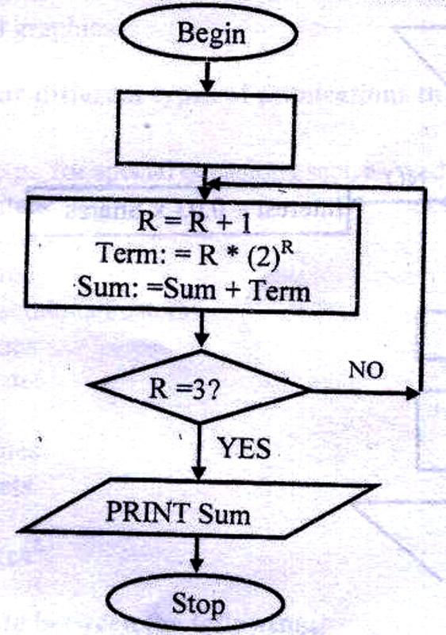

a) What will be the value of the sum when printed? Show how you arrive at your answer. (5mks)

R | Term | Sum
0 | 0x2⁰ | 0 + 0=0
1 | 1x2¹ = 2 | 0+2=2
2 | 2x2² = 8 | 2 +8 =10
3 | 3x2³ = 24 | 10 + 24 = 34

The value of Sum = 34

26. Mwalimu savings society (MSS) Pays 5% interest on shares exceeding 100,000 shillings and 3% on shares that do not meet this target. However, no interest is paid on deposits in the member’s MSS bank account
a) Design a pseudo code for a program that would:

i) Prompt the user for shares and deposit of particular members
ii) Calculate the interest and total savings
iii) Display the interest and total savings on the screen for particular members of the society. (7mks)

START
PRINT “Enter member Name, share and Deposit”
INPUT Name, Shares, Deposit
IF shares > 100,000 THEN
Interest = 0.05 x Shares
ELSE
Interest = 0.03 x Shares
ENDIF
Total savings =Deposit + shares +Interest
PRINT Name, Total savings, Interest
STOP

b) Draw a flowchart for the above pseudo code. (8mks)
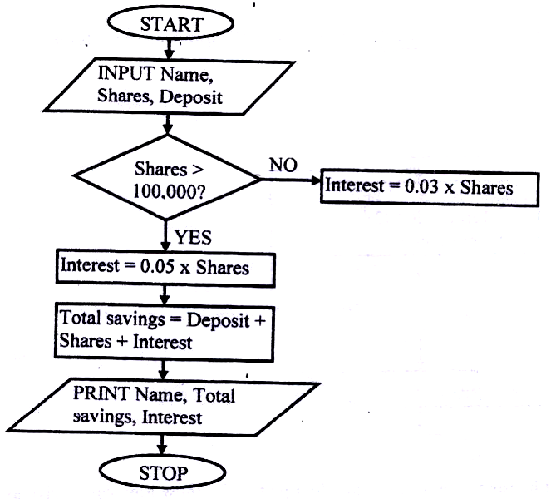

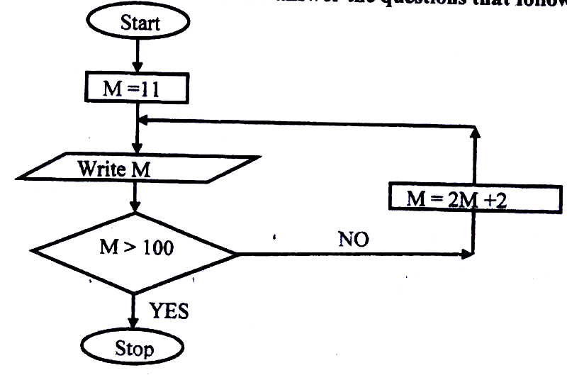
27. a) Study the flowchart below and answer the questions that follow:

a) List all the outputs from the flowchart. (3mks)

24, 50, 102 (any correct 3)

b) What will be the output if the statement in the decision box is changed to?
(3mks)
i) M≤100
Only one value, 11 will be printed √ 1

ii) M < 100
Only one value, 11 will be printed √ 1

iii) M = 100
values starting with 11 to infinity, i.e. , 11, 22, 44,………. √ 1
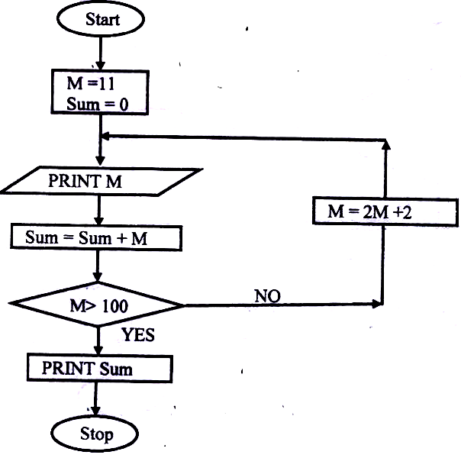
c) Modify the flowchart to print the sum of all the outputs. (9mks)

28. The gross salary of employees of Mutson Chemist is based on the Basic and additional benefits. Employees with more than 10 year’s experience get an additional pay of 10% of their basic salary. Bonuses are given as per employees’ sales of the month as:

>200,000 15%
100,000 – 200,000 10%
Below 100,000 5%
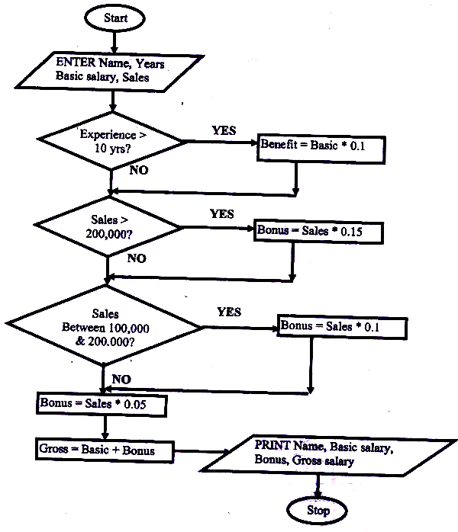
Draw a flowchart for the program that will calculate Gross salary and output each employee’s Basic salary, gross salary and all benefits. (15 mks)

SYSTEMS DEVELOPMENT

1. What do you mean by a system? (2mks)
A system is a set of items, equipments, procedures, programs or techniques & people working jointly with an aim of achieving common goals.

2. Differentiate between soft systems and hard systems. (2mks)
- In Soft systems, goals and objectives are not clearly defined. In hard systems, goals & objectives are clearly defined and the outcomes from the processes of the systems are predictable
- Soft systems are usually the human activity systems; their boundaries keep on changing.
(5mks)
3. Explain five characteristics of a system (5mks)
Holistic thinking: - a system contains a set of interacting elements. However, in
holistic thinking, a system is considered as a whole unit.
Purpose:- a system must be designed to achieve a specific predefined objective.
System boundaries and environment; -the components of each system should
operate within a specific framework, limits or space. The system receives inputs
from & communicates its outputs to the environment.
Subsystems: - A system does not exist alone, but it is made up of different components or other systems that communicate with each other
Inputs and outputs: - a system communicates with its environment by receiving inputs and giving outputs. E.g. a manufacturing firm gets inputs in form of raw materials from the environment and transforms them into finished products which are released into the environment
Process:- a system usually transforms or processes data from one state to another.
System entropy (decay);a system must have controls which help it not to operate beyond its boundaries. The controls enable the system to adapt to changes in the environment in order to give the expected output or to perform to the expected level.

4. a) Define the term information system. (2mks)
An information system is the arrangement of people, data, processes and information that work together to support and improve the day-today operations of a business.
b) Highlight three circumstances that necessitate the development of new information systems. (3mks)
- New opportunities: - a chance to improve the quality of internal processes and
service delivery in the organization may arise
- Invention of new systems which are more successful than the existing ones
- Problems: - the user may encounter some difficulties in the operations of the
existing system
- Directive: - these are requirements imposed by the management, government, or
external influences.
5. State four roles (functions) of an Information system analyst. (4mks)
- Examines the feasibility of potential computer applications.
- Reviews the existing system & makes recommendations on how to improve or implement an alternative system.
- Works hand in hand with programmers to construct a computerized system
- Coordinates the training of new system users and owners.
- He is the overall project manager of the information system being implemented. Some of his duties include: assuring quality, keeping within schedule & budgeting.

6. Define the following terms:
i) System control
A system control is a method by which a system adapts to changes in the environment in order to give the expected output or perform at the expected level.
ii) System boundary
It is the scope/limits within which the system components operate
iii) Online analytical processing
The process whereby a computer-based information system is used to capture operational data, analyze it, and generate reports that can be used to support the decision making process in an organization
7. State one disadvantage of the Traditional approach in system development (1mk)
The structure of the old system is not changed in anyway; hence; hence, the weaknesses of the old system are not corrected and are carried forward to the new system.

8. What is Prototyping as used in system development? (2mks)
It is a Rapid system/program development technique √1 where system developers quickly capture user requirements by designing system interfaces in the presence of the user. √

9. Outline the seven steps followed in structured system development. (3 ½ mks)
-Problem recognition and definition
-Information gathering
-Requirements specification
-System design
-System construction (coding)
-System implementation
-System review and maintenance. (NB: Order must be followed)

10. Define the term Feasibility study as used in system development. (2mks)
This is a special study carried out to establish the costs and benefits of a proposed
new system.
11. You are required to develop a registration system for a particular school. State
two ways in which you would gather the information required for the system development. (2mks)

-Study of available documents
-Observation
-Interviews
-Use of questionnaires
-workshops and seminars
-Use of automated methods
12. Identify two disadvantages of Observation method used in fact-finding. (2mks)
-The person being observed may perform differently or change his/her behaviour
leading to wrong requirements being observed
-The work being observed may not involve the level of difficulty or volume
normally experience during that period of time.
-The need to be on the site where the activities are taking place consumes a lot of time.
-Some activities may take place at odd times causing a scheduling inconvenience for the analyst.
13. a) Name three circumstances in which it is better to use a Questionnaire than an
Interview for gathering information. (3mks)
- If the information to be gathered is located over widely spread geographical area.
- If a large number of people are to be questioned, and the questions to be asked require short answers, or are limited to Yes/No
- Where 100% coverage is not essential
- Where privacy (anonymity) of the respondents is to be maintained.

b) Outline three advantages of questionnaires. (3mks)
- Use of questionnaires gives the respondents privacy; hence, there is likelihood that the information given is sincere and real.
- Questions can be answered quickly since respondents can complete and return the questionnaires at their convenient time.
- It is a cheap method of collecting data from large number of individuals
- Responses can easily be tabulated and analyzed quickly.

14. a) Explain the importance of using automated methods in fact finding. (1mk)
Automated method of data collection can be used in areas which are not easily
accessible.
b) Give one example of automated information gathering technique. (1mk)
-Use of a video camera to capture motion pictures
-Use of Tape recorder.
15. Mention the four factors that may be considered in order to design a good file.(4mks)
  - Output specifications (i.e., output from the system)
  - Input specifications
  - Table/file structure specifications
  - Hardware specifications
  - Software specifications

16. State four factors that may be considered in order to design a good file. (4mks)
- Record key fields
- Data type for each field
- Length of each field
- Backup and recovery strategies.
17. Define the term “attribute” (1mk)
An attribute is a unique characteristic of a record for which a data value can be stored in the system database. E.g., a student record has attributes such as Name, admission number, class, etc.

18. State two methods/tools that a system analyst may use to design a system. (2mks)
- Use of system flowcharts
- Data flow diagrams
- Entity relationship models
- Structured charts

19. Explain three tasks that are carried out during system implementation. (3mks)
- File conversions
- Staff training
- Project management
- Changeover strategies.

20. Your school has decided to replace its library control system. The current system was implemented ten years ago but has restricted reporting facilities and has a text-based interface. The school intents to replace the old system with a new computerized system, and is now considering both ‘Parallel running” and “direct changeover”.
a). (i) Briefly explain the terms parallel running and direct changeover as used in system implementation. (2mks)
- Parallel running is where both the old and the new systems are run in parallel to each other (a the same time) for sometime until users have gained confidence in the new system. Data is processed on both systems in order to compare their performance, and also cross-check the results.
- Direct changeover is a complete replacement of the old system with the new system in one bold move. The old system is stopped & abandoned and the new system starts operating immediately.

(ii) Give two disadvantages of direct changeover over parallel running. (1mk)
  - It may be very inconveniencing (or, the organization will incur huge losses) in case the new system fails or faces problems.
  - The users may not have gained enough confidence to run the new system.
  - The weaknesses of the old system may not be corrected & may still be transferred to the new system.
  - Loss of jobs for the workers whose departments are affected.
  - If the new system fails, data recovery may be impossible.

(iii) Mention any two advantages of running both the manual system ad the computerized system simultaneously. (2mks)
  - If the outputs from the two systems are similar, confidence in the ICT systems.
  - Users have time to familiarize themselves with the ICT systems.
  - It is reliable because it enables thorough testing.
  - Weaknesses in either of the systems are corrected.

NETWORKING & DATA COMMUNICATION

1. Define the following terms: (2mks)
(i) Computer network (2mks)
- A collection 2 or more computers connected together using transmission media (e.g., telephone cables, or Satellites) for the purpose of communication and sharing of resources.
(ii) Data transmission (2mks)
- Passing information from one terminal to another in a computer network through telecommunication channels
(b) Differentiate between a modern and a multiplexer. (2mks)
- A Multiplexer enables sending of multiple data signals over the same medium, either simultaneously or at different times.
- A Modern converts a digital signal to analogue form, so that it can be transmitted over analogue telephone lines.
3. State three advantages and three disadvantages of computer networking. (6mks)
Advantages
- Sharing of resources between the computers
- Sharing of risks.
- Provides cheaper and efficient communication.
- Running cost is low because of the minimal hardware required.
- Reliable and error-free.
- Enhances faster communication
- It is not time-consuming.

Disadvantages of networking
- High initial installation cost (i.e., expensive to install).
- Security threats e.g., hacking, which posses a great danger to loss of information
- Moral and cultural effects.
- Spread of terrorism, drug-trafficking and viruses.
- Over reliance on networks.

4. (a) What is a distributed system? (2mks)
- This is a system in which data is manipulated in different processors/computers, which are on the same network but placed in separate locations.

(b) State any two advantages of distributed systems. (2mks)
- There is sharing of data & other resources.
- Relieves the central computer of the burden of processing data
- Failure of the central computer does not affect the operations of the other terminals
- Processing load is shared equally; hence no time wastage
- There is faster processing of data since each machine can process & store its data
- It doesn’t need powerful & expensive servers for data storage
- It can accommodate users with variety of needs
- Creation of employment at the remote centers.

5. Distinguish between bounded and unbounded transmission media, giving two
examples in each.
- In bounded media, data signals are transmitted from the source to the destination through a restricted pathway, e.g., two open wire cables, twisted pair cables, Coaxial cables, fiber optic cables.
- Unbounded media transmits data without physical connections, e.g. microwave, satellite, radio, infrared communication.
6. State what is meant by each of the following data transmission media, and give two advantages and three disadvantages for each.
i) Twisted pair cables. (3mks)
A twisted pair cable is made up of 2 insulated copper wires twisted around each other in a spiral pattern. This prevents electromagnetic fields from developing around the two wires as they transmit data.
Advantages
-Has high data transfer rates of up to 100 Mbps
-It is cheap because; of mass production for telephone use.

Disadvantage
  - They suffer from high attenuation
  - affected by electromagnetic fields
  - It has low data transmission rates as compared to other cables

ii) Coaxial cables
Coaxial cables consist of two conductors which are insulated and shielded to provide high noise immunity & also more resistant to electromagnetic interference.

Advantages
  - They have a large bandwidth (up to 1 Gbps) compared to twisted pair cables
  - They can carry voice, data and video signals simultaneously
  - They are more resistant to radio and electromagnetic interference than twisted pair cables
Disadvantages
  - They are hard to work with
  - They are expensive to buy & install

iii) Fibre optic cables is made of transparent glass and uses light to transmit data signals from one point to another on the network.
Advantages
  - It is immune to electromagnetic interference, and eavesdropping.
  - It is fast and supports high bandwidth
  - It has low attenuation; hence, a long distance can be covered
  - It is small & light.
Disadvantages
  - Difficult & expensive to install
  - Once broken, it is difficult & expensive to repair.
iv) Wireless/microwave/radio transmission. (3mks)
- In wireless transmission, no physical connections are used to transmit data from one point to another. Instead a transmitting antenna & a receiver aerial are used to facilitate the communication
Advantages
  - wireless networks can span large geographical areas easily
  - Can be used in very remote areas that do not have high cost physical infrastructure like telephone lines
  - Flexible.
Disadvantages
  - The initial cost is very high
  - It is relatively difficult to establish or configure.
7. Explain the function of the following network devices:
i) Network interface card (NIC)
NIC creates a physical link between the computer and the transmission media.
ii) Gateway
Gateways provide access to the Wide area networks & the Internet.
iii) Bridge
This is a network device that selectively determines the appropriate network
segment for which a message is meant to be delivered.

iv) Repeater
A repeater receives a weak signal on the network, cleans and amplifies it for transmission over the next portion of the network. Signals become weak due to attenuation
8. List two advantages of cell phones over fixed lines. (2mks)
- Are cheaper than fixed lines
- Less prone to transmission errors
- Can be used even where there are no telephone lines
- Portable, i.e. can be carried around

9. a) Study the diagram below and answer the questions that follow:

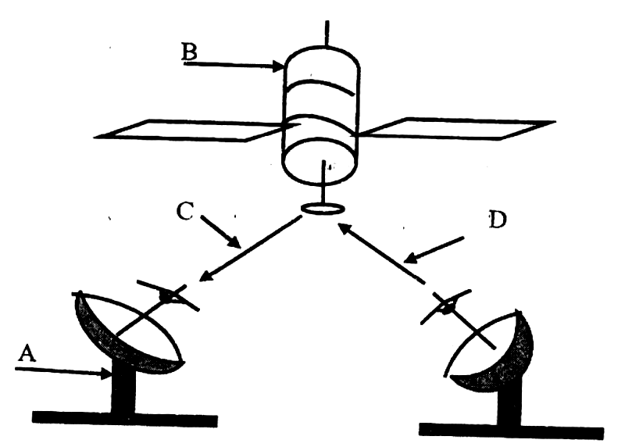

i) Name the communication media depicted in the above diagram. (1mk)
Satellite communication

ii) Name the parts labelled A, B, C, and D. (4 mks)
A -Receiving earth station
B -Satellite in space
C -Down link
D -Up link
iii) List three advantages of the above communication media. (3mks)
- It is fast
- It is convenient because; it provides a large constant line of sight to each station Hence, there is no need to keep on moving the parabolic dish so as to track the line of sight
- Can be in very remote areas that do not have high cost physical infrastructure like telephone lines. (2mks)
10. a) Define the term network topology. (2mks)
Network topology refers to the arrangement of the computers, printers and other
equipment connected on the network.
b) Distinguish between logical and physical network topology. (2mks)
- Logical (signal) topology deals with the way data passes from one device to the next on the network
- Physical topology refers to the physical arrangement (layer out) of devices on the network.
APPLICATION AREAS OF ICT
1. Write in full hence, explain the term ICT. (2mks)
- ICT- Information and Communication Technology
- ICT- refers to the integration of computers and telecommunication facilities for the
purpose of communication.
2. State four areas where computers are used today. (4mks)
i) Financial systems, e.g. accounting, stock exchange, payroll, banking, etc,
ii) Transport systems, e.g. air traffic control, shipping control, automobile traffic
control
iii) Entertainment systems, e.g. used in showing movies, playing music, &
computer games.
iv) Scientific research, i.e. weather forecasting, medical research, military & space
exploration.
3. State two ways in which a computer may be used in efficient running of a hospital.
- Keeping records of incoming and outgoing patients
- In electro-cardiogram screening and monitoring, analyzing the sickness & checking
for damages, e.g. X-ray
- A computer controls life supporting machines
- For inventory control
- To access foreign expertise or labour, i.e. to get in touch with consultants or surgeons in another country, thereby reducing traveling of patients & professionals.
4. a) Name the type of processing that would be required by a payroll system. (1mk)
Batch processing

b) Identify two benefits of using computers in accounting systems. (2mks)
- They make the processing of financial records easier
- Error checking procedures can e established to ensure accuracy & security of data
- Used to store volumes of financial records
- Ensure fast & easy production of financial reports
- They are cheaper than manual systems

5. a) Write down all the input and output devices of an ATM machine of Pesa-point in
Kenya.
- Keyboard
- The ATM card
- Screen (Visual display)
- Printer

b) List down three advantages of ATM cards. (3mks)
- Offer 24 hour service to customers
- Ensure more flexibility in cash deposits and withdrawals
- It is secure because; it requires a personal identification number (Pin), which is only
known by the card holder
- There is no need for human bank clerks.

6. a) State four components of an electronic Point-of-sale terminal. (4mks)
- Terminal, e.g. Console, which is connected to the main computer
- Monitor
- Printer

b) Give two advantages of using electronic point-of sale terminals as opposed
to manual entry at a supermarket checkout counter. (2mks)
- Fewer errors made by employees, i.e. correct prices are used at the point of entry
- It ensures faster entry of data, since the attendant does not have to enter details manually.
- Ensures good stock management procedure.
7. Define the following terms:
a) Biometric analysis
This is the study, measurement & analysis of human biological characteristics. It uses a
computer and a biometric device to recognize & analyze features of human body parts such as fingerprints, lips, voice iris colour, etc

b) Telecommuting
A situation where an employee works in a location that is remote from the
normal place of work either on full-time or part-time basis.

8. Outline four devices required in order to conduct a video conference. (4mks)
- A computer
- A digital video camera (camcorder) attached to a computer
- Network software for video conferencing
- A microphone
- Speakers
9. a) Define the term E-commerce (2mks)
E-commerce is a way of doing business where the transactions are carried out electronically without the seller and buyer interacting physically.
b) List down two advantages of e- commerce as used in modern business
environment (2mks)
- Reduces traveling, hence saves money and time
- A company can access customers all over the world, and is not limited by space & wagons
- Reduces operating costs of small business as they can establish websites where they can auction their good & services. This also increases their sales.

10. Describe how computing has been applied to each of the following areas:
i) Transportation systems. (2mks)
- Used by railway corporations to coordinate the movement of their goods & wagons
- Used in airline industry for air traffic control, surveillance of airspace using radar
equipment
- Used in shipping control
- Used in automobile traffic control in busy towns, i.e. to simulate the timing of traffic lights.

vi) Reservation systems. (2mks)
- To keep record of reservation
- For online reservation (i.e. provide online remote services)
- Paperless transaction (Paying via credit cards)
- Easy to check for vacant positions
vii) Law enforcement (2mks)
- For keeping record on fingerprints
- Biometric analysis in crime detection so as to provide immediate & accurate information
- Scene monitoring & analysis to help the police in arresting traffic offenders and criminals.

viii) Library management systems (2mks)
- Keeping book records and stock management
- Tracking overdue books

11. Suggest how computers may in future be made more user-friendly for persons
that are:
a) Blind (1mk)
- Development of Braille keyboards, or engraved keyboards
- Computers can be installed with talking software, i.e., can store voice patterns
of the user

b) Without hands
- Use of voice-activated commands.
- Computers can be installed with powerful multimedia system & speech
recognition devices.
12. Give at least four reasons why a firm may decide to computerize its operations
- Handling of errors easily
- Easy storage and retrieval of information
- Increased efficiency
- Higher quality work
- Reduced cost.

IMPACT OF ICT ON SOCIETY
1. Identify four problems associated with the introduction of computers in a society.
(4mks)
  - Job displacement and replacement
  - Computer crimes, e.g. piracy, fraud, hacking
  - Health effects, e.g. repetitive strain injury, eye problems
  - Cultural effects and immorality (DVD’s, pornographic literature on the Internet
2. Distinguish between “job replacement” and “job displacement” in reference to
Computerization (2mks)
- In job replacement, the unskilled workers may be replaced with the skilled ones. In job displacement, some employees may be displaced/ moved to new working areas as the computer may serve to perform tasks that may be performed by several people.

3. A recent breakthrough in the manufacturing industry is the development of a full
manufacturing plant, that can produce vehicles using robots only.
a) Give three advantages of fully automated manufacturing. (3mks)
- Increases efficiency due to the balancing of workload and production
capacity.
- Production increases in the workplace
- Improves customer service
- Enables production of adequate & high quality goods in time
- Enables efficient utilization of resources, e.g. raw materials, personnel and equipment; hence reducing operating expenses.
b) State three other areas where automation is applicable. (3mks)
- Intelligent control of traffic lights
- The autopilot in aircrafts
- Use of robots in industries
- Manufacturing industries such as vehicle assembly plants, oil refineries, and
food processing companies.
4. Discuss the applications of Artificial Intelligence in each of the following fields:
i) Expert systems
- In medical institutions for diagnosis of diseases
- In mining companies for prospecting of minerals.
- Financial forecasting, e.g. formulation of taxation & marketing policies, and making of investment decisions.
- Financial forecasting, e.g. formulation of taxation & marketing policies, and making of investment decisions.

ii) Natural language processing (2mks)
- It involves development of programming languages, whether spoken or written
- This will make the task of data processing even faster
iii) Artificial neural networks. (2mks)
- This is the use of electronic devices & software to emulate the learning process of the human brain and how it recognizes patterns.
5. Explain the impact of information technology on organization in each of the following areas
(i) Competition (2 mks)
- Ability to advertise in the internet
- Improved quality goods & services
- Reduced operational costs

(ii) Pace of growth (2 mks)
- Reduced costs
- Reduced need for manpower
- Reduced space requirement
- Greater output

6. State three reasons why users may resist the introduction of information and communication Technology (ICT) to their place of work
(i) Fear of change- people are creatures of habit, hence are afraid of change
(ii) Fear of losing their jobs: By installing the computer into an organization, employees fear that they might end up losing their jobs
(iii) Fear of failure – Since the computer is very new in a given working environment, the people will be afraid that they might never get used to it.
(iv) Loss of control: The management fear that once a computer system is implemented, they might lose control of the organization.

CAREER OPPORTUNITIES IN ICT
1. Give a brief description of the following careers available in the computing field.
(i) A Software engineers is one who is skilled in software development and technical operations of computer hardware
He develops and updates both system and application software together with the associated documentations.

(ii) Data processing managers (DPM) ( 2 mks)
A data processing manager is the person who usually is in charge of the overall running of the data processing department in an organization
He plans, monitors and controls the personnel, ensures that resources and labour are available as required and interfaces to users

2. Differentiate between software engineer and a computer engineer ( 2 mks)
Software engineer develops software/ programs as per requirements; computer engineer designs computer hardware and improves on existing ones.
3. (a) Sate three public universities where one can further her computer studies ( 3 mks)
- Nairobi university
- Moi University
- Kenyatta University
- Jomo Kenyatta University of agriculture and Technology (JKUAT)
- Egerton University
- Maseno university
(b) Identify at least three related courses offered at
(i) College level
- Certificate in information technology
- Diploma in information technology
- Diploma in Education (computer science)

(ii) University level
- Bsc. Computer science
- Bsc. Information technology
- Msc. Information systems

4. (a) Name three responsibilities that are carried out by a:
(i) Web administrator
- Develop & test websites
- Maintains, updates & modifies information on the websites to meet new demands by the users.
- Monitors the access & use of internet connection by enforcing security measures
- Downwards information needed by an organization or institution from internet websites

(ii) Computer trainer
- Training people on how to use a computer & the various application programs
- Development training reference materials
- Guiding learners on how to acquire knowledge through carrying out research
- Advising the learners on the best career opportunities in the broad field of ICT
- Preparing learners for ICT examinations

5. Explain two factors one would consider before enrolling for an ICT course in a college
- The cost of the course
- Marketability of the course, i.e. whether it offers courses recognized both locally and internationally.
- Basic course requirement, e.g. qualifications
- Job opportunities

K.C.S.E PREDICTION PAPER
Kenya Certificate of Secondary Education
451/1 computer studies
Paper 1 (theory)
2 ½ hours

INSTRUCTIONS TO CANDIDATES
This paper consists of TWO sections A and B
Answer ALL the questions in section A.
Answer questions 16 and any other THREE questions from section B

FOR OFFICIAL USE ONLY
SECTION | QUESTION | SCORE
A | 1- 15
 | 16
 | 17
 | 18
 | 19
 | 20
 | TOTAL SCORE

SECTION A (40 marks)
Answer all the questions in this section
- Computer systems are built from three types of physical components: processors, memories and I/O devices
(a) State two tasks of a processor
- To fetch data & information from memory
- Decodes instructions
- Execute/ runs programs
- Controls hardware operations through sending of control signals

(b) State the functions of I/O devices
- Transfer information into & out of the computer
- Serves as the interface between the user & the computer
- Enables the user to communicate with the computer

- Threats to the safety of computer system take many forms such as: white- collar crime, natural disasters, vandalism and carelessness.
Give one way as to how each of these forms of threat can be controlled ( 2 mks)
(i) White- collar crime
- Use of policies
- System auditing and use of log files
- Use of passwords
- putting in place punitive measures
- Data encryption
- Use of firewalls

(ii) Natural disasters
- Use of UPS
- Use of backups
- Installation of lightening arrestors
- Having standby fire fighting equipment
- Use of fire- proof data saves
- Contingency plans

(iii) Vandalism
- Tighten security measures, e.g. use of alarm systems, fitting, burglar- proof doors
- Punitive measures.

(iv) Carelessness
- Better selection of personnel
- Improve employee training and Education Plus Agencies
- Limit access to data and computers
- Regular backups
- Use of UNDELETE and UNFORMAT utilities

- (a) Explain the term nibbles as used in data representation in computers ( 1 mk)
A nibble is a group of 4 binary usually representing a numeric number.

(b) Perform the following binary arithmetic, giving the answers in decimal notation
(3 mks)
(i) 1110.0111 + 1101001.11

1110.0111
1101001.011 +
1110111.1101

(ii). 1001011.011 – 111.111
1001011.011
111.111 –
1000011.100

- (a) Distinguish between machine and assembly language ( 2 mks)
Machine language uses machine codes (binary digits) that consist of 0’s & 1’s, whereas assembly language makes uses mnemonic codes (symbolic representations of the machine code.
(b) State the type of translator necessary for a program written in: ( 2 mks)

  - High level language
Interpreter or compiler
  - Assembly language
Assembler
- Briefly explain the purpose of the following types of program documentation: ( 3 mks)
(a) User manual
This is a manual provided for an end user to enable him/ her use the program. It is applicable in user- oriented documentation.

(b) Reference guide
I is used by someone who already knows how to use the program but needs to be reminded about a particular point or obtain detailed information about a particular feature.

(c) Quick reference guide
This is a single sheet or card small enough to fit into a pocket, which the user may keep handy for help with common tasks carried out with as program.

- State any two features of a user- friendly program ( 2 mks)
- Error reporting and recovery
- Good screen display
- Validation of input
- Comment statements
- Indentations
- Self- descriptive variables
- Menu driven
- Online help

- (a) Distinguish between labels and formulae with respect to spreadsheets ( 2 mks)
Labels are text consisting of alphanumeric characters, while a formula is a sequence of values, cell references, functions and arithmetic operators whose calculations results to a numeric value.

(b) Consider the entries made in the cells below
Cell | B2 | B3 | C10 | C11 | C13
Entry | 200 | 100 | B2 | B3 | =C10 + C11

State the value displayed in cell C13 (2 mks)
It returns an error message: # VALUE!

- List three differences between Wide Area Networks (WAN) and local Area Networks (LAN) ( 3 mks)
- LAN is limited to a small geographical distance
- Data transmission speed in LANS is higher
- Cost of data transmission in LANs is small
- There are less transmission errors in LANs

- Study the flowchart segment below and state the last value printed from the flowchart
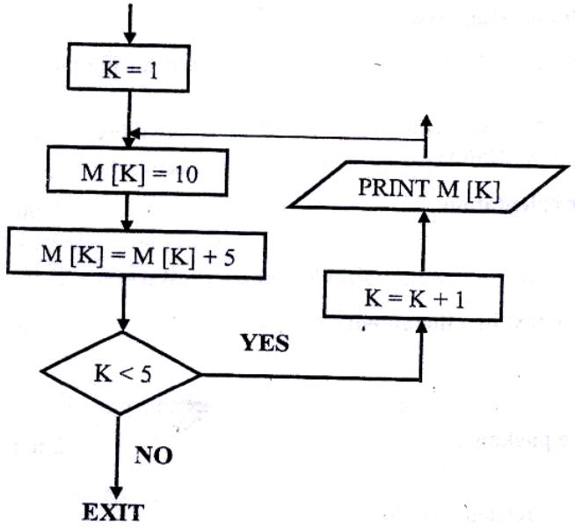

- (a) What is an expert system? ( 1 mk)
An expert system is computer software that mimics human expertise in a particular area of specialization

(b) State any two components of an expert system (2 mks)
- Inference mechanism (for making decisions)
- Knowledge base
- Explanation facility
- User interface

- Give reasons why optical disks are better storage media compared to floppy diskettes
- Have a high storage capacity
- More secure against alteration, i.e. they require writers to alter their contents
- More robust, i.e. can resist temperature, electromagnetic fields and not affected by water and dust.
- Have a relatively high access speed
- Cheaper per unit of storage. Optical disks can be used for storage of large volumes of data, hence making them economical.
- Have high data transfer rates

- What are DOS commands used for the following?
(a) Changing directories - CD/CHDIR
(b) Viewing directories - DIR/TREE
(c) Renaming directories of files - REN/RENAME
(d) Deleting a directory - RD/DELTREE
- Distinguish between copying and moving text ( 2 mks)
- Copying is making a duplicating copy of text, moving is relocating/ transferring text from one place in a document to another
- In copying the original text is left intact, while in moving all the selected text is transferred from its original location to a new location.

- (a) Name two methods of paper orientation
- Portrait
- Landscape

(b) Name two keys used to delete text in a document ( 1 mk)
- Delete
- Backspace
- Name two features of a database package ( 2 mks)
- Database creating facility
- Table/ filers structures for holding related records
- Records/ database updating facility
- Search facility that enables the user to scan through the records in the database so as to find information needed
- Forms (input screens) for viewing and entering data into a table
- Sorting facility, which enables the user to organize & arrange the records within the database.
- Report generating facility
- Query facility
- Data validating facility, which ensures that, the correct data is entered into the database
- Macros which are used to automate frequently performed procedures or tasks

SECTION B (60 MARKS)
Answer question 16 and any other three questions from this section

- Study the flowchart below and answer the questions that follow:
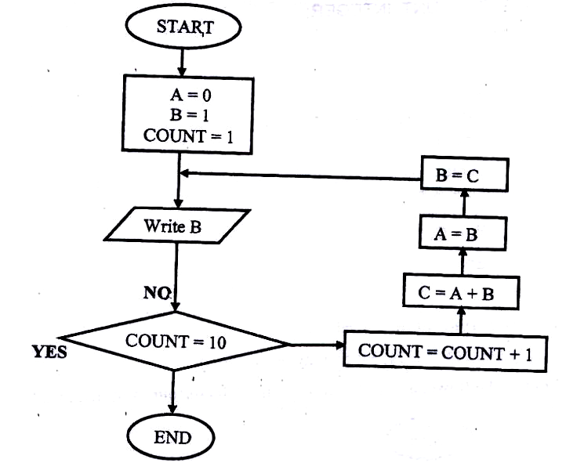

(a) Write a high level language program for the above flowchart ( 7 mks)
Program ABC;
Uses WinCRT;
VAR
A, B C COUNT: INTEGER;
BEGIN
A: 0
B=1
REPEAT
Writeln (B)
COUNT: = COUNT + 1;
C: = A+B;
A: = B
B: = C;

UNTIL COUNT = 10

END

OR
Program ABC (input, output);
USES Win CRT;

VAR
A, B, C, COUNT: INTEGER;
BEGIN
A: =0;
B: = 1
FOR COUNT: 0 TO 10 DO
Begin
Writeln (B);
C: A + B
A: = B;
B: = C’
End;

END

(b) List the outputs of the flowchart above (5 mks)

1,1,2,3,5,8,13,21,34,55 (any ten integers)

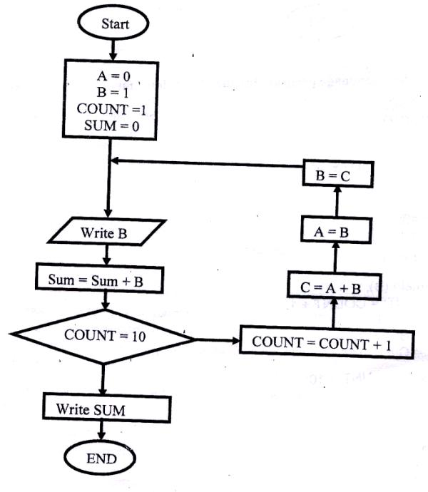
(c) Modify the flowcharts so that it adds up all its outputs and displays the sum obtained (3 mks)

- A computer specification has the following details:
Pentium II
1.44 MB floppy disk drive
20 GB hard disk
Full multimedia
17” SVGA monitor
Pre installed operating system
Pre- installed office suite

(a) What is meant by?
(i) 1.44 MB floppy disk drive?
It has a floppy disk for diskettes of capacity 1.44 megabytes

(ii) 20 GB hard disk?
Refers to the storage capacity of the hard disk in Gigabytes

(iii) 17” SVGA monitors
Refers to the type (colour) and size (17 – inch) of the screen

(b) Which operating system might be pre- installed in this computer and why? (2 mks)
Any version of windows, Linux, Macintosh, OS/2, UNIX, Solaris, Scounix
Reason- the office suite can only work under windows environment (3 mks)

(c) List three Multimedia components
- Optical drive (CD- ROM or DVD – ROM drive)
- Speakers (headphones)
- Media Player software
- Microphone
- Sound card/ adapter
- TV Tuner card
- Editing card
- Digital camera
- VGA or SVGA graphics card and monitor
- A RAM of 32 MB or higher
(d) (i) What is meant by computer aided manufacture?
CAM is the use of computers in the manufacture of industrial products (2 mks)

(ii) Give two examples of computer aided design software ( 2 mks)
- AutoCAD
- ArchCAD
- Draffics
- 3 Dmacs

- (a) Give three examples of network software ( 3 mks)
- UNIX
- Linux
- Novell NetWare
- Microsoft Windows NT
- Microsoft Windows 2000
- Microsoft Windows 2003

(b) List any three items that may be referred to as data terminal equipment in a network
( 3 mks)
- Servers
- Dummy terminals
- File servers
- Printers
- Modems
- Terminators

(c) Briefly explain the following terms as used in networking ( 4 mks)
(i) Remote communication
- This is the transfer of data between computers in different locations
- It is a long- distance data transfer without the use of cables

(ii) Distributed processing
Distributed processing is the sharing of computer processing power

- State three advantages and two disadvantages of mesh network topology ( 5 mks)

Advantages of mesh topology
- It is fast
- Failure on one mode will not cause communication breakdown
- Easy to troubleshoot cable problems. If two machines are not communicating, the administrator will only check the cable between them.
- Enhances flexibility in communication
- Enhances fault tolerance provided by redundant/excessive links

Disadvantages
- Difficult and expensive to install and maintain
- Very costly as it requires large amounts of cables ( or redundant links)
- Difficult to add more nodes when the network is large
- Difficult to isolate faults due to lack of a central control point

- (a) A company has decided to computerize their operations. They have decided to purchase packages instead of developing their own programs. Give three advantages and two disadvantages of their approach. ( 5 mks)

Advantages of packages
- They are cheaper to purchase as the cost of developing them is effectively shared between the purchases
- There is saving of the programming effort because; the company buys the software when ready- made
- Packages are thoroughly tested
- Relatively quick results are obtained

Disadvantages of packages
- The purchaser is not in direct control of the software because he/ she is not involved in developing it.
- Packages are produced to meet general needs, hence may not deal with the specific user or company needs.
- Packages cannot be modified (customized) Due to the application of the developer’s copyright acts.
- Packages include extra facilities which may not be required by an individual user or company
- Packages may allow only a clumsy solution to the task at hand
- Some packages have capabilities which will require the user to develop them further.
- It is easy to forget the commands to use the package, especially if it is not used frequently.
(b) (i) Explain why a value such as 6112334445555 may be displayed as ####### when typed in a cell on a spreadsheet ( 2 mks)

(ii) How can the problem in (b) (i) above be corrected?
By increasing the column width

(c) With reasons, briefly describe the most appropriate type of printer or output device for the output of: (6 mks)
(i) Customer invoices on multi- part stationery
- Dot- matrix printer ( or any impact printer)
It produces sharp impact on both original land and the copies

(ii) Letters to customers
- LaserJet Printer (or any impact printer) it is fast & produces quality printouts
OR
- Dot- matrix printer – It is cheaper for bulky printing
(iii) Detailed engineering designs
- Plotters
Have appropriate facilities for drawing & graphical output
- (a) Distinguish between the following pairs of terms
(i) Data verification and data validation
Verification is checking data manually to ensure/ ascertain that it has been transcribed (written out) correctly.
Validation involves subjecting data to checks built in a program to check for its appropriateness or integrity before it is processed.

(ii) Data encryption and passwords
Encryption- mixing up, distorting or changing of data being transmitted over a network to prevent unauthorized disclosure.
A password – a secret code used to prevent unauthorized access of data in a computer

(iii) Dry run and walkthrough
Dry run is where the program is tested on paper before it is keyed in
Walkthrough is a style of evaluating a program by a team of professionals which in turn reports to the programming team.

(b) Draw a labeled diagram to illustrate the internal structure of a diskette. (4 mks)

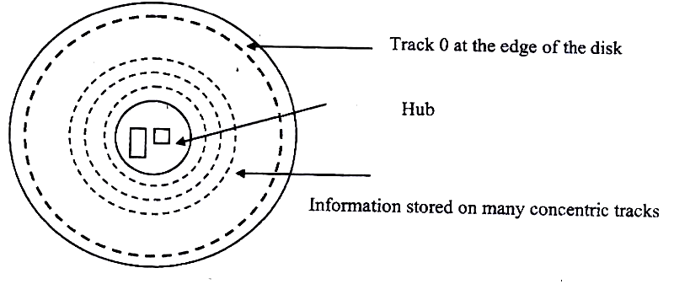

(c) Give two differences between post Office Mail electronic mail ( E- mail) ( 2 mks)
- Post office mail is operated manually; Email is computerized
- Post office mail is slow; email is fast
- Email has a wide area of coverage
- Email is more secure

(d) Speed and accuracy are some of the advantages of using computers in banking. State three other advantages of using computers in banking (3 mks)
- Makes it easy to access information
- It is easy to update records
- requires less space for storage of documents
- Improved data security & privacy

K.C.S.E PREDICTION PAPER
Kenya Certificate of Secondary Education
451/1 computer studies
Paper 1 (theory)
2 ½ hours

INSTRUCTIONS TO CANDIDATES
This paper consists of TWO sections A and B
Answer ALL the questions in section A.
Answer questions 16 and any other THREE questions from section B

FOR OFFICIAL USE ONLY
SECTION | QUESTION | SCORE
A | 1- 15
 | 16
 | 17
 | 18
 | 19
 | 20
 | TOTAL SCORE

SECTION A ( 40 marks)
Answer all the questions in this section

1. How is a point of sale terminal used in a business organization? ( 2 mks)
- It can be used for pricing the different types of commodities
- It can be used as a bar code reader
- Fore checking stock levels (stock control)
- For adding totals of purchase & calculating customers change
- For receipt production

2. Distinguish between compiler and interpreter (2 mks)
- A compiler translates the entire program at once as a unit before execution can begin. An Interpreter translates one instruction of the source program at a time. The translated instruction is immediately obeyed before the next instruction can be translated.
- An interpreter translates the program each time it is needed for execution; compiled programs can be saved on a storage media and run when required.
- For an Interpreter, syntax errors are reported & corrected before the execution can continue.
For a compiler, syntax errors are reported & corrected after the source code has been translated to its object code equivalent.

3. Explain why computers use binary numbers in data representation (2 mks)
Data is stored in computers in binary form. The computer’s CPU carries arithmetic & logical operations by binary numbers.
This is because; binary numbers has only two digits, 0 & 1, which make it suitable for representing two states of data such as OFF & ON.

4. What is meant by the term dry running as used in program development? (2 mks)
A method of checking a program for logical errors by making the corrections on a paper or from the printouts

5. A computer teacher has put a rule that diskettes should not be used in the computer laboratory

(a) Give a reason for the rule
- To prevent the spread of viruses between the computers
- To prevent unauthorized copying of programs from or to the computers
- Students may carry immoral files using the diskettes

(b) State two alternatives that can be used to achieve the same objective (2 mks)
- Using diskless computers
- Use of antivirus software to detect/ clean viruses before use

6. List three differences between a laser printer and a dot matrix printer (3 mks)
- Laser printers are faster than dot matrix printers
- Laser printers are quiet while dot matrices are noisy
- Laser printers use thermal technology while dot matrix is an impact printer
- Laser jets use Toner cartridges while dot matrix use ribbons
- A laser printer is expensive than a dot matrix
- The print quality of a laser printer is better

7. List four stages involved in the data processing cycle ( 2 mks)
- Data collection/ preparation
- Data input
- Processing
- Output of information

8. (a) What is a utility software?
This is a program used frequently by the computer to carry out routine jobs
Utility software is used to manage computer files, diagnose and repair computer problems and assist in helping the computer to run more efficiently.

(b) Give four examples of utility software
- Text editors
- Sort utility
- Language translators
- Merge utility
- Loader
- Copy utility
- Linker
- Dump utility
- Diagnostic tools
- Database management system

9. Distinguish between an intelligent terminal and dump terminal
- An intelligent terminal is one which is capable of performing some limited amount of processing on data before transmitting what is beyond their processing abilities to the central computer.
- A dump terminal is one which does not have any of its own processing capabilities/ power. It relies on the processing capabilities of the central computer that serves it.

10. List two duties of the following personnel
(a) Database administrator
- Designs & develops database applications for the organization
- Installs & co- ordinates database systems
- Updates the database by adding new record, modifying the existing records & deleting the unnecessary records.
- Responsibilities for the security of data in the database (i.e. designs & sets up security measures needed to control access to the organization’s data.
- Ensures the database meets the information needs of the organization
- Ensures facilities for retrieving data and structuring reports are appropriate to the needs of the organization
- Responsible for documenting the manuals for users

(b) Data processing manager
- Ensures that the organizational information needs are met
- In charge of the overall running of the data processing departments, e.g. he is in charge of purchasing the required equipment

11. Differentiate between source program and object program
- Source program is the program as written by the programmer using an editor program either in high level or assembly language.
- Object program is the program in machine code (or binary form) produced by a compiler or assembler after translating the source program, and can be readily and can be readily loaded into the computer.

12. (a) In DOS, what are the following commands used for?
(i) RD - Remove directory- means deleting a directory from the tree
(ii) DEL - deletes all files in a particular directory

(b) What happens when the following commands are typed in the DOS environment?
(i) CD Changes the directory one level up the directory tree
(ii) Dir It lists all the contents of the current directory

13. A student presented a budget in the form of a worksheet as follows
 | A | B | C
1 | Item | Amount
2 | Fare | 200
3 | Stationery | 50
4 | Bread | 300
5 | Miscellaneous | 150
6 | Total
The student intends to have spent half the amount by mid- term
(a) Given that the value 0.5 is typed in cell B9, write the shortest formula that would be typed in cell C2 and then copied down the column to obtain half the values in column B.(1 mks)

= B2*$B9

(b) Write two different formulae that can be typed to obtain the total in cell B6 and then copied to cell C6.
= SUM (B2: B5) (2 mks)
OR
= B2 + B3 + B4 + B5

14. State three operations that can be performed on a relational database files (3 mks)
- Indexing
- Sorting
- Filtering
- Querying
- Updating of records
- Report generation

15. List three parts that constitute an array definition statement ( 3 mks)
- Array name
- Range, which contains the initial value & the final value
- Data type
E.g. Score: Array [1….50] of integer

SECTION B (60 marks)
Answer question 16 and any other three questions from this section

16. Bidii wholesalers has two categories of customers for order processing, category ‘A’ obtains 10% discount on all orders up to Kshs 10,000 otherwise the discount is 20% on the entire order. Category “B’ obtains 30% discount on all orders if the debt repayment is ‘good’ otherwise the discount is 15%. Draw a flowchart for the order processing. (15 mks)
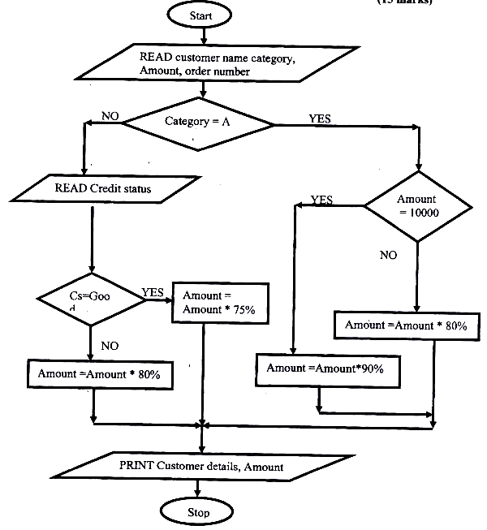
17. (a) List three application areas of artificial intelligence ( 3 mks)
- Expert systems, e.g. medical diagnosis, engine repair, legal defense etc
- Natural language processing
- Artificial neutral networks e.g. investment analysis, signature Analysis, etc
- Robotic/ perception systems

(b) With the improvement in price and performance of computers and communication equipment it will be possible for people in various business organizations to work from home. Such working using a PC as a remote terminal is often described as teleworking. State three advantages and three disadvantages of working from home.
( 12 mks)
Advantages
- Reduces unnecessary travel to the place of work
- Reduces traveling expense (i.e. saves traveling time, risk and cost)
- There is less stress due to commuting inconveniences such as traffic jams
- Reduces office space, equipment and cost
- Extends working hours
- Suitable for people with disabilities, because they are able to overcome the barrier of not being able to commute to an office
- People can live where they choose without the worry of having to move towns and break up social & family networks in order to find suitable employment.

Disadvantages
- Lack/ unavailability of appropriate facilities to allow the work to be done
- There is poor security on home offices
- Privacy threats
- Lack of control and supervision. The workers have to be able to motive themselves to work without supervision
- There is possible delegation of duties to unauthorized persons
- Isolated employees may be exploited in an environment where they can’ t easily get support from co- workers

18. (a) Explain three ways by which computer users can protect their eyes from harmful emissions from the computer screen ( 6 mks)
- Using antiglare (radiation filter) screens that are specially tinted to reduce the radiation from the monitor or light that reaches the eye.
- Controlling light intensity by adjusting the brightness buttons on the screen
- Tilting the monitors so as not to face the user directly
- Wearing special spectacles when using computers in order to control the light intensity.
- Avoid using flickering monitors as they can cause extreme eye strain that can damage eyesight.
- Very bright wall paints reflect too much light into the user’s eyes.
- Taking frequent rests

(b) List three factors to be considered when deciding on the choice of an electronic data processing method
- Type and size of business
- Timing aspects of the information produces
- Link between applications
- Volume of data records held in the organization
- Cost pf acquiring the relevant hardware, software, storage media, etc the cost of maintenance
- Operation speed
- Quality of output required

(c) Explain time sharing data processing mode, giving two advantages and two disadvantages (6 mks)
Time sharing is a processing mode where a central processor services 2 or more users who have different requirements.

Advantages of time sharing
- Reduces processor idle time. This is because the processor doesn’t have to wait for the slower commutating peripherals
- Helpful to small companies which cannot afford purchasing a computer & the related facilities. The company can be served at a fee through time- sharing processing mode.
- Provides better services to the user since the output is fast
- Files are held online, hence enquiries or file interrogation is possible
- There is user – computer dialogue established through the terminals connected to the host/ central computer
- Avoids duplicating of software
- The user of the system can benefit from the computer facilities through remote terminals

Disadvantages of time- sharing
- Te user has no control over the central computer
- Response time is high when the users are many
- Not reliable as regards to the security & privacy of data

19. A school bought a computer system. The hardware items supplied include: a 800 MHz processor, 64 MB of RAM, a sound card, speakers, a monitor, a keyboard, a 120 GB hard disk, a floppy disk drive, a CD – Read/ write drive, a mouse, a modem, an inkjet printer and a joystick.
The software supplied include: an operating system, a BASIC interpreter and the following packages: spreadsheets, graphics, word processor, art, database and games

- List three input devices from the given specifications
- Keyboard
- Mouse
- Joystick

(b) Explain the meaning of the following
(i) 800 MHZ
- 800 megahertz/ 800 million hertz
- It’s the processing speed of the CPU in Megahertz
- It means that, the system cock has a speed of 800 million oscillations per second ( 2 mks)
(ii) 64 MB of RAM
This is a measure of the storage capacity of the primary memory/ Random access Memory (RAM) in megabytes

(iii) 120 GB hard disk

- This is the measure of the hard disk storage capacity in gigabytes
- 120 Gigabytes

(c) Some of the students in the school use the computer to do homework. Name the package used to:
(i) Do calculations and draw graphs (1 mk)
Spreadsheets

(ii) Write an essay
Word processor

(iii) Make a poster
Art
- Students enjoy playing noisy computer games
(i) Which two hardware items are needed to produce sound? (2 mks)
- Sound card
- Speakers
(ii) Which input device is only used for playing games?
Joystick (1 mk)

20. A school organizes its work in directories. The director WP contains the files CATS, EXAMS and ASSIGNMENTS. The directory of SP contain the spreadsheet files. The directory DB contains the database files. The directory PROG is contained in the OTHERS directory. The directory WP also contains the PERSONAL directory. Given that the directory STUDENT contains directories SP, DB, WP and OTHERS

(a) Draw the directory tree structure with C as the root (7 mks)
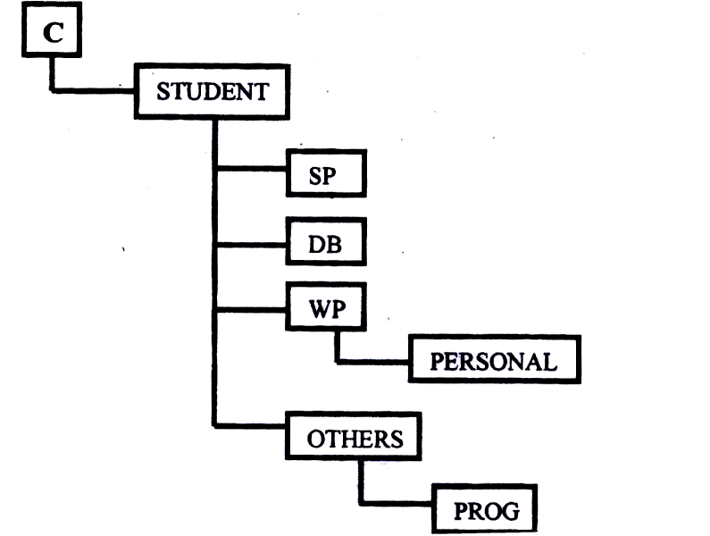

(b) Write the path at which the contents of subdirectory DB can be erased or displayed (2 mks)
C: STUDENT\DB>

(c) Write the path for the directory PROG ( 2 mks)
C:\STUDENT\OTHERS\PROG>

(d) Give two reasons for storing files in directories and subdirectories (2 mks)
- Management of the files will be easier
- Retrieving of certain files will be easier
- To avoid accidental deletion/ erasure of files when the files in C are being deleted.

(e) Give two disadvantages of using command driven interfaces as compared to menu driven interfaces ( 2 mks)
- The user must know the command to type
- It is less user- friendly i.e. it is not easy to use
- The user is required to master the format/ syntax of all commands and their usage perfectly.
- Writing commands is time consuming

K.C.S.E PREDICTION PAPER
Kenya Certificate of Secondary
451/1 computer studies
Paper 1 (theory)
2 ½ hours

INSTRUCTIONS TO CANDIDATES
This paper consists of TWO sections A and B
Answer ALL the questions in section A.
Answer questions 16 and any other THREE questions from section B

FOR OFFICIAL USE ONLY
SECTION | QUESTION | SCORE
A | 1- 15
 | 16
 | 17
 | 18
 | 19
 | 20
 | TOTAL SCORE

SECTION A (40 Marks)
Answer all the questions in this section
1. (a) What is disk formatting
- Process of preparing a new disk for use by imprinting empty tracks & sectors on the surface of the disk that can be recognized and access by a particular operating system
- The preparation/ initialization of a disk for storage of data
(b) Indicate whether the following devices are used for input or output
( 2 mks)
(i) Plotter - Output
(ii) Light pen - Input
(iii) mouse - Input
(iv) Visual display unit- Input/ output

2. (a) Explain why the following controls should be implemented for computer based systems ( 2 mks)
(i) Back- ups - Backups can be used to recover/ restore/ prevent lost data
(ii) Password- Passwords control access to computer systems/ facilities

(b) For each of the following give one reason why they are not allowed in a computer laboratory ( 2 mks)

(i) Smoking
- Smoke particles settle on storage devices and may scratch them during read/ write operation
- It can cause fire
- It deposits ash on devices causing malfunction
- It affects the health of other users

(ii) Eating foods
Food particles may fall into the moving parts of the computer and damage them

3. Distinguish between real, integer and character data types as used in programming:
Real:
- Used for numeric values that may contain fractions/ decimals
- Has a higher range than integer

Integer
- Used for whole numbers
- Has a lower range than real

Characters
- Used for alphanumeric/ control/ signal/ graphical character
- Character uses fewer bits than a real or integer

4. The cells K3 to K10 of a worksheet contain remarks on students ’ performance such as very good, good, fair and fail depending on the average mark. Write a formula that can be used to count ALL students who have the remark “very good”. (3 mks)
=COUNTIF (K3:K10,’’Verry Good’’)

5. (a) State the purpose of registers in a computer system ( 1 mks)
They act as high speed storage locations. They are used to hold data and instructions temporarily just before and after processing.

- Name two multiprogramming operating systems
- Linux
- Microsoft windows 98
- UNIX
- Microsoft windows 2000
- OS/2
- Microsoft Windows Me
- Novell Netware
- Microsoft Windows XP
- Macintosh OS
6. (a) A serial file comprises of records placed in positions 1 to 10. State the position of the end of the file market. ( 1 mk)
The end- of – file marker is the position immediately after the last record, i.e. position 11
(b) State the purpose of each of the following:
(i) File server software
- Controls access to avail files stored on a networked/ shared storage location
- Services client requests for files
(ii) Communication software
- Used for receiving/ sending messages or data in a network
- Used for routing traffic
- Used for assigning identities to nodes

7. (a) Name the control structure depicted by the flowchart below ( 1 mk)
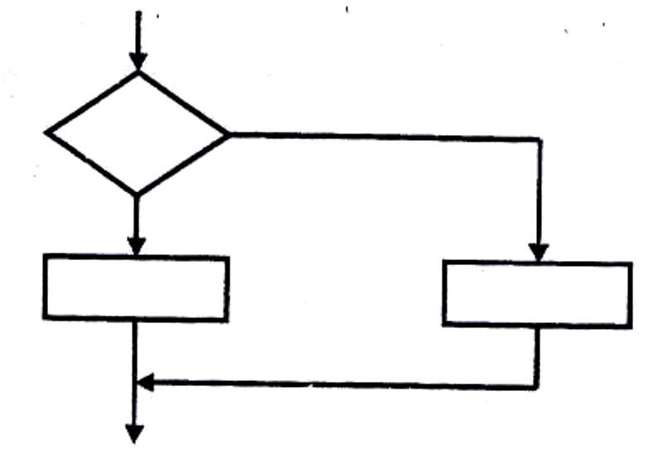

Selection control structure e.g., If-then-else

(b) Explain the following terms as used in program implementation ( 2 mks)
(i) parallel running
This is where both the existing and the new systems are run concurrently/simultaneously (at the same time) for a period of time until users have gained confidence in the new system. Data is processed on both systems in order to compare their performance, and also cross check the results.

ii) Direct change over
This is a complete replacement of the existing system with the new system in one bold move. The existing system is stopped & abandoned and the new system starts operating immediately.

8. Consider the linear arrays:
i) AA (5: 50)
ii) BBB (-5:50)
iii) CCC (18)

Find the number of elements in each array. (3mks)
AAA (5:50) = 50- 5 +1 =46
BBB (-5: 50) = 10 – (-5) +1 =16
CCC (18) = 18 – 1 +1 =18/cannot be determined

9. Define the term artificial intelligence. (2mks)
Artificial intelligence is the development of machines that imitate/copy human-like qualities in particular areas, e.g. learning, reasoning, communicating, seeing, hearing and self-correction
These are programs that make computers to mimic human intelligence
A study in which computer systems are made to think/act/imitate human beings

10. Name two types of relationships that can be applied in database design. (2mks)
- One to one
- One to many/ Many to One
- Many to Many
11. Explain the following terms as used in word processing: (3 mks)
a) Indenting
It is moving of line/paragraph text away from the left or right margin
Leaving a space at the beginning of a line/paragraph of text from the margin
b) Alignment
Refers to how text is positioned/lined up in a paragraph relative to the left, right or
centre of the page.
c) Word wrap
A facility that word processor use to automatically move the text cursor to the beginning of the next line when it reaches the right margin automatic rolling of text to the next line when you reach the end of the line.
12. Outline two ways in which computers can be used in hotels. (2mks)
- Reservation/booking of rooms
- Record keeping on sales and purchases (stock control)
- Producing bills & payrolls
- Marketing and advertising
- Communication
- Security
13. a) Explain binary coded decimal code of data representation. (1mk)
This is a data encoding system that uses 4 binary digits to represent an individual decimal digit.

b) Write the number 451₁₀ in BCD notation (1mk)
Number | 4 | 5 | 1
BCD equivalent | 0100 | 0101 | 0001

451₁₀ = 010001010001_{BCD}

14. Arrange the following data units in ascending order of size.
BYTE, FILE, BIT, NIBBLE (2mks)

Bit Nibble Byte File

15. State two health issues that may result from prolonged use of computers. (2mks)
- Harmful radiations that cause damage to eyesight/eye problems
- eyestrain/eye fatigue
- Headaches
- Repetitive Strain Injury (RSI) i.e. arm strain, wrist strain
- finger deformation
- Back strain.

SECTION B (60 MKS)

ANSWER QUESTION 16 AND ANY OTHER THREE QUESTIONS FROM THIS SECTION

16. a) State the stage of program development in which: (2mks)
i) A flowchart would be drawn
Program design

ii) The programmer would check whether the program does as required program
Testing
iii) The user guide would be written
Program testing

iii) The user guide would be written
Program documentation

iv) The requirements specification would be written.
Problem definition/analysis

b) State the output of the following flowchart segment

A=30
B=28
B=A
A= B
Write A, B

A= 30, B= 30 (2mks)

c) i) Draw a flowchart to compute the combined resistance (R) of two
resistors R+1 and Ra=2 in parallel using the formula; (51/2mks)
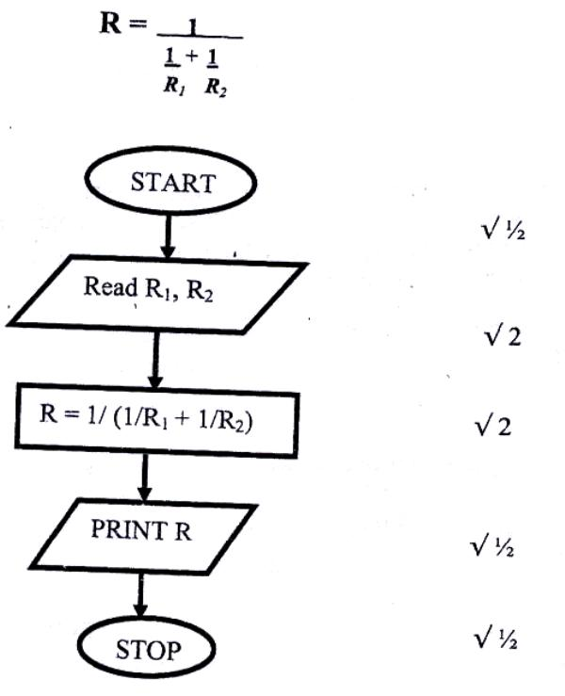

ii) WRITE A PROGRAM USING Pascal or c languages for the flowchart in c(i) above. (5mks)
PROGRAM resistors (Input, Output );
VAR
R, R1, R2: Real; √1

Begin
Writeln (‘Input R1 and R2’); Readln (R1, R2) √1

R: = 1/ (1/R+ 1/R2); 3 (reciprocals-1mk, sum/reci – 1mk, result r- 1mk)
Writeln ( R); √ ½

END
17. a) List paragraph formatting activities in word processing. (3mks)

- Changing case - Borders
- Background - Drop caps
- Bullets and numbering - alignment
- Paragraph Spacing - Indentation
- Tabs - columns

b) Differentiate between bolding and highlighting text. (2mks)

Highlighting:
- Selecting or marking a given of text e.g., a word, sentence or paragraph, in order to work with it
- Highlighting is temporary.

Bolding:
- making the selected text appear darker then the rest of the text
- To add emphasis to the text by thickening/darkening the characters
- Bolding is permanents.

c) The following information shows the income and expenditure for “behayote”
matatu
for five days. The income from Monday to Friday was Ksh. 4,000, 9,000, 10,000, 15,000, and 12,000 respectively while the expenditure for the same period was Kshs. 2,000, e, 000, 7,000, 5,000, and 6,000 respectively.

i) Draw a spreadsheet that would contain the information. Indicate the rows as 1, 2, 3…..And the columns as a, B, C…. (4mks)

 | A | B | C
1 | BEBA YOTE MATATU
2 | Day | Income (Ksh) | Expenditure (Ksh)
3 | Monday | 4,000 | 2,000
4 | Tuesday | 9,000 | 3,000
5 | Wednesday | 10,000 | 7,000
6 | Thursday | 15,000 | 5,000
7 | Friday | 12,000 | 6,000

3 columns with titles @ 1 mark each = 3 marks
Labeling rows/columns 1 mark

ii) State the expression that would be used to obtain:
I Monday’s profit (2mks)
= B3-C3
II Total income
= SUM(B3:B7) -OR- =B3 + B4 + B5 + B6 + B7
III Highest expenditure.
= MAX(C3:C7)
18. (a) Subtract Oil 1₂ from 1001₂
1001
0111 –
0010 =0010₂ =10₂
(b) Using two's complement, subtract 7 from 4 and give the answer in decimal notation. (4 marks)
Step 1: Write it as 4 + (-7)
Step 2: Change the values to 8 binary digits.

₂ | ₄ | _{Rem}
₂ | ₂ | ₀
 | ₁ | ₀
 | ₁ | ₁
=00000100₂

₂ | ₇ | _{Rem}
₂ | ₃ | ₁
 | ₁ | ₁
 | ₁ | ₁

=0000011

Step 3: Get the Ones complement of the second value.
=11111000₂
Step 4: Add 1 to the One's complement to get Two's complement.
=11111000
1 +
11111001

Step 5: Add the binary equivalent of the first value to the Two's complement of the second value.
00000100
11111001 +
11111101 = 11111101₂

(c) Convert: 91Bi₆ to octal (3 marks)
Step 1: Convert 91B₁₆ to decimal
16² | 16' | 16°
9 | 1 | B
9xl6² +1x16'+ 11x16° 2304+16 + 11 =2331₁₀
Step 2: Convert 233110 to octal
8 | 2331 | Rem
8 | 291 | 3
8 | 36 | 3
8 | 4 | 4
 | 4 | 4

(ii) 376₈ to hexadecimal
Step 1: Convert 376₈ to decimal

8² | 8¹ | 8⁰
3 | 7 | 6

3x8² + 7x8¹ + 6x8⁰
192+56+6= 254₁₀

Step 2: Convert 254₁₀ to hexadecimal
16 | 254 | Rem
16 | 15 | 14
 | 15 | 15
376₈=FE₁₆

(iii) 9.625₁₀ to binary (4 marks)

2 | 9 | Rem
2 | 4 | 1
2 | 2 | 0
 | 1 | 0
 | 1 | 1
0.625x2-1.25 1
0.250x2 = 0.50 0
0.50x2 =1.00 1

0.625₁₀-101₂

9.625₁₀= 1001.101₂

19. (a) Explain what the following DOS commands will do when executed.
(i) A:\>copy *.* B: (2 marks)
Copy all the files from drive A: to drive B:
(ii) C:\>ERASE *.DOC (2 marks)
Delete all files with extension .DOC from drive C:
(iii) B:\>DIR P*.BAT (2 marks)
Display all the files beginning with P and have extension of .BAT in drive B:
(iv) A:\>MD EXAMS (2 marks)
Creates a directory called EXAMS in drive A:
(b) (i) With the aid of a diagram, explain hierarchical (tree) network topology.
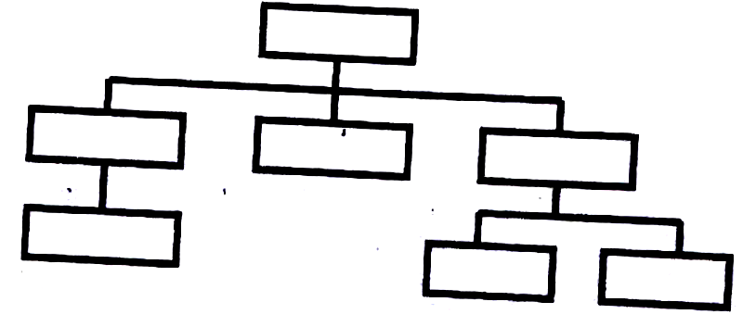
(3 marks)

- It is connected in such a way that nodes are in different levels of control such that higher nodes control those below them.
- A child node has only one parent but a parent node can have more than one child.
- The child nodes can only be accessed through the parents.
(ii) List two advantages and two disadvantages of hierarchical network
topology. (4 marks)
Advantages
- Provides centralized control.
- Enhances data security & privacy.
- Easy to isolate faults.
- Easy to add and remove nodes.
- If a non-critical node fails, partial communication is still possible.
Disadvantages
- Slow data movement along the branches.
- If the parent node fails, the child nodes are inaccessible.
- Difficult/sophisticated to implement in a wide area network.
50. (a) Name and explain the function of the keyboard keys represented by the following
symbols.

Tab key: (2 marks)

- Used in Word processors to move certain text or the cursor at set intervals on the
- Same line to the required position on the screen.
- Used to move from one cell to another.
- Used to move the cursor between options. ,
- Used to indent text.

Enter key: (2 marks)

- It is used as a RETURN key. When pressed at the end of a text line or paragraph in a word processor, it forces the text cursor to move to the next line or paragraph.
- It is used to issue completion commands to the computer. It is used to instruct the computer to carry out (execute) a command that has been typed or selected on the screen.

Shift key: (2 marks)

- It can be used for changing cases, e.g., to get single capital letters.
- It is used to get the punctuation marks on top of the Number keys or the symbols
on top of certain keys .especially on the alphanumeric section.
- Used for shortcuts in combination with other keys, e.g., SHIFT + DEL

(b) Simulation is one of the application areas of computers,
(i) What is meant by the term simulation? (1 mark)
Simulation is the designing of models of either an actual or theoretical physical item, and analyzing/testing the execution output using a computer.
(ii) Name two application areas of simulation. (2 marks)
- In training of pilots, using flight simulators.
- In medicine to train doctors on operation techniques.
- In engineering, e.g.
- Architectural design (of buildings)
- Design of electronic circuits, ships, roads and cars.
- Design of bridges.
- Aeronautical engineering (i.e., design of aircrafts)
- To simulate the timing of traffic lights.
- To simulate the timing of a nuclear attack for testing national defences.
- Aviation training.
- Laboratory experiments
- Missile launch.
- Space exploration.
- Vehicle accidents.
- Entertainment, e.g., games.
(iii) State three advantages of computer based simulation. (3 marks)
- Saves cost - it is an economical/cheap way of testing models before actually building them.
- It enables the manufacturers identify weaknesses of the real situation or object, hence;
- put the correct reinforcements to their designs
- Reduces risks - it allows some activities that would otherwise be expensive & dangerous in real-life situation to be put under test.
- Faster.
- Convenient. .
(c) Explain three ways in which computers have impacted on education.
- Standardizing learning.
- Has ensured quality output.
- Brought the need for retraining staff.
- Enabled distance learning,
- Created jobs, e.g., computer trainers.
- Causes job displacement and replacement.
(3 marks)

