CHEMISTRY
NAME………………………………………………………………..ADM……………DATE..................
- The electron arrangement of ions X³⁺ and Y²⁻ are 2.8 and 2.8.8 respectively.
- Write the electron arrangement of elements X and Y.
X - (1 mk)

Y - (1 mk)

- Write the formula of the compound that would be formed between element X and Y. (1 mk)

- Study the equation below;

Mg_{(s)} + ZnO_{(s)} MgO_{(s)} + Zn_{(s)}

- By use of arrows, indicate oxidation and reduction reactions in the equation. (2 mks)
- Name the reducing agent in the above reaction. (1 mk)

- Distinguish between the terms deliquescent and efflorescent salts. (2 mks)

- The table below shows PH value of different solutions.
Solution | A | B | C | D
PH | 14 | 7 | 2 | 11
a)Which solution is likely to be sugar solution? (1 mk)
b) Two of the solutions were found to react with both aluminium oxide and zinc oxide.
Identify the two giving reasons. (1mk)

- Identify the methods that are most appropriate to obtain. (3 mks)
- Oil from coconut

- Diesel from crude oil

- Sugar crystals from sugar solution

- An element Q has an electron arrangement of 2.8.5
(a) Identify the group and period to which it belongs.
Group - (1 mk)

Period - (1 mk)
(b) is element Q a metal or a non-metal? Explain (2 marks)

- Carbon has two isotopes namely$\begin{matrix}14 \\ 6\end{matrix}C and \begin{matrix}12 \\ 6\end{matrix}C$. Calculate the relative abundance of these two isotopes if the relative atomic mass of carbon is 12.4. (3mks)

- The diagram below shows how two gases, P and Q were collected.
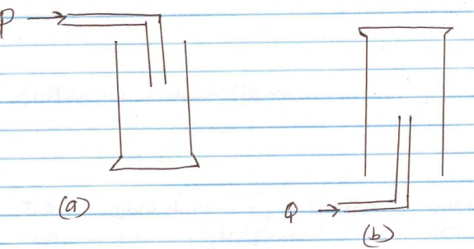

- Name the two methods shown above.
a - (1 mk)

b - (1 mk)

- State the property of Q that enables it to be collected as shown above. (1 mk)

- Give an example of a gas that is collected using the method shown in (b) above. (1 mk)

- The structure of water molecule can be represented as shown below.
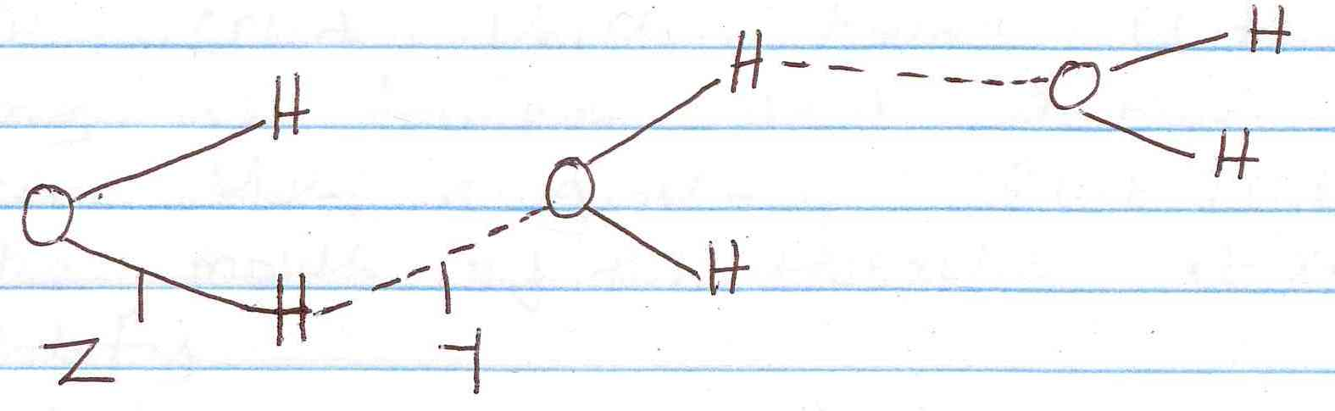

(a) Name the type of bonds represented by letters Y and Z.
Y – (1 mk)

Z - (1 mk)

- Element R has a valence of 2, element Q has a valence of 1 while element B has a valence of 3. Write the chemical formulae of their sulphates, phosphates and nitrates. (4½ mks)
Element | Sulphates | Phosphates | Nitrates
R
B
Q
- When a white solid X is heated, a yellow solid which turns white on cooling is formed and a brown gas is seen. When a glowing splint is placed at the mouth of the test-tube it relights.
- Identify;
- Solid X - (1 mk)

- The brown gas - (1 mk)

- Write an equation for the decomposition of solid X. (1 mk)

- Below is a structure of aluminium chloride.
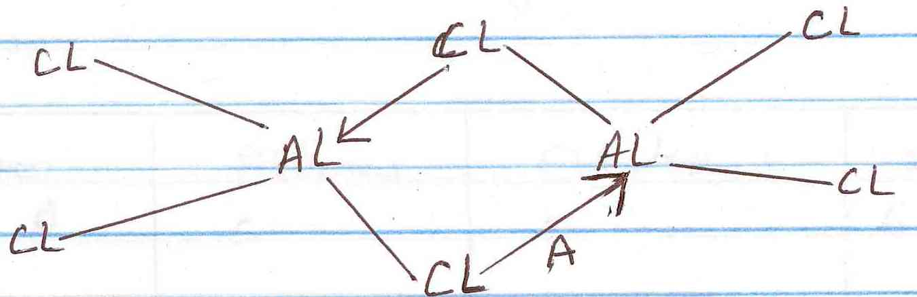

- Identify bond A. (1 mk)

- State the observations made when aluminium chloride solution is tested with blue and red litmus paper. Explain. (2 mks)

- Which particles conduct electricity in;
- Molten lead (ii) bromide (1 mk)

- Aqueous sodium chloride (1 mk)

- Graphite (1 mk)

- The following table gives the structures of the different atoms. Study it and answer the questions that follow. (A, B, C, D and E do not represent the actual symbols of the elements).

Atom | Protons | Electrons | Neutrons
A | 5 | 5 | 6
B | 9 | 9 | 10
C | 10 | 10 | 11
D | 15 | 15 | 16
E | 10 | 10 | 12
- What is the mass number of atom B? (1/2mk

- Which of the atoms has a mass number of 11? (1/2mk)

- Which of the atoms represent isotopes of the same element. (1 mk)

- Study the following flow chart and answer the questions that follow.
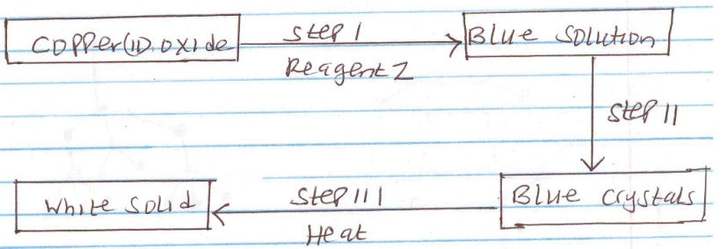

(a) (i) Identify reagent Z. (1 mk)

(ii) Identify the white solid. (1 mk)

(b) Write a chemical equation for the formation of the blue solution. (1 mk)

- State two properties that makes aluminum to be used in making of overhead electric cables.(2 mks)

- The structures below represent two allotropes of carbon. Study them and answer the questions that follow.

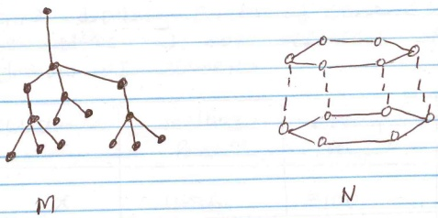

- Identify the allotropes labeled
M - (1/2 mks)

N - (1/2 mks)

- Explain in terms of structure and Bonding which of the two allotropes;
- Conducts electricity. (1 mk)

- Is used in making drilling equipment. (1 mk)

- (a) The table below shows properties of some substances.
Substance | Melting point (⁰C) | Boiling point (⁰C) | Electrical conductivity
 |  |  | Solid | Liquid
A | -112 | -107 | Poor | Poor
B | 801 | 1413 | Poor | Good
C | 97.5 | 880 | Good | Good
D | 44 | 280 | Poor | Poor
E | 1700 | 2200 | Poor | Poor
F | -110 | 46.3 | Poor | Poor
Select a substance which;
- Has a giant ionic structure. (1 mk)

- Is a metal (1 mk)

- Has a giant atomic structure. (1 mk)

(b) Using dots (.) and crosses (x) illustrate bonding in ammonia molecule (NH₃). (N=7, H=1) (2 mks)

(c) A student placed a small piece of sodium metal in a trough of water.
- State two observations made? (2 mks)

- Write a chemical equation for the reaction that took place. (1 mk)

- The products formed by action of heat on nitrates of elements A, B and C are shown below.

Nitrates | Products formed
A | Metal oxide + Nitrogen(iv)oxide + Oxygen
B | Metal + Oxygen + Nitrogen(iv)oxide
C | Metal nitrite + Oxygen
- (a) Arrange the metals inorder of increasing reactivity. (1 mk)

(b) Which element forms a soluble carbonate? (1 mk)

(c) Give an example of element B. (1 mk)

- (i) Write an equation to show the effect of heat on each of the following;
- Sodium hydrogen carbonate. (1 mk)

- Copper(ii)carbonate (1 mk)

- The figure below is used to investigate the effect of carbon (ii) oxide on copper (ii) oxide.
Study it and answer the questions that follow Copper (ii) oxide.
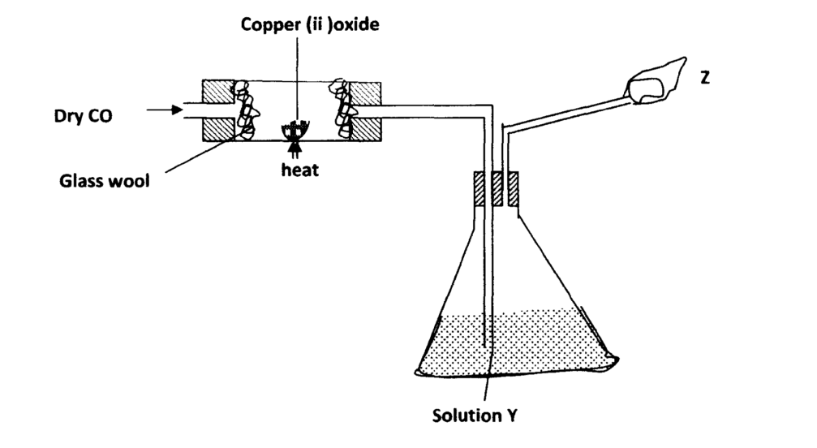
i) What will be observed in the combustion tube at the end of the experiment? (lmk)

ii) Identify Y and give its use (2mks)

iii) Why is it necessary to burn the excess gas at Z (lmk)

iv) Write the equation for the reaction taking place at Z (lmk)

v)Give two uses of carbon (II) oxide (2mks)

