NAME………………………………………………………ADM………………….CLASS………………….
CHEMISTRY
FORM 1, MID – TERM EXAM – 2022
Time 2 Hours 15 Minutes
Answer ALL Questions in the spaces provided
- Give three reasons why laboratory apparatus are made of glass. (3mks)

- A wooden splint was slipped through a region of a particulars flame in the laboratory and was shown in the diagram below.
Unburnt part

Burnt part
- Name the type of flame the splint was slipped through. (1mk)

- Explain why the splint was burnt the way it is shown in the diagram. (2mks)

- .
- Define the following terms;
- Drug (1mk)

- Drug abuse (1mk)

- Mention any two side effects of drug abuse. (2mks)

- State any four differences between luminous and non – luminous flames. (4mks)

- State one use of each of the following apparatus in the laboratory
- Dessicator (1mk)

- Crucible (1mk)

- State the correct method of separating the following mixtures. (4mks)
- A mixture of iron fillings and sulphur

- Sugar and iodine

- Sand and water mixture

- Kerosene and water.

- .
- State the role of the following parts during fractional distillation of a mixture of water and ethanol.
- Fractional column. (1mks)

- Glass beads. (1mk)

- What property of the mixture makes it possible to be separated by fractional distillation? (1mk)

- State any two application of fractional distillation. (2mks)

- In an experiment to separate a mixture of two liquids A and B a student set up the apparatus as shown below.
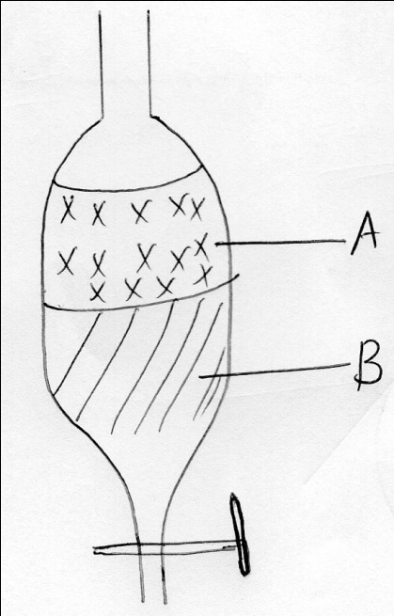

- Name the apparatus. (1mk)

- Which liquid is denser? (1mk)

- Which other methods can be used to separate the two liquids. (1mk)

- State three differences between temporary and permanent change. (3mks)

- .
- What is an acid – base indicator? (1mk)

- Fill in the table below to show the colour of the following indicators. (3mks)
Indicator | Colour in acid | Colour in alkali
Litmus

Phenolphthalein
Methyl orange

- Unknown substance had Ph values as shown in the table below.
Substance | A | B | C | D
Ph value | 6.0 | 2.0 | 12.0 | 7.0
State which substance was likely to be; (3mks)
- Lemon juice
- Sodium chloride solution
- Potassium hydroxide solution
- State three uses of acids. (3mks)

- Complete the word equation below. (4mks)
- Sodium hydroxide + Dilute hydrochloric acids

- Calcium carbonate + Dilute sulphuric acid

- Magnesium oxide + Dilute nitric (v) acid

- Zinc + dilute hydrochloric acid

- .
- Give the chemical name for the rust. (1mk)

- Apart from oiling and greasing, state two methods that can be used to prevent rusting. (2mks)

- State two conditions that accelerate rusting. (2mks)

- The diagram below is set – up for the laboratory preparation of oxygen
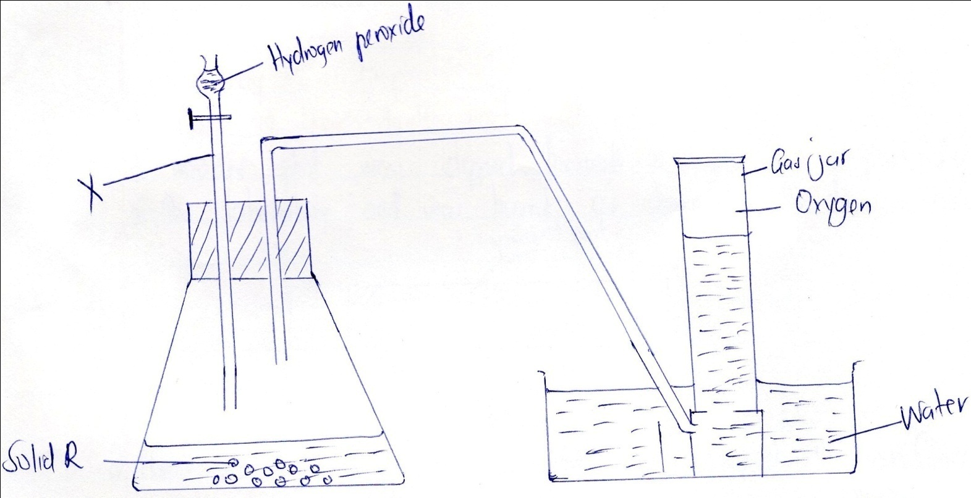
- Name solid R (1mk)

- Name the apparatus X. (1mk)

- Write an equation for the reaction that takes place in the flask. (2mks)

- Give a test for oxygen gas. (1mk)

- State two uses of oxygen gas. (2mks)

- Name the product formed when kerosene is burned in air. (2mks)

- State two chemical tests for the presence of water. (2mks)

- State three observations made when a small piece of potassium is placed in water. (3mks)

- Explain why the following reagents are not used in the laboratory preparation of hydrogen gas. (2mks)
- Nitric acid

- Potassium

- Metal X reacts with cold water slowly while Y does not react with neither cold nor hot water. Metal Z react with both cold water and hot water vigorously and explosively respectively. Arrange those metals in order of increasing reactivity. (2mks)

- The set – up below is used to investigate the properties of hydrogen gas.
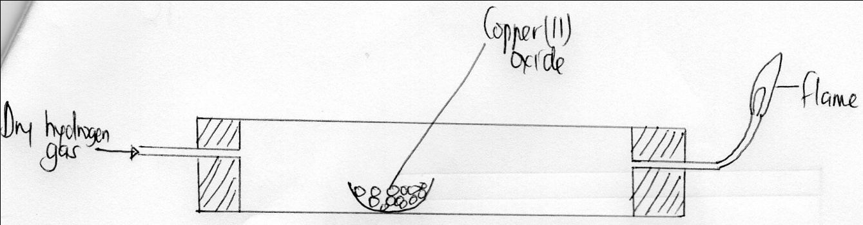
- On the diagram, indicate what should be done for the reaction to occur. (1mks)

- Write an equation for the reaction that occurs in the combustion tube. (1mk)

- Hydrogen gas is allowed to pass through the tube for sometime before it is lit. Explain. (1mk)

- What property of hydrogen gas is being investigated? (1mk)

- State and explain the observations made in the combustion tube. (3mks)

- State two uses of hydrogen gas. (2mks)

- In an experiment to investigate the percentage of oxygen in air, 200cm³ of air was passed over heated copper turnings repeatedly until a constant volume of air remained. 160cm³of air remained at the end of the experiment.
- Name the gases remaining in the 160cm³ of air. (2mks)

- Determine the percentage of air used during the experiment. (2mks)

- State one possible source of error in the experiment. (1mk)

- Write a word equation for the reaction. (1mk)

- Explain how you would obtain sand from a mixture of sand and common salt. (3mks)

- State two apparatus used to measure accurate volume. (2mks)

- Give two reasons why solid carbon (iv) oxide is preferred over ordinary ice for use by ice cream vendors. (2mks)

- The diagram below shows a chromatogram of pure dyes A,B and C. it also contains that of an impure substance K.
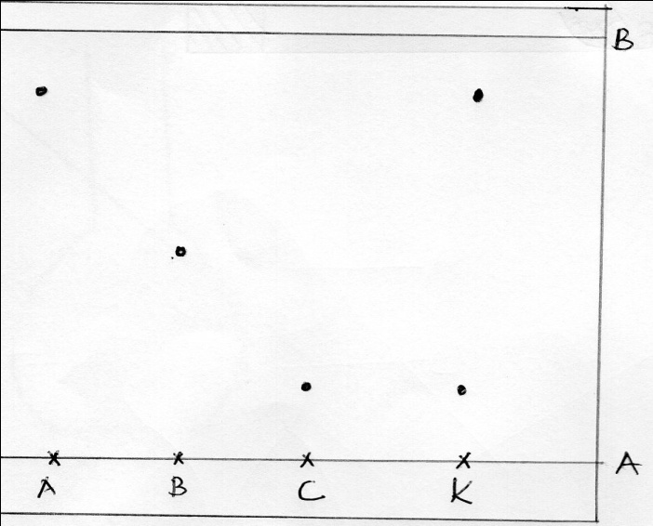
- Name lines A and B. (2mks)

- Identify which pure dyes does substance K contains. (2mks)

- .
- Which two property of the component of the mixture facilitate separation? (2mks)

- Normally line A is drawn using a pencil and not ink. Explain why the pencil is preferred to ink. (2mks)

- State two applications of chromatography. (2mks)

