CHEMISTRY
FORM 1
NAME………………………………… CLASS……………… ADM NO………..
1. The following diagram represents a non-luminous flame of the Bunsen burner
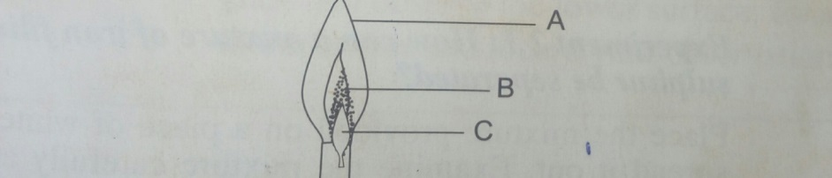
- Name the parts of the flame labeled A,B andC(3 marks)

b)Which of the parts in (a) above is the hottest and why? (2marks)

c)Under what conditions does the Bunsen burner produce the flame drawn above(1mark)

2. Complete the following word equations. (3marks)
i)Magnesium Hydrogen Carbonate+ dilute Nitric acid

ii) Carbon + Oxygen

iii) Zinc oxide + dilute Sulphuric acid

3. The curve below is a heating curve of naphthalene. Use it to the questions that follow.
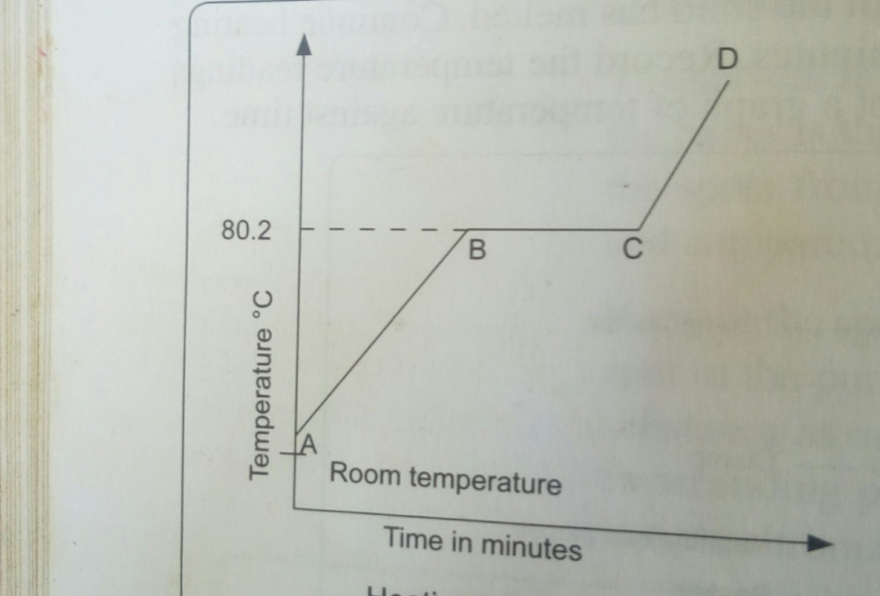
a) Explain what happens in the following regions. (6 mks)
i. AB

ii. BC

iii. CD

b) Give the effect of impurities on both melting and boiling points of a pure substance. (2mrks)

4.a) Give any two examples of mineral acids (2marks

- Give two effects of acids on substances. (2marks)

c. Acids and bases are of importance in our daily life. State 3 uses of bases (3 marks)

5. a) Air is a mixture of gases. Give the various components of air. (2marks)

b. The apparatus below were used to determine the volume of oxygen in air. About 200 cubic centimeters of air were passed repeatedly from syringe A to syringe B over heated copper turnings are shown in the diagram below. After some time, the volume of air in syringe A was 160 cubic centimeters and in syringe B 0 cubic centimetres. 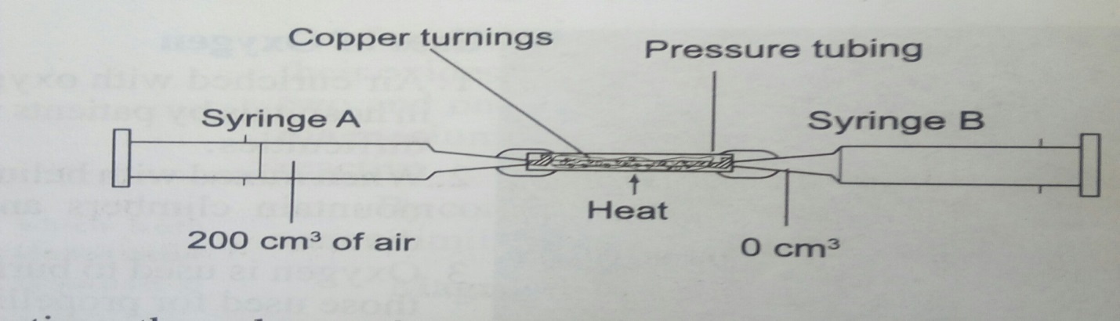
c. Calculate the percentage of oxygen in the initial sample of air. (3marks)

d. Give one possible source of error in the experiment. (1mark)

e) Write a word equation for the experiment (1mark)

6.a. Define the following terms (2marks)
i. Rust

ii Saturated solution

b. Give two conditions necessary for rusting to occur. (2marks)

c. State two ways of preventing rusting to occur. (2marks)

d. Cars in Mombasa rust faster than those in Nyeri .Explain (2mrks)

7.) Classify each of the following change as either temporary or permanent. (3marks)
  - Striking a match to burn.

  - Burning a piece of paper.

  - Zinc oxide Zinc oxide
(White) (Yellow)

8.) Identify the elements present in the following compounds.
(a) Calcium oxide(1mark)

(b) Magnesium nitrate (1¹/² marks)

(c) LeadSulphate(1¹/² marks)

9.) The diagram below shows a set-up of apparatus used to separate miscible liquids.
B
A
Mixture

- Name the parts labelled A and B. (2marks)
A

B

b) State the function of the part labeled A . (1mark)

c) State the property of the mixture that makes it suitable to be separated by the method above. (1 mark)

10. Samples of urine from three participants F, G and H at an international sports meeting were spotted onto a chromatography paper alongside two illegal drugs A1 and A2. A chromatograph was run using Ethanol. The figure below shows the chromatograph.
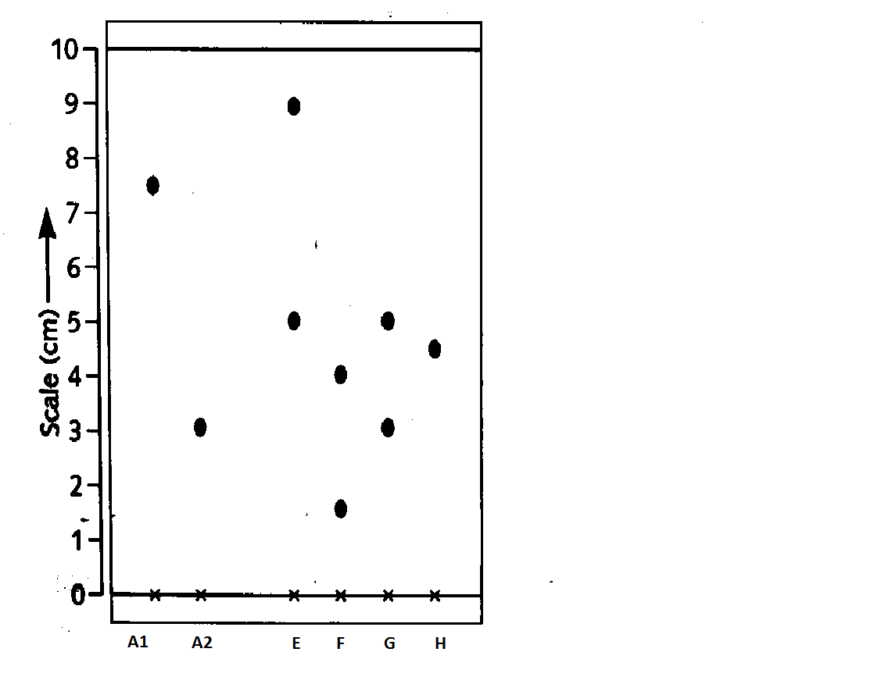
- Identify the athlete who used an illegal drug (1mk)

- Which drug is soluble in Ethanol(1 mk)

- Which two properties of the component of the mixture facilitate separation? (2 marks)

- (c) Normally line A is drawn using a pencil and not ink. Explain why the pencil is preferred to ink.(2marks)

11.a) Describe how coconut oil can be obtained from coconut in the laboratory. (3 marks)

b) State one practical application of the process in a) above (1mk)

12. Study the table below which shows the pH values of solutions A, B, C, D and E.
Use it to answer the questions that follow.

Solution | A | B | C | D | E
pH | 13.0 | 7.0 | 9.0 | 6.5 | 2.0

i) Which solution is the most acidic? (1 mark)

(ii) Which solution is a neutral? (1 mark)

(iii)Identify the solution that is most likely to be:

  - Rain water

  - Antacids tablet

  - Sodium hydroxide (3 marks)

13. State any two differences between luminous and non-luminous flames (2 marks)

14. State three uses of Oxygen gas(3marks)

