NAME……………………………………………….CLASS………SET………
JOINT PRE-MOCK EXAMINATION.
TERM 1 2021
SEPTEMBER 2021
BIOLOGY PAPER ONE
231/1
TWO HOURS
Instructions to candidates
- Write your name and class in the space provided above
- Sign and write the date of the examination in the spaces provided above
- Answer all the questions in the spaces provided
- This paper consists of 10 printed pages
- Candidates should check the question paper to ascertain that all the pages are printed as indicated and no questions are missing.
- Candidate should answer all the questions in English
FOR EXAMINERS USE ONLY

QUESTION | MAXIMUM SCORE | CANDIDATE’S SCORE
- 32 | 80

- Identify the following. (2mrks)
- Type of movement in cells.
……………………………………………………………………………………....
- Arrangement of leaves on a plant.
………………………………………………………………………………………

- Explain how adequate water supply increases the rate of glucose formation in plants. (1mrks)
………………………………………………………………………………………………………………………………………………………………………………
- Name the element obtained from insects by insectivorous plants. (1mrk)
………………………………………………………………………………………………………………………………………………………………………………

- A mushroom research station would like to employ a researcher. Which scientist is most appropriate. (1mkr)
…………………………………………………………………………………………..
- Name the branch of biology that deals with phylogenetic relationship between organisms. (1mrk)
…………………………………………………………………………………………..
- State the role of the diaphragm.
- In the light microscope. (1mrk)
………………………………………………………………………………………………………………………………………………………………………………
- During ventilation in man. (1mrk)
………………………………………………………………………………………………………………………………………………………………………………
- Explain why plants absorb water in waterlogged soil but not mineral salts. (2mrks)
………………………………………………………………………………………………………………………………………………………………………………………………………………………………………………………………………………………………
- A biological washing detergent removes stains like oils from cloths.
- Name the enzyme that it contains. (1mrk)
……………………………………………………………………………………....
- Explain why the stains would be removed faster with the detergent in water at 35ºc rather than at 15^{O}c. (1mrk)
……………………………………………………………………………………………………………………………………………………………………………....
- Below is a diagram of an embryo sac.
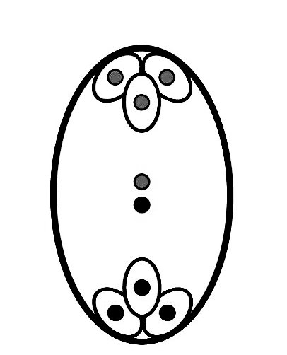
K
J
Identify the structures labelled. (2mrks)
J-…………………………………………………………………………………………

K-…………………………………………………………………………………………
- Explain why low temperature will cause seed dormancy by not very high temperatures. (1mrk)
………………………………………………………………………………………………………………………………………………………………………………………………

- Explain why the average length of the chicken egg is 6cm while that of a human is 0.1mm. (1mrk)
……………………………………………………………………………………………………………………………………………………………………………………..
- Identify two features that enable mammalian fallopian tubes perform their function. (2mrks)
…………………………………………………………………………………………………………………………………………………………………………………….

- State a limiting factor of using a potometer to measure the rate of transpiration. (1mrk)
……………………………………………………………………………………………………………………………………………………………………………………..
- Name the tissue that transports hormones in plants. (1mrk)
…………………………………………………………………………………………
- To control the spread of malaria, fish are introduced into water bodies near residential area.
- Name this method of population control. (1mrk)
…………………………………………………………………………………………
- State an advantage of the above method. (1mrk)
…………………………………………………………………………………………..
- Apart from vaccination, state two ways of controlling highly infectious disease among animals. (2mrks)
………………………………………………………………………………………………………………………………………………………………………………………………

- Name the enzyme that breaks down hydrogen carbonate ions in mammalian blood to release carbon (IV) oxide. (1mrk)
…………………………………………………………………………………………..
- Explain why obligate anaerobes die in presence of oxygen. (1mrk)
……………………………………………………………………………………………………………………………………………………………………………………..

- Name the group of sporangia born on fern leaves. (1mrk)
…………………………………………………………………………………………
- Why are fruits not produced in gymnosperms? (1mrk)
…………………………………………………………………………………………

- Explain why lactating mothers need extra energy. (1mrk)
…………………………………………………………………………………………
- State the function of interstitial cells found in the testes. (1mrk)
…………………………………………………………………………………………..
- Below is a diagram showing a foetus in the uterus.
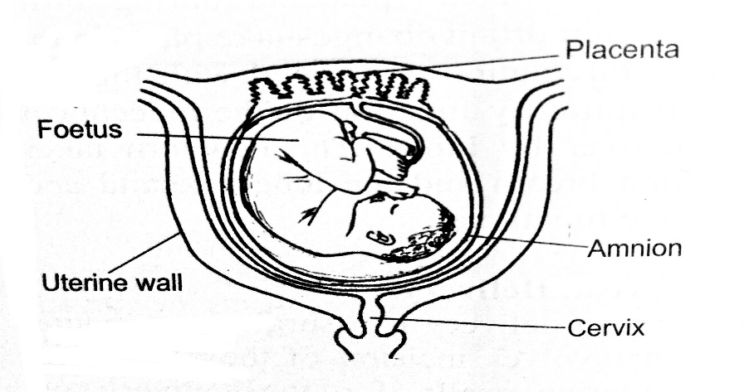
state two observations showing that parturition is about to take place. (2mrks)
………………………………………………………………………………………………………………………………………………………………………………………………
- The symptoms of typhoid disease include high fever, vomiting and diarrhoea. Explain why they may lead to death if not treated. (2mrks)
………………………………………………………………………………………………………………………………………………………………………………………………………………………………………………………………………………………………

- The table below represents a chromatid which undergoes a mutation, the letters genes.

Before mutation
L | M | N | O | P | Q

After mutation
L | O | N | M | P | Q

- Name the type of mutation. (1mrk)
…………………………………………………………………………………………

- Identify the nucleic acid whose base sequence is shown below. (1mrk)
G-A-C-U-A-G-A-C-G
…………………………………………………………………………………..
- If the above strand was involved in protein synthesis, how many amino acids would the protein have? (1mrk)
……………………………………………………..............................................
- Explain why resistance to antibiotics is considered an example of evolution. (2mrks)
………………………………………………………………………………………………………………………………………………………………………………………………………………………………………………………………………………………………

- People are encouraged to take the corona virus disease vaccine. How does it work? (1mrk)
…………………………………………………………………………………………..
- What is the significance of;
- Red blood cells lacking mitochondria. (1mrk)
…………………………………………………………………………………
- Xylem vessels being dead. (1mrk)
…………………………………………………………………………………..
- Use of fossil fuel as source of energy causes global warming. Governments are being encouraged to use ‘clean energy’. State two sources of this energy. (2mrks)
………………………………………………………………………………………………………………………………………………………………………………………………
- An athlete training to take part in an international competition moved to a high attitude area to train for 12 days. He took his pulse rate per minute and recorded as shown below.

Day | 1 | 2 | 3 | 4 | 5 | 6 | 7 | 8 | 9 | 10 | 11 | 12
Pulse rate | 72 | 78 | 89 | 92 | 92 | 90 | 86 | 80 | 77 | 74 | 72 | 72
Account for the change in the pulse rate from.
- Day 1-5. (2mrks)
………………………………………………………………………………………………………………………………………………………………………………
- Day 6-12. (2mrk)
………………………………………………………………………………………………………………………………………………………………………………
- A patient complained of frequent thirst. A sample of the patient’s urine was found not to have any sugar.
- Name the hormone the person was deficient of. (1mrk)
………………………………………………………………………………………
- Name the gland that secretes the above hormone. (1mrk)
………………………………………………………………………………………

- The paddles of a whale and fins of a fish adapt them to aquatic habitat.
- Name the evolutionary process that may have given rise do these structures. (1mrk)
…………………………………………………………………………………
- What name is given to such structures? (1mrk)
…………………………………………………………………………………..

- State two advantages of natural selection. (2mrks)
……………………………………………………………………………………………………………………………………………………………………………………..

- Explain why ingestion of salty food may reduce the amount of water passed out in urine. (2mrks)
……………………………………………………………………………………………………………………………………………………………………………………..
- Explain why small birds puff their features when cold. (2mrks)
……………………………………………………………………………………………………………………………………………………………………………………..

- Explain why halophytes have pneumatophores. (1mrk)
…………………………………………………………………………………………
- Explain how the following features adapt root hairs cells to absorption
- Large sap vacuole. (1mrk)
………………………………………………………………………………....................................................................................................................................
- Numerous mitochondria. (1mrk)
……………………………………………………………………………………………………………………………………………………………………..
- A certain metabolic pathway takes place following sequence.
J-K-L-M-N
An inhibitor was added to the reactants during an experiment. At the end of the experiment, there was more K and little L, M and N.
- At what stage of the sequence was the inhibitor added. (1mrk)
…………………………………………………………………………………………
- Briefly explain how the inhibitor affected the reaction. (2mrks)
……………………………………………………………………………………………………………………………………………………………………………………..

- Suggest a change in the diet of a person whose liver is damaged. (1mrk)
…………………………………………………………………………………………
- State the importance of caecum in herbivores. (1mrk)
…………………………………………………………………………………………
- Name the polysaccharide that offers mechanical support in;
- Arthropods (1mrk)
…………………………………………………………………………………
- Plants. (1mrk)
…………………………………………………………………………………..

- Explain why an effective respiratory system is associated with the circulatory system. (2mrks)
………………………………………………………………………………………………………………………………………………………………………………………………………………………………………………………………………………..
- Distinguish between haemoglobin and myoglobin. (2mrks)
……………………………………………………………………………………………………………………………………………………………………………………..

- New born babies have a higher heart beat than adults. Explain why? (2mrks)
………………………………………………………………………………………………………………………………………………………………………………………………………………………………………………………………………………..
- What Is the advantage of oxyhaemoglobin over carboxyhaemoglobin? (1mrk)
……………………………………………………………………………………………………………………………………………………………………………………..

- Explain why;
- Fish pass a lot of water over the gills frequently. (1mrk)
……………………………………………………………………………………....

- Lack of magnesium leads to yellowing of leaves. (1mrk)
………………………………………………………………………………………
- The organisms below belong to kingdom Animalia.
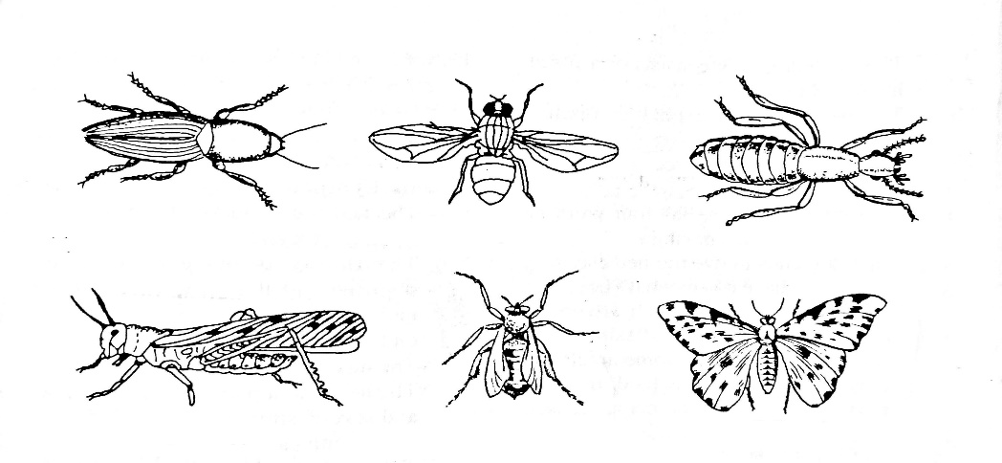
- Name the phylum and class where they belong. (2marks)
- Phylum……………………………………………………………………
- Class ……………………………………………………………………/..
- Give a reason for placing the organisms in the class in (a(ii) above. (1mrk)
……………………………………………………………………………………...

