Name: ……………………………………………………...……… Adm No: ……………………. Class…………………………………

CHOGORIA-MURUGI PRE-MOCK EXAM
231/1
BIOLOGY
PAPER 1(Theory)
MARCH-APRIL 2023
2 Hour

INSTRUCTIONS TO CANDIDATES
Write your name and index in the spaces provided.
Answer All the questions in the spaces provided.

FOR OFFICIAL USE ONLY

QUESTION | MAXIMUM SCORE | CANDINDATES SCORE
1-25 | 80

This paper consists of 10 printed Pages
Candidates should check the question paper to ensure that all the pages are printed as indicated and no questions are missing
Answer ALL questions from this section
1.
- List two professional occupations that require the study of biology. (2marks)
……………………………………………………………………………………………………………………………………………………………………………………………………………...……
(b). Other than observation, name one other scientific skill developed by studying biology. (1mark)
…………………………………………………………………………………………………………
2. The table below shows results of a study of three plants C, D and E growing in different habitat
Feature | Plant C | Plant D | Plant E
Number of stomata on upper surface of leaf per square area | 4 | 20 | 6
Number of stomata on lower surface of leaf per square area | 6 | 0 | 8
Thickness of leaf cuticle (mm) | 0.4 | 0.1 | 0.2
Surface area of roots (cm³) | 2000 | 1000 | 1200
(a) Which one of the plant C, D and E grows in an area of relatively low water availability? (1 mark)
…………………………………………………………………………………………………………
(b) Explain your answer in (i) above. (2 marks)
………………………………………………………………………………………………………………………………………………………………………………………………………………………………………………………………………………………………………………………...…….
3. Two students were observing similar slides with equal number of bacteria cells. One student used X20 objective lens while the other used X40 objective lens. The eye piece lens of the microscope they were using was X15.
(a) Which student observed more bacteria cells? (1mark)
…………………………………………………………………………………………………………
(b) State the magnification of the specimen observed under X40 objective lens. (1 mark)
……………………………………………………………………………………………………………………………………………………………………………………………………………………
4. Explain how predation affects an ecosystem. (3 marks)
……………………………………………………………………………………………………………………………………………………………………………………………………………............
…………………………………………………………………………………………………………………………………………………………………………………………………………...............
5. Explain how the following occurs during chromosomal mutations (2marks)
(a) Non- disjunction
………………………………………………………………………………………………………………………………………………………………………………………………………………….
(b)Deletion.
…………………………………………………………………………………………………………………………………………………………………………………………………………………..
6. (a). Name one defect of the circulatory system in humans (1 mark)
………………………………………………………………………………………………………
(b). State three functions of the blood other than transport. (2 marks)
………………………………………………………………………………………………………………………………………………………………………………………………………………………………………………………………………………………………………………………………
7. Distinguish between haemolysis and plasmolysis. (2marks)
…………………………………………………………………………………………………………………………………………………………………………………………………………………..
8. The diagram below show a blood vessel
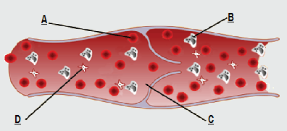

a) Giving a reason, identify the blood vessel shown above. (2 marks)
……………………………………………………………………………………………………………………………………………………………………………………………………………………
b) Name the enzymes present in A and D. (2 marks)
……………………………………………………………………………………………………………………………………………………………………………………………………………………
9.Mr. Juma has sued Serenity Hospital on grounds that their child was wrongly identified such that they got the wrong one. The child is blood group O. Mr. Juma is blood group AB while Mrs Juma is heterozygous blood group A. Work out the possible blood group of their offsprings
(4 marks)

10.
a) Name the gland on the mammalian skin that opens into the hair follicle. (1mk)
…………………………………………………………………………………………………
- State two functions of the secretions from the gland stated in (a) above. (2mks)
……………………………………………………………………………………………………………………………………………………………………………………………………
11. The chart below represents a simple respiratory pathway in cells. 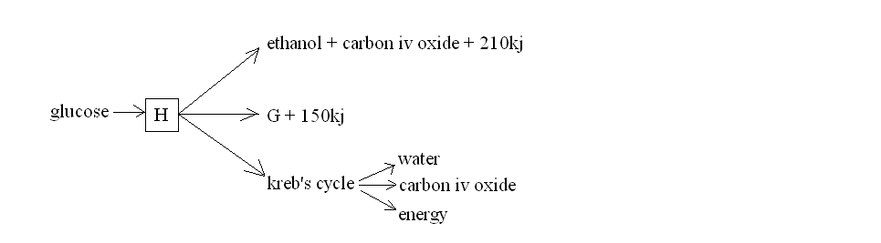
[a] Name the substance labeled; [2 marks]
H. ………………………………………………………………………………………………………
G. ………………………………………………………………………………………………………
[b] Explain briefly the reaction that occurs in the kreb’s cycle. [2 marks]
……………………………………………………………………………………………………………………………………………………………………………………………………………...……
12. The diagram below shows a part of a nephrone 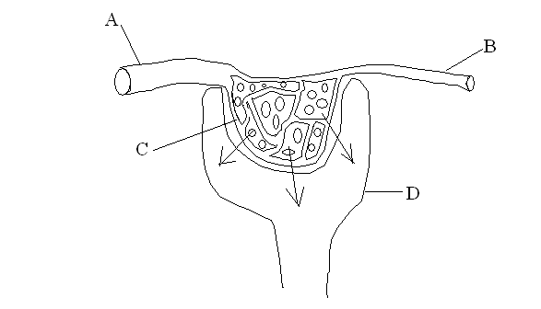
[a] Name the parts labeled; [2 marks]
A……………………………………………………………………………………………
C……………………………………………………………………………………………
[b] Explain how the fluid in D is formed. [2 marks]
……………………………………………………………………………………………………………………………………………………………………………………………………………………
13. Oil is one of the pollutants of water in major water bodies
a). In what ways is oil as a pollutant affect the following organisms:
i. Fish (1 mark)
……………………………………………………………………………………………………………………………………………………………………………………………………………………
ii. Mosquito larvae (1 mark)
……………………………………………………………………………………………………………………………………………………………………………………………………………………
iii. Aquatic birds (1 mark)
……………………………………………………………………………………………………………………………………………………………………………………………………………………
14.
(a) State the advantage of desert animals excreting their nitrogenous waste in form of urea and not ammonia. (2 marks)
…………………………………………………………………………………………………………………………………………………………………………………………………………………..
………………………………………………………………………………………………………..

(b) State two modifications on the kidney nephron of desert mammals. (2 marks)
…………………………………………………………………………………………………………………………………………………………………………………………………………………..
………………………………………………………………………………………………………..
15. Students from Heni Secondary wanted to investigate the population of crabs in their school pond. They caught 50 crabs, marked them with white paint on the cephalothorax and then released them back into the pond. After three days, they came back and caught 50 crabs of which 3 had the white mark.
- Using the data above, calculate the population of crabs in the pond (2mks)

- Suggest two assumptions the students made during this study (2mks)
………………………………………………………………………………………………………………………………………………………………………………………………………………………………………………………………………………………………………………………………………………………………………………………………………………………………………..
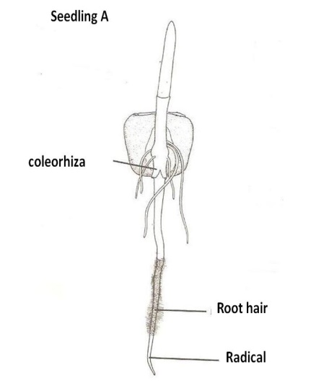
16.. The diagram below represents a stage of growth in two different seeds.

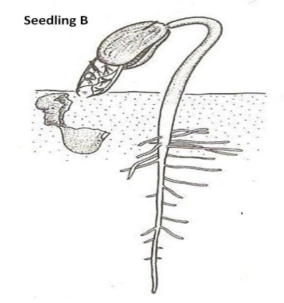

[a]

Identify the type of germination exhibited by seedlings A and B. [2 marks]
Seedling A
……………………………………………………………………………………………………
Seedling B
………………………………………………………………………………………………………
[b] State the role of oxygen during germination. [1 mark]
……………………………………………………………………………………………………
[c] Account for the loss of weight in cotyledons in germinating seeds. [1 mark]
………………………………………………………………………………………………………
17. (a) Explain how microorganisms become resistant to drugs. (2 marks)
………………………………………………………………………………………………………
(b) In the DNA sequence for the gene for sickle cell anaemia, adenine replaces thymine in a CTT triplet forming the triplet CAT. During translation of the mutant M-RNA, the amino acid valine is incorporated into haemoglobin molecule instead of glutamic acid.
Name the type of mutation described. (1 mark)
……………………………………………………………………………………………………….
18. A group of students carried out an ecological investigation on an ecosystem. They recorded the findings in the table below.
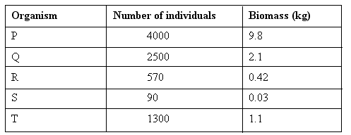
a) Write down a food chain for the ecosystem. (1 mark)
……………………………………………………………………………………………………………………………………………………………………………………………………………………..
b)
i) Which organism is the producer in the ecosystem? (1 mark)
…………………………………………………………………………………………………………
ii) Which organism would be the last to be affected if the ecosystem experienced a prolonged drought (1mk)
………………………………………………………………………………………………………………………………………………………………………………………………………………
c) Which organism recycles nutrients in ecosystem? (1 mark)
…………………………………………………………………………………………………………………………………………………………………………………………………………………….
19. The diagrams below illustrates three types of fruits.
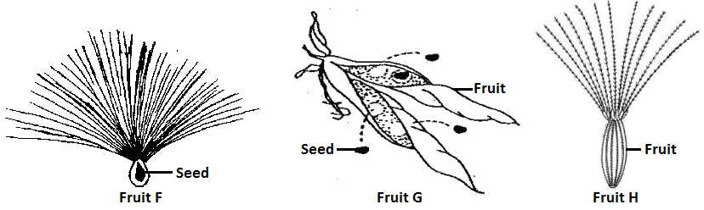
Giving a reason in each case, state:
- The mode of dispersal for fruit F and H. (2marks)
………………………………………………………………………………………………………………………………………………………………………………………………
- The type of fruit in fruit G. (1 mark)
………………………………………………………………………………………………
20. After fertilization in flowering plants has taken place, name three structures that wither off.
(3 marks)
………………………………………………………………………………………………………………………………………………………………………………………….…………………………………………………………………………………………………………………………………….
21 .A little starch solution was kept in a water bath at 37ºC. After a few minutes, the same volume of saliva was added. The experiment was left to stand for 15minutes. The mixture was then tested with Benedicts solution.
a) What would you do to the mixture after adding Benedict’s solution in order to get the valid results. (1mark) ………………………………………………………………………………………………..……………………………………………………………………………………………………………………
b) What final colour would the solution change to? (1mark) ……………………………………………………………………………………………..……………………………………………………………………………………………………….………………
c) If you added iodine instead of Benedict’s solution to the mixture of saliva and starch, what colour would the solution have? (1mark)
………………………………………………………………………………………………………
22. The following diagrams represent embryonic stages of development for various organisms.
a) Name the type of evidence for organic evolution depicted in the diagram. (1mark)
...................................................................................................................................................
b) Explain the evidence in (a) above. ( 2marks) ……………………………………………………………………………………………………………………………………………………………………………………………………………...
23. Below is a graphical representation of the effects of different concentration of auxins on shoot and root growth. Study it carefully and then answer the questions that follow.
Auxin concentration (ppm)
(a)Identify any two conclusions that can be drawn from the graph. (2marks)
……………………………………………………………………………………………………………………………………………………………………………………………………………...……
(b)Name the growth hormone responsible for ripening of fruits. (1mark)
……………………………………………………………………………………………………………………………………………………………………………………………………………...……
24. (a) Distinguish between transpiration stream and transpiration pull. (2marks)
………………………………………………………………………………………………………………………………………………………………………………………………………………………………………………………………………………………………………………………………
(b) Name the part of the mammalian heart that initiates the heartbeat. (1mark)
…………………………………………………………………………………………………………………………………………………………………………………………………………………….
25. Name the apparatus that are used in:-
(i) Catching flying insects. (1mk)
……………………………………………………………………………………………………… (ii) Attracting and trapping small animals (1mk)
………………………………………………………………………………………………………

THIS IS THE LAST PRINTED PAGE

