FORM THREE
BIOLOGY PAPER 1
NAME:………………………………………………………………………………………..CLASS:…………ADM:…………
- State three ways in which protein are important to plant. (3marks)
………………………………………………………………………………………….
……………………………………………………………………………………………………………………………………………………………………………………………………………………………………………………………………………………………………………
- The diagram below represents a cell organelle.

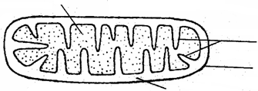
A
D
B
C

(a) Identify the organelle. (1 mark)

(b) Name the part labeled B. (1 mark)

………………………………………………………………………………..

(c) State the function of part labeled A. (1 mark)

……………………………………………………………………………………………………..

- Define binominal nomenclature. (1marks)
…………………………………………………………………………………………………………………………………………………………………………………………………..

- Name any two problems that animal species overcome by their dispersion. (2marks)
………………………………………………………………………………………………………………………………………………………………………………………………………………………………………………………………………………………………………
- Explain why tropical forests do not have undergrowth (2marks)
…………………………………………………………………………………………………………………………………………………………………………………………………………………………………………………………………………………………………
- How is blood pressure generated and maintained in a vein? (2marks)
……………………………………………………………………………………………………………………………………………………………………………………………………..
- What is the function of catalase? (2marks)
………………………………………………………………………………………………………………………………………………………………………………………………………………………………………………………………………………………………………
- (a) State the important of cross-pollination to flowering plants. (1mark)
………………………………………………………………………………………………………………………………………………………………………………………………………………………………………………………………………………………………………
(b) How is self-pollination a disadvantage to flowering plants? (1mark)
……………………………………………………………………………………………………………………………………………………………………………………………………

- What is the role of light energy in autotrophic nutrition in spermatophyte? (2 marks)
………………………………………………………………………………………………………………………………………………………………………………………………………………………………………………………………………………………………………

- How is fur important to desert animal, other than in the regulation of their body temperature?
(1mark)
…………………………………………………………………………………………………………………………………………………………………………………………………………………………………………………………………………………………………………………………………………………………………………………………………………

- What are the functions of named product of white blood cells? (3 marks)
………………………………………………………………………………………………………………………………………………………………………………………………………………………………………………………………………………………………………

- Explain three adaptations of cardiac muscles to their function. (3 marks)
……………………………………………………………………………………………………………………………………………………………………………………………………………………………………………………………………………………………………………………………………………………………………………………………………………………………………………………………………………………………………………
- A form one student trying to estimate the size of onion cells observed the following on the microscope’s field of view.

(a) Define the term resolving power. (1 mark)

(b) If the student counted 20 cells across the field of view calculate the size of one cell in micrometers. (2 marks)

- What is tidal volume in ventilation in man? (1mark)
………………………………………………………………………………………………………………………………………………………………………………………………………………………………………………………………………………………………………..

- Define peristalsis and state its importance in the nutrition of mammals. (2 marks)
……………………………………………………………………………………………………………………………………………………………………………………………………
- The diagram below shows part of plant tissue.
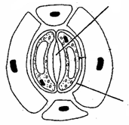
W
X

- Name cell labeled X and part labeled W. (2 marks)

X

W

- Why is the liver part of the digestive system? (2 marks)
……………………………………………………………………………………………………………………………………………………………………………………………………………………………………………………………………………………………………….

- State the importance of cytoplasmic filaments in sieve tube elements. (1 mark)
………………………………………………………………………………………………………………………………………………………………………………………………………………………………………………………………………………………………………
- State any two characteristics of populations. (2marks)
…………………………………………………………………………………………………………………………………………………………………………………………………………………………………………………………………………………………………………………………………………………………………………………………………………
- Describe any two functions of mitosis? (2 marks)
…………………………………………………………………………………………………………………………………………………………………………………………………………………………………………………………………………………………………………………………………………………………………………………………………………

- The diagram below shows the exchange of gases in alveolus.
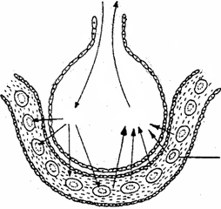
O₂
CO₂
A

- State how the alveoli are adapted to their function. (3 marks)

………………………………………………………………………………………………
……………………………………………………………………………………………………
……………………………………………………………………………………………………..
……………………………………………………………………………………………………..

(b) Name the cell labeled A. (1 mark)

……………………………………………………………………………………………………

- What are the external conditions needed, by root hair cells, for the uptake of mineral salts ions from the soil? (2 marks)
………………………………………………………………………………………………………………………………………………………………………………………………………………………………………………………………………………………………………

- The diagram below represents a pyramid of biomass derived from a certain ecosystem

Consumer
producer

(a) Suggest the type of ecosystem from which the pyramid was derived (1mk)
………………………………………………………………………………………

(b)State the significance of short food chains in an ecosystem (1mk)
……………………………………………………………………………………………………………………………………………………………………………………………

- Suggest two reasons for the appearance of glucose in the urine of a man. (2 marks)
……………………………………………………………………………………………………………………………………………………………………………………………………
- (a) State the source Carbon (IV) oxide in aquatic ecosystems. (2 marks)
...........................................................................................................................................................................................................................................................................................................
(b) State the importance of Carbon (IV) oxide to aquatic ecosystems. (2 marks)
…………………………………………………………………………………………………………………………………………………………………………………………………..

- The set up below shows apparatus to demonstrate a certain biological process
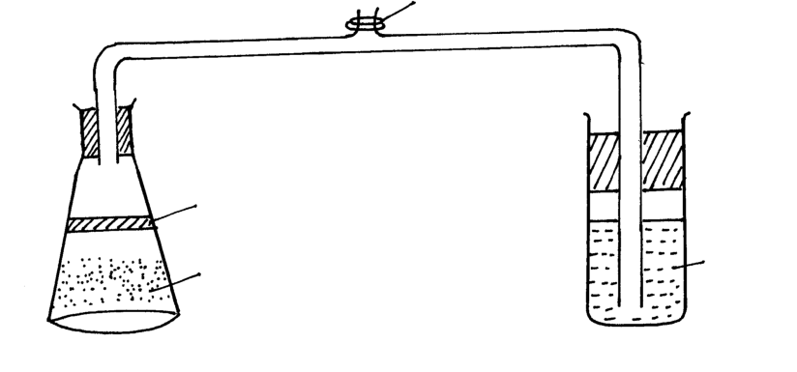
Oil
Boiled and cooled glucose plus yeast suspension
Liquid X

(a) What biological process was being investigated in the experiment (1mk)
……………………………………………………………………………………

(b)Write down a word equation that represents the reaction above (1mk)
…………………………………………………………………………………………

(c) In the above set up, why was it important to boil and cool glucose before adding yeast? (1mk)

- What is the homeostatic importance of cuticles of leaves? (2marks)
……………………………………………………………………………………………………………………………………………………………………………………………………………………………………………………………………………………………………...

- Outline two functions of parenchyma cells in herbaceous plants. (2 marks)
………………………………………………………………………………………………………………………………………………………………………………………………………………………………………………………………………………………………………..

- What is the important of diffusion to red blood cells? (2marks)
………………………………………………………………………………………………………………………………………………………………………………………………………………………………………………………………………………………………………
- The diagrams below show a pair of homologous chromosomes. Study them and answer the questions that follow.

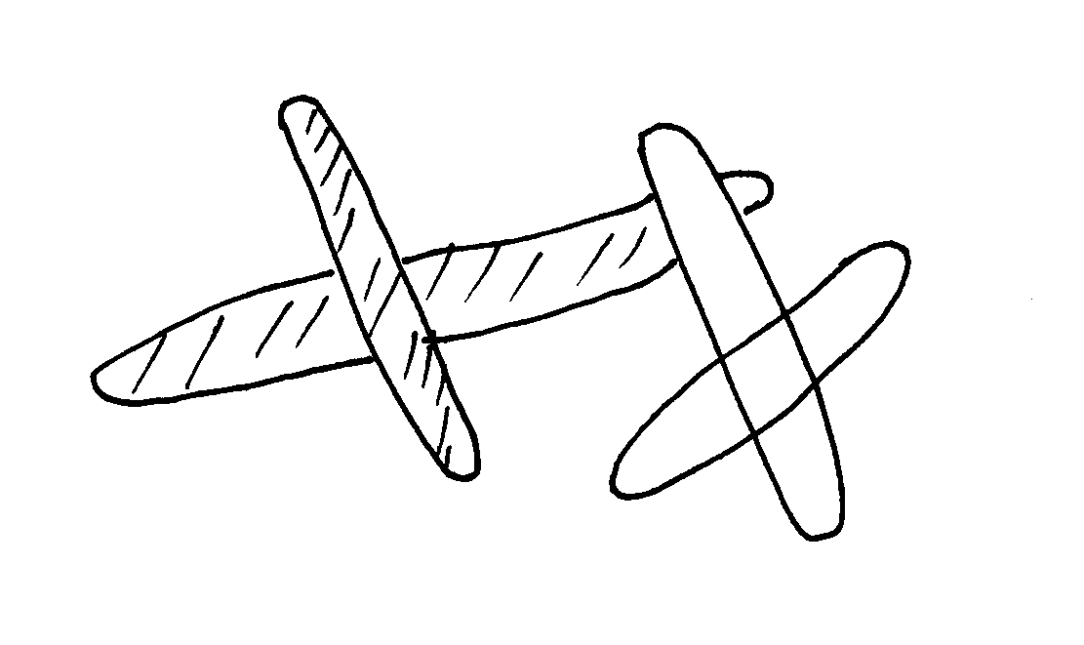

(i)State the phenomenon shown above (1mk)
………………………………………………………………………………………………
(ii) What is the genetic significance of the phenomenon above? (2mks)
……………………………………………………………………………………………………………………………………………………………………………………………………..
- Account for the thick wall and narrow lumen of an artery. (2marks)
……………………………………………………………………………………………………………………………………………………………………………………………………
- How do pathogens that enter the body through the respiratory tract in man prevented from causing diseases? (1mark)
……………………………………………………………………………………………………………………………………………………………………………………………………

- Where does the detoxification of ammonia take place in mammals? (1mark)
……………………………………………………………………………………………………………………………………………………………………………………………………

- Name the processes that take place in the grana of chloroplast. (2marks)
……………………………………………………………………………………………………………………………………………………………………………………………………

- The experiment illustrated below was set up to investigate a certain physiological process using a raw tuber
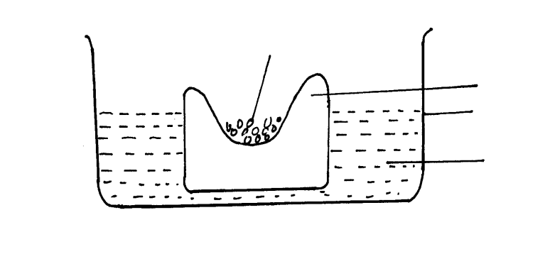
Raw potato tuber
Trough
Distilled water
Concentrated glucose solution

(a) Suggest a possible physiological process that was being investigated (1mk)
………………………………………………………………………………………………

(b) Explain the results obtained in the above experiment after a few hours (2mks)

………………………………………………………………………………………………..
(c) State the observations that would have been made if the experiment was repeated using boiled potato (2mks)
……………………………………………………………………………………………
…………………………………………………………………………………………….
………………………………………………………………………………………………
36. Name the causative organism of the following diseases
(i) Malaria (1mk)
……………………………………………………………………………………………
(ii) Bilharzia (1mk)
………………………………………………………………………………………………

