PAVEMENT NATIONAL EXAMINATION
OPENER EXAMINATION TERM ONE 2021/2021
FORM 4 PHYSICS PP2 (MARKING SCHEME)
1. B- more current was supplied by the batteries to a low resistance circuit.
2. Hard magnetic materials are difficult to magnetize though they retain the magnetism for a longer period. Soft magnetic materials are easily magnetized but don’t keep it for a longer period.
3. This is because of multiple reflection of the object and its image on each mirror
4. $n= \frac{1}{\sin{C}}$
$= \frac{1}{\sin{41}}$
= 1.524
6. $P=\frac{V^{2}}{R}$
$= \frac{240×240}{950}$
= 60.63 W
7. $Distance = 12×2+x$
= $(24 +x$) m
=$330×0.45=24+x$
148.5 = $24 – x$
$x$ = 124.5 m
8. $3.5 +\frac{5×4}{5+4}+4 =7.5+\frac{20}{9}$
= $9.72Ω$
9. $R =$ $\frac{200}{5}$
=$40Ω$
P $= VI$
= $200 × 5$
= $1000W$

10.
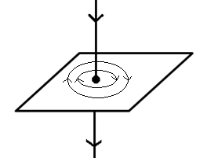
11. (a) $ɳ =\frac{Real depth}{Apparent depth}$
= $\frac{9}{9-4}$
$= 1.8$
(b) C = $\sin^{-1 }({\frac{1}{1.8}) }$
= $\sin^{-1 }({0.5556) }$
=
(c) - the critical angle must be exceeded
- the light ray must be coming from a denser medium to a rarer medium
12.
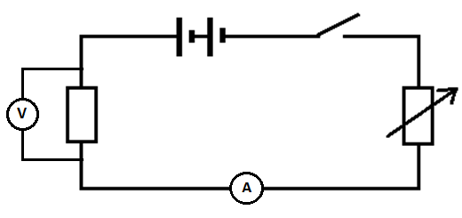
13. the majority negative charges are first attracted to the cap leading to a decrease in divergence, then minority positive charges are repelled. This leads to increase in divergence
14. I $= \frac{Q}{t}$
= $\frac{360}{15×60}$
= $0.4 A$
15. $v = \frac{3.0 ×{10}^{8}}{1.33}$
= $2.26×{10}^{8}m/s$
16. $\frac{1}{f}=\frac{1}{u}+\frac{1}{v}$
$\frac{1}{v}=\frac{1}{20}-\frac{1}{50}=0.03$
$v=33.33 cm$
The image is - real, diminished and inverted
17. (a) generator
(b) has a high resistance and melting point
(c) (i) $1500 = V×2×10×60$
V = $1.25V$
(ii) $R= \frac{{1.25}^{2}}{1500}$
= 0.00104 Ω
18.
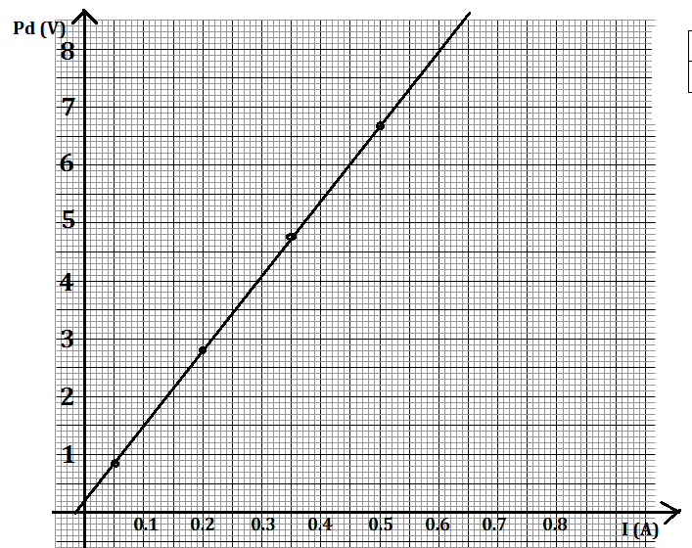
- Gradient = $\frac{0.85-0.2}{0.5-0}=1.3 Ω$
- 0.2 V
- 0.65 V

19. (a) the currevt flowing ia a circuir is direcly proportional to the potential difference across it provided temperature and other factors are kept constantt
(b) (i) $\frac{1}{3}× 3=1 A$
(ii) 3 +1 = 4 A
(iii) R = 28 +$\frac{10×30}{40}=35.5Ω$
(iv) V $= 4 ×35.5$
= 142 V
20. (a) WZ and XY
(b) anticlockwise
(c) – increase the current
- use stronger magnet
- increase the number of turns
- making sure that the coils are perpendicular to the magnetic field lines
(d) the coil rotates in the opposite direction
21. (a)
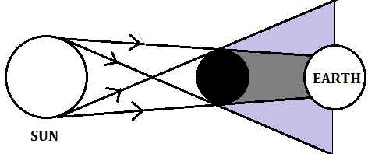
(b) it is possible since moon is rotating/moving. The shadow “moves”
(c) when the moon is far from the earth, the moons shadow is usually short and doesn’t reach he earth.

