SAMIA SUB-COUNTY JOINT EXAMINATIONS – 2021
PHYSICS PAPER 2
Marking Scheme

SECTION A: (25 Marks)
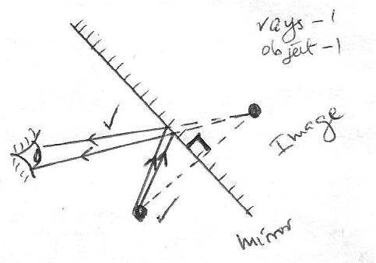
1.

- - Moving the object towards the pinhole (Reducing the object distance)
- Moving the screen away from the pinhole (increasing the image distance)

- - Leaf divergence of A decreases while the leaf divergence of B increases
- Due to the repulsion of charges in electroscope A, some charges move to electroscope B

- Formation of hydrogen gas around the copper plate insulates the electrode.

- Hammering causes the dipoles to vibrate, making them lose their alignment

Ray // to principal axis
Ray directed towards C

Erect object located

O
I
F
C

- - The rider moves to the left.
- The rider experiences a force when placed to a magnetic field according to Fleming’s left hand rule

- $T=0.5 s$
$$f=\frac{1}{0.5}$$

= 2 Hz

- - the charges in the plates induces opposite charges at ends of the mica sheet
- the induced charges produce electric field that opposes the electric field due to the plates hence reducing the resultant electric field and since V = $\vec{E}d$, V reduces

- $I= \frac{P}{V}$

= $\frac{3 000}{240}$

= 12.5 A The fuse is not suitable

- a) - the galvanometer deflects
- magnetic field in P builds up from zero to a maximum, cutting coil Q and inducing an e.m.f in it, hence current flows

- The deflection is also halved

- $N=N_{O}{\left(\frac{1}{2}\right)}^{\frac{T}{t}}$

$\frac{32}{1 024}= {\left(\frac{1}{2}\right)}^{\frac{80}{t}}= {\left(\frac{1}{2}\right)}^{5}$Accept alternative method

$$\frac{80}{t}=5$$

t = 16 days

SECTION B (55 MARKS)

- a) light is an electromagnetic/ transverse wave while sound is a mechanical/longitudinal
wave

- – it penetrates deepest
– it is easily reflected by tiny grains of sand
- - An increase in temperature increases the kinetic energy of the air particles
- This leads to an increase in the speed of sound.

d) (i) Sound becomes less audible until it cannot be heard any more.

- Steam condenses, creating a (partial) vacuum in the jar.
Sound, which requires material media for transmission, will not be heard.

- (i) - the distance between the boy and the wall
- the time taken to hear the echo

- time for 1 clap = $\frac{10}{10}=1 s$

$$d= \frac{1}{2} ×330 ×1$$

= 165 m

- a) the amount of current flowing through a conductor is directly proportional to the
potentialdifference across its ends, provided that temperature and other physical
conditions arekept constant.

V

Wire
A
S

- Close the switch and adjust the rheostat to obtain the value of current, I and the corresponding value of voltage, V. Record the values in a table.

- Repeat the experiment for other values of I and the corresponding values of V.

- Plot a graph of V against I. The graph should be a straight line through the origin

- (i)$0.8 R_{1}=10$
$$R_{1}= 12.5 Ω$$

$$0.5 \left(12.5+ R_{2}\right)=10$$
$12.5+R_{2}=20$
$R_{2}=7.5$Ω

- $R= \frac{7.5 ×12.5}{7.5+12.5}=4.688$ Ω

$$I= \frac{10}{4.688}$$

= 2.133 A

- a)- the angle of incidence in the optically dense medium is greater than the critical angle

- the ray must be travelling from optically dense medium to optically less dense medium

b) i) n = $\frac{c}{V}$
$$= \frac{3.0 × {10}^{3}}{1.88 × {10}^{8}}$$

= 1.5957
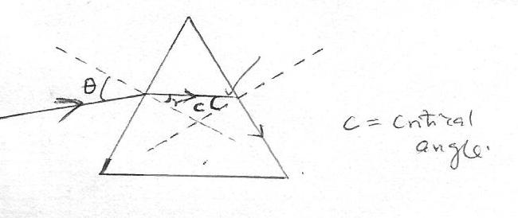

ii)
C = critical angle

$$\sin{c}=\frac{1}{n}=\frac{1}{1.5957}$$
c = sin⁻¹$\left(\frac{1}{1.5957}\right)$ = 38.81º

iii)$\frac{\sin{i}}{\sin{{21.2}^{°}}}$ = 1.5957
$θ$ = sin⁻¹ (1.5957 sin 21.2º) = 35.24°

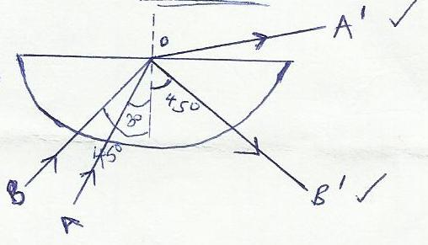
c) i)

ii) n = $\frac{1}{\sin{{42}^{o}}}$

= 1.4945

- a)i.)
-To travel at the speed of light in a vacuum
- Cause some substances to fluoresce
- Undergoes diffraction, Refraction, interference
- Penetrates matters
- Obeys the wave equation

ii.) K.E = eV = hf
f = eV/h x 5 % = 1.6 x 10⁻¹⁹ x 10000x5/60620x 10⁻³⁴ x 100

f = 1.208 x 10¹⁷ Hz

b.)- Dope a group 3 element with a pure semiconductor
- 3 outermost electrons from the group 3 element form bonds with their neighbours leaving a hole
which acts as a positive charge.
- This creates P type (positive charge) semiconductor

c) (i)Sound wave – cannot travel in a vacuum

- Cathode rays – are deflected by both magnetic and electric fields

- $E$ =h $\frac{c}{λ}$
λ = $\frac{6.23 × {10}^{-34} × 3.0 × {10}^{8}}{5.9 × {10}^{-19}}$
= $3.168 ×{10}^{-7}$m

- a)the direction of induced current is such that it opposes the change causing it

b) (i) North (N)
(ii) Change of flux linkage

c) i) N_{P} = 800, N_{S} = 40
V_{P} = 240v, I_{P} = 0.2A
$\frac{N_{S}}{N_{P}}= \frac{V_{S}}{V_{P}}\frac{40}{800}= \frac{V_{S}}{240}$
V_{S} = 12 V

ii) $\frac{Power out}{power input} ×100\%=80\%$
$$P_{S}= \frac{100\% \left(240v\right)(0.2)×80}{100\%}$$

= 38.4N

