PRE-MOCK 1, 2021

Kenya Certificate of Secondary Education
232/3 PHYSICS (Practicals)
PAPER THREE
TIME: 2½HRS
INSTRUCTIONS TO CANDIDATES
- This paper consist of two questions and Answer ALL questions in the spaces provided
- All workings MUST be clearly shown.
FOR EXAMINERS USE ONLY
PART | QUESTION | MAX SCORE | CAND SCORE
I | 11 | 19
II | A | 16
 | B | 5
 |  | 40 MKS

You are provided with the following
- Water in a beaker
- Complete retort stand
- Two clamps
- 100ml measuring cylinder
- Boiling tube
- Cotton thread
- Meter rule
- Beam balance(can be shared)
- Vernier calipers (can be shared

Proceed as follows
- a) Using the vernier calipers, measure the internal diameter of the boiling tube D=…………………………………………. (1mk)

b) Measure the length H, of the boiling tube
H=…………………………………….cm (1mk)

- Measure the mass of the boiling tube using the beam balance M=…………………………………….g (1mk)

- Clamp the boiling tube vertically with its base resting on a flat surface as shown, Use the second clamp to clamp the meter rule beside the boiling tube.

- Measure 10ml of water and pour into the boiling tube. Measure the height h, of the water. Keep adding water in small amounts in the boiling tube and complete the table below
VOLUME IN CM³/ML | HEIGHT H(CM)
10
20
35
45
50
65
(3MKS)
- On the grid provided, plot a graph of volume V(cm³) of water (y-axis) against height h(cm) (5mks)

- From the graph determine the slope, (3mks)

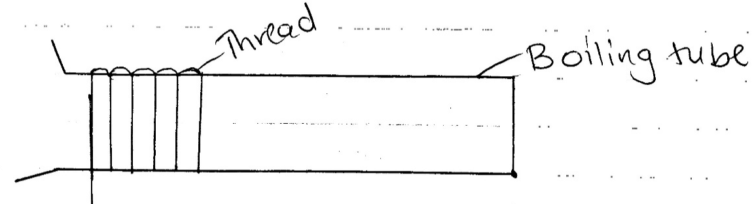
- Wind the cotton thread ten times round the boiling tube, pushing the windings very close together, the turns should not overlap on each other.

Unwind the thread and measure the length L of the thread.
L……………………….(cm) (1mk)

- Calculate the volume V,of the glass material which the boiling tube is made of, given that

V=h$\left\lceil \frac{{2L}^{2}}{2500}-5\right\rceil$
V= ………………………………………. (2mks)

- Calculate the density d, of the glass material of the boiling tube d=…………………………................... (2mks)

QUESTION 2
PART A
You are provided with the following
- A meter rule
- Convex lens
- A candle
- Len’s holder
- Cross wither mounted on a cardboard
- A white screen
Proceed as follows:-
- Set up the apparatus as shown

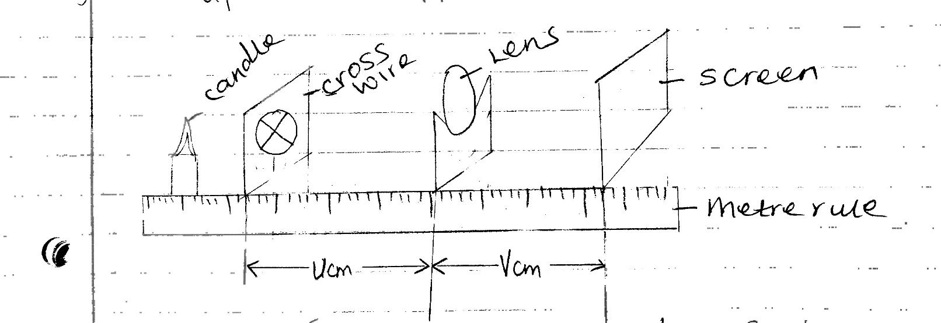

- Starting with U=30cm vary the position of the screen S until a sharp image of the cross wire is observed on the screen. Measure and record the value of the image distance V.

- Repeat the experiment above for other values of U, and complete the table below
(6mks)

U(cm) | 30 | 35 | 40 | 45 | 50 | 55
V(cm)
M= V
U

- Plot a graph of M against V (5mks)
- Determine the slope of the graph (3mk)

- The equation of the graph is given by M= $\frac{v}{f}-1$ . Use your graph to obtain the value
of f (2mks)

PART B
You are provided with the following apparatus:
- One cell and a cell holder
- Six connecting wires, two with crocodile clips
- A switch
- A 10 carbon resistor labledded R
- An Ammeter
- A voltmeter
Proceed as follows
- Set up the apparatus as shown below.
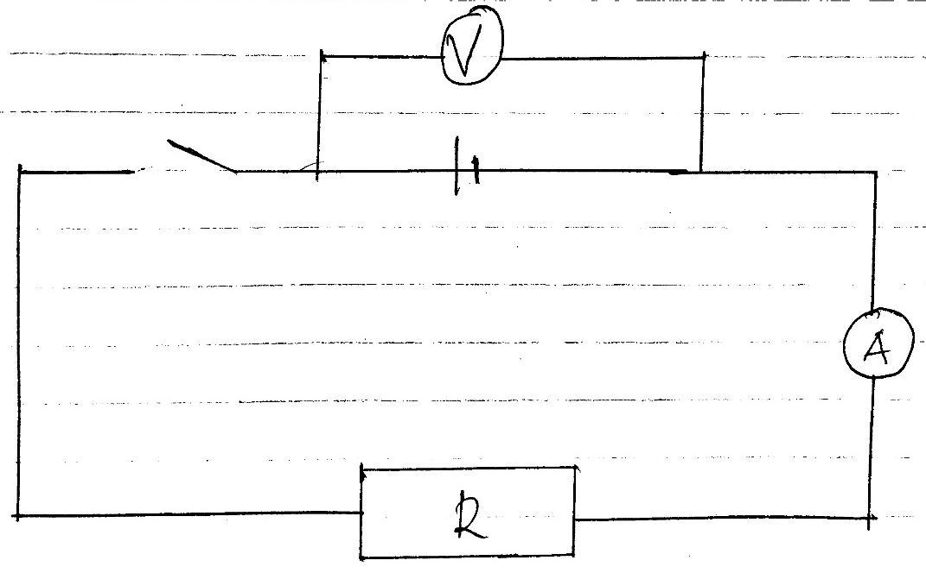

Record the reading E of the voltmeter E…………………………………….. volts (1mk)

- Close the switch and record the reading, V, of the voltmeter and I the reading of the ammeter
V= ………………………………..volts (1mk

I= ……………………….amperes (1mk)

- Given that E = v + V + 1r, determine the value of r
r………………………………….. volts (2mks)

