BURAMU II PAPER 1 MARKING SCHEME

QUESTION |  | ANSWER | MARKS
 |  | 2.55+0.05=2.60cm | 2marks
 | i) | floating wax | 1 mark
 | ii) | heat is transferred upwards by convectional current | 1 mark
 |  | Resultant force = 4+2.5-5  =1.5 to the right | 2marks
 |  | Extension in A  e =  e =  =0.7  Extension in B and C  e =  e =  =0.3  Total extension  0.7+0.3=1.0m | 3marks
 |  | 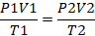  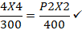  P2=10.6 ATM | 2marks
 |  | loading the roof rack raises the cog  which lowers its stability hence topples | 2marks
 |  | ρg=ρhg+pa  =900x10x0.06+100000  = 100560Pa | 3marks
 |  | 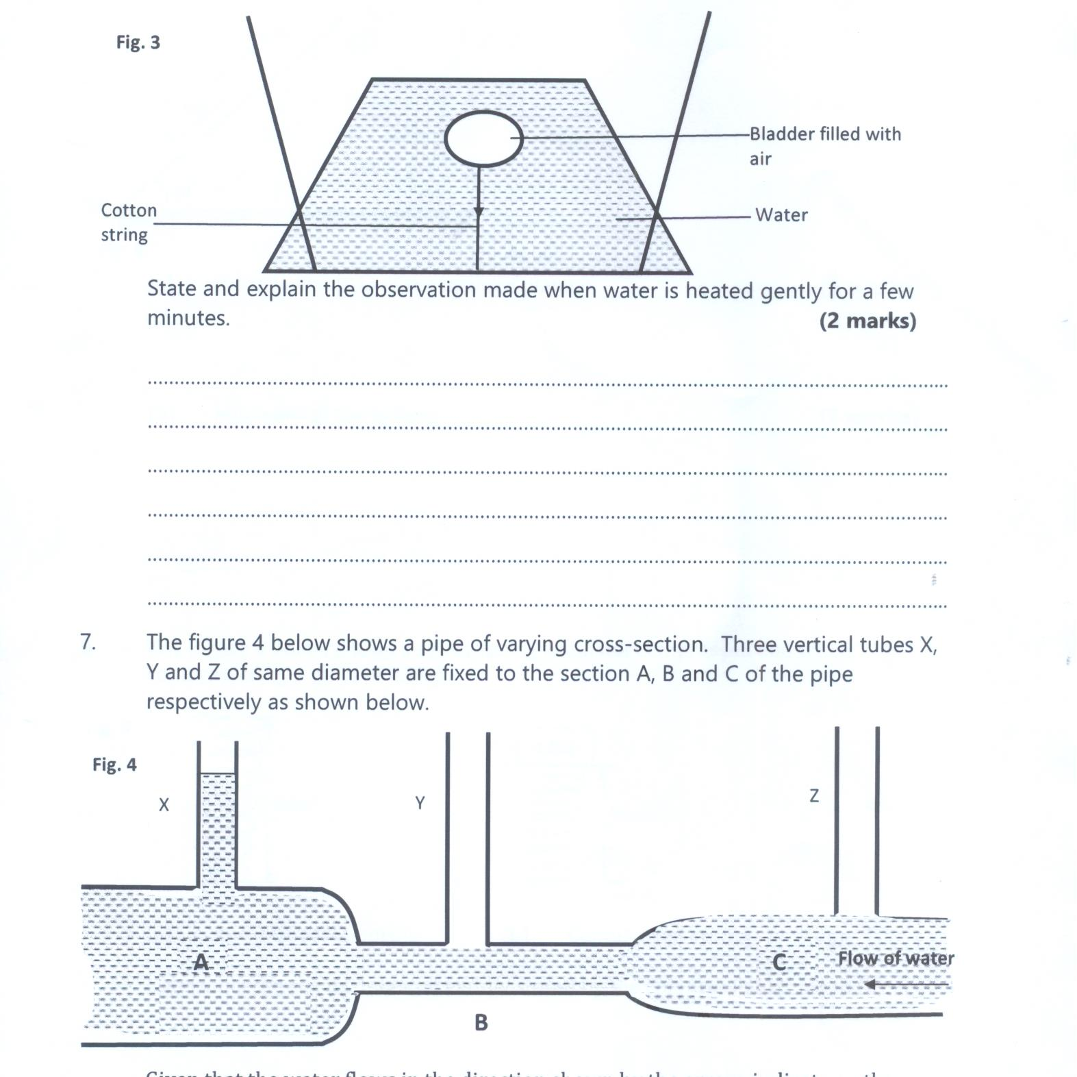
Clock wise moments= anticlockwise moments
30x2=15W
W =4
 | a) | 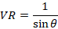  =  =2 | 1 mark
 | b) | 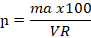  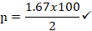  =83.5% | 2marks
 |  | bulb Q lights.  The strip contracts and bends downwards closing the contact at x making the | 2 marks
SECTION B
 | a) | When a set of bodies collide their total momentum before and after collision is always conserved.
 | b)i) | ₁u₁+m₂u₂=(m₁+m₂)v  (1200 X 15) +(600 X 0) =(1200+600) v  V=10m/s | 2marks
 | ii) | S=vt  =10x25  =250m | 2marks
 | iii) | Ft=mu-mv  Fx1.5=1200(15-10)  F=4000N | 2marks
 | iv) | Change in KE= ½ x1200x(15²-10² )  =75000J | 2marks
 | (c)i) | Weight  Upthrust | 1 mark
 | ii) | upthrust reduce.  Water is denser than air causing the upthrust to increase | 2marks
 | iii) | velocity  water  time | 2marks
 | (a) | This is the quantity of heat required to raise the temperature of a unit mass of a substance by 1K | 1 mark
 | (b) i) | The pressure by the weights lowers the melting point of the ice beneath causing the ice to melt.  The wire then conducts the latent heat of fusion to the ice below it making the wire to cut through. The process continues until the wire cuts though | 2marks
 | ii) | The thread would not cut through | 1mark
 | (c)i) | Q =mL_{f}+mcθ  Q =0.04x340000+0.04x4200(T-0)  Q=13600+136T | 2marks
 | ii) | Q=mcθ  Q=0.4x4200x(20-T)  Q=33600+1680T | 2marks
 | iii) | 13600+136T=33600+1680T  1680T-136T=13600-33600 | 2marks
 | (d) |  | 2marks
  Boiling | Evaporation
  Occurs at constant temperature | Occurs at all temperatures
  Takes place throughout the liquid | Occurs on the surface of the liquidType equation here.
 | (a) | it is the movement of particles from a region of high concentration to low concentration | 1 mark
 | (b) | Bright specs are observed to move randomly.  This is due to bombardment of smoke particles by the air particles | 2marks
 | (c) i) | To prevent water from pouring out | 1 mark
 | ii) | The salt particles occupy the spaces between the water molecules | 1 mark
 | (d) i) | denser gases diffuse slower than the less dense gases | 1 mark
 | ii) | the smaller the size the faster the diffusion | 1 mark
 | iii) | it takes a longer time to diffuse due to the lesser kinetic energy | 1 mark
 | (a) | A floating liquid displaces its own weight of fluid in which it floats | 1 mark
 | (b i) | Weight, upthrust, tension | 1 mark
 | ii) | Upthrust = weight + tension | 1 mark
 | (c)i) | U=Vρg  =11.5x10⁻⁶x800x10  =0.092N | 3marks
 | ii) | P=m/v  =0.0092/8.5x10⁻⁶  =1082.35kg/m³ | 2marks
 | iii) | U=vρg  =1082.35x11.5x10  =0.1245N | 2marks
 | (d) | 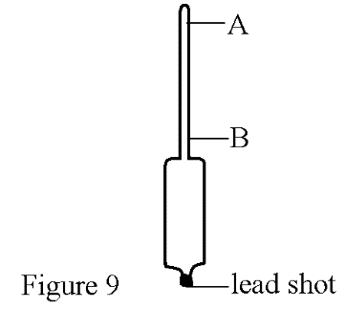  A = 1.0 and B = 1.2 | 1mark
 | (a) | This is the rate of change of angular displacement. | 1mark
 | (b) | the centripetal force holds the water in the bucket | 1mark
 | (c)i) | 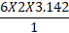  =37.702 rad/s | 1mark
 | ii) | A =  =  =62.84m/s² | 2marks
 | iii) | F=ma  =0.045x62.84  =2.8278N | 2marks
 | iv) | V = wr  = | 2marks

