FORM 1 PHYSICS – APRIL 2023 HOLIDAY ASSIGNMENT
- The mass of a lump of gold remains constant wherever it may be shifted to. Explain. (2mks)
- The water level in a burette is 30 cm³. If 55 drops of water fall from the burette and the average volume of one drop is 0.12 cm³, what is the final water level in the burette? (4mks)
- What mass of lead has the same volume as 1600 kg of alcohol? (Density of alcohol =790kg/m³, Density of lead = 11300kg/m³) (3mks)
- The mass of a density bottle of volume 50cm³ 10.0g when empty. Aluminium turnings are poured into the bottle and the total mass 60.0g.water is then added into the turnings till the bottle is full. If the total mass of the bottle and its contents is 90.0g, calculate the density of the Aluminium turnings. (5mks)
- Define force and give its SI units. (2mks)
- Name all the forces acting on the following bodies:
  - A box placed on a table (1mk)
  - A mass suspended from a spring balance (1mk)
  - A moving car negotiating a bend (1mk)
- State the type of force involved in each of the following:
  - A steel needle placed carefully on the surface of water does not sink (1mk)
  - When a small drop of detergent is placed on water, the needle moves rapidly away from it and sinks when more detergent is added. (Assume that the detergent does not affect the density of water). (1mk)
  - A match stick rubbed at one end with soap starts moving immediately in one direction when placed on the surface of water. (1mk)
  - Water wets clean surfaces of glass but not waxed ones. (1mk)
  - Water rising a narrow tube (1mk)
- a) Define surface tension (2mks)
b) How does temperature rise and impurities affect the surface tension of water? (1mk)
c) How would the surface tension of water be increased? (2mk)
- Give five differences between mass and weight (5mks)
- A man has a mass of 70kg. Calculate:
- his weight on earth, where the gravitational field strength is 10N/kg (2mk)
- his weight on the moon, where the gravitational field strength is 1.7N/kg (1mk)
- The mass of an object is 50kg. if its weight is 1000N in a certain planet, calculate the gravitational field strength of the planet. (1mk)
- What is pressure? (1mk)
- The atmospheric pressure on a particular day was measured as 750mmHg. Express this in N/m². (Take Density of mercury = 13600kg/m³ and g=10N/kg) (1mk)
- The barometric height in a town is 76cmHg. Given that the standard atmospheric pressure is 76cmHg and the density of mercury is 13600kg/m³, determine the altitude of the town. (Density of air is 1.25kg/m³) (4mks)
- The figure below shows a U-tube filled with water, mercury and another liquid:
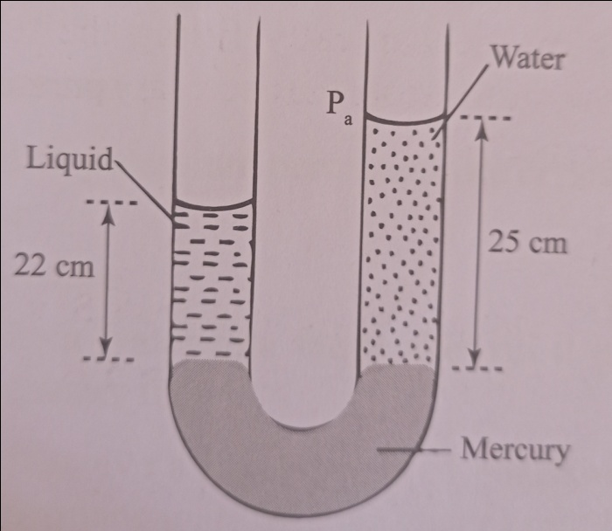
  - Determine the density of the liquid (4mk)
  - State a possible reason why mercury is used. (1mk)

