NAME ……………………………………..…… CLASS …………………………

ADM NO. …………….………………….……..….. SIGNATURE ….………..…..………..

232/3
PHYSICS
PAPER 3
PRACTICAL
TIME: 2 ¹/₂HOURS

FORM 3 END OF TERM 3 EXAMINATION 2022

INSTRUCTIONS TO CANDIDATES
- Write your name and admission number in the spaces provided
- Answer ALL the questions in the spaces provided in the question paper.
- You are supposed to spend the first 15 minutes of the 2 ¹/₂ hours allowed for this paper reading the whole paper carefully before commencing your work.
- Marks are given for clear record of observations made, their suitability, accuracy and the use made of them.
- Candidates are advised to record their observations as soon as they are made.
- Non-programmable silent electronic calculators and KNEC mathematical table may be used.
- This paper consists of 5 printed pages. Candidates should check to ensure that all pages are printed as indicated and no questions are missing

FOR EXAMINER’S USE ONLY

QUESTION MAXIMUM SCORE CANDIDATES SCORE
- 20
- 20
TOTAL 40

1. You are provided with the following apparatus:-
      - A rectangular glass slab.
      - A soft board.
      - White sheets of paper.
      - 4 optical pins.
      - Four tamp pin
NB: You should have mathematical tables / calculator, geometrical set and a transparent ruler.
Proceed as follows:
        - Fix a white sheet of paper on the soft board using tamp pins.
        - Place the glass slab on the white piece of paper. Trace the outline of the glass slap on the paper.
        - Stick two pins P₁ and P₂ so that the line joining them falls on the edge of the glass obliquely, forming an angle of 15⁰ with normal NA.
        - Stick two other pins P₃ and P₄ so that they appear to be in line with the images of object pins P₁ and P₂ in the slab as shown on the diagram below.
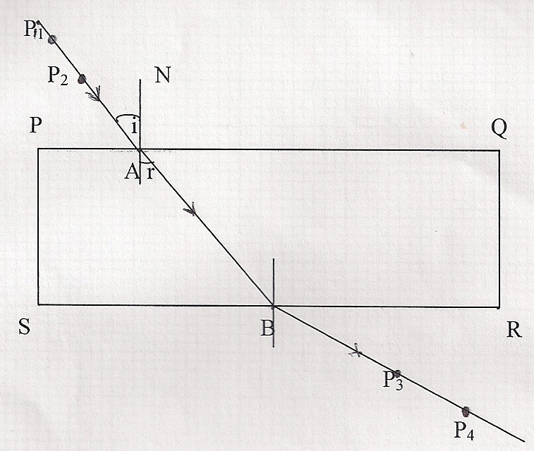
        - Now remove the slab. Draw the lines joining P₁ and P₂ and P₃ and P₄. Extend the two lines to meet the outline of the block at the points A and B respectively. The lines P₁ and P₂, AB and P₃ and P₄ show the path the ray follows as it passes from one medium to another: air to glass and back to air again. Mark the direction with arrows.

        - Measure the angle of refraction (r) between AB and the normal. Record it in the table below. Repeat the procedure for angles of incidence of 30⁰, 45⁰, 60⁰ and 75⁰ and record the values in the table below. (7mks)

Angle of incidence (i⁰) | 15⁰ | 30⁰ | 45⁰ | 60⁰ | 75⁰
Angle of refraction (r⁰)
Sin i⁰
Sin r⁰

        - Draw a graph of sin i⁰ (Y-axis) against sin r⁰ (X-axis) in the grid provided below. (5mks)

        - Determine the gradient of the graph and write down the equation of the graph. (3mks)

        - Compare the value of refractive index, ŋ, if ŋ = sin i / sin r using a point on the graph. (3mks)

        - NB: Remember to hand in the pieces of white sheet of paper you used. (2mks)

- You are provided with the following apparatus
- Two dry cells
- An ammeter
- A voltmeter
- A cell holder
- Five connecting wires
- A jockey
- A nichrome wire mounted on a mm scale labeled PQ
PROCEDURE
- Set up the apparatus as shown below

100
V
A
0
P
R
Q

Disconnect the jockey from the wire at point R and record the voltmeter reading V and the corresponding ammeter reading. (2marks)
V =........................................................................................................................................
I = ............................................................................................................................................
- Now connect the jockey at the 70cm mark and record the voltmeter reading V and the corresponding ammeter reading in the table below. Repeat for values of V and J at the 50cm, 40cm, 30cm,20cm and10cm mark (6 marks)
Length cm | 70 | 50 | 40 | 30 | 20 | 10
p.d (v)
Current I(A)

- Plot a graph of p.d (v) against current I (5marks)

- From the graph determine
  - The e.m.f of one cell (2marks)

  - The internal resistance of one cell, given that E = V + Ir (3marks)

  - The voltage p.d when current I=0.05A (1mark)

  - The current I when the p.d voltage is 1.0V (1mark)

