Name:…………………..........…………………....…Index No……………………….......
232/2 Candidate’s Signature…………………………
PHYCICS PAPER 2 Date…………...........
Time: 2Hrs.
ELDORET DIOCESE EXAM 2021
The Kenya Certificate of Secondary Education
PHYSICS
Paper 2
Instructions:
- This paper consists of TWO Sections: A and B.
- Answer ALL the questions in sections A and B in the spaces provided.
- ALL workings MUST be clearly shown.
- Mathematical tables and electronic calculators may be used.

For Examiner’s Use Only

Section | Question | Maximum Score | Candidate’s Score
A | 1 – 12 | 25
B | 13 | 12
 | 14 | 9
 | 15 | 11
 | 16 | 10
 | 17 | 8
TOTAL SCORE |  | 80

Section I (25 marks)
1. Figure 1 shows a pencil lying in front of a plane mirror. The pencil is moved 2cm towards the mirror in the same orientation.
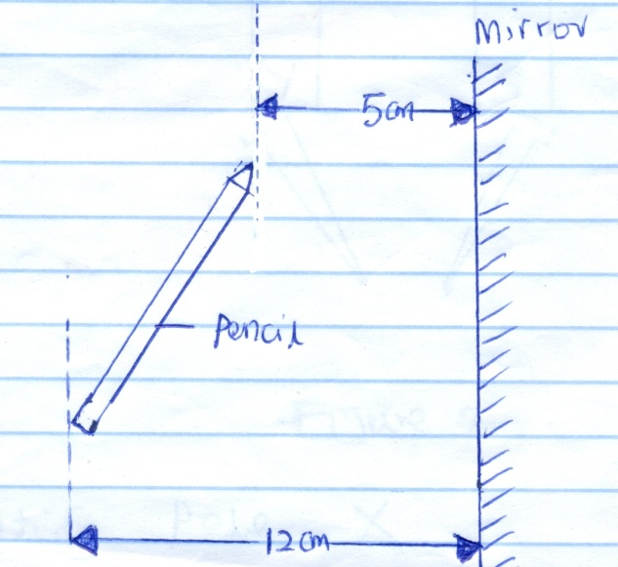
Figure 1
Determine the distance between the new position of the tip of the pencil and its image. (2mks)

2. a) State the basic law of magnetism. (1mks)

b) Figure 2 shows two bar magnets, one whose poles are labelled and a second one whose poles are labelled X and Y. Iron nails are attracted to the lower ends of the magnets as shown.

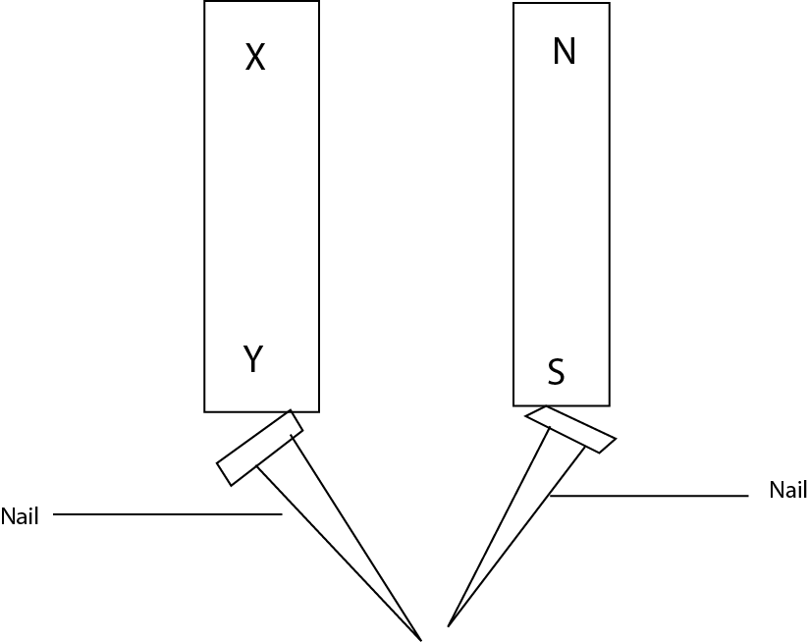
(1mk)
Figure 2
Identify pole X

3. State the reason why convex mirror is preferred over a plane mirror for use as driving mirrors in cars. (1mk)

4. Figure 3 shows the displacement-time graph for a certain wave.

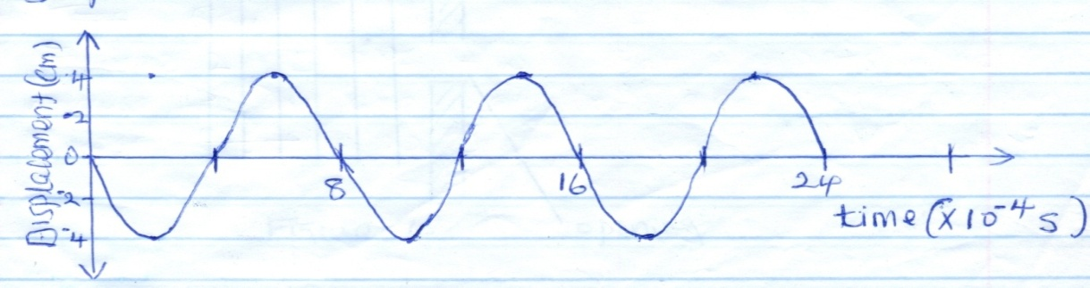

Figure 3
a) Determine the frequency of the wave. (2mks)

b) On the same diagram, draw a wave with half the amplitude and twice the frequency of the one
shown. (1mk)

5. a) State the main difference between primary chemical cells and secondary chemical cells. (1mk)

b) State how the design of a dry Lechlanche cell reduces polarization. (1mk)

6. Figure 4 shows a wave incident on a narrow opening.
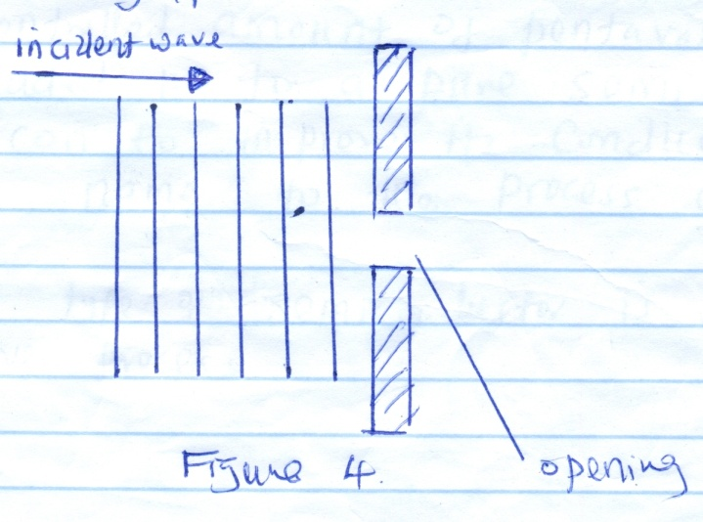

Figure 4

Draw the appearance of the wave after passing through the opening. (1mk)

7. A student stands between two classroom walls and claps. After 0.6 seconds, she hears the first echo and hears the second echo after 0.8 seconds. Determine the distance from the student to the further wall. Take speed of sound in air = 320m/s. (3mks)

8. The list below is some radiations in the electro-magnetic spectrum. Red light, Gamma rays, Ultra violet radiations and Blue light. Arrange the radiations in order of increasing wavelength. (1mk)

9. A controlled amount of pentavalent (donor) impurity atoms added in to a pure semi conductor such as silicon to improve its conductivity.
a) Give name to the process above. (1mk)

b) What type of semiconductor is obtained in the above process? (1mk)

10. Figure 5 shows the cross-section of two bar magnets and a current carrying conductor held between them. The direction of current is into the paper.
N

Conductor
S

N

S
Figure 5
a) indicate with an arrow the direction of force experienced by the conductor. (1mk)

b) State one way in which the force on the conductor above can be reduced. (1mk)

11. a) State the reason why electrical power is transmitted over long distances at very high voltage
and low current. (1mk)

b) An electric bulb is labelled 100W 20V. Determine the resistance of its filament at its operating
temperature. (2mks)

12. a) State Ohm’s law. (1mk)

b) Figure 6 shows an electrical circuit.
A
3Ω
6Ω

Switch
5V

Figure 6
Determine the Ammeter reading in a closed circuit. (2mks)

SECTION B (55 Marks)
13. a) State Lenz’s law of electromagnetic induction. (1mk)

b) Figure 7 shows stationary magnet and a solenoid being moved as shown.
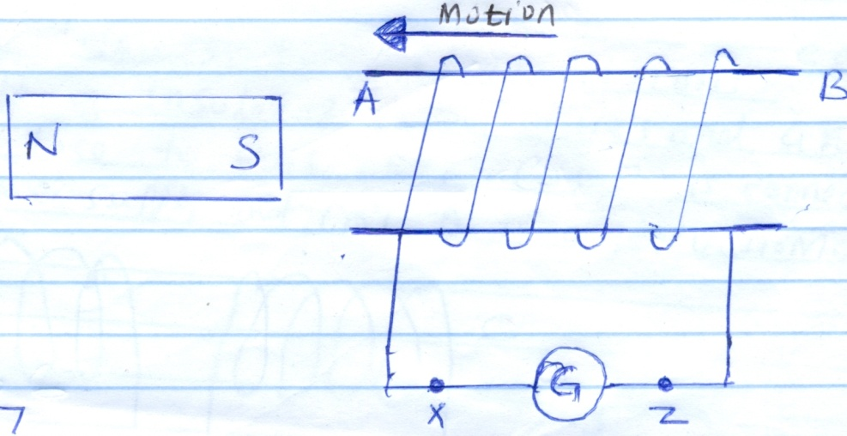
Figure 7
i) State with a reason the direction of deflection of the galvanometer. (2mks)
\

ii) State one way through which the size of deflection of the galvanometer can be decreased. (1mk)

c) State how energy losses in a transformer through eddy currents is minimized in its design.(1mk)

d) Figure 8 shows two identical coils C and D made of insulated copper wires and are placed close to each other. Coil C is connected to DC power supply and Coil D to a galvanometer.
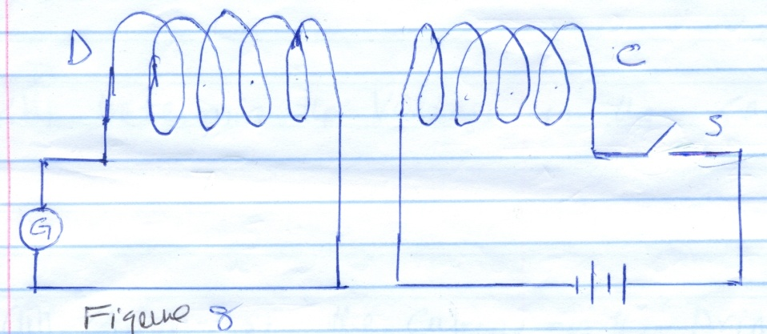
Figure 8

(i) State and explain what would be observed on the galvanometer immediately switch S is closed
and then opened. (2mks)

ii) How would the observation made in d(i) differ if the number of turns in coil C were doubled
but those in D remain unchanged? (1mk)

e) The primary coil of a transformer has 250 turns and the secondary coil has 50 turns. The
primary coil is connected to a 120V AC supply.
i) State with a reason the type of transformer described above. (1mk)

ii) Determine the voltage in the secondary coils. (1mks)

iii) Given that the current in the primary coil is 0.50A and in the secondary coil is 2.0A. Determine the efficiency of the transformer. (2mks)

14. a) State the law of electrostatic charges. (1mk)

b) Figure 9 shows a highly positively charged glass rod being brought slowly near the cap of a
negative charged gold leaf electroscope. It is observed that the leaf initially falls and then rises.

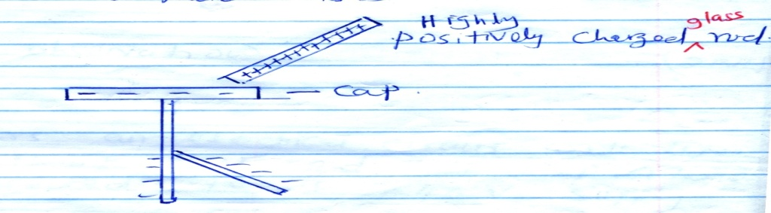

Figure 9
Explain this observation. (1mks)

c) Figure 10 shows an electric circuit used to charge a capacitor C. When switch is closed, it is
observed that, the millimeter records some current which gradually reduces to zero with time.

Power Supply

R
mA

C

Figure 10
Explain the observation (1mks)

d) Figure 11 shows an electrical circuit with three capacitors of 10μF, 2μF and 3μF capacitance
connected to a 240V supply.

2μF

3μF

10μF

240V
Figure 11
Determine

i) The effective capacitance of the capacitor combination. (2mks)

ii) The charged stored in the circuit. (2mks)

iii) The potential difference across the 2μF capacitor (2mks)

15. a) State one condition necessary for total internal reflection to occur. (1mk)

b) Figure 12 (a) shows a ray of light travelling in an optically denser medium to an optically rarer
medium. The angle of incidence i and angle of refraction r are also shown.

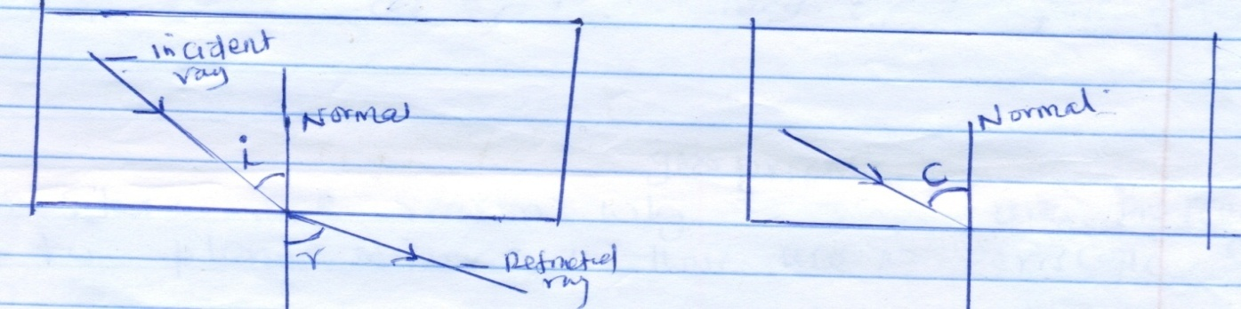

Figure 12 (a) Figure 12 (b)
Complete Figure 12 (b) to show the path of refraction ray when the angle of incidence is increased to reach critical angle. (1mk)

c) An optical pin placed at the bottom of a glass measuring cylinder filled with a liquid and appears to be 11.4cm below the surface of the liquid. If the refractive index of the liquid is 1.48. Determine The height of the column of the liquid in the measuring cylinder. (2mks)

d) i) State one reason why glass prisms are preferred to plane mirrors in their use in periscope. (1mk)

ii) Figure 13 shows two right angled glass prism arranged to be used in a periscope.
An object is placed besides one prism as shown.

object

eye

Figure 13
Complete the diagram by showing the path of rays of light from the object until they reach the eye. (1mk)

e) In an experiment to determine the focal length of a lens, you are provided with the following
apparatus.
- A converging lens and a lens holder
- A lit candle
- A metre rule
- A white screen
i) State one measurements that you would take in the experiment. (1mk)

ii) In another experiment similar to the above, a graph showing the relationship between and was plotted as shown in figure 13.

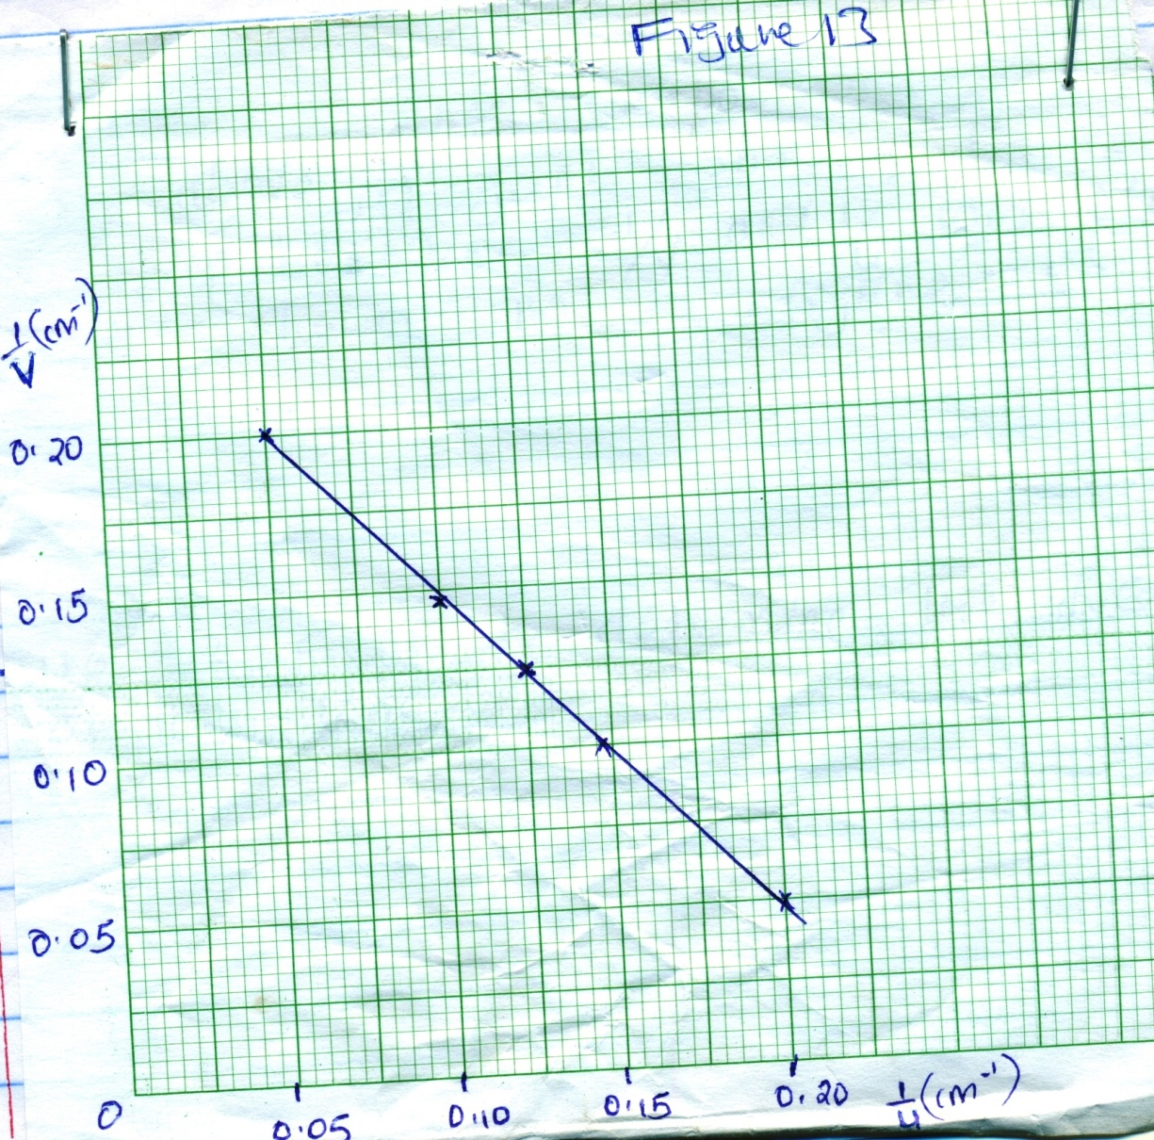

- Use the graph to determine the focal length, f of the lens. (2mks)

e) Figure 14 shows a defeat of the eye

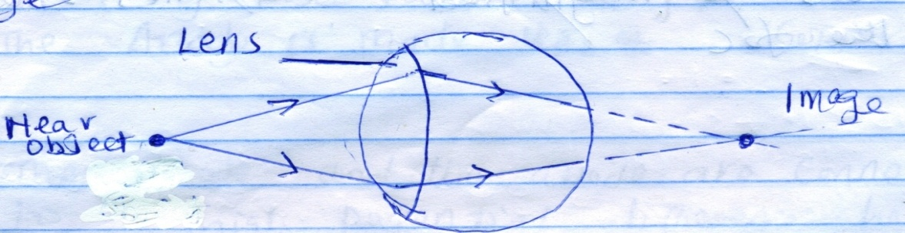

Figure 14

i) State two possible causes of the defect. (2mks)

ii) Explain how the defect is corrected. (1mk)

16. a) i) In an X-ray tube explain why
I. The anode is made up of copper. (1mk)

II. The cathode and the anode are connected to a high potential difference between them. (1mk)
ii) State the adjustments made in an X-ray tube in order to decrease the intensity of X-ray. (1mk)

iii) State the property of X-rays that makes it used in detecting foreign objects in human bodies.
(1mk)

b) i) Explain the meaning of the term photoelectric effect. (1mk)

ii) A monochromatic light frequency 6.25 x 10¹⁴ Hz is incident on a metal surface. The minimum
frequency that can cause photo emmission on the metal surface is 5.5 x 10¹⁴Hz. Given that Planck’s constant, h is 6.63 x 10⁻³⁴ Js.
Determine
I. The energy of the source light. (2mks)

II. The work function of the metal surface. (2mks)

III. The average kinetic energy of the photo electrons. (2mks)

17. a) Figure 15 shows some features of a cathode ray tube.

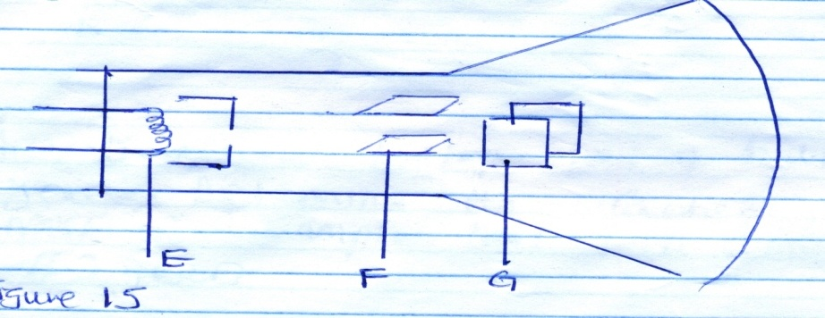
Figure 15
i) Name parts E & F (2mks)

ii) The process through which electrons are produced. (1mk)

b) i) Alpha (α) particles cause more ionization in a gas compared to Beta (β) particles. Give one
reason for this. (1mk)

ii) The following is part of radioactive decay series. The symbols do not represent the actual
symbols of the nuclides.
β
α
Determine the values of a and b (2mks)

iii) A radioactive Isotope has a halflife of 5.25 years. Determine the fraction of the original
mass in a sample that will remain after 42 years (2mks)

