MOMALICHE JOINT EXAMINATION

232/2

PHYSICS PAPER 2

Name…………………………………………………………Class…………..Adm……………..

Candidate’s signature……………………Date…………………..INDEX NO:……………….

Instructions to candidates:
- Write your name, index number in the spaces provided above.
- Sign and write the date of the examination in the spaces provided.
- This paper consists of TWO Sections: A and B.
- Answer ALL the questions in section A and B in the spaces provided.
- All working MUST be clearly shown.
- KNEC mathematical tables and silent non-programmable electronic calculators may be used.

This paper consists of 13 printed pages.
- Candidate should check the question paper to ascertain that all the pages are printed as indicated and that no questions are missing.
- Candidates should answer the questions in English.

For Examiners Use Only

Section | Question | Maximum score | Candidate’s score
A | 1 – 12 | 25
B | 13 | 09
 | 14 | 15
 | 15 | 15
 | 16 | 9
 | 17 | 07
 | TOTAL SCORE | 80

SECTION A (25 MARKS)
Answer All the questions in this section in the spaces provided
- Figure 1 shows the path of a ray of light after striking two mirrors at an angle. Determine the angle between the two mirrors. (Show your working) (1 mark)

Figure 1
𝟒𝟎° 𝟒𝟎°

……………………………………………………… ……………………………………
…
- Polarization is a defect of a primary cell.
  - Define polarization (1 mark)
………………………………………………………………………………………………
………………………………………………………………………………………………
  - State the other defect. (1 mark)
………………………………………………………………………………………………
- Determine the time it will take a ray of light to traverse a transparent glass block of length 20 𝑐𝑚 given that the velocity of light in air is 3.0 × 108 𝑚𝑠−1. (Take the absolute refractive index of glass as 1.5) (3 marks)
………………………………………………………………………………………………
………………………………………………………………………………………………
………………………………………………………………………………………………
………………………………………………………………………………………………
………………………………………………………………………………………………
………………………………………………………………………………………………
- State one other factor that increases the speed of sound in solid a part from increase in temperature. (1 mark)
………………………………………………………………………………………………
………………………………………………………………………………………………

- Figure 2 shows an object placed at the center of curvature of a concave mirror. Draw a ray diagram to show how the image of the object is formed by the mirror.
O
C
F
P

(2 marks)

Figure 2

- A charge of 240 𝜇𝐶 flows through a conductor of resistance 4 𝑘Ω in 2 𝑚𝑖𝑛𝑢𝑡𝑒𝑠. Determine the work done to move the charge through the conductor. (3 marks)
…………………………………………………………………………………………………………

…………………………………………………………………………………………………………………..

…………………………………………………………………………………………………………………..

………………………………………………………………………………………………………..

- State the reason why radio signals have clear reception than television signals in area that is surrounded by hills. (1 mark)
…………………………………………………………………………………………………………

…………………………………………………………………………………………………………………..

………………………………………………………………………………………………………………….

- A physics student dipped a bar magnet into iron fillings during an experiment in the lab. When the student lifted the bar magnet, the distribution of iron fillings around the bar magnet was as shown in Figure 4.

Iron fillings
N
S

Figure 4

Bar magnet

State the conclusion the student made. (1 mark)
…………………………………………………………………………………………………………
………………………………………………………………………………………………………….
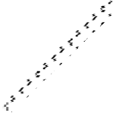
- Figure 3 shows a copper rod AB lying across two metal rods L and M which are fixed onto a plastic support and also connected to a battery.
N
Plastic support
B
M
R
L
A
S

Figure 3

U-shaped magnet K

(i) Indicate on the diagram the direction of force experienced on the copper rod AB.

(1 mark)
(iii)State the direction of force on copper rod AB if the direction of both current and magnetic field are reversed simultaneously. (1 mark)
……………………………………………………………………………………………………….
(iv)State one way of increasing the force on the copper rod AB. (1 mark)
…………………………………………………………………………………………………………
…………………………………………………………………………………………………………

- State one advantage and one disadvantage of using a convex mirror as a driving mirror. (2 marks)

Advantage:
………………………………………………………………………………………………............

……………………………………………………………………………………………………….

……………………………………………………………………………………………………….

Disadvantage:
……………………………………………………………………………………………………….
……………………………………………………………………………………………………….
……………………………………………………………………………………………………….

- Give a reason why a pinhole camera forms a blurred image of an object in front of it if the diameter of the pinhole is reduced to less than 1.00 𝑚𝑚. (1 mark)
………………………………………………………………………………………………
………………………………………………………………………………………………
………………………………………………………………………………………………

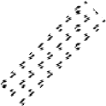
- Figure 5 below shows a ferromagnetic material PQ being magnetized.
Permanent S
magnet
N
P
Q

Path of magnet

Figure 5

  - (I)State the method of magnetization being used.

(1 mark)

………………………………………………………………………………………………
(II)State the pole acquired at P. (1 mark)
………………………………………………………………………………………………
(b) The figure below shows how a distant object is focused in a defective eye.

i) State the nature of the defect. (1mark)
…………………………………………………………………………………………..........................

…………………………………………………………………………………………………………….
- On the same diagram, sketch the appropriate lens to correct the defect and sketch rays to show the effect of the lens. (2 marks)

SECTION B (55 MARKS)

Answer All the questions in this section in the spaces provided.

- (a) When current flows through a coil of nichrome wire in an electrical circuit, the wire becomes very hot.
- Give a reason why the nichrome wire becomes very hot. (1 mark)
………………………………………………………………………………………………
………………………………………………………………………………………………
………………………………………………………………………………………………

- Give a reason why heat is produced only across nichrome wire and not across other devices in the circuit. (1 mark)
………………………………………………………………………………………………
………………………………………………………………………………………………

(iii) State one factor that determines the amount of electrical energy converted to heat energy by nichrome wire. (1 mark)
………………………………………………………………………………………………
………………………………………………………………………………………………
………………………………………………………………………………………………

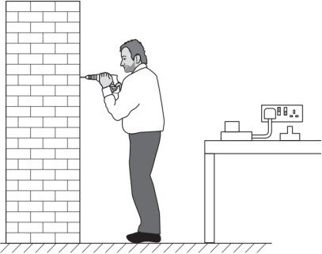
(b) Figure 6 shows a workman using a cordless electric drill.

Figure 6
The motor of the drill is powered by a rechargeable battery with an e.m.f. of 23 V. When the drill is used, the power supplied to the motor is 550 W. The workman uses the drill for 1 hour and 30 minutes. Calculate;
- The electrical energy supplied to the motor. (3 marks)
………………………………………………………………………………………………
………………………………………………………………………………………………

- The charge that the battery supplies. (3 marks)
………………………………………………………………………………………………
………………………………………………………………………………………………

- (a) (i) Distinguish between a transverse wave and a longitudinal wave. (1 mark)
………………………………………………………………………………………………
………………………………………………………………………………………………
………………………………………………………………………………………………
………………………………………………………………………………………………
(ii) State one example of a transverse wave and a longitudinal wave. (2 marks)
Transverse wave: …………………………………………………………………………
Longitudinal wave: ………………………………………………………………………
- Figure 7 (a) shows a wave profile for a pendulum bob X released from point P and allowed to swing through Q to R and back a number of times as shown in Figure 7 (b).

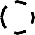
P R
0.04
0
1.0
2.0
3.0
t (𝒔)
-0.04
Displacement (m)

Figure 7 (a)
Q

Figure 7 (b)

- Determine the amplitude of the wave. (1 mark)
………………………………………………………………………………………………
- Calculate the frequency of the wave. (3 marks)
………………………………………………………………………………………………
………………………………………………………………………………………………

- Sketch a wave profile on the same axes for a similar pendulum bob Y released from point R and oscillating on its own path through Q to P and back a number of times at the same frequency but with half-amplitude as the pendulum bob X.

(2 marks)
- In an experiment to observe the interference of light waves, a double slit was placed close to the source of monochromatic light as shown in Figure 8.

Figure 8 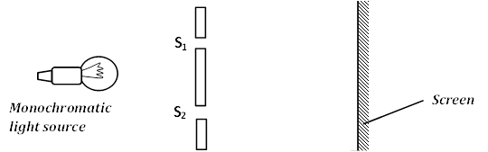
- State one condition for interference to occur. (1 mark)
……………………………………………………………………………………………...

- State the function of the double slit. (1 mark)
………………………………………………………………………………………………
(iii)State the observation made on the screen. (1 mark)
………………………………………………………………………………………………
………………………………………………………………………………………………
(iv)Explain the observation made on the screen. (2 marks)
………………………………………………………………………………………………
………………………………………………………………………………………………
………………………………………………………………………………………………
………………………………………………………………………………………………

- State what would happen if the monochromatic light source was replaced with white light source. (1 mark)
………………………………………………………………………………………………
………………………………………………………………………………………………
……………………………………………………………………………………………….
- (a) Define critical angle. (1 mark)
………………………………………………………………………………………………
………………………………………………………………………………………………
………………………………………………………………………………………………
- There are two conditions necessary for total internal reflection to occur. One is that the ray of light must be moving from an optically denser medium to a rarer medium. State the other condition. (1 mark)
………………………………………………………………………………………………
………………………………………………………………………………………………
………………………………………………………………………………………………
- Figure 9 shows the interface between water and diamond.
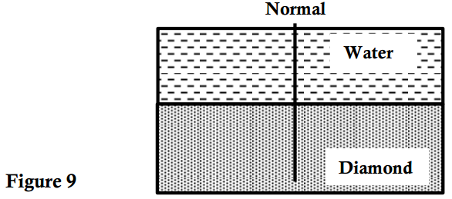
- Draw on the figure a ray diagram to illustrate the critical angle C. (2 marks)
- Calculate the critical angle C given that n =⁴ and n =2.42. (3 marks)

a w 3 a d

………………………………………………………………………………………………
………………………………………………………………………………………………
………………………………………………………………………………………………
- Figure 10 shows a small piece of an optical fibre cable.

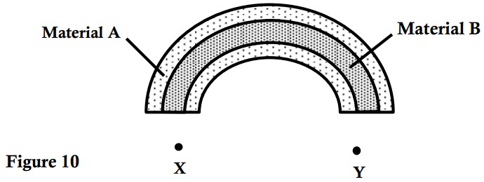
(i)State which material has a higher refractive index. (1 mark)
………………………………………………………………………………………………
(ii)A ray of light enters the optical fibre at X and emerges from Y.
  - Sketch the path of the ray through the optical fibre. (1 mark)
  - State the reason why light travels through the fibre as in (i) above. (1 mark)
……………………………………………………………………………………………………….
………………………………………………………………………………………………………
………………………………………………………………………………………………………
(iii) State one advantage of optical fibre over conventional copper cables as used in telecommunication. (1 mark)
………………………………………………………………………………………………………
………………………………………………………………………………………………………
(iv)Apart from its use in telecommunication, state any other application of optical fibre cable. (1 mark)
………………………………………………………………………………………………………….
…………………………………………………………………………………………………………..
(e) The diagram shows an arrangement of lenses; Lo and Le used in a compound microscope F0 and Fe are principal foci of L₀ and L_{e} respectively. Draw the rays to show how the final image is formed in the microscope. (3 marks)
O
L₀
F_{o}
F_{o}
F_{e}
F_{e}
L₀

16.(a) Define electromotive force (e.m.f) of a cell. (1 mark)
……………………………………………………………………………………………………….
………………………………………………………………………………………………………..
……………………………………………………………………………………………………….
(b) Figure 11 shows ammeters, resistors and a voltmeter connected to a battery of
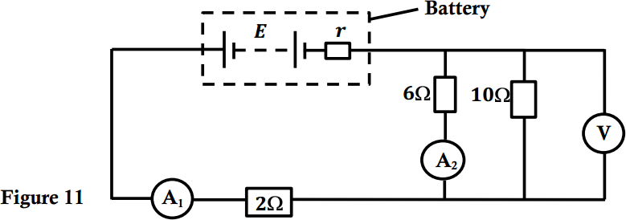
e.m.f 𝐸 and internal resistance 𝑟 of 0.25 Ω. The reading of ammeter 𝐴₂ is 2.0 A.

Calculate the;
- Total resistance of the circuit. (2 marks)
………………………………………………………………………………………………………..
…………………………………………………………………………………………………………
…………………………………………………………………………………………………………
………………………………………………………………………………………………………..
- Voltmeter reading. (3 marks)
……………………………………………………………………………………………………….
……………………………………………………………………………………………………….
………………………………………………………………………………………………………
………………………………………………………………………………………………………
(iii) Reading of ammeter 𝐴₁. (1 mark)
……………………………………………………………………………………………………….
……………………………………………………………………………………………………….
……………………………………………………………………………………………………….
……………………………………………………………………………………………………….

(iv)e.m.f, E of the battery. (2 marks)
………………………………………………………………………………………………………..
………………………………………………………………………………………………………..
………………………………………………………………………………………………………..
- (a) Define capacitance of a capacitor. (1 mark)
……………………………………………………………………………………………………….
……………………………………………………………………………………………………….
- Figure 12 shows three capacitors connected to a battery of voltage 12 𝑉.
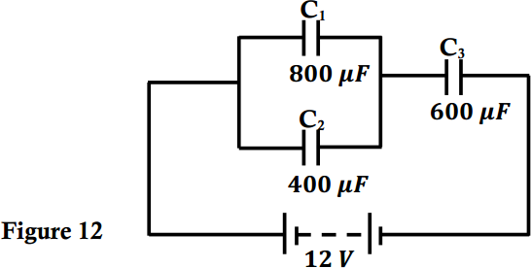
- Calculate the effective capacitance of the arrangement. (2 marks)
…………………………………………………………………………………………………………
………………………………………………………………………………………………………….
…………………………………………………………………………………………………………..
- Calculate the charge on the 6 μF capacitor. (3 marks)
…………………………………………………………………………………………………………
…………………………………………………………………………………………………………
…………………………………………………………………………………………………………
…………………………………………………………………………………………………………
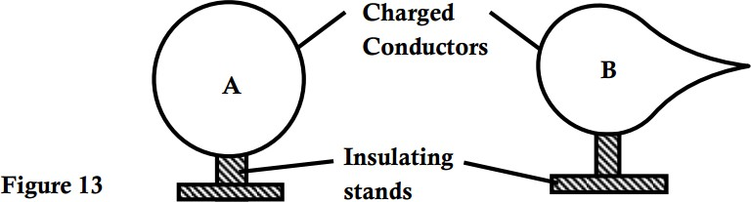
- The conductors A and B in Figure 13 are positively charged and each placed on insulating stands. Show the distribution of charges on conductors A and B. (2 marks)

THIS IS THE LAST PRINTED PAGE

