**Name**: **………………………………………………………. Reg. No……………..Class………**

**232/2**

**FORM FOUR**

**PHYSICS**

**2021/2022**

*2 hours*

**PAVEMENT FORM 4 TRIAL 2 EXAMINATION 2021/2022**

**Kenya certificate of secondary education (K.C.S.E)**

**PHYSICS PAPER 2**

*2 hours*

**INSTRUCTIONS TO CANDIDATES**

* *This paper consists of* ***20*** *questions.*
* *Answer* ***ALL*** *the questions in the spaces provided.*
* ***ALL*** *working* ***MUST*** *be clearly shown.*
* ***ALL*** *numerical answers* ***MUST*** *be expressed in decimal forms.*

**FOR EXAMINER’S USE ONLY**

|  |  |  |  |
| --- | --- | --- | --- |
| **Section** | **Question** | **Maximum**  **Score** | **Candidate’s**  **Score** |
| **A** | 1 – 13 | 25 |  |
| **B** | 14 | 12 |  |
| 15 | 13 |  |
| 16 | 10 |  |
| 17 | 12 |  |
| 18 | 08 |  |
|  | **Total Score** | **80** |  |

*Candidates should check the question paper to ascertain that all the pages are printed as indicated and that no questions are missing*

**SECTION A (25 Marks)**

***Answer all the questions in this section in the spaces provided***

1. The following diagram shows the path of light after striking two mirrors at an angle.



Determine the angle between the two mirrors. **(2mark)**

.....................................................................................................................................................................................................................................................................................................................................................

1. The figure shows the eye defect

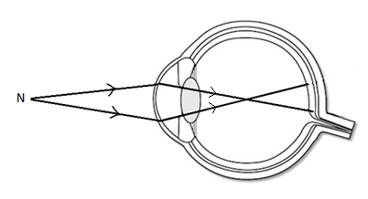

1. Name the defect  **(1mark)**

...........................................................................................................................................................................

1. State how the defect can be corrected. **(1mark)**

........................................................................................................................................................................... ...........................................................................................................................................................................

1. Explain why a plain sheet of paper and a plane mirror both reflect light yet only the plane mirror formsimages while paper cannot form images. **(2 marks)**

..............................................................................................................................................................................................................................................................................................................................................................................................................................................................................................................................

1. What property of light is suggested by the formation of shadows? **(1 mark)**

…………………………………………………………………………………………………………………

1. An object placed **15 cm** from a convex lens forms an upright image which is magnified two times. Determine the focal length of the lens. **(3 marks)**

…………………………………………………………………………………………………………………………………………………………………………………………………………………………………………………………………………………………………………………………………………………………………………………………………………………………………………………………………………

1. State **one** advantage of a lead-acid accumulator over a nickel-iron accumulator. **(1 mark)**

……………………………………………………………………………………………………………………………………………………………………………………………………………………………………

1. An electric bulb rated, **40W** is operating on **240 V** mains. Determine the resistance of its filament.

**(3 marks)**

…………………………………………………………………………………………………………………………………………………………………………………………………………………………………………………………………………………………………………………………………………………………………………………………………………………………………………………………………………

1. Explain why earthing is necessary in the domestic wiring circuit. **(1 mark)**

……………………………………………………………………………………………………………………………………………………………………………………………………………………………………

1. A positively charged rod is brought near the cap of a leaf electroscope. The cap is the earthed momentarily by touching with the finger. Finally, the rod is withdrawn. The electroscope is found to be negatively charged. Explain how this charge is acquired. **(2 marks)**

……………………………………………………………………………………………………………………………………………………………………………………………………………………………………………………………………………………………………………………………………………………………………………………………………………………………………………………………………………………………………………………………………………………………………………………………

1. The force on a conductor carrying a current in a magnetic field can be varied by changing, among others, the magnitude of the current and the magnetic field strength. Name any other factor that can be changed to vary the force. **(1 mark)**

……………………………………………………………………………………………………………………………………………………………………………………………………………………………………

1. The table below carries information on the type of radiation, detector and use for some of the electromagnetic radiations.

|  |  |  |
| --- | --- | --- |
| **Type of radiation** | **Detector** | **Use** |
| Microwave | Crystal detector, solid state diodes | ...................................................... |
| ...................................... | Thermopile, blackened bulb thermometer | Warmth sensation |

Fill in the blank spaces. **(2 mark)**

1. The figures below show a convex mirror and a plane mirror of equal aperture

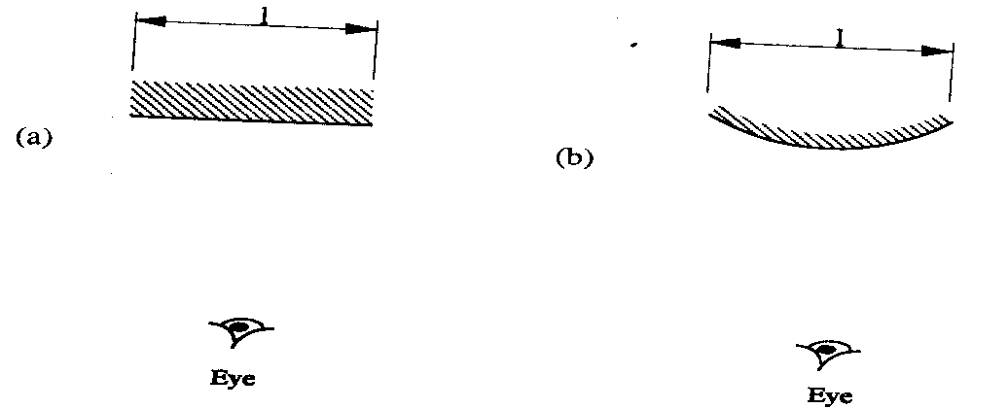

By sketching a pair of incident and reflected rays for each(a) and (b) show how the convex mirror provides to the eye, a wider field of view than a plane mirror. **(2marks)**

1. Water is flowing in a very narrow stream from a water tap (faucet). A negatively-chargedplastic strip is held close to the stream of water, as shown in the figure below.

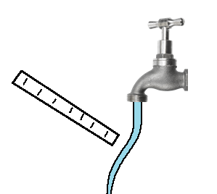

The stream of water moves towards the plastic strip.Explain whythis observation. **(2mark)**

..............................................................................................................................................................................................................................................................................................................................................................................................................................................................................................................................................................................

**SECTION B (55 Marks)**

*Answer all the questions in this section in the spaces provided*

1. **(a)** State Faradays law of electromagnetic induction. **(1 mark)**

.....................................................................................................................................................................................................................................................................................................................................................

**(b)** The primary coil of a transformer has 1200 turns and the secondary coil has 60 turns. The transformer is connected to a 240V a.c source. Determine

1. The output voltage. **(3 marks)**

 ........................................................................................................................................................................................................................................................................................................................................................................................................................................................................................................................................................................................................................................................................................................

**ii)** The output current when the primary coil has a current of 0.5A (Assume there is no energy losses)

**(3 marks)**

................................................................................................................................................................................................................................................................................................................................................................................................................................................................................................................................................................................................................................................................................................

**iii)** One of the primary ways in which power is lost in transformers is through eddy currents. State how eddy currents can be minimized. **(1 mark)**

........................................................................................................................................................................

**(c)** Determine the cost of using an electric iron rated 1500W, for a total of 30 hours given that the cost of electricity per kwh is Ksh 8. **(3 marks)**

................................................................................................................................................................................................................................................................................................................................................

**(d)** The figure below shows a coil and a magnet being removed from the coil.



Indicate the direction of flow of current on the coil. **(1 mark)**

1. Study the circuit diagram below and answer the questions that follow

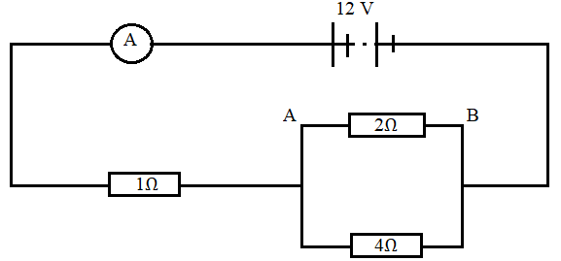

1. Calculate
2. The current flowing through the ammeter. **(3 marks)**

..............................................................................................................................................................................................................................................................................................................................................................................................................................................................................................................................................................................................................................................................

1. The PD across AB **(2 marks)**

..............................................................................................................................................................................................................................................................................................................................................................................................................................................................................................................................................................................................................................................................................................

1. The current through the 4Ω **(2 marks)**

..........................................................................................................................................................................................................................................................................................................................................................................................................................................................................................................................................

1. The graph below shows relationship between voltage and the current obtained from an experiment performed by form 4 students.

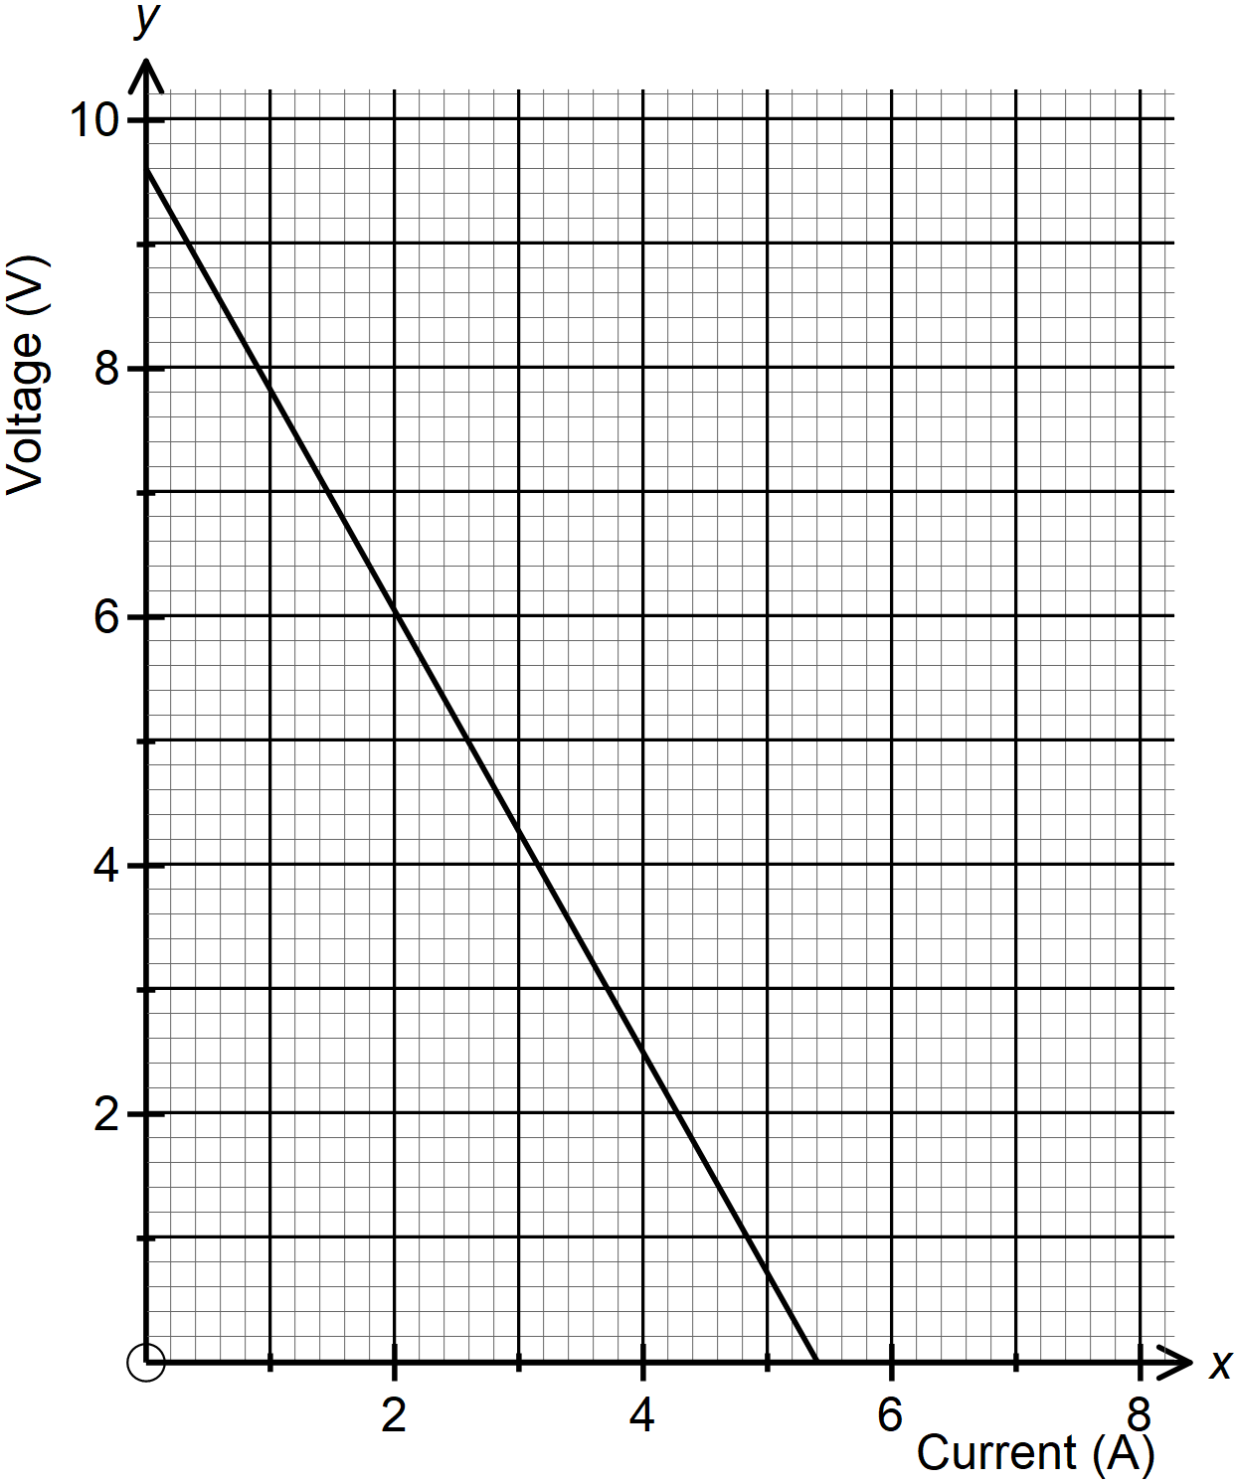

1. Draw a circuit that could be used to obtain the results shown on the graph. **(1 mark)**

.......................................................................................................................................................................................................................................................................................................................................................................................................................................................................................................................................................................................................................................................................

1. From the graph determine the emf of the battery used give the relation $E=IR +Ir$**(3 marks)**

.......................................................................................................................................................................................................................................................................................................................................................................................................................................................................................................................................................................................................................................................................

1. Determine the internal resistance of the battery. **(2 marks)**

.......................................................................................................................................................................................................................................................................................................................................................................................................................................................................................................................................................................................................................................................................

1. (a) State the conditions necessary for total internal reflection to take place **(2 marks)**

................................................................................................................................................................................................................................................................................................................................................................................................................................................................................................................................................................................................................................................................................................

1. A ray of light travelling in the direction EO in air enters a rectangular block at an angle of incidence of 30o. The resulting angle of refraction is 18o.

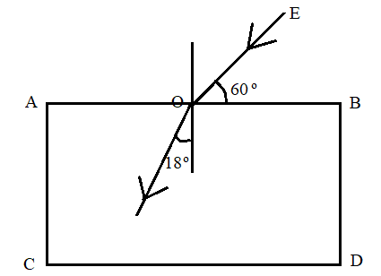

Find,

1. The refractive index of the block. **(2 marks)**

..........................................................................................................................................................................................................................................................................................................................................................................................................................................................................................................................................

1. The critical angle of the block. **(2 marks)**

.......................................................................................................................................................................................................................................................................................................................................................................................................................................................................................................................................................................................................................................................................................................................

1. If the ray is incident on surface BD, as shown in the figure

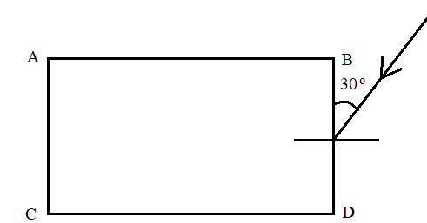

1. Complete the diagram to show the path of light throughout the diagram. **(2 marks)**
2. At what angle will the ray leave the block **(2 marks)**

......................................................................................................................................................................................................................................................................................................................................................................................................................................................................................................

..................................................................................................................................................................

1. The figure below shows a circuit where a battery of 4.5V, switches A and B, two capacitors C1 = 0.3 µF and C2 = 0.5µF and a voltmeter are connected.

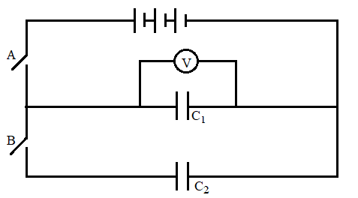

1. Determine the charge on C1 when switch A is closed and switch B opened. **(2 marks)**

......................................................................................................................................................................................................................................................................................................................................................................................................................................................................................................

1. What is the effective capacitance of the circuit **(2 marks)**

....................................................................................................................................................................................................................................................................................................................................

1. What is observed in the voltmeter when;
2. Switch A is closed and switch B opened. **(1 mark)**

...............................................................................................................................................................................................................................................................................................................................................

1. Switch is closed and opened and then switch B is closed. **(1 mark)**

................................................................................................................................................................................................................................................................................................................................................

1. Explain the observation made in (b) (ii) above. **(2 marks)**

................................................................................................................................................................................................................................................................................................................................................

1. The following figure show a circuit consisting of a resistor that may be used to charge a capacitor.

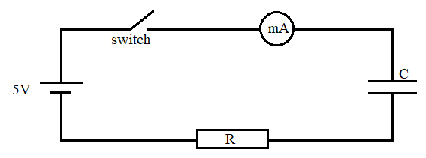

1. State the observation made on the milliammeter when the switch is closed. **(1 mark)**

...............................................................................................................................................................................................................................................................................................................................................

1. Explain the observation made in (c) (i) above. **(2 marks)**

............................................................................................................................................................................................................................................................................................................................................................. ...............................................................................................................................................................................

1. The circuit in the figure is left on for some times. State the value of the Pd across
2. Resistor R **(1 mark)**

....................................................................................................................................................................

1. The capacitor C **(1 mark)**

.....................................................................................................................................................................

1. **(a)** distinguish between a transverse and a longitudinal wave **(2marks)**

…………………………………………………………………………………………………………………………………………………………………………………………………………………………………………….....................................................................................................................................................

**(b)**The diagram shows how displacement varies with time as a wave passes a fixed point.Displacement in metres.

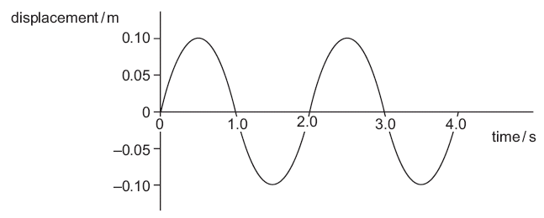

What is the frequency of this wave? **(2marks)**

.................................................................................................................................................................................................................................................................................................................................................................

**(c)**Figure belowshows a tuning fork producing waves. The wave fronts are as in the diagram.

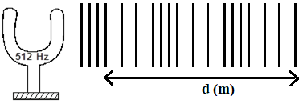

   If the speed of sound in air is 330ms-1. Determine the value of d.  **(3 marks)**

...............................................................................................................................................................................................................................................................................................................................................................................................................................................................................................................

**(d)** The figure below shows wave front in a ripple tank approaching a shallow region in the tank.

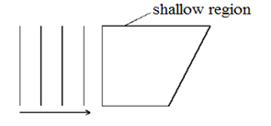

   Complete the diagram to show the wave front as they pass over shallow region and after leaving the region.

**(1 marks)**