PAVEMENT FORM 4 TRIAL 2 EXAMINATION 2021/2022
Kenya certificate of secondary education (K.C.S.E)
MARKING SCHEME PHYSICS
✓2
- angle =180-(90+20)= 70º
- (a) Long sightedness
✓1
(b) Introducing a concave lens
✓1
- The plain sheet of paper absorbs some light while the mirror doesn’t. it reflects all the light.
✓1
- Rectilinear propagation of light.
✓1
- $m=2$
$2=\frac{v}{u }→v=2u$
✓1
$$u=15 cm$$
$$v=-30 cm since the image is upright$$
$\frac{1}{f}=\frac{1}{u}+\frac{1}{v}$
$\frac{1}{f}=\frac{1}{15}-\frac{1}{30}$
✓1
$\frac{1}{f}=\frac{2-1}{30}=\frac{1}{30}$
$f=30cm$
✓1
✓1
✓1
✓1
- Has a higher emf per cell than nickel-iron accumulator.
- $P=VI$
$$40=240I$$
$$I=\frac{1}{6}A$$
$$R=\frac{V}{I}=\frac{240}{\frac{1}{6}}$$
$$R=1440Ω$$
- Prevents the risk of electric shock in case of faulty connection of electrical current.
✓1
- The positively charged rod attracts the negatives and “repels” the positives.
✓1
When earthed, electrons flow from the earth and neutralize the positive charges.
✓1
The electroscope acquires negative charge.
✓1
- - The angle at which the conductor cuts the magnetic field.
✓1 for one correct
- The length of the conduct

Type of radiation | Detector | Use  ✓$any correct$
Microwave | Crystal detector, solid state diodes | - Radar  - point to point communication links  - wireless networks  - remote sensing
Infra red  ✓1 | Thermopile, blackened bulb thermometer | Warmth sensation

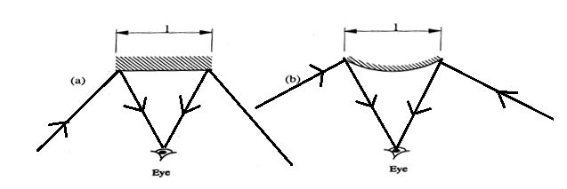

- The negative charges induce positive charges on water by repelling the negative charges. This causes the stream to be attracted towards the rod
✓1
✓1
- .a) Whenever there is change of magnetic flux an emf is induced whose magnitude is proportional to the rate of change of flux 1
b) i) $\frac{Vs}{Vp}$ =$\frac{Ns}{Np}$1
$\frac{60}{1200} =\frac{Vs}{240}$1
$Vs=12V$1
ii) Power Input = Power Output
VI = Power Output 1
240 × 0.5 = 12 × I 1
I = 10A 1
iii) - by laminating the core 1
c) E = Pt
E = 1.5 × 30 = 45kwh 1
Cost = (45 × 8)sh 1
$= Shs 360$ 1
d)
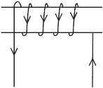1 for correct arrow directions
- (i) $R=\frac{2×4}{6}+1$ 1
$$=1.333+1$$
$= 2.333Ω$1
$I=\frac{12}{2.333}$
$= 5.144A$1
(ii) $V=IR$
=$1.333×5.144$ 1
= 6.857 V1
(iii) $I =\frac{6.857}{4}$1
$= 1.7143A$ 1
(b) (i)
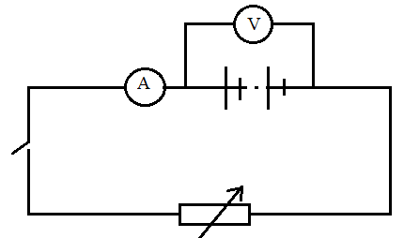
(ii) $V=-Ir+E$✓1
$E= V intercept$✓1
$= 9.6 V$ ($±0.1$) ✓1
(iii) $Internal resistance = gradient$
= $\frac{9.6-0}{0.-5.4}$✓1
$=1.778Ω$ ($±0.2$) ✓1
- (a) - The angle of incidence must exceed the critical angle ✓1
- Light must travel from optically denser to a rarer medium. ✓1
(b) (i) $n =\frac{\sin{30}}{\sin{18}}$✓1
$= 1.6180$✓1

(ii) $\sin{c}=\frac{1}{n}$ ✓1
$\sin{c}= \frac{1}{1.618}$✓1
$c=38.17^{o}$✓1
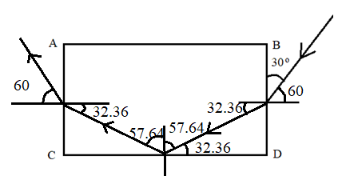
✓1
✓1
✓1
$\frac{\sin{60}}{\sin{r}}=1.6180$ ✓1

$\sin{r }=\frac{\sin{60}}{1.6180}$✓1
$r=32.36^{o}$✓1
- (a) (i) $Q=CV$✓1
$=0.3×4.5$✓1
$=1.35μC$✓1

(ii) $C= C1 +C2$ ✓1
$0.3+0.5 =0.8μF$✓1
(b) (i) the reading of the voltmeter increases from zero to attain a maximum of 4.5V✓1
(ii) the reading increases to 4.5V then decreases to a lower value. ✓1
(ii) C1 is charged by the battery Pd increases until the capacitor is fully charged. ✓1
(c) (i) deflects then reduces to zero✓1
(ii) electrons flow from plate A of the capacitor towards the positive terminal of the battery. ✓1
(d) (i) 0V✓1
(ii) 5V✓1
- (a) Transverse-vibration of wave particles is perpendicular to the direction of wave motion
Longitudinal- displacement of the wave particles is perpendicular to the direction of the wave motion
(b) $f=\frac{1}{T}$ 1
=$\frac{1}{2}$
$=0.5Hz$1
(c) $\frac{330}{512}$1
$=0.6445m$1
d = $0.6445×2.5=1.6113$m1
(d)
