232/1
PHYSICS LANJET 2021
PAPER 1

MARKING SCHEME

- 16.21mm1 correct answer with correct units
Accept 1.621cm or 0.01621m
Magnetic force
Electrostatic force
Gravitational force
- Momentum is conserved momentum before = momentum after
72 $×$9 = 216 $×$41
⇒ u = $\frac{72 ×9}{216}$ 1
= 3.0m/s1
- Roofing materials allows radiations to penetrate into the greenhouse1 but not out. Higher concentration of carbon dioxide inside the greenhouse helps to retain higher temperature by trapping/ insulating1 the heat.

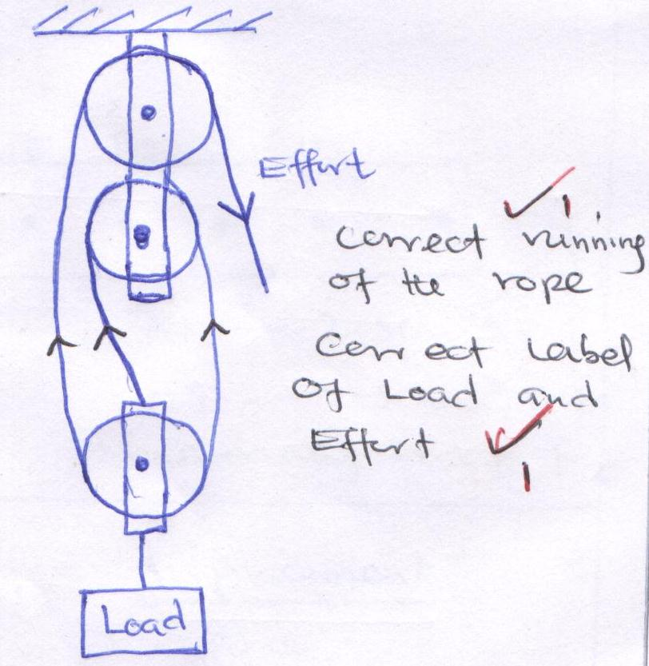
- V.R = 31
- Increase in temperature increases1 the speed of sound.
- i) Convection takes place in air upwards direct due to1 to density defect.
ii) Convection requires a 1 material medium but the space between the sun and the earth i.e. space of the atmosphere has no material medium
- From the equation of continuity
A₁U₁ = A₂U₂ 1(flow rate is constant)
120 $×$ 0.4 = 4 $×$ U₂
$∴$ U₂ = $\frac{120 ×0.4}{4}$ 1
= 12 ms⁻¹1
- Work done on the mass
= force $×$ distance
= 25 $×$10 $×$ 120
= 5000J. 1
Work done = power $×$ time
= 200 $×$ 301
= 6000J1
But = $\frac{work output}{work input}$ $×$100
= $\frac{5000}{6000}$ $×$ 100
= 83.3% 1
- ΔH = MCΔ$θ$
= $\frac{150}{1000} ×1000×4200 ×\left(70-15\right)$ +
390 $×20×\left(70-15\right)$
= 34650.000 + 429000
= 4636501
Energy dissipation E = pt
3000 $×t=4636501$
⇒t = $\frac{463650}{3000}$ = 154.55 sec1
- At balance
Sum of clockwise = sum of anti-clockwise moments
$\left(\frac{180}{1000}×100\right)×$ 40 = 30 $×$X + (10$×1.8$) 1
1.8$×$40 = 30X +18
X = $\frac{1.8 ×40-18}{30}$ 1
= 1.8N1
- To increase surface area of contact thus reducing pressure exerted on the road1
SECTION B

13. (a) (i) A-B - stationary body
(ii) B – C to moves with increasing velocity
(iii) CD to deceasing velocity

b)
50m
45m

R = Ut
h = ½ gt2
45 = ½ x 10 x t
t² = 45 = 9
5
t = 3less
14.a) The pressure of a fixed mass of gas is directly proportional to absolute temperature provided that volume is kept constant. 1
b) When a gas is heated it expands 1 increasing the number of collusions per unit area which in turn raise the pressure1
c)
i) - Temperature of water1
- Pressure gauge reading1
ii) - Collect various values of pressure under different temperatures1
- Plot a graph of pressure against temperature and study the values1
iii) P $α T →P=KT →K=\frac{P}{T}$
P₁ – 5.0 x 10⁵ Pa
P₂ = ?
T₁ = 273 + 37 = 300k
T₂ = 75 + 273 = 348k
$\frac{P_{1}}{T_{1}}= \frac{P_{2}}{T_{2}}$
$\frac{500000}{300}= \frac{P_{2}}{348}$ 1
P₂ = $\frac{500000 ×348}{300}$
= 580000
P₂ = 5.8 x 105 Pa1

(ii) R = ut
50 = 0 x 3
3 3

U = 50 = 16. 67 m/s
3

(iii) V = u + at
= gt
= 10 x 3
=30m/s

15.a ) i) In elastic collision – K.E and momentum of the objects are conserved1
Elastic collision – only momentum is conserved1
ii) Initial momentum = Final momentum

b) i)
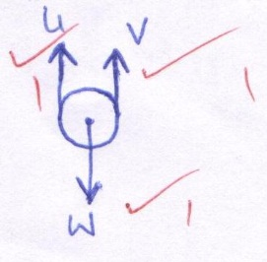

ii)
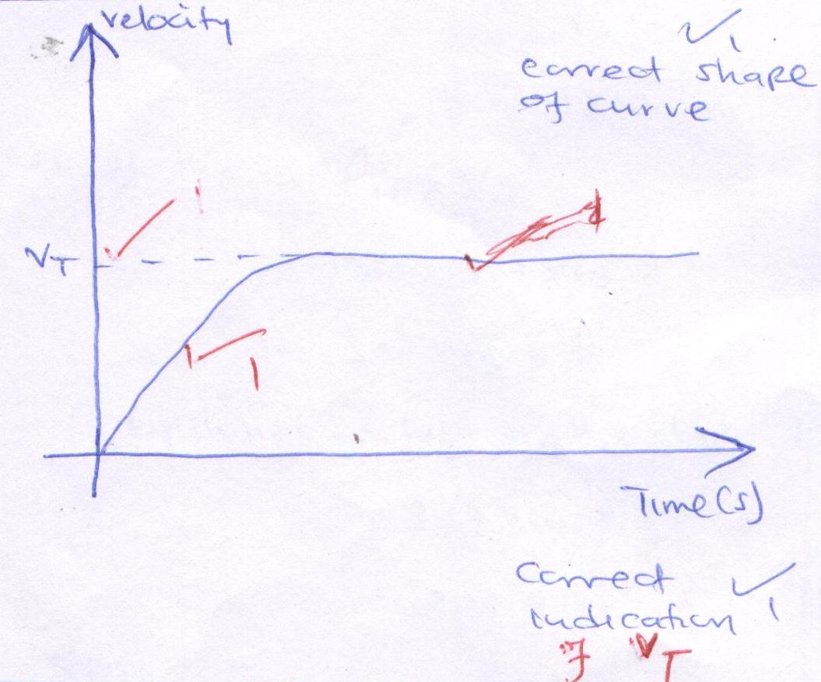
16.a) i) $ω$= 2$π$f
= 2$π$ $×$10
= 20$π$rad s⁻¹
= 62.83 rad⁻¹
T_{A} = M$ω$ ²r – mg
= $\left(1×{62.83}^{2 }×0.5\right)- \left(1×10\right)$1
= 19 + 3.9 – 10
= 1963.9N1
ii) At the lowest point
F_{c} = T – Mg
⇒ Fe + Mg
= mr$ω$ ² + mg
= 1$×$0.5$×{62.83}^{2}$+ $\left(1×10\right)$1
= 1973.9 + 10
= 1983.9N1
b(a) (i) Tension in the spring supporting the object. ¹
(ii) There is change in the direction of instantaneous velocity at various
points along the circular path. ¹
(b) (i) The spring balance reading increases. ¹
(ii) The centripetal force
- The object moves tangentially to the circular path at that point where it cuts. ¹

a) 17 (a) A floating object displaces its own weight of the fluid in which it float.
b (i)
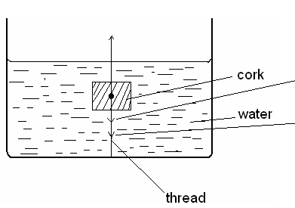
Upthrust, u

(ii) U = mg + T
(ii) Viscous drag
B (i) Upthrust = weight of solid
= 11.5 x 0.8 x 10
1000
= 0.092 N

(ii) Density of solid = volume submerged
Density of liquid Total volume
0.8 = 8.5
e₁ 11.5
e₁ = 1.0824g/cm³
Alternatively
e = m
v
= 0. 0.92 x 100
8.5
1mk
= 1.0824g/cm³
d) i)
Load | 0.00 | 1.00 | 2.00 | 4.00 | 5.00 | 6.00
L | 10.00 | 11.50 | 13.50 | 16.00 | 18.00 | 24.00
E  Weight (mg) | 0.00 | 1.50 | 3.50 | 6.00 | 8.00 | 14.00 | 1
ii) Suitable axes labelled 1
Tension (T)
All points correct 1
Suitable line 1
iii) Springs constant K = F 1
e
Use students graph
Correct units 1
iv) Energy stored when the length is stretched by 16 cm
Area under the graph 1
Or E = ½ ke²
Use k from graph and e = 16 cm.
K must be correct.
Correct substitution 1
Answer correct unit 1

(iii) Upthrust = weight of liquid displaced
= 11.5 x 1.0824 x 10 1000
= 0.1245 N

18.

