FORM 4 ENTRANCE EXAMS 2023

Name …………………………………..…………………………..……. Adm No ……………..

Class…………..…… Date……….……………….Student’s signature………………………..

232/3
PHYSICS
Paper 3
Time 2¹/₂ HOURS

Kenya Certificate of Secondary Education (K.C.S.E)
Paper 3(232/3)
(Practical)
232/3
PHYSICS
Paper 3
Time 2¹/₂ HOURS

INSTRUCTIONS TO CANDIDATES
1. Write your name, index number, class, date and signature in the spaces provided above.
2. This paper consists of two questions 1 and 2.
3. Answer all questions in the spaces provided.
4. Non-programmable calculators and mathematical tables may be used.
5. Show all your workings.

QUESTION 1 | a(ii) | a(iii) | a(iv) | a(v) | a(vi) | b(vii) | TOTAL
Maximum score | 6 | 5 | 3 | 1 | 2 | 3
Candidates score

QUESTION 2 | a(i) | a(ii) | a(iii) | b(vii) | b(viii) | b(ix) | b(xi) | b(xii) | b(xii)I | b(xii)II | b(xiii)
Maximum score | 1 | 1 | 1 | 6 | 2 | 1 | 1 | 1 | 1 | 2 | 3
Candidates score
This paper consists of 8 printed pages.
Candidates should check the question paper to ensure that all pages are printed as indicated and no questions are missing

Question 1
You are provided with the following:
-Two dry cell
- Cell holder
-A piece of resistance wire labeled W
-Voltmeter (0 - 3V or 0 - 5V)
-Ammeter (0 - 1A)
-A nichrome wire mounted on a millimeter scale labelled PQ
-Seven connecting wires in which four are with crocodile clips on both ends and three are with crocodile clips on one end
- Jockey attached to a connecting wire
- Micrometer screw gauge (can be shared)

Proceed as follows:
a) i). Set up the circuit as shown in the figure below.

W
Q
P
A
V
Jockey
Nichrome wire
L

ii) With the Jockey at Q i.e. L= 0.0 cm, take the voltmeter reading and ammeter reading. Record V and I. Repeat to get the readings for L=20.0cm, 40.0cm, 60.0cm, 60.0cm, 80.0cm and 100.0cm respectively and complete the table below.

Length L (cm) | 0.0 | 20.0 | 40.0 | 60.0 | 80.0 | 100.0
Voltage V (v)
Current I (A)
(6marks)

iii).Plot a graph of voltmeter readings (y-axis) against ammeter readings. (5marks)

iv) Determine the slope of the graph (3marks)

v) What physical quantity is represented by the slope of the graph at any given point (1mark)

vi) Using a micrometer screw gauge, measure the diameter, d of the wire W.

d = mm (1mark)

= m (1mark)

vii) Calculate the quantity and give its units. (3marks)

Question 2
PART A
You are provided with the following apparatus
- A meter rule
- A concave lens with holder
- A candle stick
- A white screen
- A stop watch
- Marble
- Watch glass
- Plasticine
- Micrometer screw gauge
Proceed as follows:

(a) Find the approximate focal length by focusing a sharp image of a distant object onto a screen. The object (preferably window frame) must be at least 4m away. Turn lens such that side A faces the screen

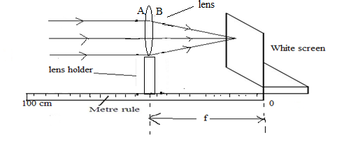

i) f₁=…………………………… (1mark)
(ii) f₂=…………………….. (1mark)
iii) Find the Average of f₁ and f₂ (1mark)

b)(i)Now Set up the apparatus as shown in figure below such that S=55cm.Adjust the position of the lens to obtain a sharp enlarged image of the candle flame. (Ensure that the candle flame, the lens and white screen same horizontal level)

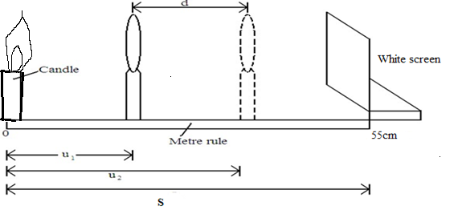

ii) Measure the distance u₁ between the candle and the lens

iii)Without changing the position of the candle and the screen, move the lens to obtain a sharp diminished image of the candle flame
iv) Measure the distance u₂ between the candle and the lens
v) Record the values of u₁ and u₂ in the table below.
vi) Repeat the procedure in (i) above for S=45cm.
(vii)Complete the table (6marks)
S(cm) | U₁(cm) | U₂(cm ) | d=U₁-U₂
55
45

viii) Determine the average value of K (2marks)

ix) What does physical quantity K represent (1mark)

PART B
Procedure:
x. Arrange the apparatus as shown in the figure below:

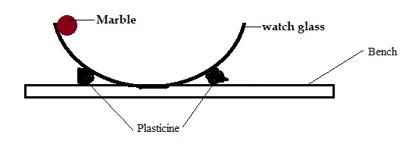

xi.Release the marble from the edge of the watch glass to freely oscillate. Measure the time taken, t, for 5 oscillations.

t = …………………… (1 mark)

xii. Calculate the periodic time, T

T = ……………………… (1 mark)

(I) Measure the diameter, D of the marble using the micrometer screw-gauge.

D = ……………………m (1 mark)

(II) Determine the volume, V of the marble. (2 marks)

xiii) The period, T, of oscillation of the marble and radius, r of the marble are related by the equation:
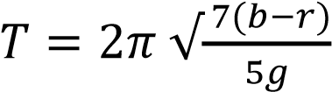
Where g = 10 m/s² and b is a constant of the watch glass. Determine the value of b
(3 marks)

