Name _________________________________________ Index No__________________________
School ________________________________________ Candidate’s Signature ______________
Date ______________________________
232/3
PHYSICS PRACTICAL
PAPER 3

MARCH/APRIL 2023
TIME: 2 ½ hours

ARISE AND SHINE EXAMINATION
FORM FOUR TRIAL 1 - 2023
Kenya Certificate of Secondary Education (KCSE)

INSTRUCTIONS TO CANDIDATES
- Write your name and index number in the spaces provided above
- Answer ALL the questions in the spaces provided.
- You are supposed to spend the first 15 minutes of the 2 ½ hours allowed for this paper reading the whole paper carefully before commencing your work.
- Marks are given for a clear record of the observations actually made, their suitability, accuracy and the use made of them.
- Candidates are advised to record their observations as soon as they are made.
- KNEC MATHEMATICAL TABLES AND NON PROGRAMMABLE SILENT CALCULATORS MAY BE USED.
For Examiners’ Use Only
Question 1 |  |  |  |  |  |  |  |  |  |  |  | TOTAL
 | b | c | e | f | g | h | i
Maximum score |  |  |  |  |  |  |  |  |  |  | 20
Candidate’s score
Question 2 |  |  |  |  |  |  |  |  |  |  |  | TOTAL
 | a | b | c | d | e | f | g | h
Maximum score |  |  |  |  |  |  |  |  |  |  | 20
Candidate’s score
GRAND TOTAL

QUESTION 1
QUESTION 1
You are provided with the following apparatus.

- An ammeter (range 0 – 1A)$√$
- A resistance wire labeled R$√$
- Two new dry cell (size D)$√$
- Six connecting wires (at least three with crocodile clip)$√$
- A switch$√$
- A jockey$√$
- A micrometer screw gauge (to be shared)$√$
- A voltmeter (0-3V)$√$

Proceed as follows:
- Assemble your apparatus as shown in Figure 1
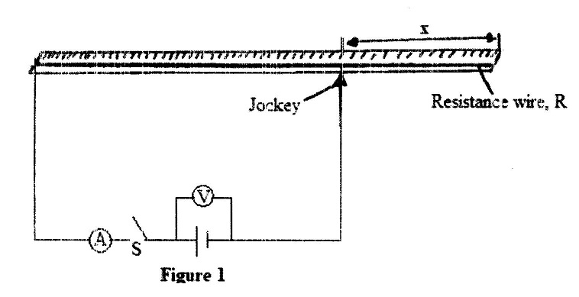
(b). With the switch S open, record the voltmeter reading.

V = ……………………. Volts (1 mark)

(c). Adjust the length x of the wire to 25cm. Close the switch, read and record the value of current I in Table 1

Table
Length x (cm) | 25 | 35 | 45 | 55 | 65 | 75
Length (100 – x) cm
Current I (A)
.$\frac{1}{I}$ (A⁻¹)

(d). Repeat (c) for other values of x given in Table 1. Complete the table. (5 marks)
(e) On the grid provided plot a graph of length (100-x) m against $\frac{1}{I}$ (A⁻¹) (5 marks)

(f). calculate the slope S of the graph (3 marks)
……………………………………………………………………………………………………………………………………………………………………………………………………………………………………………………………………………………………………………………………………………………………………………………………………………………………………………………………………………………………………………………………………………………………………
(g). what does the y-intercept represent? (1 mark)
……………………………………………………………………………………………………………
(h). Using the micrometer screw gauge provided measure the diameter t, of the resistance wire R
t = ………………………………………mm (2 marks)
t = ………………………………………..m

(i). Given P = $\frac{{SVt}^{2}}{4}$
Determine the value of P (3 marks)
……………………………………………………………………………………………………………………………………………………………………………………………………………………………………………………………………………………………………………………………………………………………………………………………………………………………………………………

QUESTION 2

This question has two parts A and B. Answer all the parts

Part A
You are provided with the following:
- A metre rule$√$
- Two identical 100g masses (labelled A and B)$√$
- Liquid L in 250ml beaker ¾ full $√$
- Three pieces of thread, each 30cm long.$√$
- Stand with clamps$√$
- Tissue paper$√$
- Vernier calipers$√$

Proceed as follows:
(a).Take one 100g mass and measure the diameter d and height h using the Vernier calipers
d = …………………………. M (1 mark)

h = …………………………. M (1 mark)

b. Determine the volume V given that V = $π$ $\left(\frac{d}{22}\right)$²h

V ……………………………….m³ (1 mark)
c. Using a stand and one piece of thread, suspend the metre rule in air such that it balances horizontally.
Record the position of the centre of gravity G.
G = ………………………………………………..cm (1mark)
NOTE: the metre rule should remain suspended at this point throughout the experiment.

d. Set up the apparatus as shown in Figure 1 below;
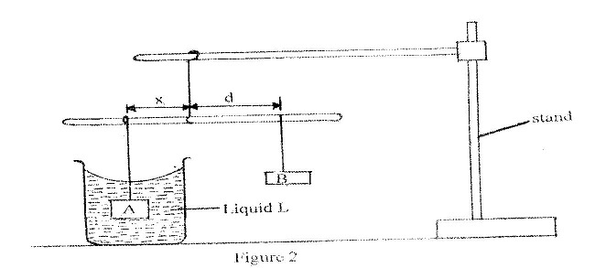
- Suspend the mass A at a distance x = 30cm and completely immerse it in liquid L without touching the sides of the beaker.
- Hang mass B and adjust its position such that the rule is balanced and measure the distance dcm. Tabulate your results in table 1 below;

- Table (3 marks)
x (cm) | 30 | 35 | 40
d (cm)
$$\frac{d}{x}$$

(i).(e). Determine the weight F of one of the masses A or B in air. Given that
g = 10N/K g and A = B
Weight F in air = …………………………………….. (1 mark)

(ii). Using the principle of moments, determine the apparent weight P of A when completely immersed
in Liquid L
Apparent weight P = ………………………………………………………………………………….
………………………………………………………………………………………………… (2 marks)

(iii). Find the up thrust U on A when completely immersed. (1 mark)
(iv).Upthrust; U = .......................................................................................................................................
…………………………………………………………………………………………………………….
(h). Determine the density of liquid L, given that; (1 ½ marks )
P = $\frac{Un}{V}$ where n = 0.1 Kg/N (1 ½ marks)
PARTTWO
You are provided with the following apparatus
- A glass beaker$√$
- A metal solid$√$
- Some water$√$
- Source of heat$√$
- A piece of cotton thread$√$

- A plastic beaker wrapped with tissue$√$
- Thermometer$√$
- Liquid L$√$

Proceed with the experiment as follows:

(f). Fill the glass beaker with the water provided and place it on the fire source. Use the piece of thread to carefully lower the metal solid to the bottom of the beaker.
Heat the water to its boiling point. Use the thermometer to measure its boiling point.
Boiling point of water …………………………….Kelvin (1 mark)

(g). (i). Find the following measurements using appropriate instruments
Mass of the solid M_{s} = …………………………………g (¹/₂ mark)

Mass of the wrapped empty plastic beaker M₁ ……………..g (½ mark)

Use the plastic beaker to measure 240ml of liquid L, hence find the joint mass of the plastic beaker and its content liquid L, M_{2 = ………………………………………….}(g) ( ½ mark)

: Initial temperature of liquid L, T₁ = ………………………Kelvin (1 mark)

((ii). At boiling point of water; quickly transfer the metal solid into liquid L, stir well and measure the temperature of the mixture immediately.

Temperature of the mixture T₂ ……………………..Kelvin (1 mark)

(h). By using the measurements taken in pars (f) g(i) and g(ii) as well as the equation provided below, determine the specific heat capacity of liquid L. (Take S.H.C of metal solid = 480J/kg/k and S.H.C of plastic = 359 J/kg/k).
(Heat lost by metal) = (heat gained by liquid L) + (heat gained by plastic beaker). (3 marks)

