NAME:………………………………………………INDEX NO. …………………ADM NO….................
SCHOOL……………………………….….Signature: …………………..… Date: ………………………

232/2
PHYSICS
PAPER 2

MARCH/APRIL, 2023.
TIME: 2 HOURS

ARISE AND SHINE EXAMINATION
Kenya Certificate of Secondary Education (KCSE)
Physics Paper 2

Instructions to candidates
- This paper consists of two sections A and B.
- Answer all the questions in the two sections in the spaces provided after each question
- All working must be clearly shown.
- Electronic calculators, mathematical tables may be used.
- All numerical answers should be expressed in the decimal notations.
- This paper consists of 14 printed pages and check to ensure all the pages are there.

SECTION | QUESTION | MAX MARKS | CANDIDATE’S SCORE
A | 1 – 12 | 25
B | 13 | 13
 | 14 | 07
 | 15 | 11
 | 16 | 13
 | 17 | 11
TOTAL |  | 80
SECTION A – 25MARKS
- On the diagrams below, show how a convex mirror gives a wider field of view than a plane mirror. (2 marks)

- Figure 1 below shows a negatively charged object suspended using a thread. A glass rod was rubbed using a wooden cloth and then brought closer to the object.
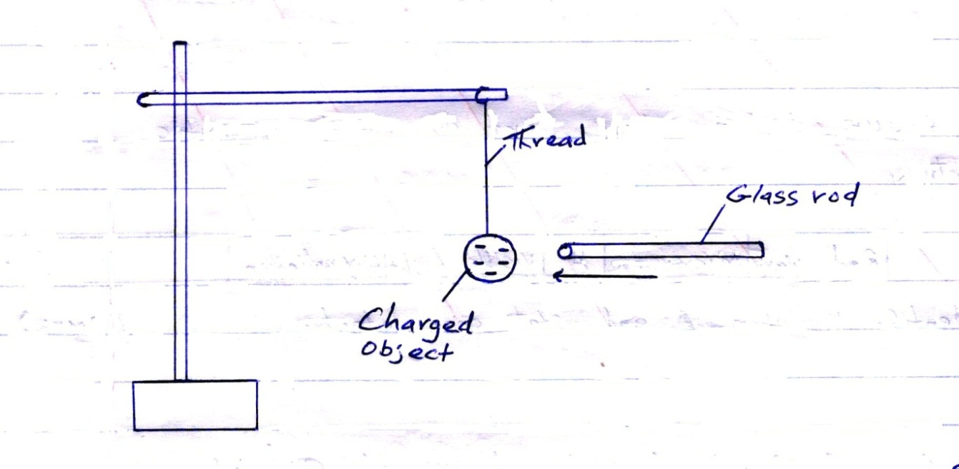
State the observation made when a rubbed glass rod is brought closer to the object. (1 mark)
……………………………………………………………………………………………………………………………………………………………………………………………………
- Figure 6 below shows a simple cell.
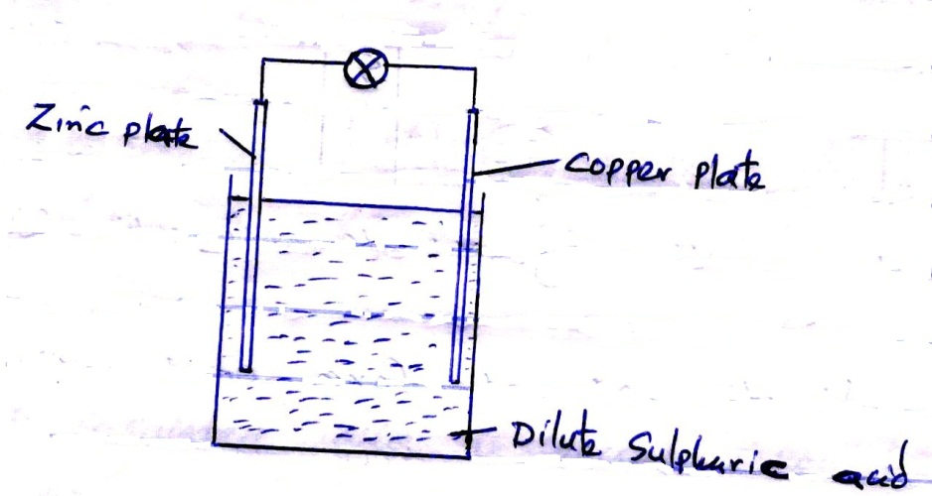
- On the same diagram, indicate the direction of current. (1 mark)

- It is observed that the bulb goes off after a short time. Explain this observation. (1 mark)
…………………………………………………………………………………..……………………………………………………………………………………………..………………………………………………………………………………………………………………………..
- A coil of insulated wire is wound around a U-shaped soft iron core XY and connected to a battery as shown in the figure 3 below.
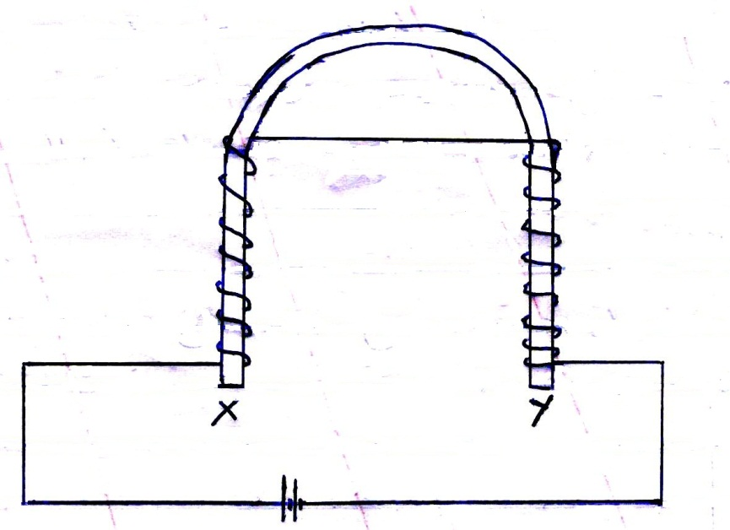
- On the same diagram, indicate the direction of current in the coil. (1 mark)

- State the polarity of end X (1 mark)
……………………………………………………………………………………………………………………………………………………………………………………………............
- A soldier standing between 2 cliffs fires a gun. He hears the first echo after 2.16s and the next after 4.75s. Determine the distance between the two cliffs. (Take speed of sound as 30m/s) (3 marks)
…………………………………………………………………………………………………………………………………………………………………………………………………………………………………………………………………………………………………………………………………………………………………………………………………………………………………………………………………………………………………………………………………………………………………………………………………………………………………………………………………………………………………………………
- (i) Arrange the following waves in order of decreasing wavelength; x-rays, infrared, microwaves and visible light. (1 mark)
………………………………………………………………………………………………………………………………………………………………………………………………………………………………………………………………………………………………………
(ii) State one application of visible light. (1 mark)
……………………………………………………………………………………………………………………………………………………………………………………………………
- An electric bulb is rated 40W, 240v, what is the resistance of the filament. (2 marks)
…………………………………………………………………………………………………………………………………………………………………………………………………………………………………………………………………………………………………………………………………………………………………………………………………………………………………………………………………………………………………………………………………………………………………………………………………………………………………………………………………………………………………………………………………………………………………………………………………………………….
- The figure 4 below shows a current carrying conductor placed perpendicularly between the poles of a magnet.
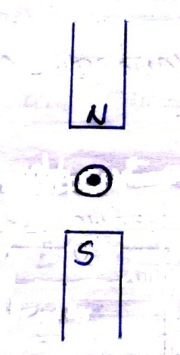

- Show on the diagram; the magnetic field pattern. (1 mark)

- The direction of net force on the conductor. (1 mark)

- Study the circuit shown below.
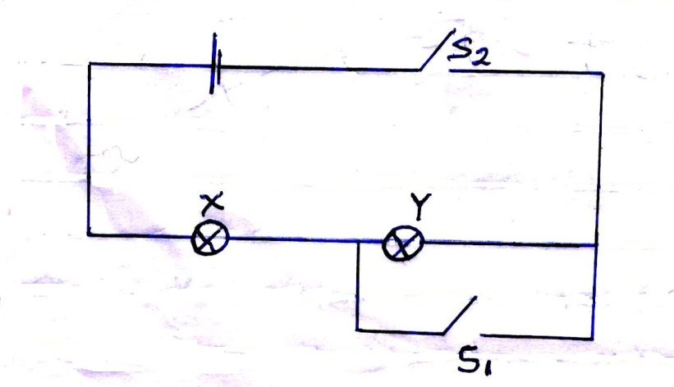
State and explain what happens to the identical lamps X and Y in the circuit, when:
- Switch S₂ only is closed. (2 marks)
…………………………………………………………………………………………………………………………………………………………………………………………………………………………………………………………………………………………………………………………………………………………………………………………………………
- Switches S₁ and S₂ are closed. (2 marks)
………………………………………………………………………………………………………………………………………………………………………………………………………………………………………………………………………………………………………………………………………………………………………………………………………….
- Figure 5 below shows sound waves emitted by a drum struck by a stone. The sound waves are transmitted through air.
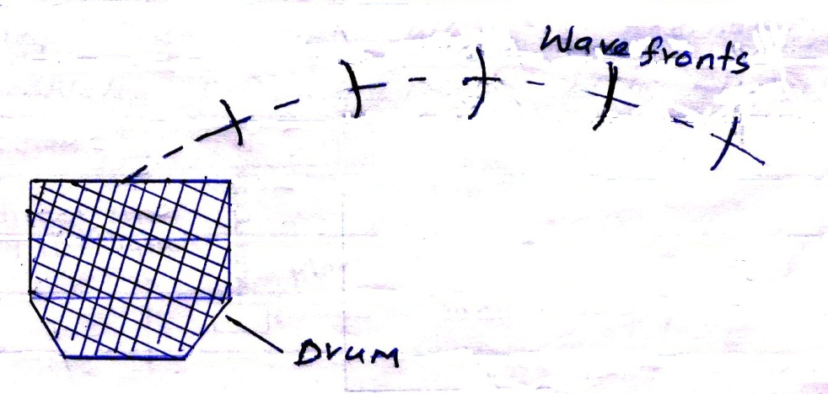

Explain why the wave fronts are directed towards the ground. (2 marks)
…………………………………………………………………………………………………..…………………………………………………………………………………………………..…………………………………………………………………………………………………..…………………………………………………………………………………………………..
- State one advantage of using optical fibre in communication. (1 mark)
……………………………………………………………………………………………………………………..……………………………………………………………………………..
- A cell supplies a current of 0.6A through two 2Ω resistors connected in parallel. When the resistors are connected in series, the current is 1.8A. Calculate the internal resistance of the cell. (2 marks)
……………………………………………………………………………………………………………………………………………………………………………………………………………………………………………………………………………………………………………………………………………………………………………………………………………………………………………………………………………………………………………………………………………………………………………………………………………….

SECTION B (55 MARKS)

- (a) Figure 7 below shows a series of wave fronts one wavelength apart approaching a gap between two barriers in a ripple tank.
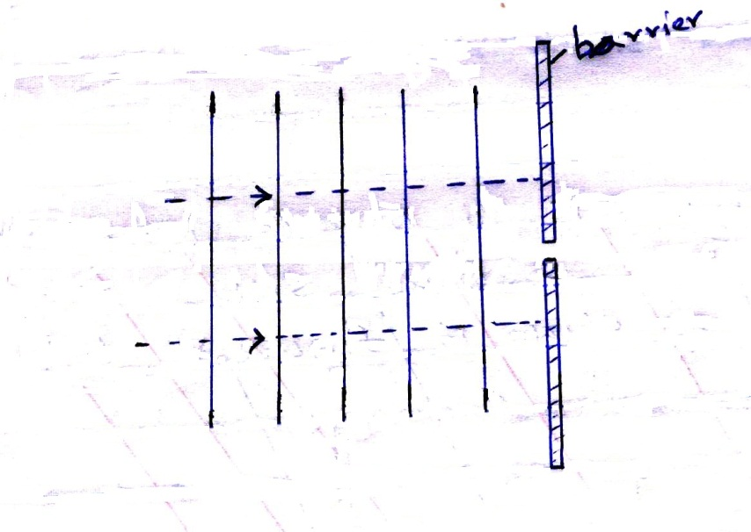
Show on the figure what happens as the waves pass the gap. (1 mark)

(b) A student set up a mass attached to a spring such that when it oscillates, it taps on the water surface in a wide shallow tank.
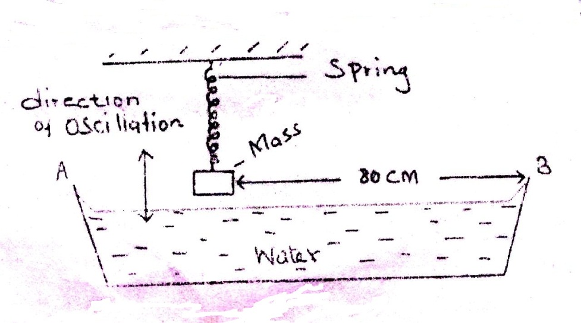
The student measured time for 20 oscillations and found that the mass takes 36seconds. Given that the student counted four ripples between the mass and end B of the tank;
- Determine,
- The frequency of the water waves. (2 marks)
…………………………………………………………………………………………………………………………………………………………………………………………………………………………………………………………………………………………………………………………………………………………………………………………………………
- The speed of the waves. (3 marks)
………………………………………………………………………………………………………………………………………………………………………………………………………………………………………………………………………………………………………………………………………………………………………………………………………….
- What would happen to the waves produced if the water is made shallower? (1 mark)
…………………………………………………………………………………………………………………..……………………………………………………………………………………………………………………………………………………………………………………..

(c) In the experiment to observe interference of light waves, a double slit is placed close to the source as shown in figure 8 below.
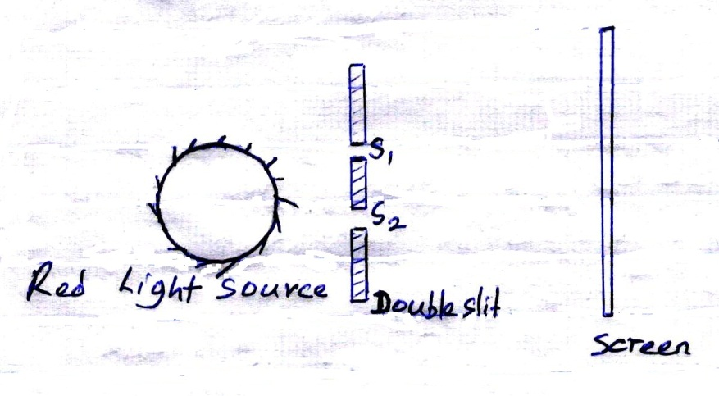
- State the function of the double slit (1 mark)
……………………………………………………………………………………………………………………………………………………………………………………………………
- State and explain what is observed on the screen (3 marks)
………………………………………………………………………………………………………………………………………………………………………………………………………………………………………………………………………………………………………………………………….………………………………………………………………………………………………………………………………………………………………………….
- State what is observed on the screen when:
- The slit separation S₁S₂ is reduced. (1 mark)
……………………………………………………………………………………………………………………………………………………………………………………………………..
- Violet light source is used in place of red light source. (1 mark)
….………………………………………………………………………………………………………………………………………………………………………………………………….
- (a) State the conditions to be satisfied for total internal reflection to occur. (2 marks)
………………………………………………………………………………………………………………………………………………………………………………………………………………………………………………………………………………………………………………………………………………………………………………………………………….

(b) A ray of light traveling in the direction EO in air enters a rectangular block as shown in the diagram. The resulting angle of refraction is 18⁰.
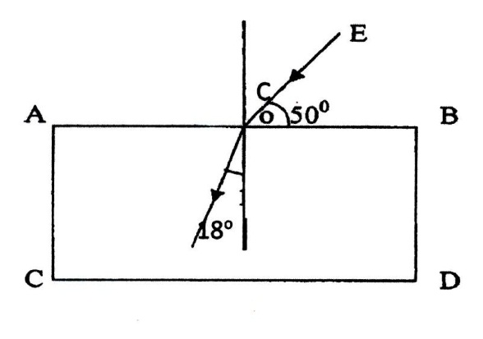
Find:
- The refraction index of the block. (2 marks)
………………………………………………………………………………………………………………………………………………………………………………………………………………………………………………………………………………………………………………………………………………………………………………………………………….
- The critical angle c of the block. (3 marks)
………………………………………………………………………………………………………………………………………………………………………………………………………………………………………………………………………………………………………………………………………………………………………………………………………………………………………………………………………………………………………………………………………………………………………………………………………………
- (a) State Ohm’s law. (1 mark)
……………………………………………………………………………………………………………………………………………………………………………………………………
(b) A starter coil has a current of 6A passing through it. If the p.d across it is 12V, determine the resistance of the starter coil. (3 marks)
………………..……………………………………………………………………………………………………………………………………………………………………………………………………………………………………………………………………………………………………………………………………………………………………………………………………………………………………………………………………….………………………………………………………………………………………………………………………………………………………………………………………………………………………….
(c) The graph below shows the voltage – current relationship for a conductor.
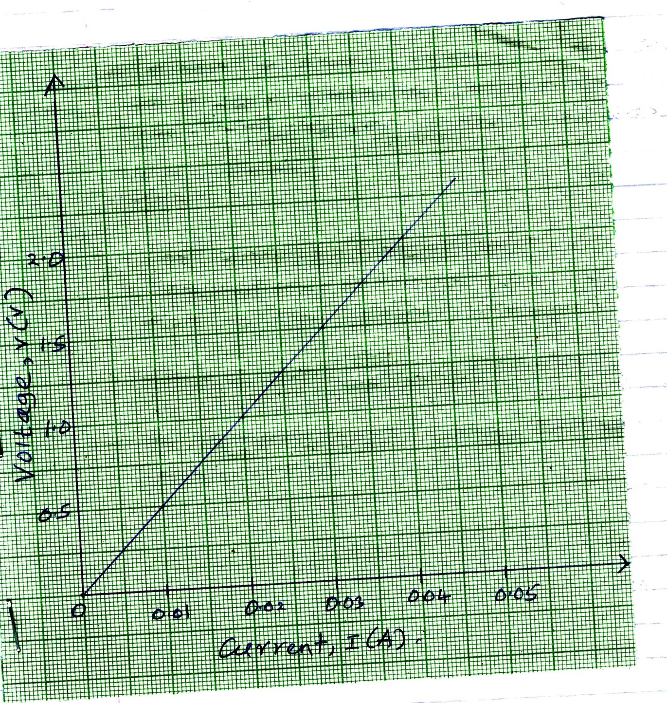
- Determine the resistance of the conductor. (3 marks)
……….……………………………………………………………………………………………………………………………………………………………………………………………………………………………………………………………………………………………………………………………………………………………………………………………………………………………………………………………………………………………………………………………………………………………………………………………………….
- State with reasons whether the conductor obeys Ohm’s law. (2 marks)
………………………………………………………………………………………………………………………………………………………………………………………………………………………………………………………………………………………………………………………………………………………………………………………………………….
(d) State two factors that determine the resistance of a conductor. (2 marks)
………………………………………………………………………………………………………………………………………………………………………………………………………………………………………………………………………………………………………………………………………………………………………………………………………….
- (a) The figure below shows an object in front of a lens.
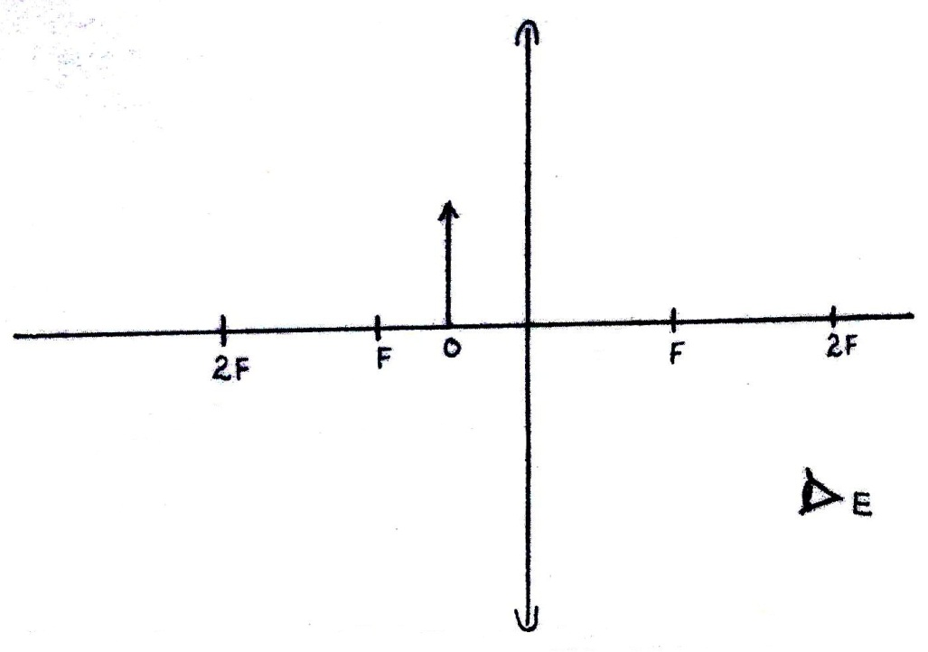

- Using rays, locate the image as seen by observer E. (2 marks)

- Give one application of such lens as used above. (1 mark)
..………………………………………………………………………………………………………………………………… ………………………………………………………………….

(b) Figure I and II show diagrams of the human eye.
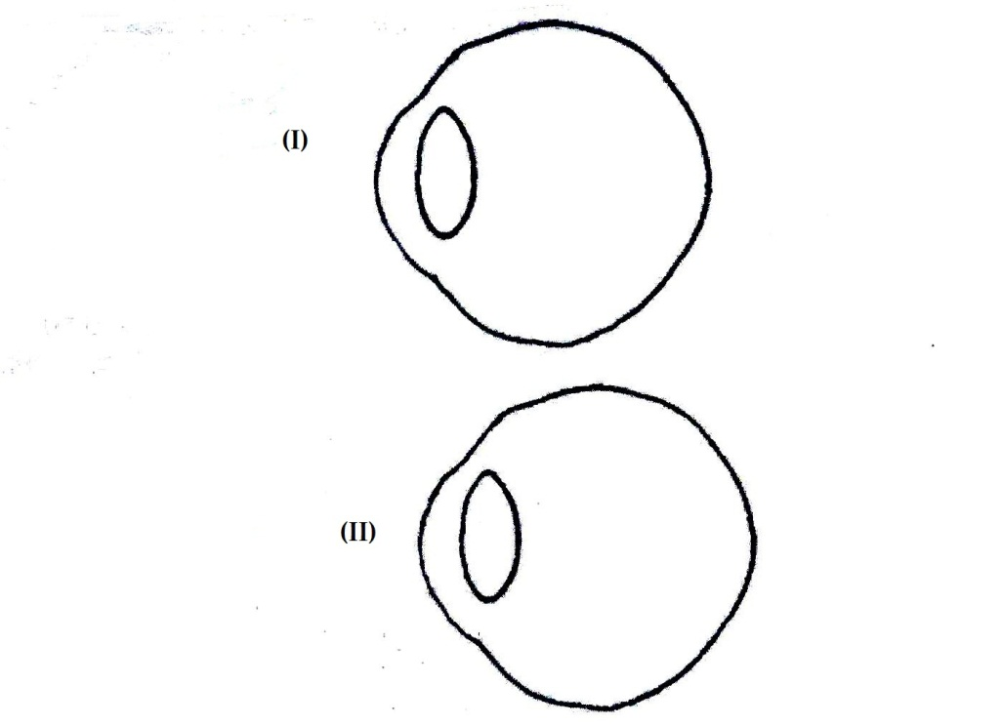

- In figure (I), sketch a ray diagram showing long sightedness. (1 mark)

- In figure (II), sketch a ray diagram showing how lens is used to correct long sightedness. (2 marks)
(c) An object of height 10.5cm stands before a converging lens of focal length 10cm and a distance of 20cm from the lens. Determine;
- Image distance. (3 marks)
..…………………………………………………………………………………………………………………………………………………………………………………………………………………………………………………………………………………………………………………………………………………………………………………………………………
…………………………………………………………………………………………………………………………………………………………………………………………………….
- Magnification (2 marks)
..……………………………………………………………………………………………………………………………………………………………………………………………………..…………………………………………………………………………………………………..…………………………………………………………………………………………………..
…………………………………………………………………………………………………..
- Height of the image. (2 marks)
………………………………………………………………………………………………….………………………………………………………………………………………………….………………………………………………………………………………………………….………………………………………………………………………………………………….
………………………………………………………………………………………………….
- (a) Define capacitance of a capacitor. (1 mark)
..……………………………………………………………………………………………………………………………………………………………………………………………………..…………………………………………………………………………………………………..
(b) State two factors affecting capacitance of parallel plate capacitor. (2 marks)
..………………………………………………………………………………………………… …………………………………………………………………………………………………..…………………………………………………………………………………………………..…………………………………………………………………………………………………..
(c) The diagram shows 3 capacitors 4μF, 5μF and 6μF connected to a 12V d.c supply.

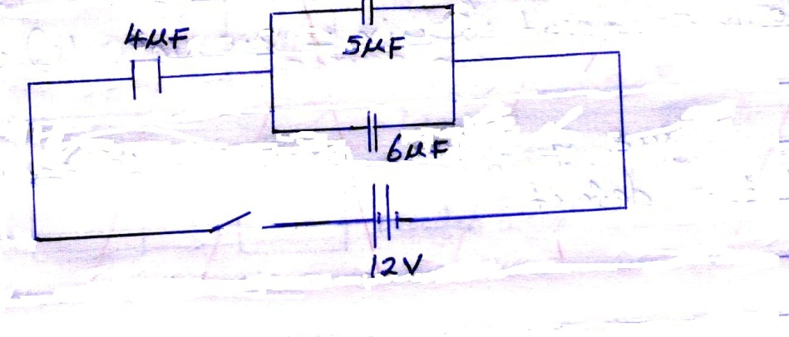
Determine;
- The effective capacitance (3 marks)
..……………………………………………………………………………………………………………………………………………………………………………………………………..…………………………………………………………………………………………………..…………………………………………………………………………………………………..
…………………………………………………………………………………………………..…………………………………………………………………………………………………..
- The charge stored in the 4μF capacitor. (2 marks)
..……………………………………………………………………………………………………………………………………………………………………………………………………..…………………………………………………………………………………………………..…………………………………………………………………………………………………..
…………………………………………………………………………………………………..
- The p.d across 5μF capacitor. (3 marks)
..……………………………………………………………………………………………………………………………………………………………………………………………………..…………………………………………………………………………………………………..…………………………………………………………………………………………………...………………………………………………………………………………………………….
…………………………………………………………………………………………………..

