MARKING SCHEME - PHYSICS PAPER 2
MARCH/APRIL, 2021

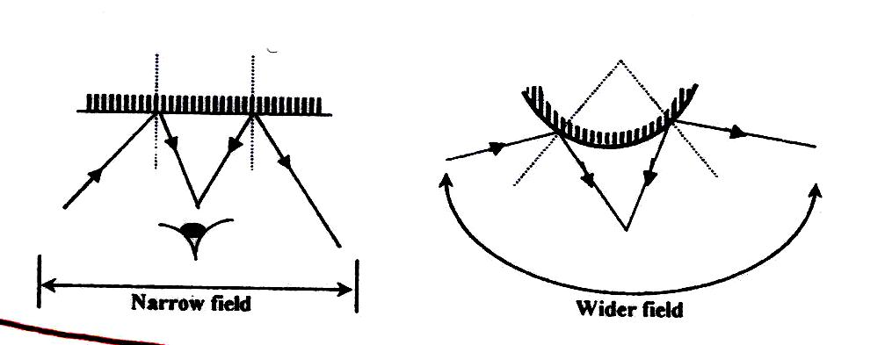

- They attract. √1
- (a)
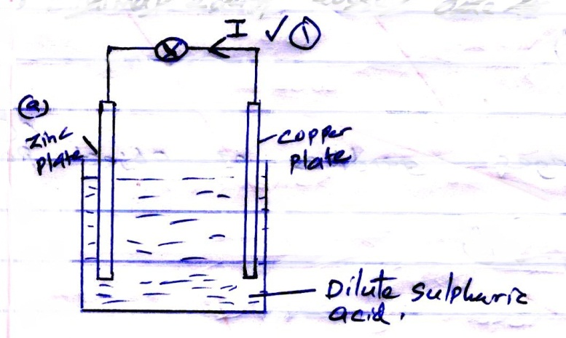
(b) The cell suffers polarization and local action.√1
- (a)
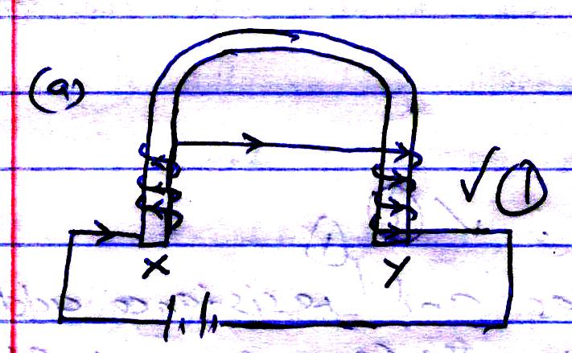
(b) North pole√1
- V = $\frac{2d}{t}$ √
330 = $\frac{2xd}{2.16}$
d = $\frac{330 x 2.16}{2}$
d = 356.4m
330 = $\frac{2xd}{4.75}$
d = $\frac{330x4.75}{2}$ √
= 783.75m
Distance between the wall = 356.4 + 783.75
= 1140.15m √

- (i) Microwaves, infrared, visible light, X-rays.
(ii) Observing objects
Taking pictures.

- P = v²/R
40 = (240)²/R
R = 57600/40
= 1440Ω

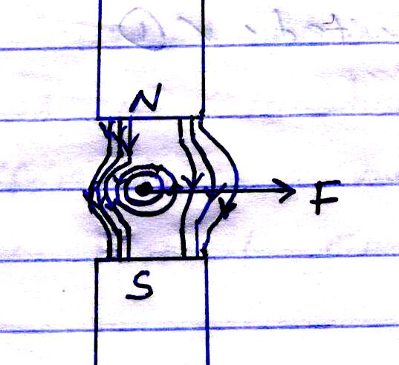

Field – 1 mark (N – S; around conductor)
Force – 1 mark
- (i) Bulbs X and Y light dimly. √1
They are connected in series and resistance add up.
Or Bulbs X and Y light with same brightness. The same current flows through them.√1

(ii) Bulb X lights brightly while Y does not.
Bulb Y is short circuited. √1

- Air is warmer at upper layer. √1
Velocity of sound wave fronts will be higher in the upper layer than in the lower layer hence the waves will be refracted downward.

- - More information can be transmitted at the same time.√1
- Flexible.

- Circuit 1
E = V + Ir
E = 0.6 + 0.6r (1) √
E = 7.2 + 1.8r (2)
Equation 1 & 2
1.2r = 6.6
r = 5.8Ω √
SECTION B – 55 MARKS
- (a)
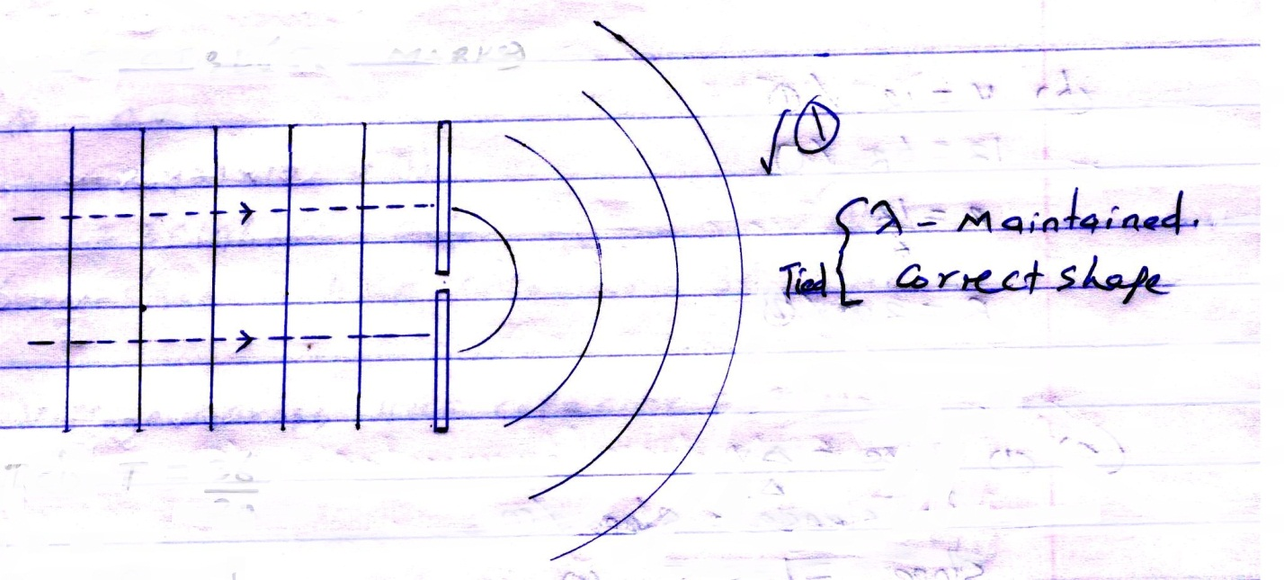
- I (i) T = $\frac{36}{20}$
ƒ = $\frac{1}{T}$
ƒ = $\frac{20}{36}$ √1
= 0.5556Hz √
(ii) v = ƒλ √
= 0.5556 x $\frac{0.80}{4}$√1
= 0.1111m/s √1

- Waves of shorter wavelength are produced /more waves are produced (shorter wavelength).

c) (i) It provides coherent sources.√1
(ii) Alternating dark and bright fringes.√1
Dark fringes are due to destructive interference√1 while bright fringes are due to constructive √1 interference

(iii) (I) Increased distance between the fringes. √1
(II) Fringes will be closer.√1

- (a) (i) Light must travel from optically denser medium to less dense medium.
Angle of incidence in the denser medium must be greater than critical angle.
(b) (i) $\frac{\sin{i}}{\sin{r}}$ = n
n = $\frac{\sin{40}}{{\sin{18}}^{0}}$

n = 2.080

(ii) sin C = $\frac{1}{n}$ Allow T.E (Transfer of Error)

sin C = $\frac{1}{2.08}$

C = sin⁻¹ 0.48077
C = 28.74⁰

- (a) The current flowing through a current carrying conductor is directly proportional to the potential difference across it provided temperature and other physical conditions are kept constant. √1

(b) v = IR √1
12 = 6R √1
R = $\frac{12}{6}$
R = 2Ω √1

(c) (i) Slope = $\frac{Δ v}{Δ I}$
Resistance = slope √1
Slope = $\frac{1-0.5}{0.02-0.01}$ √1
= $\frac{0.5}{0.01}$
= 50Ω
Resistance = 50Ω √1
(ii) It obeys Ohm’s law √1
Current is directly proportional to voltage √1

(d) Cross-section area /thickness of √1 the conductor.
Length of the conductor √1
Temperature (Any 2 correct)

- (a) (i)
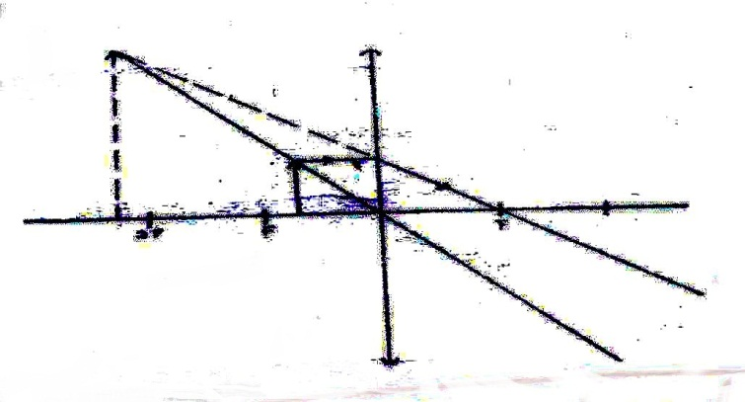
(ii) As a magnifying glass

(b)
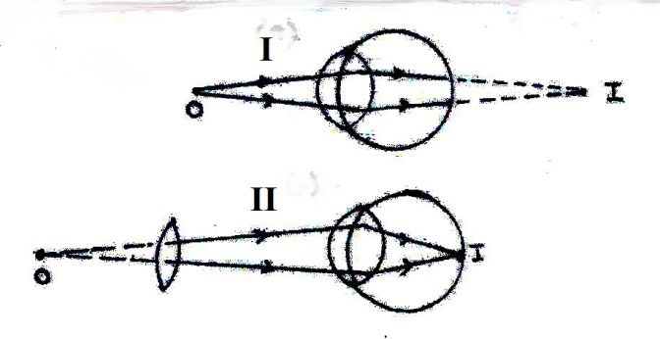
(c) (i)
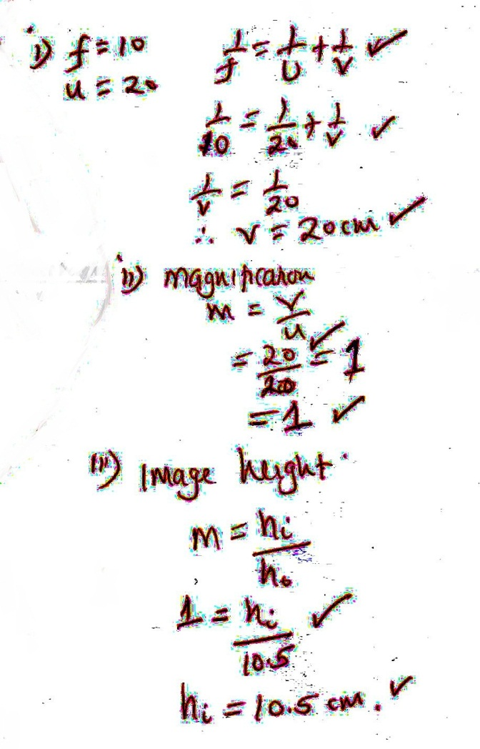
- (a) Charge per unit voltage √1

(b) Area of overlap √1
Distance of separation √1
Type/Nature of dielectric (Any 2 correct)

(c) (i) CP = 5 + 6
= 11μF √1
Cλ = $\frac{11 x 4}{15}$ √1
Cλ = 2.933μϝ √1

(ii) Q = Cv
= 2.933 x 12 √1
= 35.196μc √1
Charge stored in 4μϝ capacitor = 35.196μc

(iii) Voltage across 4μϝ capacitor = $\frac{35.196}{4}$
= 8.799 √1
p.d across 5μϝ capacitor = 12 – 8.799 √1
= 3.201 √1

(d) - In rectification to smoothen output
-
-
-

