Name: …………………………………………………………Index No. …………….……………
School: ……………………………………………. Candidate’s Sign. …………..........................
ADM.NO: ……………………………………… Date: ……………............................................

PHYSICS THEORY
PAPER 1
232/1

AUGUST/SEPTEMBER - 2023
TIME: 2 HOURS

ARISE AND SHINE EXAMINATION
FORM FOUR TRIAL 1 – MARCH/APRIL 2023
Kenya Certificate of Secondary Education (KCSE)

Instructions to the candidates:
- This paper consist of two Section A and B
- Answer all questions in section A and B in the spaces provided
- All working must be clearly shown, and use the CONSTANTS given,
- Ensure that the paper has all the questions
Take g = 10N/kg, Atmospheric pressure = 760mmHg, density of mercury = 13600Kg/m³
For Examiners’ Use Only
SECTION | QUESTION | MAXIMUM SCORE | CANDIDATE’S SCORE
A | 1-11 | 25
B | 12 | 15
 | 13 | 11
 | 14 | 10
 | 15 | 10
 | 16 | 09
 | TOTAL | 80

SECTION A (25 MARKS)
Answer All Questions in This Section in the Spaces Provided

- The figure below shows the change in volume of water in a measuring cylinder when an irregular solid is immersed in it.
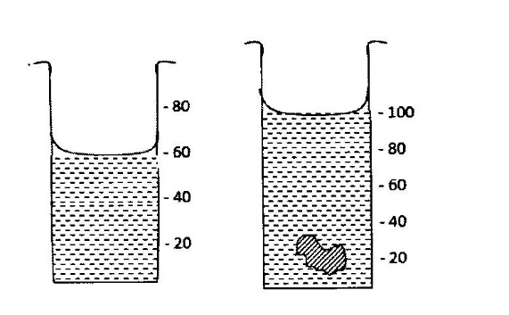
Given that the mass of the solid is 567g determine the density of the solid in Kg/m³. (3 marks)

2 in a ball and ring experiment, the ball goes through the rings at room temperatures. When it is heated it does not go through the ring, but when left on the ring for some time, it goes through.
Explain this observation. (2marks)
………………………………………………………………………………………………………………………………………………………………………………………………………………………………
- The diagram below shows a uniform wooden beam of length 6m and mass 30kg pivoted as shown below.

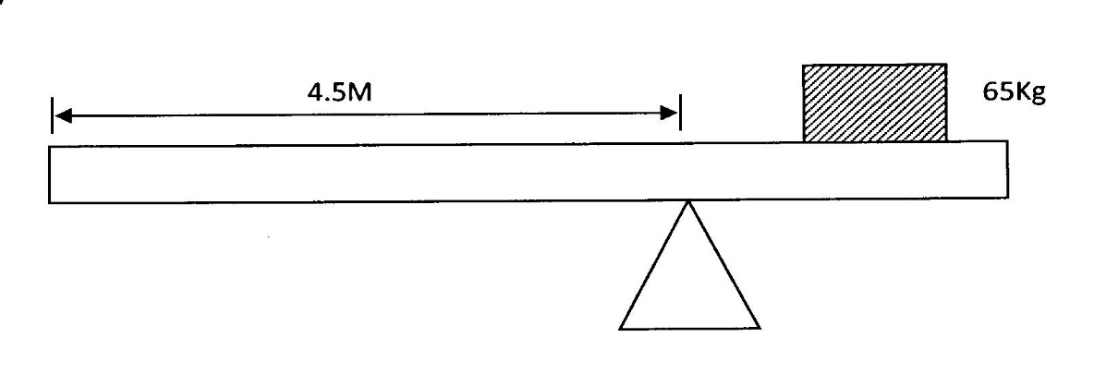
How far from the pivot will the 65kg mass be placed for the beam to be in equilibrium? (3 marks)

………………………………………………………………………………………………………………………………………………………………………………………………………………………………………………………………………………………………………………………………………………

- The figure 3 below shows an arrangement to demonstrate diffusion through solids:-

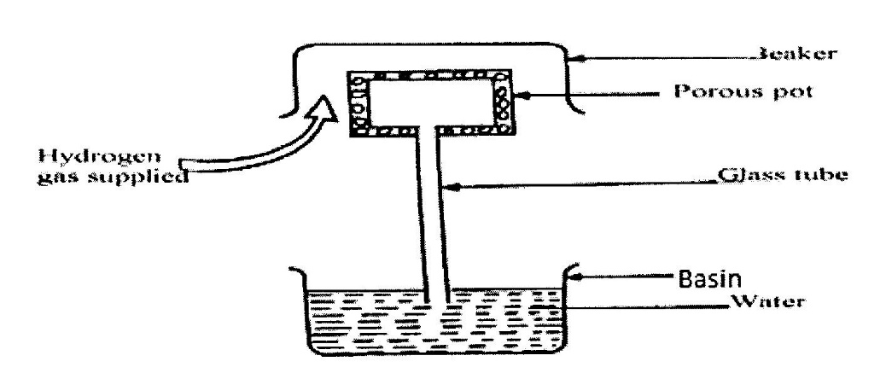
The hydrogen gas is supplied for sometimes then stopped and the beaker removed. State and explain what is likely to be observed when the hydrogen gas supply is stopped. (3 marks)
………………………………………………………………………………………………………………………………………………………………………………………………………………………………………………………………………………………………………………………………………………

- State how the pressure in a moving fluid varies with speed of the fluid. (1 mark)
………………………………………………………………………………………………………………

- A piece of metal weighs 3N in air and 2N when totally immersed in water. Calculate the volume of the metal. (density of water = 1000kg/m³) (3 marks)
………………………………………………………………………………………………………………………………………………………………………………………………………………………………………………………………………………………………………………………………………………
………………………………………………………………………………………………………………………………………………………………………………………………………………………………………………………………………………………………………………………………………………

- Explain how a person is able to drink a soda using a drinking straw. (2 marks)
………………………………………………………………………………………………………………………………………………………………………………………………………………………………

- A needle may float on clean water but sinks when a detergent is added. Explain. (1 mark)
………………………………………………………………………………………………………………………………………………………………………………………………………………………………
………………………………………………………………………………………………………………………………………………………………………………………………………………………………………………………………………………………………………………………………………………

- The identical springs of spring constant 3N/cm are used to support a load of 30N as shown.
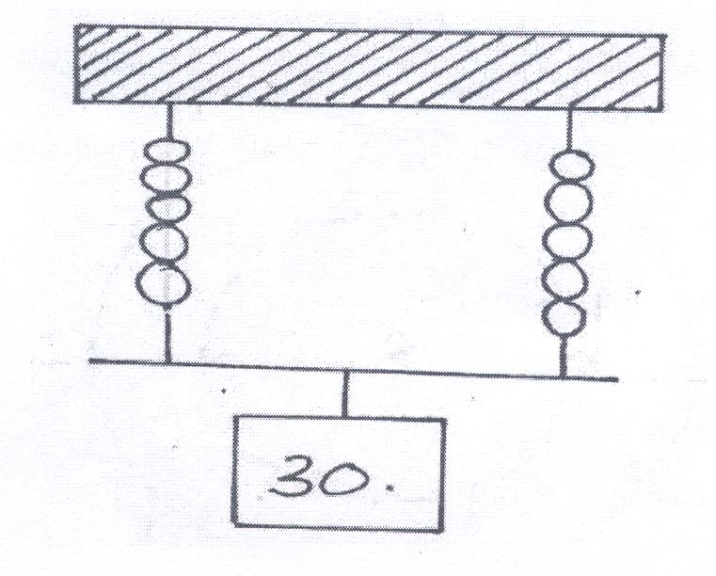
Determine the extension on each spring. (3 marks)

- In a vacuum flask, the walls enclosing there vacuum are silvered on the inside. State the reason for this. (1 mark)
………………………………………………………………………………………………………………

- A student set up the apparatus as shown below. The boiling tube was heated in the middle as shown
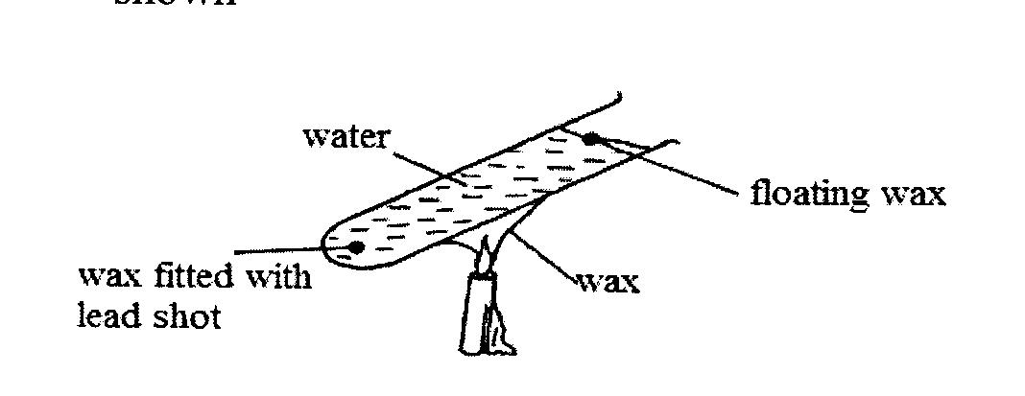
- State the role of the lead shot in the experiment (1 mark)
………………………………………………………………………………………………………………

- With reason, state the wax that will melt firs. (2 marks)
………………………………………………………………………………………………………………………………………………………………………………………………………………………………

SECTION B (55 MARKS)
Answer all questions in this section in the spaces provided

- (a). The figure below shows displacement-time graphs of two objects A and B of equal masses drawn on same axes.
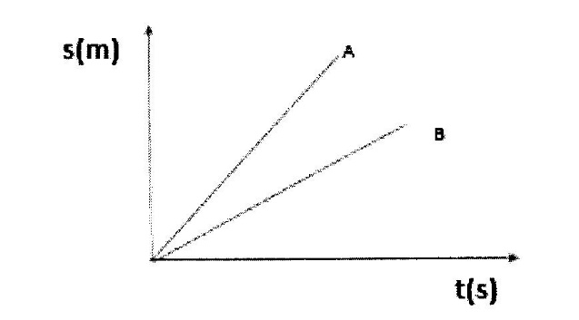
- What does the slope of the graph represent? ( 1mark)

- The same size of force is applied against each object. State with a reason which of the two objects stops in a shorter distance. (2 marks)
………………………………………………………………………………………………………………………………………………………………………………………………………………………………

(b). An object moving at 30m/s starts to accelerate at 5m/s² so that its velocity becomes 50/ms
i) Find the distance moved during this acceleration (3marks)
………………………………………………………………………………………………………………………………………………………………………………………………………………………………………………………………………………………………………………………………………………
………………………………………………………………………………………………………………………………………………………………………………………………………………………………………………………………………………………………………………………………………………

ii) The object is now braked so that it comes to rest in a time of 5 seconds. Find the braking
force if its mass was 2000g. (3 marks)
………………………………………………………………………………………………………………………………………………………………………………………………………………………………………………………………………………………………………………………………………………
………………………………………………………………………………………………………………………………………………………………………………………………………………………………………………………………………………………………………………………………………………

(c) State the law of conservation of linear of linear momentum. (1 mark)
………………………………………………………………………………………………………………

(d) Anobject of the mass 100kg moving at 20 m/s collides with a stationary object of mass 20kg.
They stick together after collision. Determine the:

(i) Total momentum below collision (2marks)
………………………………………………………………………………………………………………………………………………………………………………………………………………………………

(ii) Total momentum after collision (1mark)
………………………………………………………………………………………………………………
………………………………………………………………………………………………………………………………………………………………………………………………………………………………
(iii). Their common velocity after collision (2 marks)
………………………………………………………………………………………………………………………………………………………………………………………………………………………………
………………………………………………………………………………………………………………………………………………………………………………………………………………………………………………………………………………………………………………………………………………

- (a). Explain why an air bubble increasing volume as it rise from the bottom of a lake to the surface.
(2 marks)
………………………………………………………………………………………………………………………………………………………………………………………………………………………………………………………………………………………………………………………………………………
(b) The diagram below shows a set-up used to investigate a particular gas law. Study the diagram and answer the questions that follow.
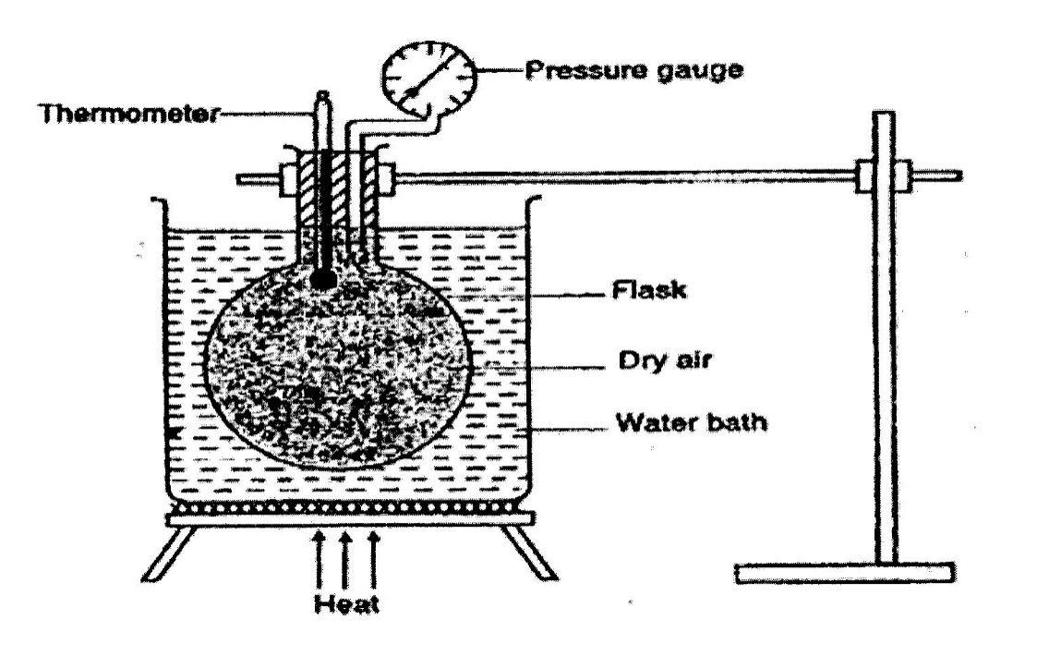
- State with a reason which gas law is being experimented by the set-up. (2 marks)
………………………………………………………………………………………………………………………………………………………………………………………………………………………………

- Name the two factors that are held constant in the experiment (2marks)
………………………………………………………………………………………………………………………………………………………………………………………………………………………………

- Give the reason why heating is done through a water bath. (1 mark)
………………………………………………………………………………………………………………

(c) A balloon of volume 1.5m³ containing helium gas at a pressure of 3.0 x 10⁶ pa is released from the ground when the temperature is 20ºC. What will be the pressure when it reaches an altitude where the volume becomes 3.0m³ and the temperature 5ºC. (3 marks)
………………………………………………………………………………………………………………………………………………………………………………………………………………………………………………………………………………………………………………………………………………

(d) State the kinetic theory of gases. (1 mark)
………………………………………………………………………………………………………………

- (a) An immersion heater rated 2.5W is immersed into a plastic jug containing 2kg of water and switched on for one minute. Determine
(i) The quantity of heat gained by water. (2marks)
………………………………………………………………………………………………………………………………………………………………………………………………………………………………

(ii) The temperature change for water. (Specific heat capacity of water = 4.2x10³Jkg⁻¹K⁻¹(3 marks)
………………………………………………………………………………………………………………………………………………………………………………………………………………………………………………………………………………………………………………………………………………

(b) Explain why a drop of methylated spirit on the back of the hand feels cold. (2marks)
………………………………………………………………………………………………………………………………………………………………………………………………………………………………

(c) What makes Freon suitable for use as a refrigerant? (1 mark)
………………………………………………………………………………………………………………

(d). State two differences between boiling and melting. (2 marks)
………………………………………………………………………………………………………………………………………………………………………………………………………………………………………………………………………………………………………………………………………………

15. The figure below shows an inclined plane used to load heavy luggage’s onto a lorry. The length of the place is L metres and the height is h metres, the plane makes angle a with the horizontal

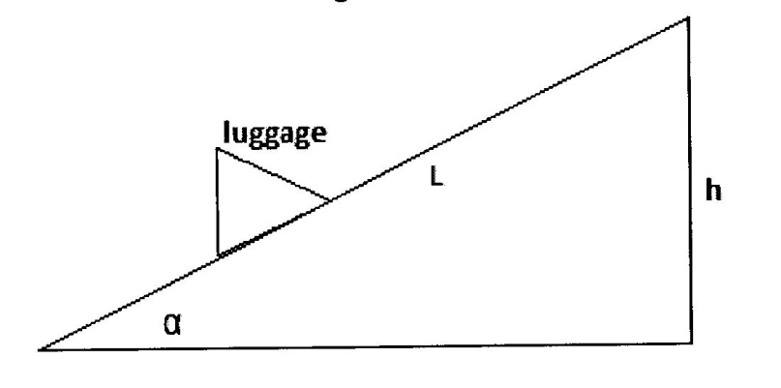
(a) Show that the velocity ratio is given by ¹/_{sin a} (3 marks)
………………………………………………………………………………………………………………………………………………………………………………………………………………………………………………………………………………………………………………………………………………

(b) A man uses the inclined plane above to lift a 50kg load through a vertical height of 4m. The inclined
plane makes an angle of 30º with the horizontal. If the efficiency of the inclined plane is 72%. Calculate
I. The effort needed to move the load up the inclined plane at a constant velocity. (4 marks)
………………………………………………………………………………………………………………………………………………………………………………………………………………………………………………………………………………………………………………………………………………
………………………………………………………………………………………………………………

II. The work done against friction in raising the load trough the 4.0 m height. (3 marks)
[Take g = 10N/kg]
………………………………………………………………………………………………………………………………………………………………………………………………………………………………………………………………………………………………………………………………………………

- (a). State what provides centripetal force for the moon moving round the earth. (1 mark)
………………………………………………………………………………………………………………………………………………………………………………………………………………………………………………………………………………………………………………………………………………
(b). The figure (6) below shows a turnable on which a mass of 50g isplaced 10cm from the center.

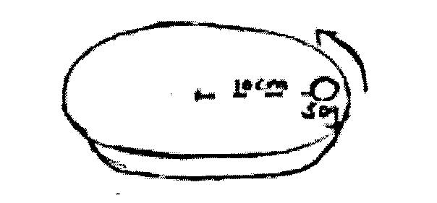

The Frictional force between the 50g mass and the turnable is 0.2N. When the turnable is made to rotate with angular velocity of $ω$rad/sec, the mass tarts to slide off.
i) Determine the
I. Angular velocity (3marks)
………………………………………………………………………………………………………………………………………………………………………………………………………………………………………………………………………………………………………………………………………………

II. Time taken to make a complete revolution when moving with the above angular velocity. (2 marks)
………………………………………………………………………………………………………………………………………………………………………………………………………………………………
………………………………………………………………………………………………………………………………………………………………………………………………………………………………
ii On the figure, draw a path that would be taken by the 50g mass at above position if the turnable suddenly came to stop. (1 mark)
………………………………………………………………………………………………………………
(c) State two changes can be made to keep the 50g mass from sliding off. (2marks)

………………………………………………………………………………………………………………………………………………………………………………………………………………………………

