PHYSICS FORM 3 APRIL HOLIDAY ASIGNMENT
Name__________________________________________AdNo_______________________________

- Explain why an increase in temperature increases browmian motion (1mk)

- (i) Which glass among the two glasses in fig 3 is more stable. (1mk)

Water empty glass

(a) (b)

Fig 3
(i) Give reason for (i) above. (1mk)

- The tape in figure 4 below was obtained from an experiment using a ticker timer of frequency 50Hz. the tape was pulled by a trolley.

● ● ● ● ● ● ● ●

Fig 4 2cm 8cm
If the trolley that was pulling the tape was accelerating, use diagram to answer question 5 and 6 show the direction of acceleration of the trolley. (1mk)

Calculate the acceleration of the trolley. (3mks)

- (a) Distinguish between streamline and turbulent flow. (2mks)

(b) Figure 11 below shows two light sheets of paper arranged as shown.

X Y

A B
Explain the observation made when air is blown at the same speed and as the same time at point A and B (2mks)

(c) Fig 12 below shows an incompressible fluid moving through a tube of varied cross-sectional area. If the area of the small tube is 0.056m², calculate the area of the large tube in cm².

V₁ = 0.6ms⁻¹
V₂ = 2.5ms⁻¹
0.056cm²

Fig 12

(d) Explain why birds have sharp-nosed shape. (2mks)

- Figure 14 below shows a 200mm column of air trapped in a long tube closed at one end by mercury of length 7.8mm as shown below. The prevailing atmospheric pressure is 760mmHg.

20mm 7.8mm

Open end

Closed end
Mercury

(a) Determine the pressure of the trapped air column when the tube is held vertically with the open end falling up. (1mk)

(b) Determine the height of the trapped air column when the tube is held vertically with the open end falling up. (3mks)

- (a) (i) Define the term heat capacity. (1mk)

(ii) 100cm³ of water at room temperature (20⁰C) is kept in a refrigerator. It cools to -10⁰c in 1 hour. Calculate the work done by the refrigerator. (Take specific heat capacity of water and ice as 4200J/Kg/k and 2100J/Kg/k and specific latent heat of ice as 336000J/Kg) (3mks)

(b) A block of ice of mass 40g at 0⁰C is placed in calorimeter containing 400g of water at 20⁰C ignoring heat absorbed by the calorimeter, Determine the final temperature of the mixture after all the ice has melted (Specific latent heat of fusion of ice = 340000J/kg, specific heat capacity of water = 4200J/kg (3mks)

- (a) Fig 15 below shows a pendulum bob swinging to and fro

/////////////////////////////////

h = 20cm
A B C

(i) State the position where the pendulum bob has maximum kinetic energy (1mk)

(ii) Determine the velocity of the bob and position identified in (a) (i) above if the maximum vertical displacement of the bob is 20cm. (3mks)

(b) (i) What is meant by perfectly inelastic collision? (1mk)

(ii) A minibus of mass 1600kg traveling at a constant velocity of 72km/h collides with a stationary car of mass 800kg. Impact takes 2 seconds before the two moves together at a constant velocity of 15 seconds. Determine
(I) The common velocity (3mks)

(II) Distance moved after the impact (2mks)

(III) Impulsive force (3mks)

- Fig 1 shows a ray of light incident on a plane mirror at point O.

35⁰
/////////////////O/////////////////////
Fig 1
The mirror is rotated clockwise through an angle of 20⁰ about an axis perpendicular to the paper
Determine the angle through which the reflected ray rotates (2mks)

- How does polarization weakens the current flow in a cell. (1mk)

- A positively charged rod is brought near the cap of a leaf electroscope. The cap is then earthed momentarily by touching with the finger. Finally the rod is withdrawn. The electroscope is found to be negatively changed. Explain how this charge is acquired. (2mks)

- Each battery in circuit diagram in fig 4 below has an emf of 2.0V and zero internal resistance.

A
4.2Ω

2.9Ω
4.2Ω

Determine the ammeter reading when the switch is closed. (3mks)

- A student used the measuring instrument shown below to measure the thickness of a cylindrical wire, If the wire is 10cm long, find the volume of the wire. (3mks)
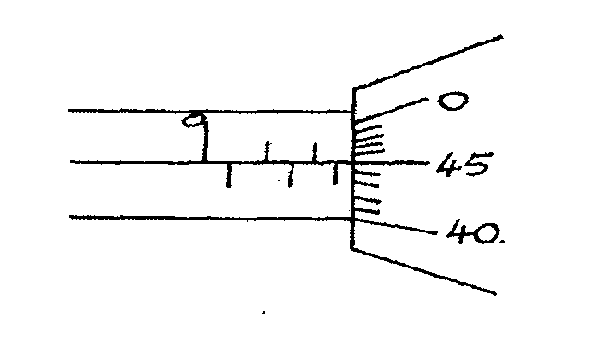

- The figure below shows two containers of equal volume but of different diameters.

Equal volume of hot water was put in both containers. Explain why it cools faster in the
Wider container than in the narrower one. (lrnk)

- A body in a uniform circular motion experiences acceleration despite moving at a constant
speed. Explain. – (1mk)

- The diagram below shows a-metal tube made of iron and copper. The joint is tight at room temperature.
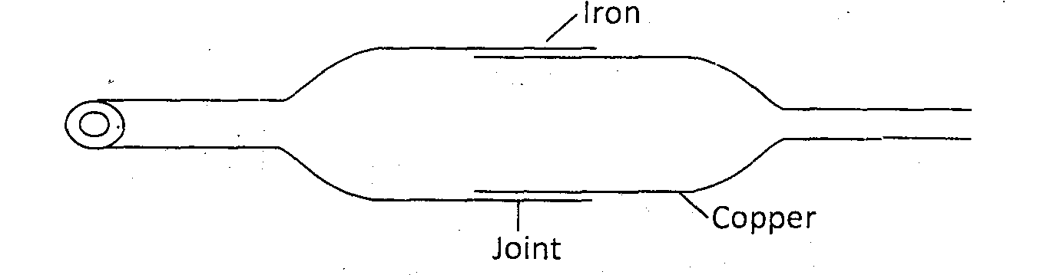

Explain how you would separate the two by changing the temperature given that copper expands more than iron for some change in temperature. (2mks)

- Figure below shows a pulley system being used to raise a lead.
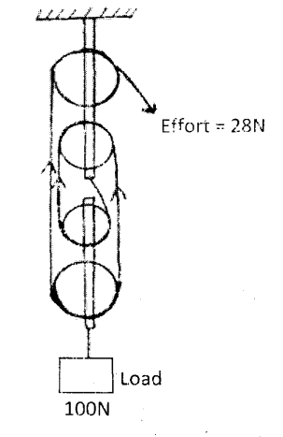

if the effort applied is 28N and the load lifted is l00N, determine the efficiency of the
system. (3mks)

- (a) What is surface tension? (1mk)

(b) The figure below shows a funnel dipped into a liquid soap solution.
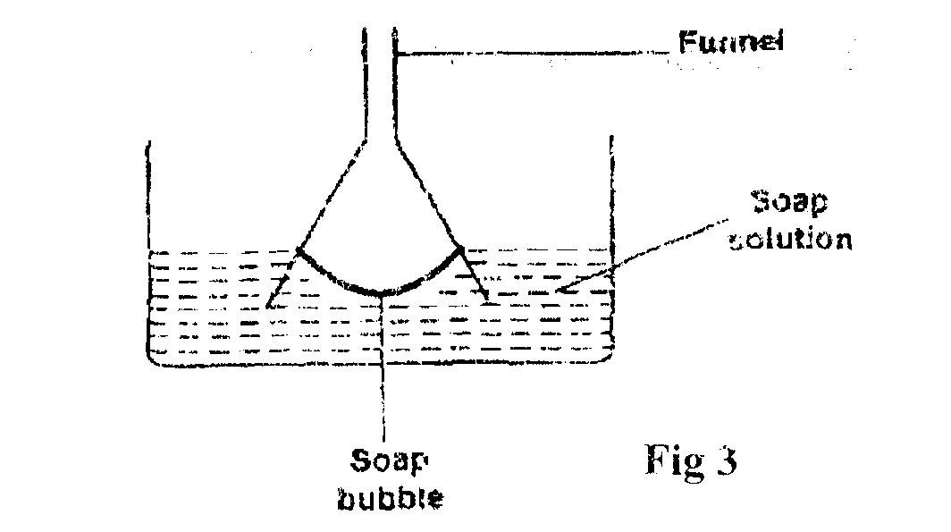

Explain what happens to the soap bubble when the funnel is removed. (1mk)

7. A trolley of mass 0.5kg moving with a velocity of I .2ms⁻¹ collides in elastically with a second trolley of mass 1.5kg moving in the same direction with a velocity of 0.2ms⁻¹ .Determine the
velocity of the trolleys after collision. (2mks)

8. Highlight one fact which shows that heat from the sun does not reach the earth surface by
convection. (1 rnk)

9. State one reason why mercury is preferred as a barometric liquid and not water. (lmk)

10. State one reason why racing cars are stable. (lmk)

11. Find the velocity ratio of the following gear wheels. (2mks)
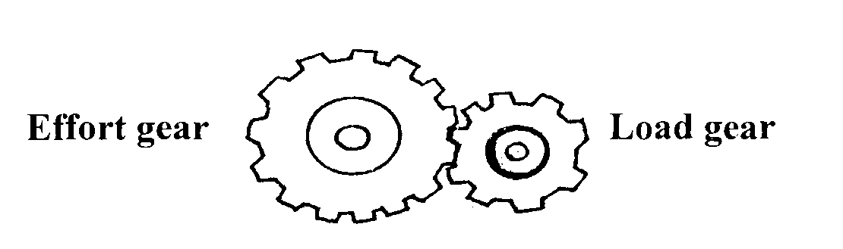

12. A stone and a feather are dropped from rest from a building 20m tall. If they reach the ground at the same time, find.
(a) The velocity with which they reach the ground. (Take g=l0m/s²) (2rnks)

(b) The condition under which they fall. (lmk)

13. The forces act on a trolley as shown below.

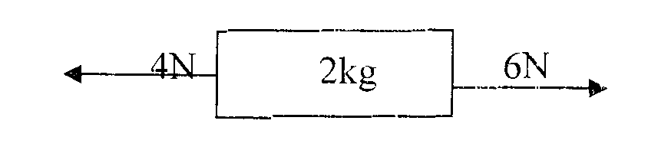
Find the acceleration of the trolley. (2mks)

14. On the axes below, sketch the graph of density of water against temperature. ( 1mk)
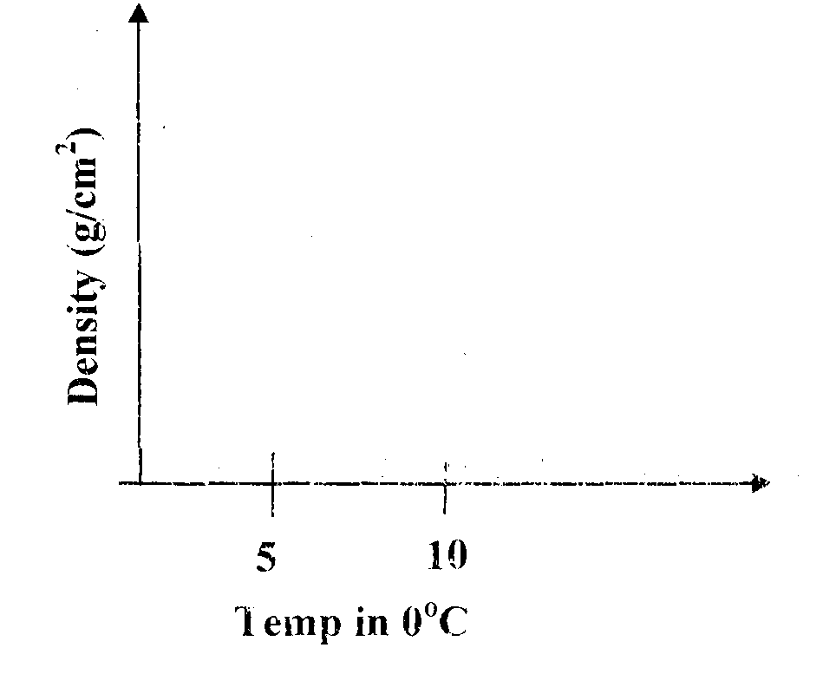
15. (a) A car is negotiating unbanked circular track. State one factor that will determine
the critical speed of the car. (1mk)

.
(b) Given that the ear above has a mass of 1000kg and the circular path has a radius of 25m. Determine the maximum speed with which the motorist can travel so as not to skip the
frictional force between the tyres and the road is 6500N. (3mks)

(c) A 200g mass tied to a string is being whirled in a vertical circle of radius 32cm with uniform speed, At the lowest position the tension in the string is 10.5N. Calculate:
(i) The speed of the mass (2mks)

(ii) The tension in the string when the mass is at the uppermost position of the circular path (Take g = 10m/s²) (2rnks)

16. Brownian motion of smoke particles can be studied by using the apparatus shown in figure.7. To observe the motion, some smoke is closed in the smoke cell and then observe through the Microscope.

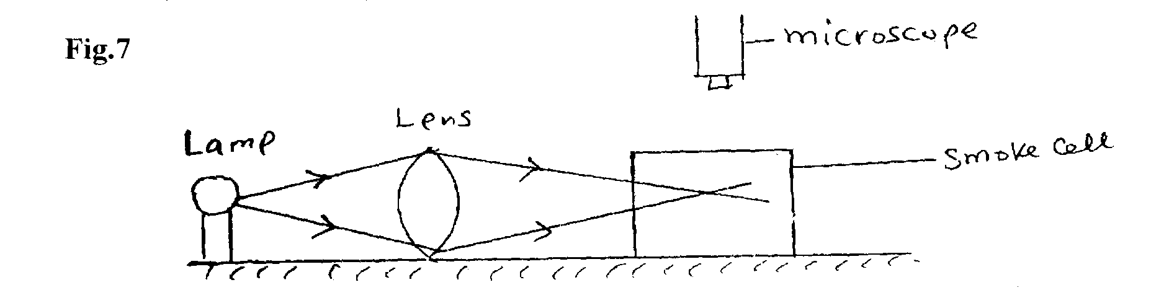

(a) Explain the role of the smoke particles, lens and microscope in the experiment.
(i) Smoke cell. (1 mk)

(ii) Lens (1 mk)

(iii) Microscope (lmk)

(b) State and explain the nature of the observed motion of the smoke particles. (2rnks)

(c) State what will be observed about the motion of the smoke particles if the temperature surrounding the smoke cell is raised slightly. (1 mk)

17. (a) State what is meant by an ideal gas (1mk)

(b) The pressure acting in a gas in a container was changed steadily while the temperature of the gas was maintained constant. The value of volume V of the gas measured various values of pressure. The graph in the figure A shows the relation between the pressure. P1 and the reciprocal of volume 1/V
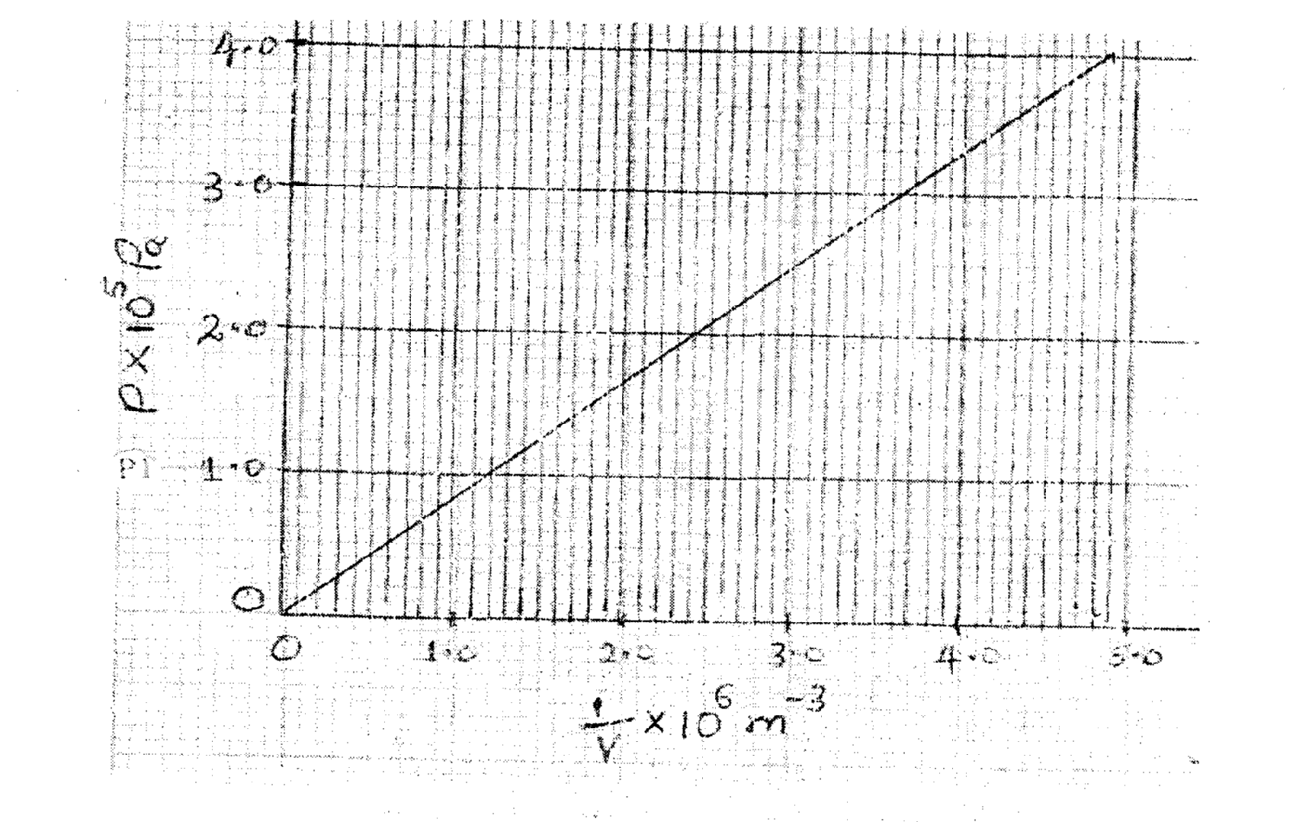

- Given that the relation between the pressure P1 and the value, V1 of the gas is given by PV = k Where k is a constant, use the graph to determine the value (3rnks)

(ii) What physical quantity does K represent? (1mk.)

iv) State one precaution you would take when performing such an experiment. (1mk)
(c) A gas occupies a volume of 4000 litres temperature of 37°C and normal atmosphere pressure. Determine the new volume of the gas if it is heated at constant pressure to a temperature of 67°C (normal atmosphere pressure P = 1.01 x 10⁵pa) (3marks)

20. (a) What is meant by specific heat capacity? (1 mk)

b) A heater rated 1 .25 kW is used to heat 3 kg of a substance which is initially in solid state.
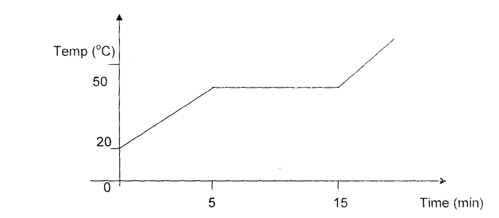

Use the information in the graph to find:
- the specific heat capacity of the substance in solid form. (3 mks)

- the latent heat of fusion of the substance. (2 mks)

iii) The time taken for the temperature to reach 90°C, assuming specific heat capacity
does not change . (3 rnks)

iv) Suggest a reason why the actual time may be longer. (1 mk)

