PHYSICS FORM 2 APRIL HOLIDAY ASSIGNMENT
NAME......................................................................................................ADM.NO.................................

- Define the term electrostatic and state it SI unit (1mark

- State the basic law of electrostatic charges (1mark)

- Kimani connected three identical bulbs, as shown below.
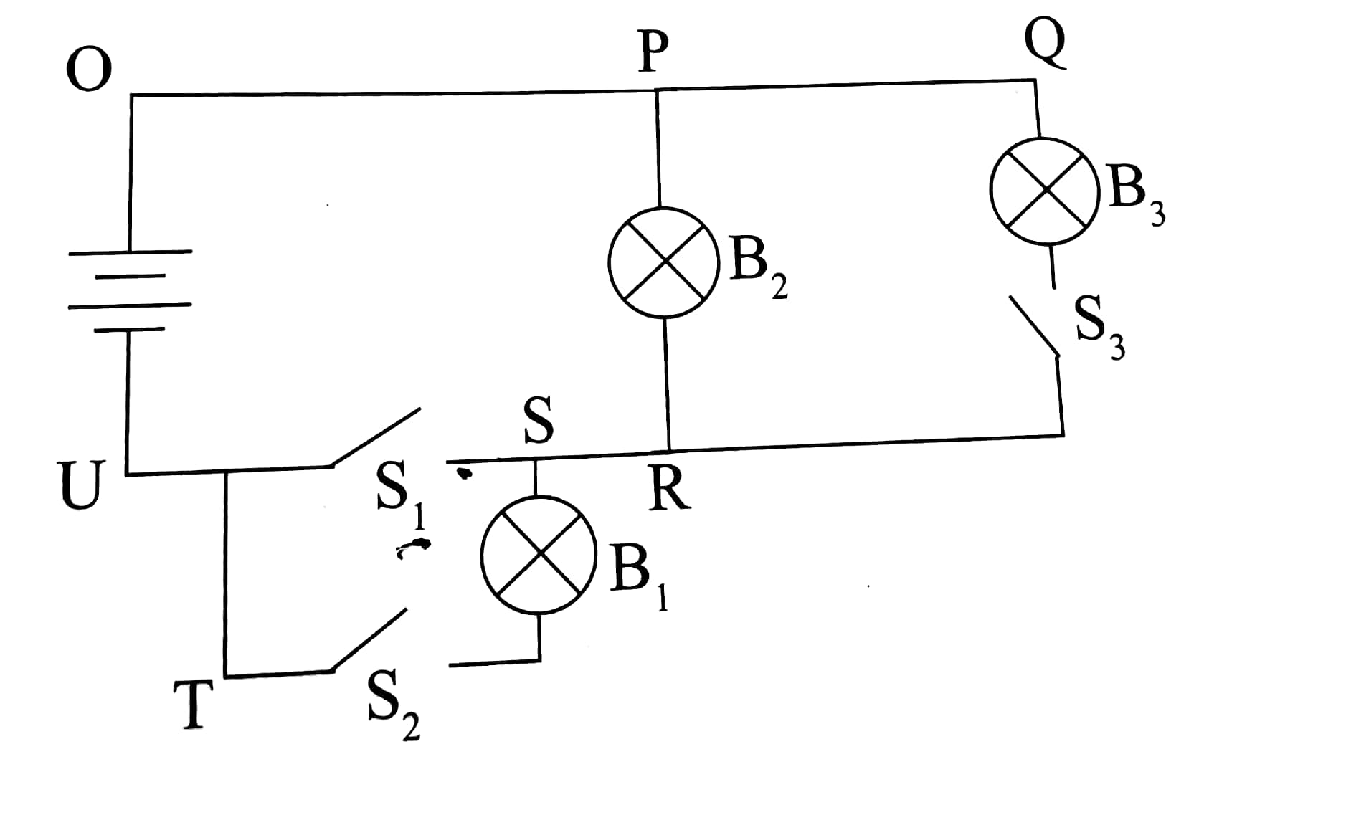
Explain what happens , indicating the path of current when:
a)S₁ is closed while S₂ closed and S₃ are open. (2marks)

b) S₂ is closed while S₁ and S₃ are open . ( 2marks)

c) S₁ and S₂ are closed while S₃ is open. (2marks)

d) S₁ and S₃ are closed while S₂ is open (2marks)

e) S₂ and S₃ are closed while S₁ is open . (2marks)

- a Define electric current and state its SI unit. (2marks)
b)A charge of 240 coulombs flows through a lamp every minute.Calculate the current flowing through the lamp. (2marks)

- State three advantages of Alkaline Accumulators over lead acid Accumulators . (3marks)

- What is the use of Manganese( IV) oxide in the dry cell . (1mark)

- Name two defects in the primary cell and how they can be reduced. (2marks)

- .List three ways in which we can maintain the Accumulators (3marks)

- Name two uses of the electroscope (2marks)
- List three ways in which we can charge a conductor (3marks)

- Name two instruments that can be use to measure the volume of an irregular

- What is atmospheric pressure (1mks)

- States three factors affecting thermal conductivity (3mks)

- Give two precautions necessary while handling a density bottle. (2mks)

- The mass of an empty density bottle is 20g. its mass when filled with water is 40g and 50g when filled with liquid X. calculate the density of liquid X if the density of water is 1000Kgm⁻³.

- Explain why water rises up in narrow tubes but mercury, which is also a liquid, falls in narrow tubes to a level below the outside surface. (2mks)

- Give two factors affecting surface tension.

- List three conditions to be observed for effective operation of a siphon

- The figure below shows a U-tube filled with water, mercury and another liquid, determine the density of the liquid. (3mks)

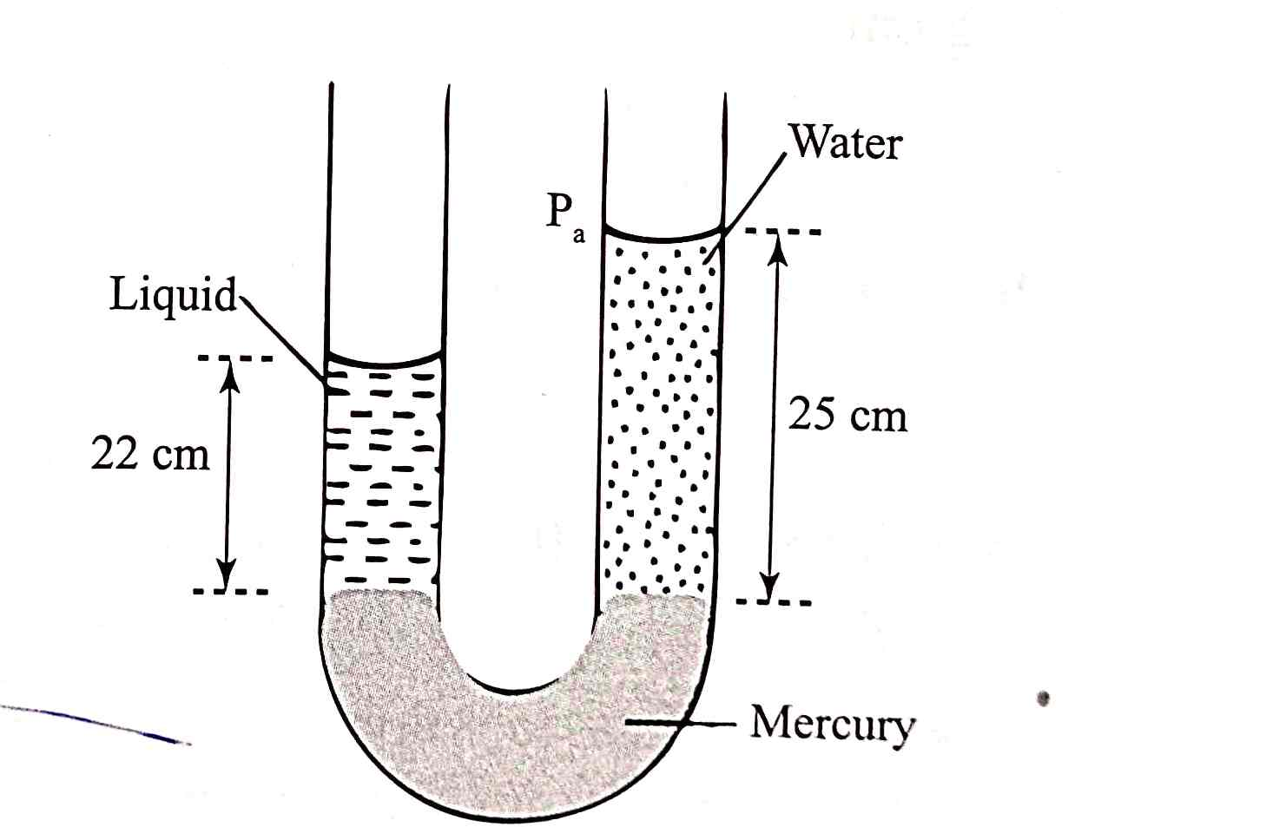

The figure below, ammonia gas and an acid gas diffuse and react to form a white deposit on the walls of the glass tube, the deposit forms nearer end B.

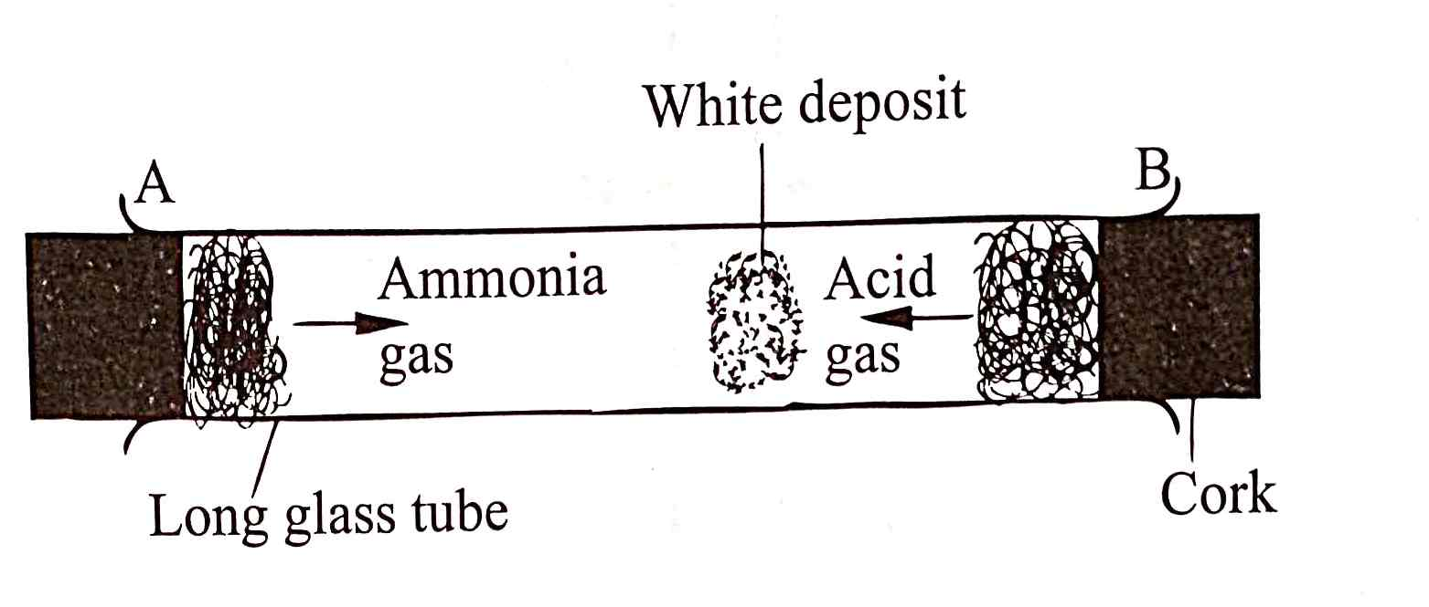
a.State which gas diffused faster. (1mk)

b.Explain how the rate of diffusion depends on the density of a gas. (2mks)

c.Explain the effect of performing the experiment above at a higher temperature. (2mks)

  - State and explain three factors affecting velocity of sound in air. (3marks)
- Distinguish between streamline flow and turbulent flow. (2marks)

- In deriving the equation of continuity, there are assumptions made. State the three assumptions that the fluid must have. (3marks)

- The figure below shows a pipe of varying cross section. Three vertical tubes x, y and z of same diameter are fixed to the section A, B and C of the pipe respectively as shown below.

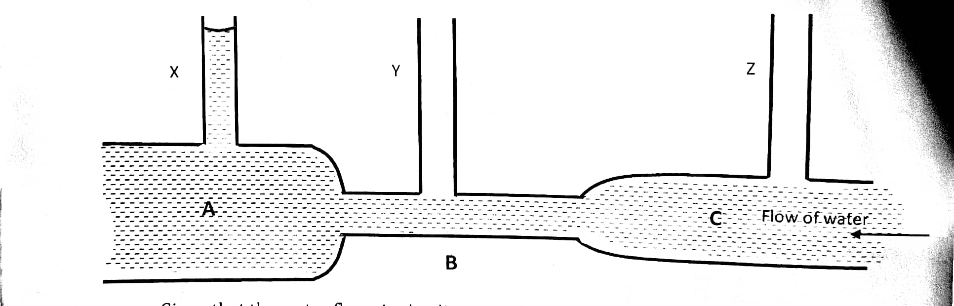
Given that the water flows in the direction shown by the arrow, indicate on the diagram the relative levels of water in y and z. (2marks)

- State two hazards of Bernoulli’s effect. (2markks)

- State and explain three factors affecting velocity of sound in air. (3marks)

- Define moment of a force. (2marks

b. State two factors affecting moment of force. (2marks)

c. A uniform metre rule pivoted at its centre is balanced by a force of 4.8N at 20cm mark and some other two forces, F and 2.0N on the 66cm and 90cm marks respectively. Calculate the force F.
- Define magnetic field. (1mark)

State three uses of magnets. (3marks)

- The air pressure at the base of a mountain is 75.0cm of mercury while at the top it is 60.0cm of mercury. Given that the average density of air is 1.25kg/m³ and the density of mercury is 13600kg/m³, calculate the height of the mountain. (3marks)

- In an experiment to estimate the size of a molecule of olive oil, a drop oil of volume 0.12mm³ was placed on a clean water surface. The oil spread into a patch of areas 6.0x10⁴mm².
- Estimate the size of a molecule of olive oil. (3marks)

- b. Give two assumption made when calculating the thickness of the oil drop. (2marks)

- Explain how A is effective in reducing heat transfer. (1mark)

- An object is placed 10cm in front of a convex mirror of a focal length 20cm. Determine the position of the image. (2marks)
- Nature of the image. (1mark)

- Define the following terms as used in curved surface.

Pole: (2marks)

Radius of curvature: (2marks)

- State the basic quantities of measurement (3marks)

2. A piece of metal of mass 120g is placed in 100ml measuring cylinder containing 20ml of water.Find the density of the metal if water level rises to 50ml mark. (3marks)

3.The mass of a solid of dimensions 4m x2m x3m is 96kg.Calculate
a)Minimum pressure it can exert. (2marks)

b)Maximum pressure it can exert. (2marks)

4. a)State three modes of heat transfer. (3marks)

b)Explain why a piece of metal feels colder than a piece of wood. (2marks)

5.An object is placed 10cm in front of a plane mirror. When the object is moved 4cm towards the mirror ,calculate the distance between the object and the image. (2marks)

6.What is the use of manganese( IV) oxide in the dry cell. (1mark)
7.State two characteristics of an image formed by a pinhole camera. (2marks)

8.Distinguish between a dull black surface and a shiny polished surface based on heat transfer. (2marks)
9. a State one disadvantage of anomalous expansion of water. (1mark)

b)State three properties of mercury that make it suitable for use in a thermometer. (3marks)

c)State two reasons why water is not a suitable thermometric liquid. (2marks)

10.Convert the following as indicated :
a) 25⁰C to Kelvin (1mark)
b) 300K to degree Celsius (1mark)

c) 25cm³ to m³ (1mar
d) 5mg to kg (1mark)

11.Explain the following observations.
a)Water wets glass (1mark)

b)Water does not wet polythene (1mark)

12. a Name three sources of electrical energy. (3marks)
b Calculate the amount of current flowing through a bulb if 420 C of charge is flowing through the circuit in 3.5 minutes. (3marks)

13.The diagram in the figure below shows an arrangement for observing Brownian motion .
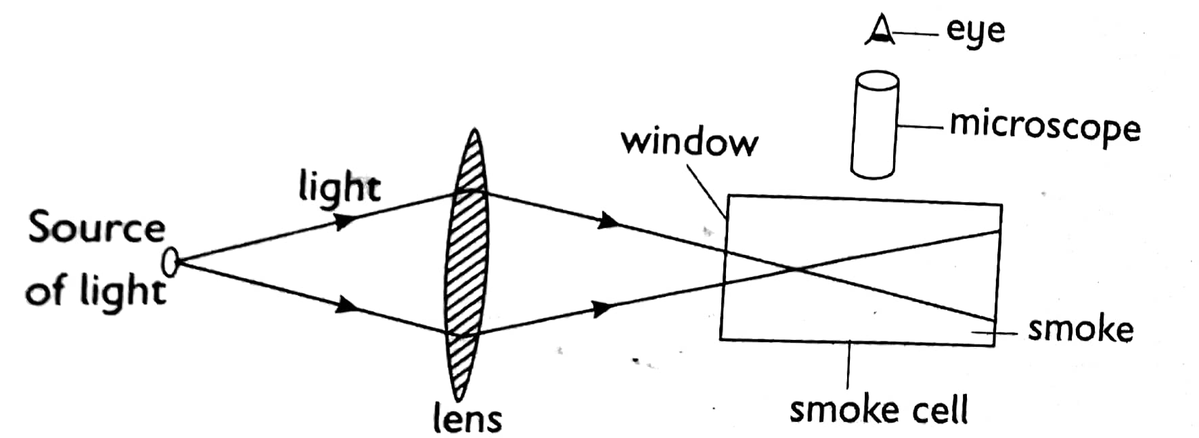

a)Explain the observation made. (2marks)

b)What will be observed when the glass cell temperature is lowered? (2marks)

c)State the kinetic theory of matter (1mark)

14.The figure below shows a thermos flask.
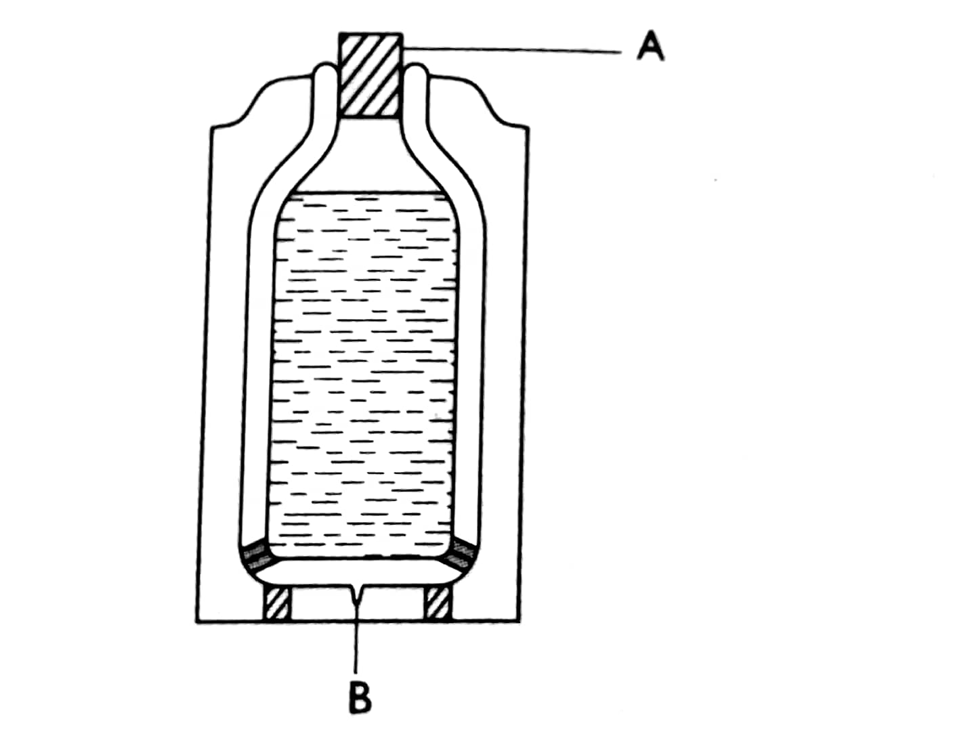
a)Name the part labelled:
A (1mark)
B (1mark)
b)State the use of part labeled B. (1mark)

c)Explain how the heat loss is minimised in the thermos flask (4marks)
15. a)State the pascals principle. (1mar
b)The figure below shows a simple hydraulic lift used to lift a load

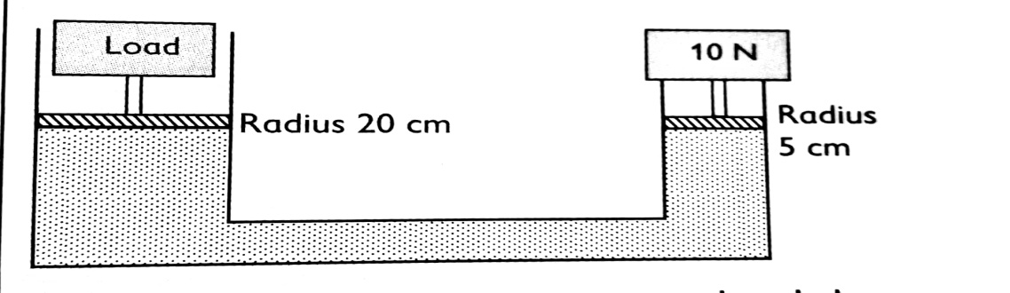
Calculate the maximum load that can be lifted using a downward effort of 10 newtons. (4marks)

c) State two limitation of a lift pump that make it impossible to rise water to a height greater than 10m. (2marks)

(d)Name three conditions necessary for a siphon to work effectively (3marks)

17. a)Describe an experiment to show that light travel in a straight line. ( 5marks)

18. In an experiment to determine the density of sand using a density bottle ,the following measurements were recorded:
Mass of empty density bottle = 43.2g
Mass of density bottle full of water=66.4g
Mass of density bottle with some sand =67.5g
Mass of density bottle with the sand=82.3g
Use the above data to determine the:
a)Mass of water that completely filled the bottle (2marks)

b)Volume of water that completely filled the bottle (1mark)

c)Volume of the density bottle. (1mark)

d) Mass of sand (1mark)

e)Mass of water that filled the space above the sand (1mark)

f)Volume of the sand (3marks)

g)Density of the sand (2marks)

19.Study the diagram below and answer the questions that follows.
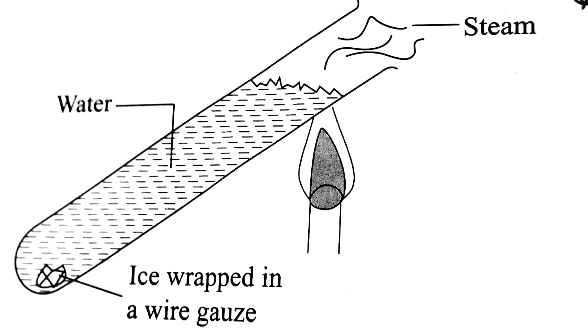
a)Why was the boiling tube made of glass (1mark)

b)Why was ice wrapped with a wire gauze (1mark)

c)Give a reason why ice did not melt and the wire gauze is a good conductor of heat (2marks)

d)Explain why water was heated at the top. (2marks)

