232/3
FORM FOUR
PHYSICS
PAPER 3
PRACTICAL

END OF TERM 2 EXAMINATION
Kenya Certificate of Secondary Education
MARKING SCHEME
- (a) (i ) Width = 3.02cm 1 mk
Thickness = 0.72cm 1 mk
(ii) Volume = 3.02 x 0.72 x100
=217.44cm³ 1 mk
(iii) Density =
=
= 0.46g/cm³ 1 mk
1(d)
d (cm) | d(cm) | (m ⁻²) | Time for 20 oscillations t(s) | Period T (s) | T2 (S2)
80 | 0.80 | 1.56 | 13.00 | 0.65 | 0.42
60 | 0.60 | 2.78 | 16.00 | 0.80 | 0.64
50 | 0.50 | 4.00 | 20.00 | 1.00 | 1.00
40 | 0.40 | 6.23 | 25.00 | 1.25 | 1.56
30 | 0.30 | 11.11 | 33.00 | 1.65 | 2.70
20 | 0.20 | 25.00 | 50.00 | 2.50 | 6.25
 |  | 1 MK | Each correct value ½ mk. Total 3 mks | 1 mk | 1mk

1(e)
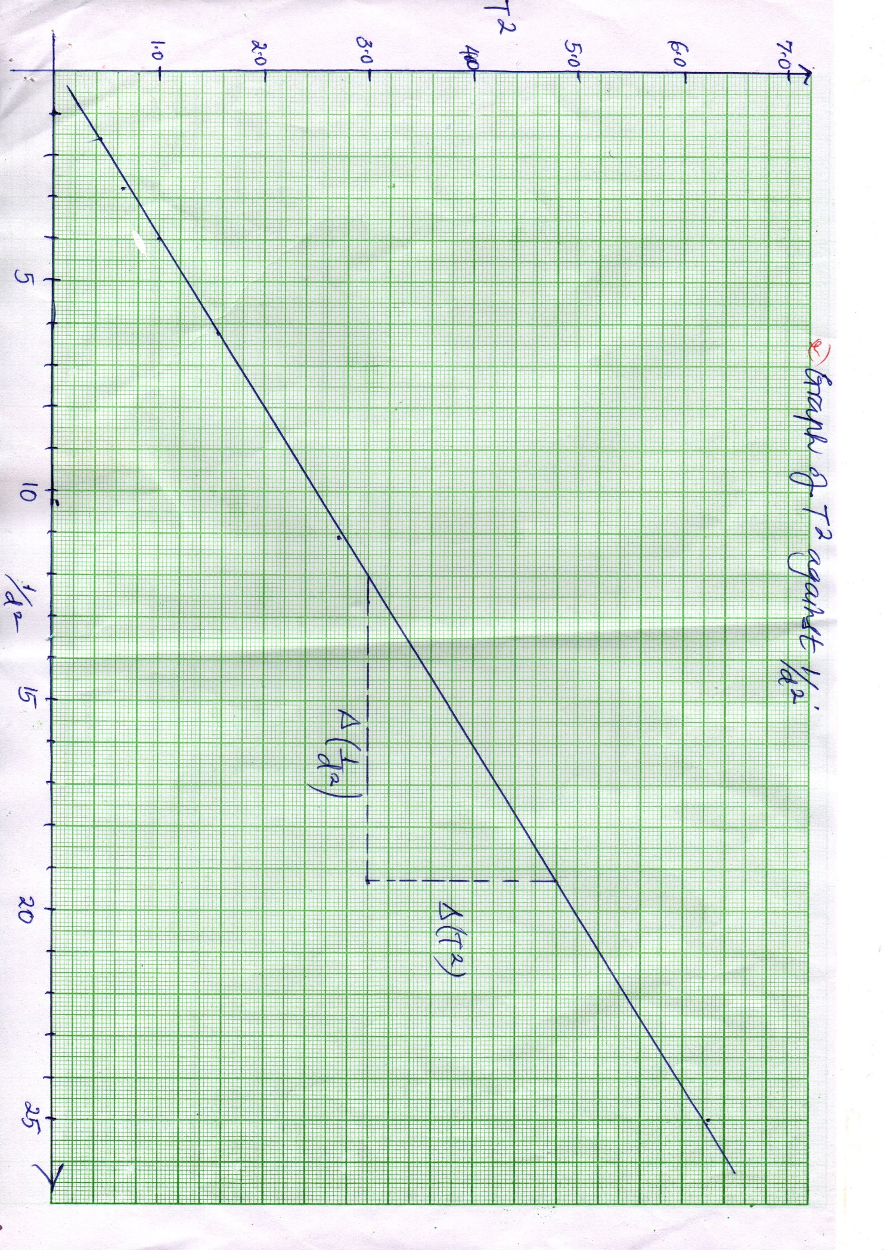
Labelling axes – 1mk
Scale – 1mk
Plotting – 2mks
Straight line – 1mk
Total - 5mks

(f) Slope = 48 – 3.0
19.3 - 11.2
(3mks)

= 0.2222
(g) T² =
Y = mx +c
Gradient =
0.2222 =
K = 0.2635
2mks

2. PART A
d) TABLE OF RESULTS
L(CM) | 10 | 20 | 30 | 40 | 50 | 60 | 70
V(VOLTS) | 1.20 | 1.15 | 1.05 | 0.95 | 0.90 | 0.85 | 0.80
I(AMPERES) | 0.23 | 0.22 | 0.20 | 0.18 | 0.17 | 0.16 | 0.15
(4mks)

d (I)

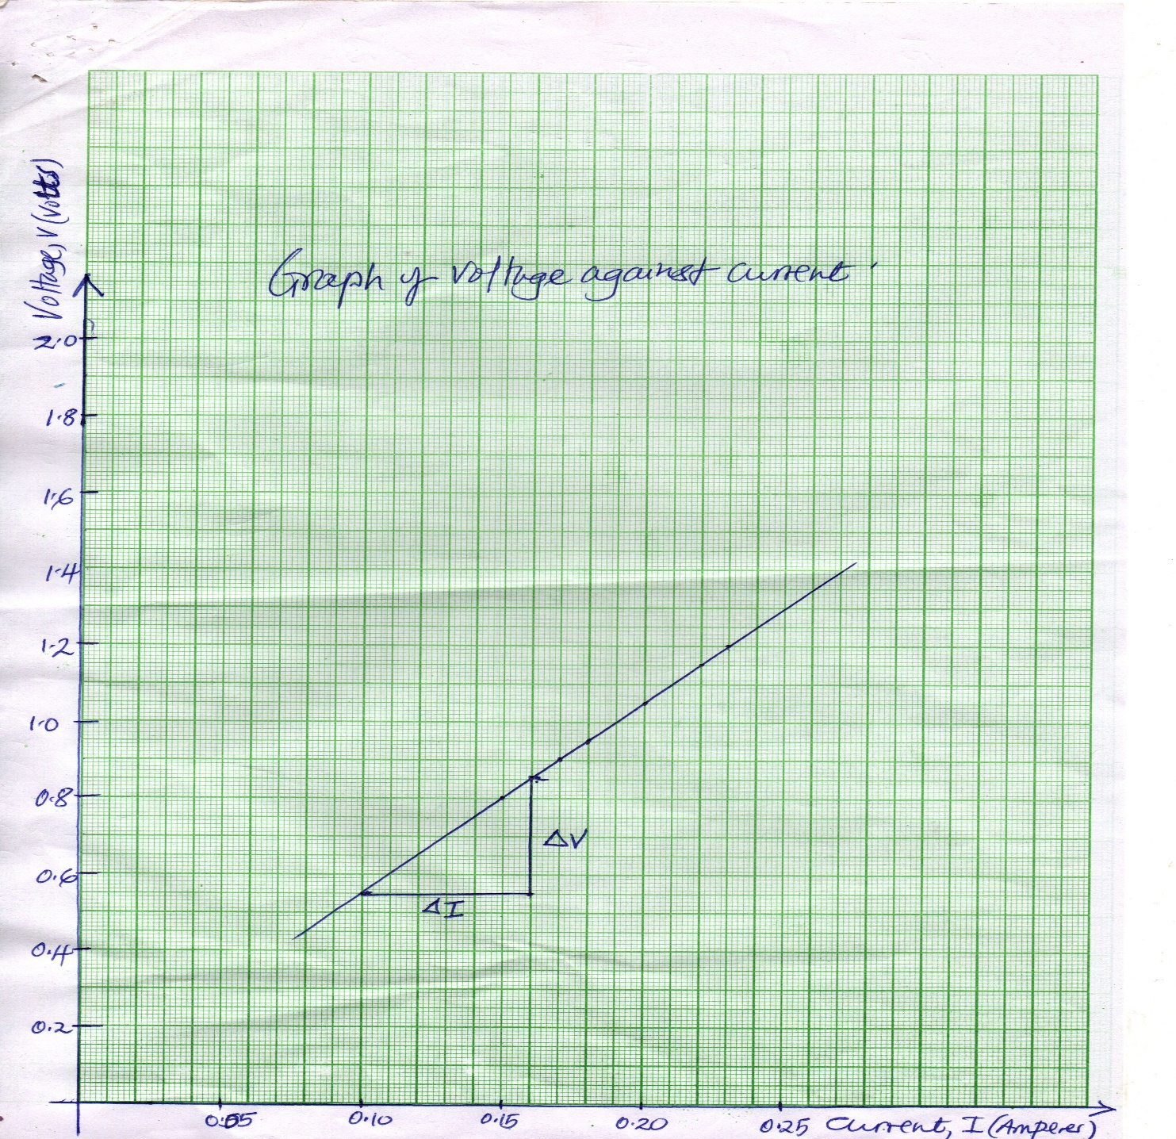

Labelling axes – 1mk
Scale – 1mk
Plotting – 2mks
Straight line – 1mk
d(ii) Slope = = = = 5.0 Ω (3mks)

d(iii) Slope represents resistance of the resistor R (mounted on cardboard) = 1mk
2 PART B

(a) G = 50 ± 0.5 CM………………………………………….1mk

(b) (I) P = 67.3 ± 0.5 CM…………………………………..1mk

(ii) y = 67.3 – 50 = 17.3 cm …………………………1mk

(iii) Clockwise moment = anticlockwise moment

= x10 x Y = ( X 10 – U) x X ……………………….….1mk
0.5 Y = (1 - U) X…………………………………………………………1mk
0.5 X 17.3 = (1 -U) X 10
8.65 = 10 – 10U
10U = 10-8.65
10U =1.35
U = ……………………………………………………………….…..1mk
= 0.135 N…………………………………………………………………1mk

