FORM 4 TERM 2
PHYSICS PAPER 2
Marking scheme
SECTION A
1. n = 360/𝜃 - 1 √1
S = 360
𝜃 -1
θ = 360
6
= 600√1
2. i. Polarization√1
ii. Add a depolarizer/ an oxidizing agent√1
3. (i) Reciprocal of the focal length power of the lens
(ii) 1/f = gradient => f = 1/gradient
f= 13cm
iii v =u= 27cm
- 4. Hammering makes the dipoles to vibrate√1
Earth magnetic field aligns the dipoles√1
5. B- North pole√1
A- South pole – Allow correct pole at one end
6. A1 will shows a reading while A2 will not show any reading. This is the fact that P will be forward biased hence conducting while Q is reverse biased hence it wil not conduct.
7. r =beta particle , c=206 d= 82
8. It forms a coating at the surface to prevent rusting and as an insulator
It is less dense hence easy to carry
It is easily available/cheaper (Any TWO √1 each)
9. Distance between a particle in the wave medium and the next one that is in phase with it or Distance between two successive crest/trough √1
10. V=2nd/t
= 400*2/2.5
=320m/s
11. n=(2.2x10⁸)/(2.0x10⁸)
=1.1
  - = sin i/sin 30
Sin I = 1.1 x sin30
=0.55
I = sin⁻¹ 0.55

12. (i)

(ii)
Right hand grip rule
Maxwell – cork screw rule
13. i) Wide view
ii) Gives upright image

14. ultra violet light

15. a) i) A – Grid1
B – Electron gun1
ii) C – Vertical deflection of beam of electrons1
D – Horizontal deflection of beam of electrons1
iii) By thermionic emission or heating the filament1
iv) To prevent ionization of electrons as they move to the anode1
b) i) E = ev1
E = 1.6 x 10-19 x 800001
= 1.28 x 10⁻¹⁴ J1
ii) ½ mv² = 1.28 x 10⁻¹⁴1
v² = $\frac{2 ×1.28 × {10}^{-14}}{9.11 ×10-31}$
v = $\frac{\sqrt{2 ×1.28 ×10-14}}{9.11 ×10-31}$1
v = 2.23 x 10⁸ ms1

- (a) 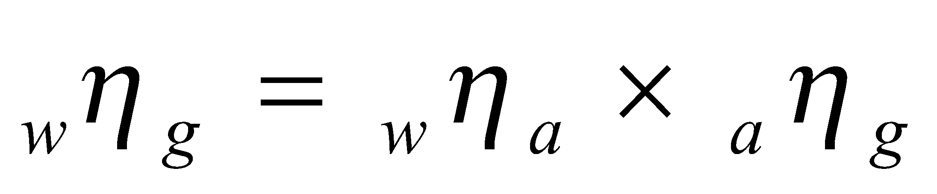
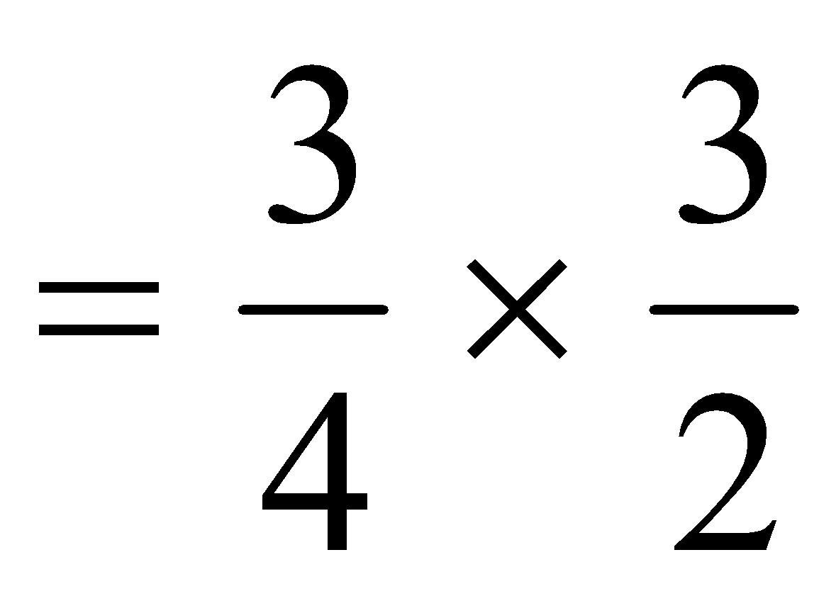
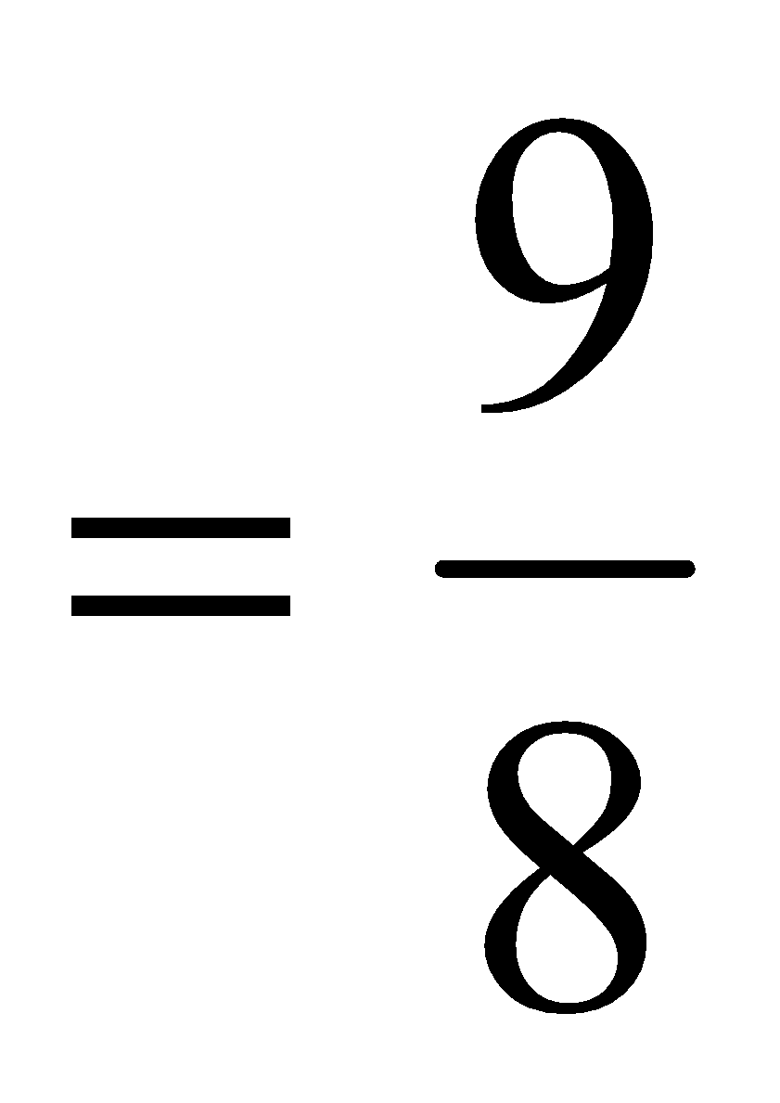
= 1.13
(b) (i) 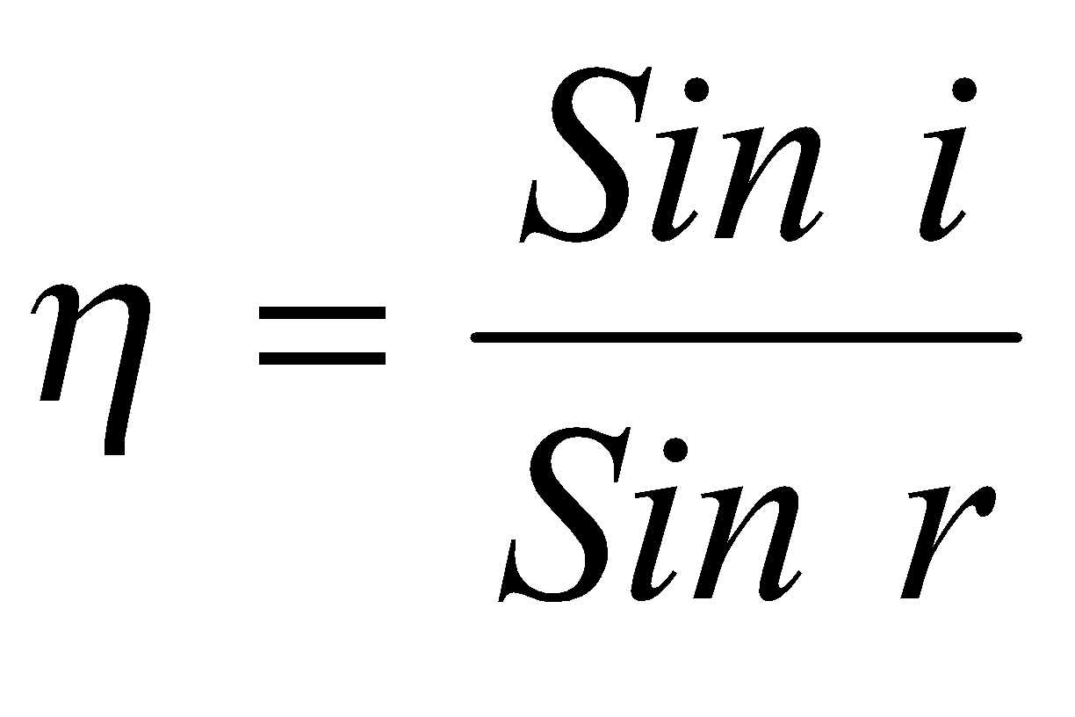
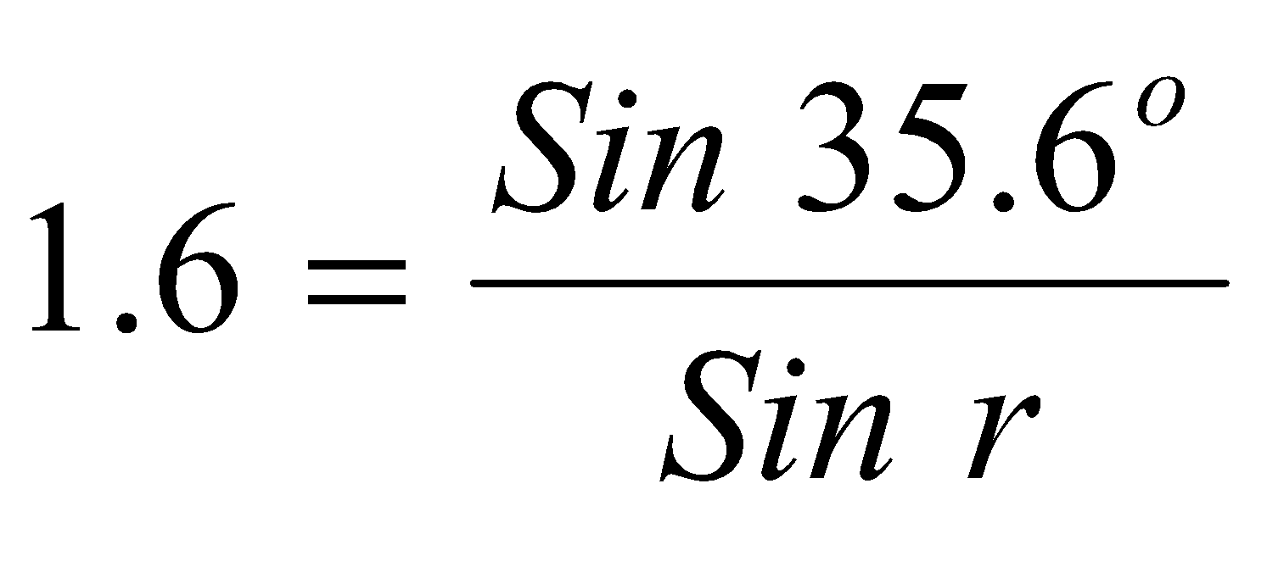
r = 21.3º
- Angle of incidence = 38.7º (show working)
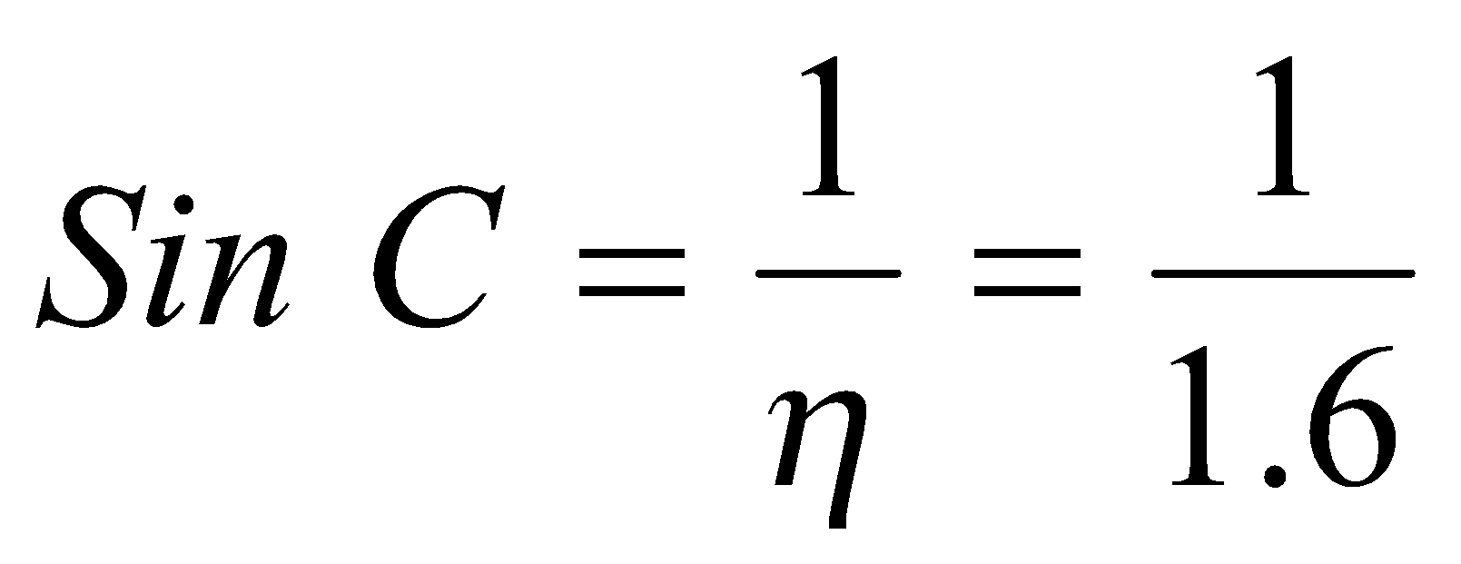
= 38.7º

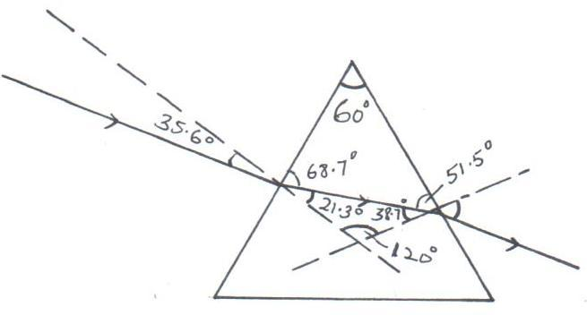
(iii)

(iv) - The critical angle must be exceeded. ✓¹
- Light must be travelling from a dense medium to a less dense medium. ✓¹
- a) Capacitors are used in
- rectification smoothing circuits
- tuning circuits
- camera flash
- reduction of sparking in induction coil contact
any one 1

b) i) 2 x 8 = 16 = 1.6μF
2 + 8 10
1.6 + 3.2 = 4.8μF ✔
C_{T} = 5 x 4.8 ✔ = 24 = 2.45 x 10⁻⁶F ✔
5 + 4.8 9.8
ii) Q = CV
= 2.45 x 10⁻⁶ x 12 = 2.94 x 10⁻⁵C ✔
charge on 3.2μF = ²/₃ x 2.94 x 10⁻⁵
= 1.96 x 10⁻⁵C ✔
iii) p.d on 5mF = Q = 2.94 x 10⁻⁵ = 5.88volts ✔
C 5 x 10⁻⁶
iv) energy = $\frac{1}{2}$CV² ✔
= ½ x 2 x 10⁻⁶ x 6.12²
= 3.75 x 10⁻⁵J ✔
(c) (i) Capacitance will also increase
(ii) capacitance will decrease.
Parallel circuit 1/30 + 1/20 = 5/60 or 60/50
R = 12 Ω
Total resistance = 10 + 12 = 22Ω (2 marks)
(ii) l = ^{V}/_{R} = ^{2.1}/₂₂ = 0.095A (1 mark)
(iii) Reading of the voltmeter
V = lR = 10 x 2.1
22 = 0.95 (2 marks)

- a) Lenz’s Law states that the direction of induced current is such that it opposes the charge producing it.✔
b) i) When switch S is closed, the magnetic field strength increases (magnetic flux) from zero to maximum ✔^{1/2} This changing magnetic flux (field) induces an e.m.f
in the secondary coil ✔1When the switch is opened, the magnetic field strength decreases (magnetic flux) from maximum to zero ✔^{1/2} This produces an induced current in the secondary coil
ii) Having more turns on the coil connected to the cell ✔
c) i) - Hysterisis
- Eddy currents
- Resistance of wire
- Loss of magnetic flux linkage
ii) Power Primary x 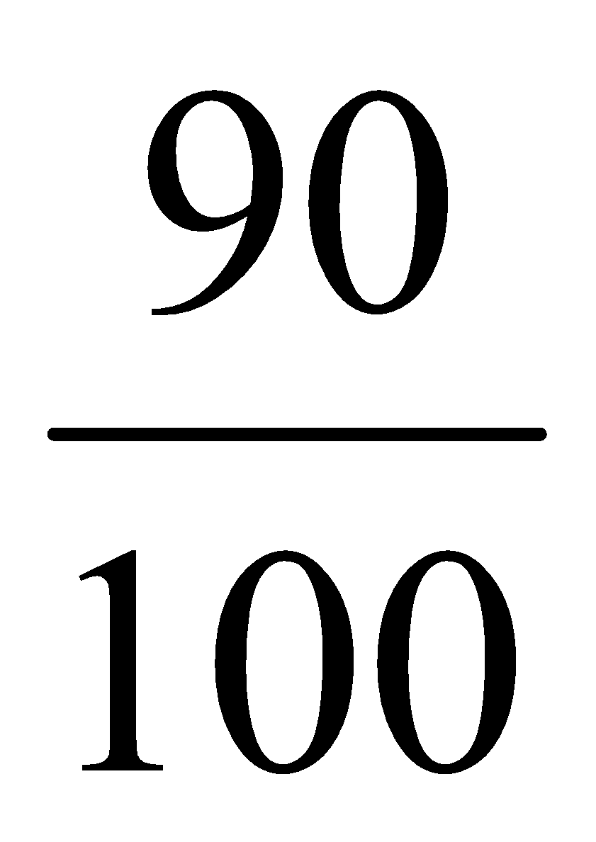= VsIs ✔1
240 x IP x = 80 x 9
IP = 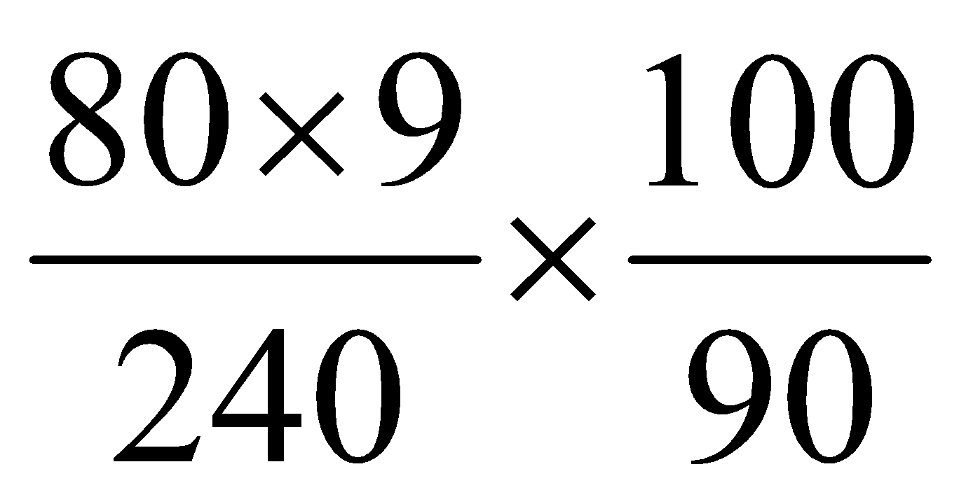✔1 = 3.33A ✔1

18. (a) A – cathode B – Anode C – Cooling fins
(b) (i) increase the p.d at the anode (B)
(ii) : increase the cathode heater current
(c) Tungsten:- It has a high melting point so the heat produced will not melt it easily
(d) Copper – it is used to cool/conduct heat away from the anode
(e) So that the electrons do not collide with gas molecules which could result in loss of energy.
f) E = QV = hf ✔$\frac{1}{2}$
1.6 x 10¹⁹ x 1,200 = 6.63 x 10³⁴ x f ✔$\frac{1}{2}$
f = 2.9 x 10¹⁸ Hz ✔

(g) (i)Detecting fracture in bones
(ii) Detecting flaws in metals



