NAME__________________________________ ADM NO. ____________DATE_____________

232/1
PHYSICS
THEORY
PAPER 1
2 HOURS
MULTILATERAL EXAM
FORM 4 TERM 2
Kenya Certificate of Secondary Education
INSTRUCTIONS
- Write your name and admission number in the space provided
- Write the date of the examination in the space provided above
- This paper consists of two sections A and B.
- Answer all the questions in the spaces provided.
- All workings must be clearly shown.
- Mathematical tables and silent electronic calculators may be used.
For examiner’s use only
SECTION | QUESTION | TOTAL MARKS | CANDIDATE’S SCORE
A | 1-12 | 25
B | 13 | 11
 | 14 | 13
 | 15 | 11
 | 16 | 12
 | 17 | 8
 |  | GRAND TOTAL

Section A ( 25 marks)
Answer all the questions in the spaces provided
- Figure 1 (a) below is micrometer screw gauge when closed, and figure 1 (b) shows the same micrometer screw gauge measuring the thickness of a sim card.
Determine the thickness of the sim card. (2mks)
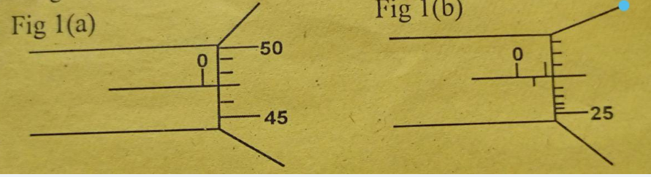
…………………………………………………………………………………………………………………………………………………………………………………………………………………………………………………………………………………………………………
- A rectangular container measures 2.4cm x 4cm x 6cm. what is the weight of the mercury that will fill the container to the brim. ( take g =10N/kg, density of mercury =13600kg/m³) (3mks)
……………………………………………………………………………………………………………………………………………………………………………………………………………………………………………………………………………………………………………………………………………………………………………………………………………………………………………………………………………………………………………………………………………………………………………………………………………………
- It is painful when you press a small piece of stone with your palm of the hand than when you place the same stone on the palm. Briefly explain. (2mks )
……………………………………………………………………………………………………………………………………………………………………………………………………………………………………………………………………………………………………………………………………………………………………………………………………………………………………………………
- Why are luggage compartments in buses placed under the seats rather than on the roof racks ( 1mks)
……………………………………………………………………………………………………………………………………………………
- a) A uniform metre rule in balanced horizontally at its centre. When a mass of 50g is suspended at 4cm mark the rule balances horizontally if a mass M is suspended At 73cm mark. determine the mass m. (2 marks)
……………………………………………………………………………………………………………………………………………………………………………………………………………………………………………………………………………………………………………………………………………………………………………………………………………………………………………………………………………………………………………………………………………………………………………………………………………………
b) Give one application of moment of force. 1mk)
……………………………………………………………………………………………………………………………………………
- Figure below shows a U-tube containing coloured water, two boiling tubes Y and Z both painted black. A container with hot water painted black on one side and polished shinny on the opposite side is placed as shown in the diagram below.

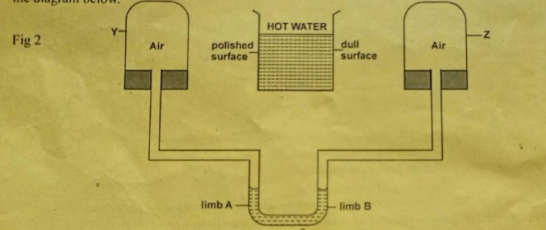

(a)State the observation made after some time in the level of the liquid in the U-tube. (1mk)
……………………………………………………………………………………………………………………………………
(b)Explain your observation.(3mks)
………………………………………………………………………………………………………………………………………………………………………………………………………………………………………………………………………………………………………………………………………………………………………………………………………………………………………………………………………………………………………………………………………………………………………………………………………………………………………………………………………………………………
- A stone is thrown vertically upwards from the edge of a platform. Eventually the stone lands without bouncing on the ground below the platform. Taking upwards velocity to be positive sketch the velocity –time graph of the motion of the stone.
(2mks)

- Trees along a busy road grow bending towards the road, Explain. (1 mk)
…………………………………………………………………………………………………………………………………………………………………………………………………………………………………………………………………………………………………………………………………………………………………………………………………………………………………….

- A solid displaces 5.5cm³ of ethanol when floating and 20.0cm³ when fully immersed in it. Given that the density of ethanol is 0.8g/cm. Calculate the density of the solid. ( 3 mks)
……………………………………………………………………………………………………………………………………………………………………………………………………………………………………………………………………………………………………………………………………………………………………………………………………………………………………………………………………………………………………………………………………………………………………………………A student observed light rays penetrating through a small hole on the roof of smoky room. State the observation made on the smoke particles. ( 1 mk)
…………………………………………………………………………………………………………………………………………………………………………………………………………………………………………………………………………………………………………………………………………………………………………………………………………………………………….

- Give the energy transformation involved when a boy kicks a football to a wall. (1mk)
……………………………………………………………………………………………………………………………………………………………………………………………………………………………………………………………………………………….

- Identify the forces acting on a ball bearing as it moves down a cylinder containing glycerine
(2 mks)
..................................................................................................................................
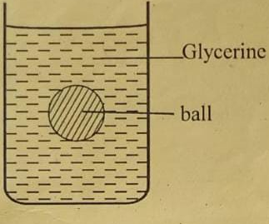

Section B (55 marks) Answer all the questions in this section

13.i) State the law of conservation of energy. (1mks)
…………………………………………………………………………………………………………………………………………………………………………………………………………………………………………………………………………………………………………………………………………………………………………………………………………………………………….

ii). It is easier to use a thick screw driver than a thin one. Explain. (1mk)
…………………………………………………………………………………………………………………………………………………………………………………………………………………………………………………………………………………………………………………………………………………………………………………………………………………………………….

b) The figure below shows a force-distance graph for a car being towed on a horizontal ground.
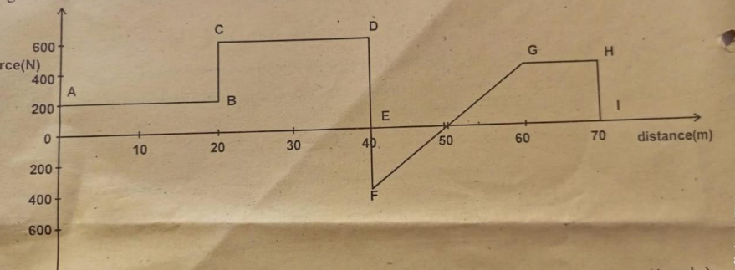

From the graph;
.
i). Calculate the total work done. ( 4 mks)
……………………………………………………………………………………………………………………………………………………………………………………………………………………………………………………………………………………………………………………………………………………………………………………………………………………………………………………………………………………………………………………

(i). If the velocity just before reaching point D is 0.6m/s. Calculate the power developed by the source providing the force at this point. ( 2 mks)
…………………………………………………………………………………………………………………………………………………………………………………………………………………………………………………………………………………………………………………………………………………………………………………………………………………………………….
.
c). An electric pump can raise water from a low level reservoir to a higher level reservoir at a rate of 3.6x10kg/hr. The vertical height the water is raised is 400m. if the rate of energy loss inform of heat is 200kw,determine the efficiency of the pump. (3.mks)
……………………………………………………………………………………………………………………………………………………………………………………………………………………………………………………………………………………………………………………………………………………………………………………………………………………………………………………………………………………………………………………………………………………………………………………………………………………………………………………………………………………………………………………………….

14.(a) State two ways in which the centripetal force on a body of mass m can be increased.
(2mks)
(i)………………………………………………………………………………………………………………………..
(ii)…………………………………………………………………………………………………………………………
(b) Figure below shows an object at the end of a light spring balance connected to a peg using a string. The object is moving in a circular path on a smooth horizontal table with a constant speed.

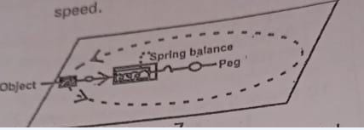

- State what provides the centripetal force (1mk)
………………………………………………………………………………………………………………………

- Indicate with an arrow on the figure the direction of the centripetal force ( 1mk)

………………………………………………………………………………………………………………………
- State with a reason why the object is accelerating while its speed remains constant. (1mk)
………………………………………………………………………………………………………………………

(iv). Given that the mass of the object is 0.5kg and it is moving at a speed of 8m/s at a radius of 2m ,determine the reading on the spring balance (3mks)
………………………………………………………………………………………………………………………………………………………………………………………………………………………………………………………………………………………………………………………………………………………………………………………………………………………………………………………………………………………………..
- A stone thrown vertically upwards reaches a height of 100m. determine:

- Initial velocity of the stone. ( neglect air resistance and take g= 10m/s) (3mks)
…………………………………………………………………………………………………………………….
…….……………………………………………………………………………………………………………….
…………………………………………………………………………………………………………………….
- Total time the stone is in air (2mks)
…………………………………………………………………………………………………………………
………………………………………………………………………………………………………………..
……………………………………………………………………………………………………………….
………………………………………………………………………………………………………………..
15 . Draw a block and tackles pulley system that has a velocity ration of 3. (2 mks)

.

Determine:
- The mechanical advantage of the system in 80% efficient ( 3marks)
……………………………………………………………………………………………………………………………
……………………………………………………………………………………………………………………………
……………………………………………………………………………………………………………………………
……………………………………………………………………………………………………………
- The effort used, if the load lifted is 4.8N (3mks)
……………………………………………………………………………………………
…………………………………………………………………………………………………………………………………………….
…………………………………………………………………………………………………………………………………………….
………………………………………………………………………………………………………………………………….
- The work done by the effort in lifting the load through a distance of 70cm (3marks)
………………………………………………………………………………………………………………….
………………………………………………………………………………………………………………..
………………………………………………………………………………………………………………..
- How much energy is wasted? (2 marks)
…………………………………………………………………………………………………………………………………………………………………………………………………………………………………………………………………………………….........................
16.(a) Define the term specific heat capacity. (1mk)
……………………………………………………………………………………………………………………………
(b). The following data was obtained from an experiment to determine specific heat capacity of a solid by electrical method.
^{Mass of the solid. ………….750g}
Initial temperature of solid……………..200C
^{Ammeter reading………….1.0A}
^{Voltmeter reading…………6.0V}
Final temperature of the solid…….240C
Time for which current flows in water……..6 minutes.
(i)Draw a simple diagram to show how the experiment was done. (3mks)

(ii). From the data given calculate;
(I).Electrical energy supplied to water. (2mks)
…………………………………………………………………………………………………………………………………………………………………………………………………………………………………………………………………………………………………………………………………………………………………………………………………………………………………………………………………………………………………………………………………………………………………………………………………………………….
(II).Specific heat capacity of the solid. (3mks)
……………………………………………………………………………………………………………………………………………………………………………………………………………………………………………………………………………………………………………………………………………………………………………………………………………………..

(c). The heat capacity of kerosene is 84JK⁻¹. Calculate the quantity of heat energy required to warm kerosene from 20⁰C to 26⁰ (3mks)
……………………………………………………………………………………………………………………………………………………………………………………………………………………………………………………………………………………………………………………………………………………………………………………………………………………………………………………………………………………………………………………………………………………………………………………………………………………..

17. (a)State Newton’s first law of motion (1 mk)
………………………………………………………………………………………………………………………………………………………………………………………………………………………………………………………………………………………………………………………………………………………………………………………………………………………
(b) A wooden block resting on a horizontal bench is given an initial velocity u so that it slides on the bench surface for a distance d, before coming to a stop. The values of d were measured and recorded for various values of initial velocity. Figure below shows the graph of u² against d.

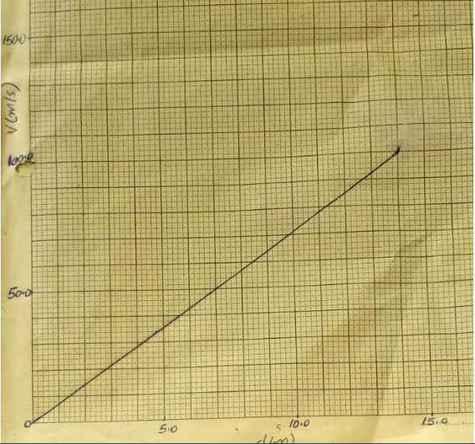

- Determine the slope of the graph. ( 2mks)
………………………………………………………………………………………………………………………………………………………………………………………………………………………………………………………………………………………………………………………………………………………………………………………………………………………………………………………………………………………………………………………………………………………………………………………………
- Given that u²= 20kd, where k is a constant for the bench surface, determine the value of k form the graph. (2mks)
…………………………………………………………………………………………………………………………………………………………………………………………………………………………………………………………………………………………………………………………………………………………………………………………………………………………………………………………………………………………………………………………………………………
(iii). A car of mass 800kg start from rest and accelerates at0.12m/s² determine its momentum after it has moved 400m from the starting point ( 3 mks)
……………………………………………………………………………………………………………………………………………………………………………………………………………………………………………………………………………………………………………………………………………………………………………………………………………………………………………………………………………………………………………………………………………………………………………………………………………………….

