FORM 4 TERM 2
PHYSICS PAPER 1
Marking scheme
- * Error 0.47mm
Thickness = 1.30mm-0.47mm
=0.83mm
- * W = Mg
=PxVxG
=13600x(2.4x4x6) x 10⁻ x10
= 7.834N
- *. When pressed, pressure increases or is high thus pain , when the stone is placed without pressing, pressure I slow thus less pain.
- * To lower the position of 60g of the bus thus increasing stability
- 50x46 = m x 23
M = 50x46
23
M = 100g
- *. Opening and closing door
- Steering wheels
- Water taps
- Bicycle handle bars
- Sprinklers
- Spanners

- * Level of water decreases in limb B and rises in Limb A
b. air in Z is heated faster than in Y. this is because dull surfaces are good better emitters of radiant heat. Expanded air pushes the level of water in lim B downwards raising the level in limb A

- …

- *. Fast moving vehicles , increase the velocity of air between the vehicle and trees, this reduces pressure in between. Excess outside pressure pushes the trees towards the road making them bend.
- * Mass of solid = 5.5 x 0.8
=4.4g
Volume of solid = 20cm³
Density of solid = 4.4
20
= 0.22g/cm³

- * Smoke particles were seen to move in random motion ( brownian motion)

- * Chemical energy – kinetic energy – sound and heat energy

- * - Up thrust force
- Weight
- Viscous drag

- *. Energy can neither be created nor destroyed but can only be changed from one form to another.
(ii) a thick screw driver has a greater turning effect than a thin one.
b. total work done = area under the graph
= (200x20) + (600x20) + (1/2 x 10x 400) + (1/2 x (20+10) x 400)
= 4000+12000+2000+6000
= 24000J
(ii) Power = force x velocity
= 600 x 0.6
=360W
c. efficiency = 3.6x10x 400
(3.6 x 10x400) +200000
= 99.86%
- "* Increasing the radius of the circular path
Increasing the angular velocity
B,
- Tension in the string
- Shown/ indicated in the diagram( towards the Centre of the circular path).
- M = 0.5 kg F = MV2
V = 8 m/s r
R = 2 m = 0.5x8²
2
F = 16N

Reading of the balance = tension m the string = centripetal force = 16N

V. U= √2gh
=√2X10X100
U = 44.72m/s
- V= u-gt
0 =44.72 - 10t
T = 2t
=2x4.472
T= 8.944(s)
15(a) 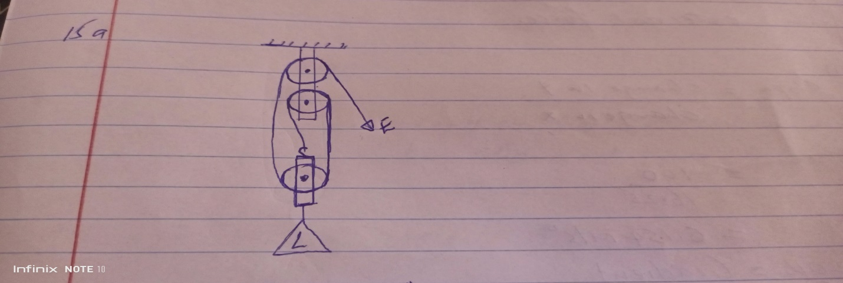
- M.A = V.R x 80/100
M.a = 3x80/100
M.a = 2.4
- M.A = L/E
2.4 = 4.8/E
E= 2N
- Work done by effort = effort x distance
- = 2 x 70x3 =4.2J
100

Wasted energy = 4.2 – ( 4.8X70/100)
= 4.2J – 3.36j
= 0.84J
16…*. .(a)Heat capacity is heat energy required to change the temperature of a substance by 1 Kelvin

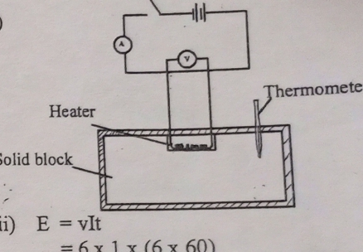
(b)
(ii) E = vIt
=6x1x(6x60)
=2160Joules
(iii) MCO = VIt
C = VIt/MO =2160/0.75x(24-20)
= 2160/0.75x4
= 720Jkg-1K-1 (c) Q. = CO
=8X(26-20)
=504Joules
17.* A body remains in its state of rest or uniform motion in a straight line unless acted upon by an external force.
    - Slope = change in Y
change in x
= 100
16.25
= 6.154m/s²
    - 20K = gradient

K = 6.154
20

K = 0.307 m/s²

    - M = 800KG

U = 0M/s
a= 0.12M/S²

S=D = 400M

V = 4+29 s

V = 0+2x 0.12 x 400

V = 960m/s

Momentum = mass x velocity

= 800 x 96

= 76800kg m/s

