Name ………………………..……………………………... Index No: ………………..…….…... Date: ……………………………….
232/3
PHYSICS
(PRACTICAL)
Paper 3
FORM 4
SEPTEMBER, 2022
OPENER EXAMINATION TERM 3, 2022

TIME 2 ½ Hours

Kenya Certificate of Secondary Education (KCSE)

INSTRUCTIONS TO CANDIDATES
- Write your name and index number and school in the spaces provided above.
- Sign and write the date of examination in the spaces provided above.
- Answer ALL the questions in the spaces provided in the question paper.
- You are supposed to spend the first 15 minutes of the 2½ hours allowed for this paper reading the whole paper carefully before commencing your work.
- Marks are given for a clear record of the observations actually made, their suitability, accuracy and the use made of them.
- Candidates are advised to record their observations as soon as they are made.
- Non-programmable silent electronic calculators may be used.
- This paper consists of 7 printed pages.
- Candidates should check the question paper to ascertain that all the pages are printed as indicated and that no questions are missing.
- Candidates should answer the questions in English.

FOR EXAMINER’S USE ONLY

QUESTION | MAXIMUM SCORE | CANDIDATE’S SCORE
1 | 20
2 | 20
TOTAL | 40

QUESTION 1
You are provided with the following:
- A metre rule
- A spring balance
- A mass M
- Stand
- Knife edge support.
- Two light strings about 10cm long.
Proceed as follows:
- Use the spring balance to determine weight of mass M ………………N. ( 1mk)
- Using the string provided make two loops to be used as hooks L1 and L2 in the diagram.
- Suspended the spring balance from a clamp and using one loop to support the rule from the spring so that the loop L2 is on 85cm mark.
- Support the other end of the rule with a knife edge at the 10cm mark so that the rule is horizontal.
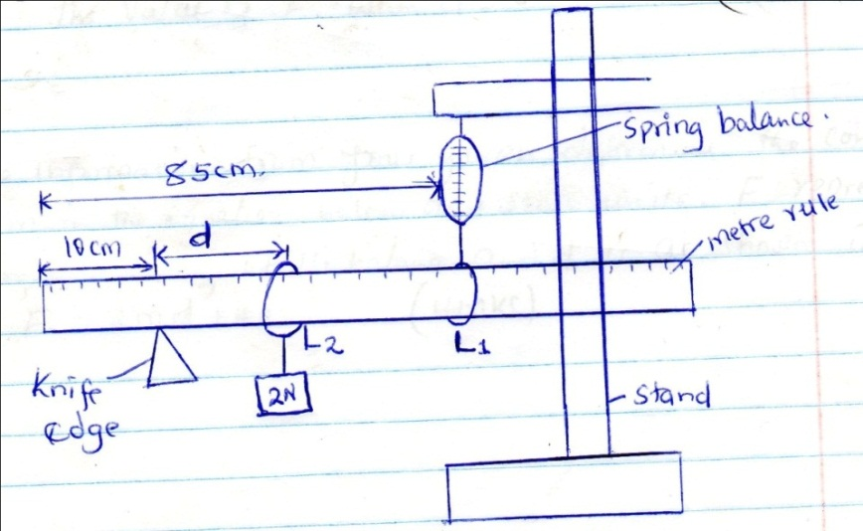
- Using loop 1 suspended the mass M at a distance d=10cm from the knife edge as shown and take the reading of the spring balance, record the results in table 1.
- Adjust the distance, d, to 20cm, 30cm e.t.c and each time recording the reading of the balance to complete the table.
Table 1
Distance (d)cm | 10.0 | 20.0 | 30.0 | 40.0 | 50.0 | 60.0 | 70.0
Distance (d) m
Force (N)

(3marks)
- Plot a graph of force F against distance d(m) (5 marks)
- From your graph determine:
- The slope (3mks)
………………………………………………………………………………………………………………………………………………………………………………………………………………………………
………………………………………………………………………………………………………………
- The value of F when d=0 (2mks)
………………………………………………………………………………………………………………………………………………………………………………………………………………………………
………………………………………………………………………………………………………………
- Using the information from your graph, determine the constant k and n in the equation below and indicate their units, F=2nd +40k.
- N (3mks)

- K (3mks)
QUESTION 2
You are provide with the following
- A nichrome wire mounted on a millimeter scale labelled AB
- A galvanometer.
- Jockey
- A carbon resistor labelled X .
- 8 Connecting wires, 4 with crocodile clips at both ends.
- A resistance wire labelled R mounted on a half meter rule
- Ammeter
- Voltmeter
- One dry cell in a cell holder
- Micrometer screw gauge

Proceed as follows:
(a ) Set up the circuit as shown below.
A
V
X

- Record the voltmeter reading when the switch is open.

E = ………………………………………………………… (1mark)
(ii) Close the switch and record the voltmeter and ammeter readings V and I.
V = ………………………………………………………… (1mark)
I = …………………………………………………………… (1mark)
(iii) Explain why V is less than E . (1mark)
………………………………………………………………………………………………………………………………………………………………………………………………………………………………………………………………………………………………………………………………………………

(iv) Now connect the voltmeter across the carbon resistor X and record voltmeter reading V₁ when the switch is on.
V₁ = …………………………………………………………. (1mark)
(v) Determine X given that X =$\frac{V_{1}}{I}$ (1mark)
………………………………………………………………………………………………………………………………………………………………………………………………………………………………
(b) Using the micrometre screw gauge, measure and record the diameter D of the resistance wire R provided
D =……………………………………………………m (1mark)
(c) Now connect another circuit as shown in the figure below.
G
X

L₁
L₂

10cm mark
90cm mark
R
B
A

Touch the 10cm mark and the 90 cm mark and see that the galvanometer deflects in opposite direction in each case.
(i)Move the sliding jockey along the resistance wire AB and note the length L₁ and L₂ where the galvanometer pointer points at the zero mark. Record the values of L₁ and L_{2.}
L₁ =…………………………………………………………………m (1mark)
L₂ =………………………………………………………………… m (1mark)
(ii) Determine the resistance of the resistance wire R using the relationship, (2marks)
$\frac{R}{L_{1} }=$ $\frac{X}{L_{2}}$
……………………………………………………………………………………………………………………………………………………………………………………………………………………………………………………………………………………………………………………………………………..
(iii)Determine the resistance of the wire R per metre. (1 mark)
……………………………………………………………………………………………………………………………………………………………………………………………………………………………..
(iv) Given that, R = $\frac{0.1114S}{D^{2}}$ determine the value of S , where R is the resistance per metre.
(3mark)
………………………………………………………………………………………………………………………………………………………………………………………………………………………………………………………………………………………………………………………………………………

PART B
You are provided with the following;
- Soft board
- Vernier calipers.
- Rectangular Glass block
- Four optical pins.
- Plain sheet of paper.
- Two thumb tacks
- Protractor

Procedure;
- Measure and record the width t of the glass block using the vernier calipers provided.
t = ……………………………………………… (m) (1 mark)
- Fix the white plain paper on the soft board using the two thumb tacks.
- Place the glass bock on the paper, trace its outline and label it ABCD, as shown.
- Remove the glass block and draw a normal, say at point O.
- Draw a line making an angle of 30⁰ with the normal to represent the incident ray.
- Replace the glass block carefully to its original position.

- Fix two pins P₁ and P₂ on the line in such a way that they are vertical and at least 4cm apart.
- Looking through the glass block through face AB, fix two pins P₃ and P₄ so that they are exactly in line with the P₁ and P₂. Mark the positions of P₃ and P₄
A
D
B
C
t
O

O¹

N
P
d
P₃
P₄
P₁
P₁

- Join P₃ and P₄ and produce the line to meet face AB of the block at O¹. Join O and O¹.
Measure angle O¹OP.
Also, Measure angle OO¹P.
O¹OP = …………………………………………………………………………(1mark)
OO¹P = …………………………………………………………………………(1mark)

- Measure the perpendicular distance d from the line O¹N to OP produced.
d = ………………………………………………………………… (m) (1mark)
- Determine t₁ given that, t1 = $\frac{dcos angle(OO^{1}P)}{sin angle({O^{1}OP})}$ . (3marks)
………………………………………………………………………………………………………………………………………………………………………………………………………………………………………………………………………………………………………………………………………………
- How do the values of t and t₁ compare. (1mark)
………………………………………………………………………………………………………………………………………………………………………………………………………………
NB. The worksheet should be handed in with the question paper.

