**Name: …………………………………………… Adm. No………...... Date……………………...**

**232/2**

**PHYSICS THEORY PAPER 2**

**FORM 4**

**OPENER EXAMINATION TERM 3, 2022**

**Time: 2 Hours**

**INSTRUCTION TO CANDIDATES**

* Write your name, index number and date in the spaces provided.
* This paper consists of TWO sections: A and B
* Answer ALL questions in section A and B in the spaces provided.
* ALL workings MUST be clearly shown.
* Mathematical tables and electronic calculators may be used.

**For examiner’s use only.**

|  |  |  |  |
| --- | --- | --- | --- |
| Section | Question | Maximum score | Candidate’s score |
| A | 1 – 13 | 25 |  |
| B | 14  15  16  17  18 | 10  9  14  14  9 |  |
|  | Total | 80 |  |

*This paper consists of* ***14*** *printed pages. Candidates should check the question paper to ensure that all the Pages are printed as indicated and no questions are missing.*

SECTION 1 (25 MARKS)

1. State one conditions necessary for the occurrence of an annular eclipse (1mk)

…………………………………………………………………............

…………………………………………………………………………

2. Two plane mirrors are inclined at an angle of 120o to each other such that their reflecting surfaces face each other. An object pins stands midway between the mirrors.

Calculate the number of images formed. (2mks) .....................................................................................................................................................................................................................................................................................................................................................................................................................................................................................................................................................................

3. Distinguish between hard and soft magnetic materials. (2marks)

....................................................................................................................................................................................................................................................................................................................................................................................................................................................................................

4. The figure shows the eye defect

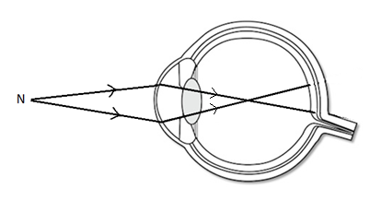

1. Name the defect and state how it can be corrected. (2marks)

……………………………………………………………………………………………..

…………………………………………………………………………………………….

5. State two defects of a simple cell and how each can be minimized. (2mks)

................................................................................................................................................................................................................................................................................................................................................

6. Differentiate between electromotive force and potential difference. (2mks)

......................................................................................................................................................................................................................................................................................................................................................................................................................... (2mks)

7. An electric bulb rated, 40W is operating on 240V mains. Determine the resistance of its filament. (3mks)

…………………………………………………………………………………………………………………………………………………………………………………………………………………………………………………………………………………………………………………………………………………………………………………………………………………………….

8. State one factor other than thickness, which determines the frequency of sound from stretched wire at room temperature. (1mk)

……………………………………………………………………………………………………………………………………………………………………………………………………………………………………………………………………………………………………………………………………………..

9. The figure below shows a ray of light passing through a transparent material placed in air.

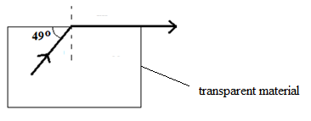

Calculate the refractive index of the transparent material. (2 marks)

....................................................................................................................................................................................................................................................................................................................................................................................................................................................................................................................................................................................................................................................................................................

10. The force on a conductor carrying a current in a magnetic field can be varied by changing, among others, the magnitude of the current and the magnetic field strength. Name any other factor that can be changed to vary the force. (1marks)

11. Arrange the following electromagnetic waves in the order of increasing wavelength.

Ultraviolet, X –rays, radio waves, γ-rays. (1mk)

………………………………………………………………………………………………………………………………………………………………………………………………………………

12. State one causes of power loss in long distance transmission wires and how these loses can be minimized. (2mks) .....................................................................................................................................................................................................................................................................................................................................................................................................................

13. The table below carries information on the type of radiation, detector and use for some of the electromagnetic radiations.

|  |  |  |
| --- | --- | --- |
| Type of radiation | Detector | Use |
| Microwave | Crystal detector, solid state diodes | ...................................................... |
| ...................................... | Thermopile, blackened bulb thermometer | Warmth sensation |

Fill in the blank spaces. (2mks).

SECTION B (55 MARKS)

*Answer all the questions in this section in the spaces provided.*

14 (a) Figure 7 shows a simple electric bell circuit.

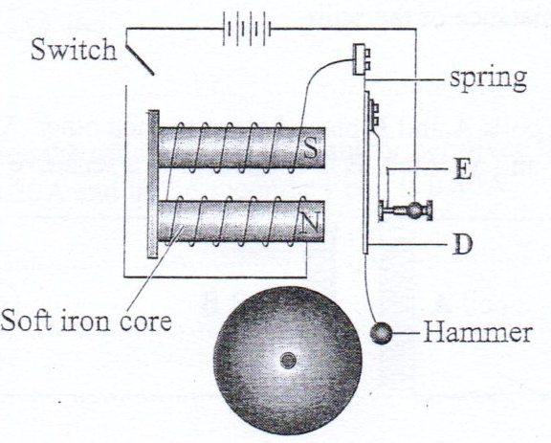

1. Name the parts labelled

I. D ………………………………………………………. (1 mark)

II. E ……………………………………………………….. (1 mark)

1. When the switch is closed, the hammer hits the gong repeatedly. Explain why:
2. The hammer hits the gong. (2 marks)

…………………………………………………………………………………………………………………………………………………………………………………………………………………………………………………………………………………………………………………………………………

1. The hammer hits the gong repeatedly. (2 marks)

………………………………………………………………………………………………………………………………………………………………………………………………………………………………………………………………………………

b) An electric bulb is rated 60W, 240V. Determine:

I. the current that flows through it when it is connected to a 240V supply. (2 marks)

 ..........................................................................................................................................................................................................................................................................................................................................................................................................................................................................................

II. The resistance of the bulb. (2 marks)

 ........................................................................................................................................................................................................................................................................................................................................................................................................................................................................................................................................................................................................

15. (a) State Faradays law of electromagnetic induction. (1 mark)

.....................................................................................................................................................................................................................................................................................................

(b) The primary coil of a transformer has 1200 turns and the secondary coil has 60 turns. The transformer is connected to a 240V a.c source. Determine

1. The output voltage. (2 marks)

 ........................................................................................................................................................................................................................................................................................................................................................................................................................................................................................................................................................................................................

ii) The output current when the primary coil has a current of 0.5A (Assume there is no energy losses)

(2 marks)

....................................................................................................................................................................................................................................................................................................................................................................................................................................................................................

  iii) One of the primary ways in which power is lost in transformers is through eddy currents. State how eddy currents can be minimized. (1 mark)

.....................................................................................................................................................................................................................................................................................................

(c). Determine the cost of using an electric iron rated 1500W, for a total of 30 hours given that the cost of electricity per kwh is Ksh 8. (2 marks).

 ........................................................................................................................................................................................................................................................................................................................................................................................................................................................................................................................................................................................................

(d). The figure below shows a coil and a magnet being removed from the coil.



Indicate the direction of flow of current on the coil. (1 mark).

16. (a) State Ohms’ law (1mark). ……………………………………………………………………………………………………………………………………………………………………………………

(b) From the circuit diagram below

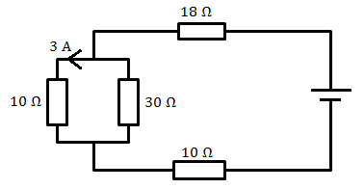

Determine

(i) The current through the 30Ω resistor (2 marks)

…………………………………………………………………………………………………………………………………………………………………………………………………………………………………………………………………………………………………………………………........

(ii) The total current in the circuit (2 marks)

………………………………………………………………………………………………………………………………………………………………………………………………………………………………………………………………………………………………………………………………

(iii) The total resistance in the circuit (2 marks)

…………………………………………………………………………………………………………………………………………………………………………………………………………………………………………………………………………………………………………………………........

(iv) The total P.d in the circuit (2 marks).

…………………………………………………………………………………………………………………………………………………………………………………………………………………………………………………………………………………………………………………………........

(c). The graph below shows relationship between voltage and the current obtained from an experiment performed by form 4 students.



1. Draw a circuit that could be used to obtain the results shown on the graph. (1 mark)

....................................................................................................................................................................................................................................................................................................................................................................................................................................................................................

(ii) From the graph determine the emf of the battery used give the relation Description: Image (2 marks)

…………………………………………………………………………………………………………………………………………………………………………………………………………………………………………………………………………………………………………………………........

(iii) Determine the internal resistance of the battery. (2 marks)

…………………………………………………………………………………………………………………………………………………………………………………………………………………………………………………………………………………………………………………………........

17. a) distinguish between hard and soft x-rays . (1mk)

………………………………………………………………………………………………………………………………………………………………………………………………………………

b) Figure below shows a circuit of a modern x-ray tube.

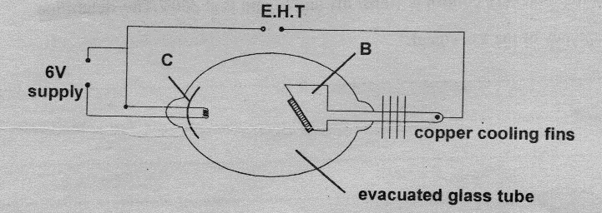

1. Indicate the path of the x-ray beam produced by the tube. (1mk)
2. Give the function of the part labelled C. (1mk)

……………………………………………………………………………………………………………………………………………………………………………………………………

1. Identify part labelled B. (1mk)

……………………………………………………………………………………………………

1. In modern models of x-ray tubes, part B rotates, Give a reason for this rotation. (1mk)

…………………………………………………………………………………………………………………………………………………………………………………………………………

c). How can the intensity of the x-rays be increased (1mk)

………………………………………………………………………………………………………………………………………………………………………………

d). An x-ray tube operates at 30k V and a current of 20m A, calculate the electric power dissipated. (2mks) ……………………………………………………………………………………………………………………………………………………………………………………………………………………………………………………………………………………………………………………..

e). Give a reason why C.R.O is a more accurate device as a voltmeter than a moving coil meter. (1mk)

……………………………………………………………………………………………………………………………………………………………………………………………………………..

Give one difference between x-rays and cathode rays. (1mk)

……………………………………………………………………………………………………………………………………………………………………………………………………………..

g). Figure below shows the trace on the screen of an a.c signal connected to Y-plates of a C.R.O

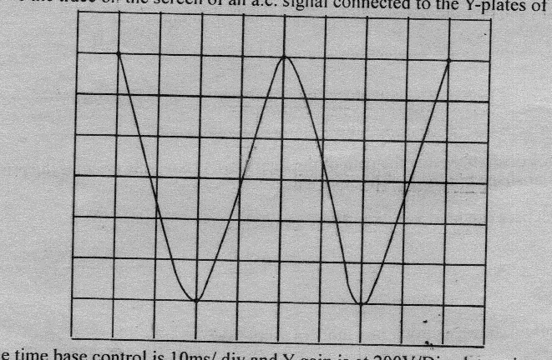

Given that the time base control is 10ms/div and y gains200V/div. Determine;

1. The frequency of the a.c signal. (2mks)

………………………………………………………………………………………………………………………………………………………………………………………………………………………………………………………………………………………………………………………………………………

ii) The peak voltage of the signal. (2mks)

…………………………………………………………………………………………………………………………………………………………………………………………………………………………

18a).When a radiation was released into a diffusion chamber, short, thick tracks were observed. State with reason, the type of radiation was detected. (2mks)

………………………………………………………………………………………………………………………………………………………………………………............

b) The half-life of a certain radioactive element is 8 years.What fraction of the element will be remaining after 32 years. (2mks)

…………………………………………………………………………………………………………………………………………………………………………………………………………………………………………………………………………………………………………………………………………………………………………

(c) State what is meant by an extrinsic semi-conductor. (1 mark)

………………………………………………………………………………………………………………………………………………………………………………………………………………

(d) Figure 11 shows a depletion layer in an unbiased p-n junction.

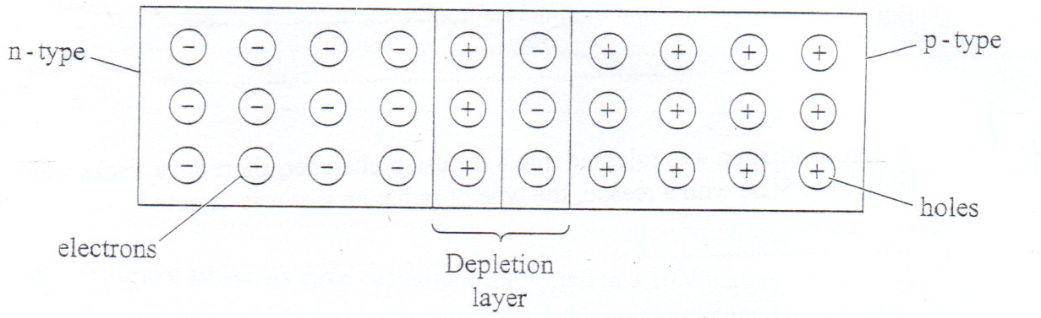

Figure 11

State how a battery can be used to make the depletion layer narrower. (1 mark)

………………………………………………………………………………………………………………………………………………………………………………………………………………

(e) Figure 12 shows an incomplete circuit of a full wave rectified.

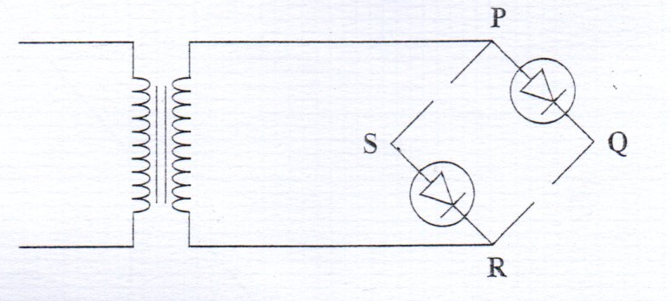

Figure 12

1. Draw in the Figure 12 two more diodes to complete the circuit. (2 marks)
2. Show on the Figure 12 the points across which the output of the rectifier should be obtained

……………………………………………………………………………………………………………………………………………………………………………………………………. (1 marks)