Name: …………………………………………… Adm. No………...... Date……………………...

232/1
PHYSICS THEORY PAPER 1
FORM 4
OPENER EXAMINATION TERM 3, 2022
Time: 2 Hours

Instructions to candidates

- Write your name and admission number in the spaces provided above
- Answer all the question in the spaces provided.
- All working must be clearly shown in the spaces provided
- Mathematical tables and calculators maybe used.
- All questions amount to 100 marks.

SECTION A (25MKS)
- A 60000cm³ litre giant density bottle has its weight stated as 100N when empty. What would be its weight when filled with a liquid W, whose density is 0.72 g/cm³ (3mks)
.....................................................................................................................................................................................................................................................................................................................................................................................................................................................................................................
- Given the following graph below
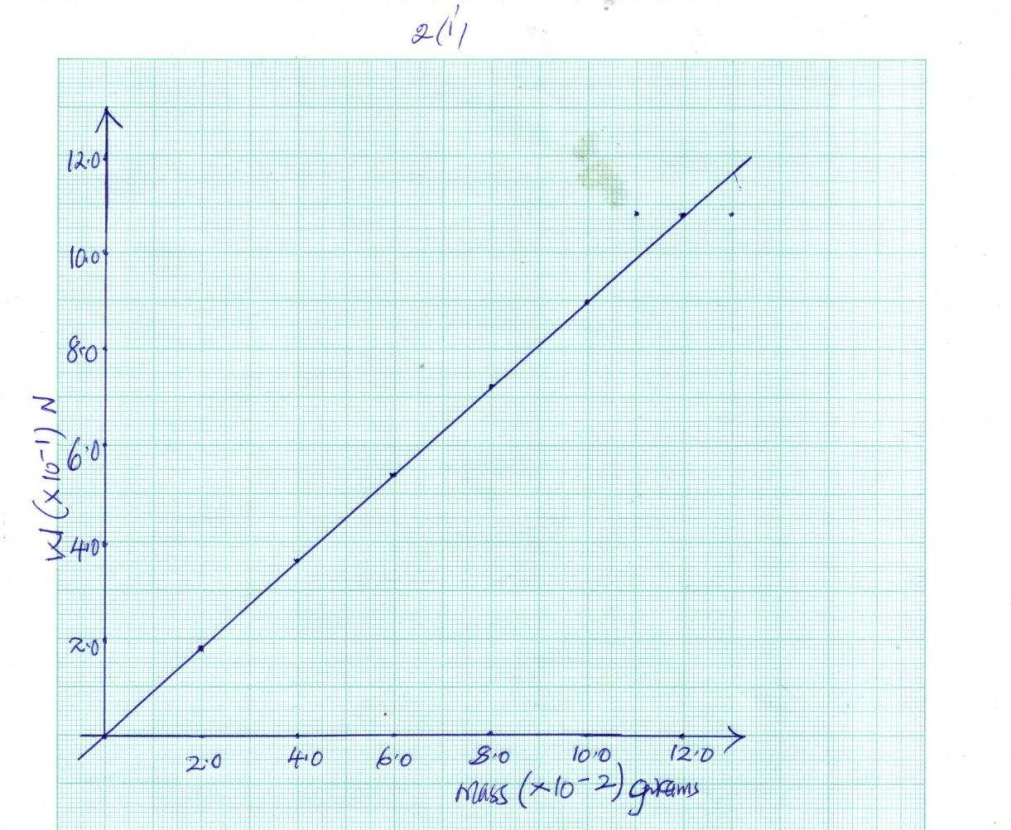

    - Determine the gradient (2mks)
....................................................................................................................................................................................................................................................................................................................................
    - State what the gradient represents (1mk)
....................................................................................................................................................................................................................................................................................................................................
- State one negative effects of ANOMALOUS EXPANSION of water (1mk)
....................................................................................................................................................................................................................................................................................................................................

- Sketch the variation of density of water with temperature between 0°C to 10°C (2mk)
....................................................................................................................................................................................................................................................................................................................................
....................................................................................................................................................................................................................................................................................................................................
- Apart from conductivity of a material, state other factor which determine rate of heat flow in a material (1mk)
....................................................................................................................................................................................................................................................................................................................................
- Give one reason why liquids are poor conductors of heat. (1mks)
....................................................................................................................................................................................................................................................................................................................................
- Three springs are arranged in parallel as shown and a 600gm mass hanged as shown below. If each spiral spring has 24 N/m spring constant.

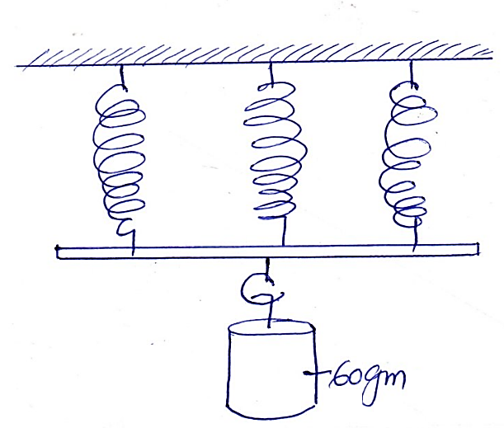
Determine the:
  - Effective spring constant (2 mks)
....................................................................................................................................................................................................................................................................................................................................
..................................................................................................................................................................
  - Extension produced (2 mks)
....................................................................................................................................................................................................................................................................................................................................
..................................................................................................................................................................

- A ball is thrown horizontally from the top of a cliff 20m high with a horizontal velocity of 10m/s. Calculate the time taken by the ball to strike the ground (2mks)
..................................................................................................................................................................
..................................................................................................................................................................
..................................................................................................................................................................
- State one (1) factor that affect the diffusion of gas (1mk)
..................................................................................................................................................................
- A trolley of mass 1.5 kg is pulled along by an elastic cord and given an acceleration of 2m/s². Find the frictional force acting on the trolley if the tension in the cord is 5N. (2mks)
..................................................................................................................................................................
..................................................................................................................................................................
..................................................................................................................................................................
- State the law of conservation of linear momentum (1mks)
..................................................................................................................................................................
..................................................................................................................................................................
- A point in the rim of a wheel has a velocity of 5.6 m/s. if the rim has a radius of 0.4m, determine the angular velocity of the point (2mks)
..................................................................................................................................................................
..................................................................................................................................................................
..................................................................................................................................................................
- A form 2 student measured the diameter of a ball bearing using a micro meter screw gauge as shown below
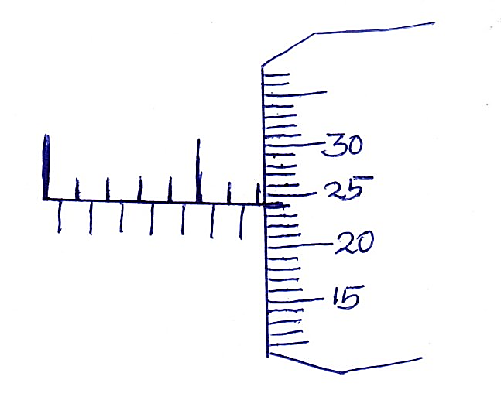
10
5
State the diameter of the ball as read from above if it has an error of -0.02 (2mks)
..................................................................................................................................................................

SECTION B (55 MARKS)
- (a) State the principle of transmission of pressure in liquids (1mk)
..................................................................................................................................................................
..................................................................................................................................................................
.................................................................................................................................................................
(b) The figure below shows two masses placed on light pistons. The pistons are held stationery by the liquid, L as shown.
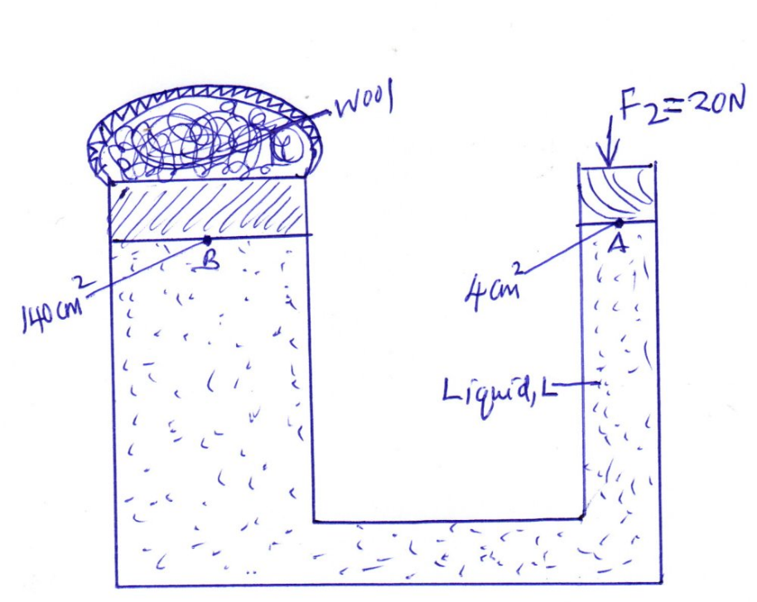
Determine
    - Pressure exerted by force F₂ = 20N at point A of the liquid (2mks)
..................................................................................................................................................................
..................................................................................................................................................................
    - Pressure at point B (1mks)
..................................................................................................................................................................
..................................................................................................................................................................
    - Force F₁ produced on B to press wool enclosed (2mks)
..................................................................................................................................................................
..................................................................................................................................................................

c. An electric motor raises a 50 kg load at a constant velocity, if it takes 40 seconds to raise the load through a height of 24m, determine
- The work done (g = 10N/Kg)(2mks)
..................................................................................................................................................................
..................................................................................................................................................................
- The power of the motor (2mks)
..................................................................................................................................................................
..................................................................................................................................................................
d. State two (2) factors which determines the mechanical advantage of a machine (2mks)
..................................................................................................................................................................
..................................................................................................................................................................
- (a) Define centre of gravity (1mk)
..................................................................................................................................................................
.................................................................................................................................................................
(b) State the principle of moments (1mk)
..................................................................................................................................................................
..................................................................................................................................................................
(c) Calculate the force F required to be applied vertically to the wheelbarrow handles in the figure below to lift a 50kg load at the centre of gravity indicated. Disregard the mass of the wheel barrow. (3mks)
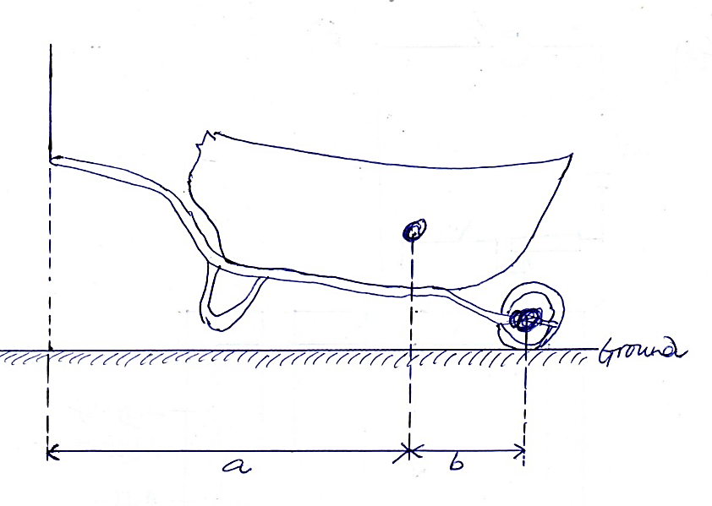
C.O.G
F
Take a =70cm, and b = 30cm.
Clockwise moments = anticlockwise moments
..................................................................................................................................................................

(d) The graph below shows the force on a tennis ball when served during game. Assuming the ball is stationery before it is struck and it is struck with velocity of 40m/sec.
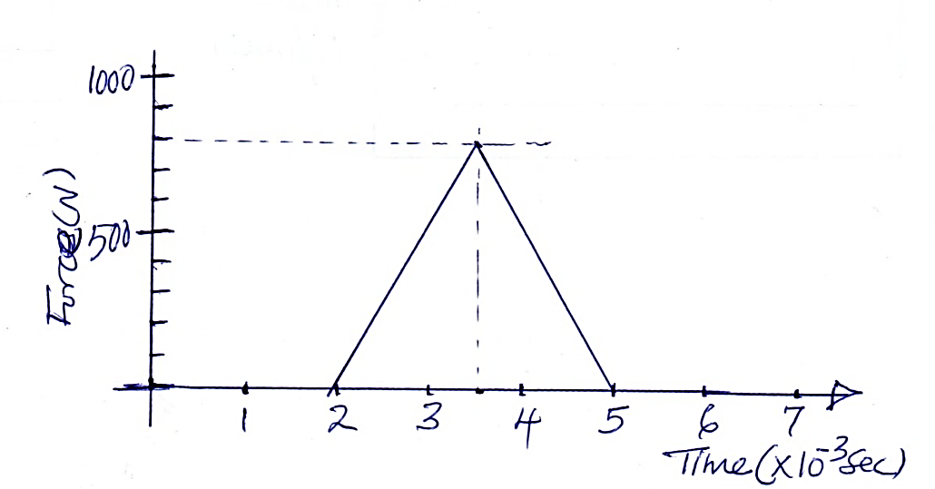
Find
- The impulsive force on the ball (2mks)
..................................................................................................................................................................
..................................................................................................................................................................
- The mass of the racket (2mks)
..................................................................................................................................................................
..................................................................................................................................................................
(e) A passenger of mass 80kg stands on the floor of a lift car. Determine the
Reaction of the floor when the car
- Accelerates at 1.2 m/s² downwards (2mks)
..................................................................................................................................................................
..................................................................................................................................................................
..................................................................................................................................................................

- Decelerates at 0.8 m/s² upwards (2mks)
..................................................................................................................................................................
..................................................................................................................................................................
..................................................................................................................................................................

- (a) State Charles law as it relates to ideal gas (1mk)
..................................................................................................................................................................
..................................................................................................................................................................
(b) Distinguish between evaporation and boiling (2mks)
Evaporation | boiling

(c) Study the diagram below
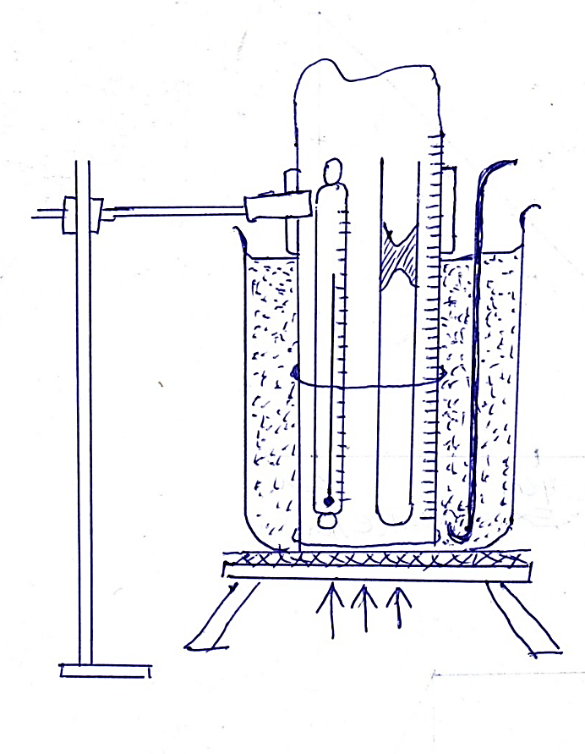
- State two quantities to be measured (2mks)
..................................................................................................................................................................
..................................................................................................................................................................
- Explain how the measurements obtained above can be used to verify Charles law (4mks)
..................................................................................................................................................................
..................................................................................................................................................................
..................................................................................................................................................................

(iii) A mass of a gas has a volume of 800cm³ and is heated at a constant pressure from 10°C to 100°C. Calculate the final volume of the gas (3mks)
..................................................................................................................................................................
..................................................................................................................................................................
..................................................................................................................................................................
- (a) Define heat capacity (1 mk)
..................................................................................................................................................................
..................................................................................................................................................................
(b) The figure below illustrates an experiment in which electrical energy is
Used to determine specific heat capacity of a metal heated for a period of time.
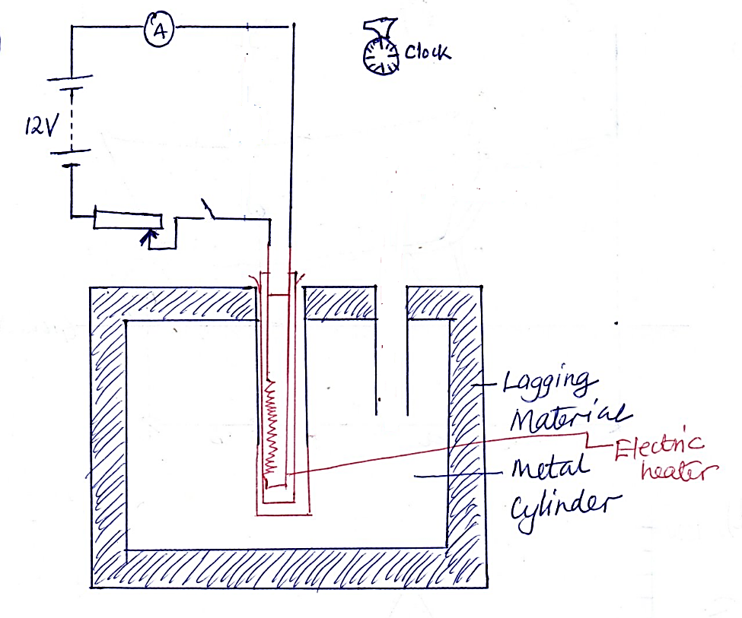

    - Complete the circuit to show connection of the essential circuit components and name them (2mks)

    - Outline the procedure on how to determine the value of specific heat capacity, C, of the metal block. (3mks)
..................................................................................................................................................................
..................................................................................................................................................................
..................................................................................................................................................................
..................................................................................................................................................................

In a similar experiment the following readings were obtained when the heater was switched on for 10 minutes
Voltmeter reading = 15v
Ammeter reading = 3A
Temp after 10min = 80c
If the mass of the metal cylinder was 0.5kg and the initial temperature of the metal block before switching on current was 20°c. Determine the specific heat capacity of the metal cylinder (3mks)
..................................................................................................................................................................
..................................................................................................................................................................
..................................................................................................................................................................
..................................................................................................................................................................
- (a) State Archimedes principle (1mk)
..................................................................................................................................................................
..................................................................................................................................................................
(b) A cylinder of length 5cm and uniform cross section area 50.24cm² is suspended from a spring balance and totally immersed in water. If the density of the material of the cylinder is 1.25g/cm³ determine:
    - The up thrust on the cylinder (3mks)
..................................................................................................................................................................
..................................................................................................................................................................
..................................................................................................................................................................
..................................................................................................................................................................
    - Weight of the cylinder (3mks)
..................................................................................................................................................................
..................................................................................................................................................................
..................................................................................................................................................................
    - The reading on the spring balance (2mks) (take g = 10m/s² or N/kg S_{h2O} =1000kg/m³) (2mks)
..................................................................................................................................................................
..................................................................................................................................................................
..................................................................................................................................................................

